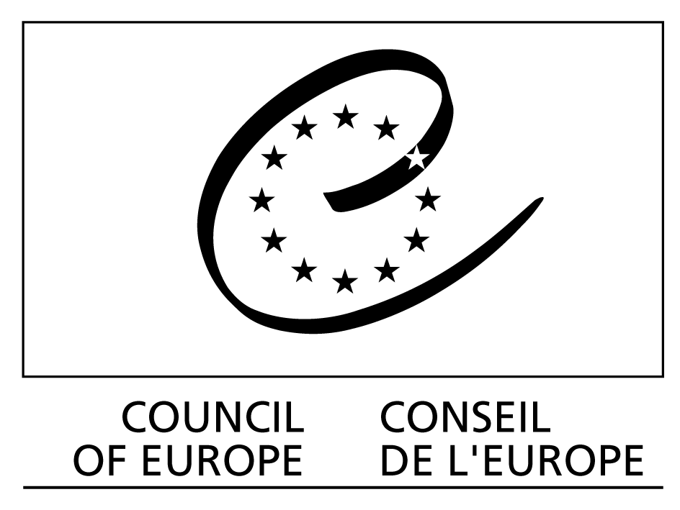

30 June 2015

Council of Europe
contribution for the report of the United Nations High Commissioner for Human Rights, pursuant to UN Human Rights Council resolution 27/31 on civil society space and examples of good practices

The Council of Europe pursues a comprehensive and inclusive approach to protecting and extending the “civil society space” in the member States and at the headquarters.

The Council of Europe:
- uses the full spectrum of standard setting, monitoring and cooperation to assist its member States in this respect;
- provides financial assistance to international youth NGOs;
- is open for cooperation with NGOs;
- keeps questions of the “civil society space” on the European political agenda and takes action.

The Secretary General’s report on the “State of democracy, Human Rights and the Rule of Law in Europe. A shared responsibility for democratic security in Europe” dedicates a whole chapter to “freedom of assembly and freedom of association”. While it takes stock of the “shrinking civil society space”, it contains also recommendations for future action to protect and extend it. These include
- preparation of new guidelines to ensure meaningful civil participation in political decision-making, based on best practice and shared standards;
- updating of the Council of Europe practice to ensure a greater voice for civil society within the Organisation;
- revision of the guidelines on participatory status.

https://wcd.coe.int/ViewDoc.jsp?id=2316783&Site=COE&BackColorInternet=C3C3C3&BackColorIntranet=EDB021&BackColorLogged=F5D383

Council of Europe standards and policy documents of relevance for the “civil society space”

- The Committee of Ministers’ Recommendation CM/Rec (2007)14 on the Legal Status of non-governmental organisations in Europe establishes minimum standards and basic principles that should guide member states in their legislation, policies and practices in respect of NGOs. The Recommendation outlines the objectives NGOs should be free to pursue and sets out principles pertaining to their legal personality, membership and management. Issues such as the financing and accountability of NGOs are also addressed in the Recommendation. Finally, the Recommendation encourages states to ensure the effective participation of NGOs in decision making and requires that they be consulted during the drafting of legislation which is likely to affect them.
- The Code of Good practice for civil participation in the decision-making process was adopted by the Conference of INGOs of the Council of Europe in October 2009 and endorsed by the Committee of Ministers, the Parliamentary Assembly and the Congress of Local and Regional Authorities. The Code of good practice draws upon practical experience and tried-and-tested methods from various countries in Europe. It exists in 20 languages. http://www.coe.int/t/ngo/code_good_prac_en.asp . This soft standard setting tool has been used in numerous countries for the reform of legislation and structures for participation of NGOs in political decision-making processes at local, regional and national levels. Two examples:

Montenegro:
http://www.coe.int/t/ngo/Source/Code_Handbook_Montenegro.pdf
Sweden:

- Anonymity on Internet may be one of the conditions for a safe and enabling environment for the work of human rights activists. The Committee of Ministers of the Council of Europe adopted on 28 May 2003 a Declaration on the freedom of communication on the Internet where it decided to ensure protection against online surveillance and to enhance the free expression of information and ideas for a safe and enabling environment for civil society. In this Declaration, and as a principle of anonymity, the member states are encouraged to respect the will of the users of the Internet not to disclose their identity, which, nevertheless, does not prevent member states from taking measures and co-operating in order to trace those responsible for criminal acts, in accordance with national law, the Convention for the Protection of Human Rights and Fundamental Freedoms and other international agreements in the fields of justice and police.

- In a Declaration on Risks to Fundamental Rights stemming from Digital Tracking and other Surveillance Technologies adopted on 11 June 2013, the Committee of Ministers welcomes measures taken by both State and non-State actors to raise awareness among users, and, a fortiori, within the private sector and among technology developers about the potential impact of the use of such technologies on human rights and the steps which can be taken at the design stage to minimise the risks of interferences with these rights and freedoms (e.g. “privacy by design” and “privacy by default”).

Council of Europe bodies monitoring the “civil society space”

- The European Court of Human Rights has repeatedly recognised civil society’s important contribution to the discussion of public affairs (see, for example, Steel and Morris v. the United Kingdom (no. 68416/01, § 89, ECHR 2005 II). “[I]n a democratic society even small and informal campaign groups […] must be able to carry on their activities effectively and […] there exists a strong public interest in enabling such groups and individuals outside the mainstream to contribute to the public debate by disseminating information and ideas on matters of general public interest […].”

- By signing a Memorandum of Understanding with five partner organisations (Article 19, the Association of European Journalists, the European Federation of Journalists, the International Federation of Journalists and Reporters Without Borders), the Council of Europe launched in April 2015 an Internet Platform to promote the protection of journalism and safety of journalists. The platform is designed to facilitate the compilation, processing and dissemination of factual information, verified by the partner NGOs, concerning serious physical threats to journalists and other media personnel, threats to the confidentiality of media sources and forms of political or judicial intimidation, enabling the Council of Europe to highlight serious concerns about media freedom and journalists’ rights, to react more effectively in response to these threats and to initiate a dialogue with the member states concerned on possible remedies and protective measures.

- The Conference of INGOs created the Expert Council on NGO Law in 2008 with the aim of creating an enabling environment for NGOs through examining national NGO legislation and its implementation and providing advice on how to bring national law and practice into line with Council of Europe standards and European good practice. It is an initiative by civil society for civil society. (http://www.coe.int/t/ngo/Articles/Expert_Council_TermsofReference_270612_en.asp)

The Expert Council carries out thematic and country studies on specific aspects of NGO legislation and its implementation that seem to pose problems of conformity with international standards, notably the European Convention on Human Rights and the above-mentioned Recommendation (2007)14. It raises awareness of its findings by organising round tables in the countries concerned by its reports so as to facilitate dialogue between civil society and authorities to address the shortcomings identified in its reportsIts work covers the 47 member countries of the Council of Europe and Belarus. It co-operates closely with other Council of Europe bodies, in particular the Venice Commission and the Commissioner for Human Rights.

Recent examples of its work include opinions on NGO Legislation in the Russian Federation http://www.coe.int/t/ngo/Articles/Expert_Council_Russia_country_study_en.asp and in Azerbaijan http://www.coe.int/t/ngo/Articles/Expert_Council_Azerbaijan_country_study_en.asp and a thematic study on regulating political activities of NGOs http://www.coe.int/t/ngo/Source/OING_CONF_EXP_2014_2_Study_Political_Activities_en.pdf .

Council of Europe cooperation activities to enlarge the “civil society space”

- Several country-specific Action Plans of the Council of Europe contain projects for strengthening civil society and in particular at improving its participation in the democratic decision-making process. The civil society project of the Action Plan for Ukraine (2015-2017) aims at advancing and consolidating an inclusive approach in sustainable dialogue, including the legal and institutional framework for involvement of civil society in decision-making processes. It is based on strategic priorities which were prepared at the end of 2014 by a multi-stakeholder group including representatives of the administration of the President, Parliament, Cabinet of Ministers, Ministry of Justice and several civil society platforms and networks. https://wcd.coe.int/ViewDoc.jsp?id=2275763&Site=COE&BackColorInternet=C3C3C3&BackColorIntranet=EDB021&BackColorLogged=F5D383

Participation of civil society in the Council of Europe structures and work

- The Committee of Ministers engaged in a reflection process on the role and functioning of NGOs at the Council of Europe and looks in particular at concrete measures for enhancing its own interaction with civil society while respecting the intergovernmental nature of the Organisation and the confidentiality of its own work. Discussions are still ongoing. https://wcd.coe.int/ViewDoc.jsp?id=2200515&Site=COE&BackColorInternet=C3C3C3&BackColorIntranet=EDB021&BackColorLogged=F5D383

- The Council of Europe created a consultative status for INGOs back in 1952 and transformed it in 2003 in a participatory status to reflect the practice of INGO involvement in policy making. http://www.coe.int/t/ngo/Articles/Resolution_2003_8_en.asp At present, 320 INGOs enjoy the status. The INGOs enjoying participatory status with the Council of Europe form the Conference of INGOs. Alongside with the Parliamentary Assembly and the Congress of Local and Regional Authorities it participates in the Council of Europe’s intergovernmental committees which oversee and coordinate the intergovernmental work. Individual INGOs may join these intergovernmental committees as observers.

- With a view to increasing the impact of the human rights monitoring systems, it is advisable to allow participation of civil society in the monitoring of their application. As a very good example should be mentioned the possibility of INGOs to protect the social rights as enshrined in the European Social Charter through the collective complaints procedure. Such a participation of INGOs in the monitoring of the application of the European Social Charter represents a more transparent, open and democratic monitoring system.

- For over 40 years, the Council of Europe has supported the contribution of young people to the Organisation’s objectives through specifically designed participatory structures and programmes. Besides the possibilities offered by the instruments placed at the disposal of its Youth Department, in particular the European Youth Centres (Strasbourg and Budapest) and the European Youth Foundation, the CoE has developed a rather elaborated model of youth participation through a system of “co-management” which enables young people, through their organisations, to act as partners of governments in the formulation, implementation and monitoring of the Organisation’s policy and programmes in the field of youth.

The principle and practice of co-management as conceived by the Council of Europe involves different dimensions of participation:

- Consultation

The Advisory Council on Youth (CCJ) - composed of 30 representatives of national and European youth NGOs - has the task of advising the CoE Committee of Ministers on questions relating to the youth domain and of contributing to the effective mainstreaming of youth policies across the CoE programme of activities by formulating opinions and proposals on general or specific questions concerning youth.

- Co-operative dialogue

The Council of Europe encourages a form of partnership which involves regular, ongoing dialogue between the various players in the youth sector, in particular young people and other sectors of the Organisation. This leads, for instance, to active direct involvement in Parliamentary Assembly of the Council of Europe (PACE) and the CoE Congress of Local and Regional Authorities’ activities relating to youth, with subsequent cross-sectoral projects.

Co-operative dialogue takes also the form of participation of some 80 youth representatives in the debates of the CoE Conference of Ministers Responsible for Youth. These representatives take part in a youth event prior to each Conference, in order to prepare their contribution to its debates.

- Co-decision

The CoE strategy regarding its youth policy is developed in particular within two bodies duly mandated by the Committee of Ministers to take decisions in this regard: the Joint Council on Youth (CMJ) and the Programming Committee on Youth (CPJ). The CMJ is the central policy-making body of the CoE youth sector, bringing together the governmental partners (CDEJ members) and the non-governmental partners (CCJ youth representatives members).

The CMJ oversees the CoE programme in the field of youth and advises the Committee of Ministers on all questions within its area of competence. The CMJ establishes the structure and programme policy of the youth sector, prepares the priorities and objectives of the youth sector, and apportion the budgetary means available. The Programming Committee has the task of establishing the programme of activities of the European Youth Centres, and allocating the grants from the European Youth Foundation to youth projects.

- Co-management

The participation of youth representatives in the above structures of the CoE’s youth sector goes far beyond sharing decisions together with the governmental partners. The Joint Council on Youth and the Programming Committee on Youth, have an important role in ensuring that the policy and programmes are implemented in accordance with their respective decisions. It is a shared responsibility of youth and governmental representatives to monitor, follow-up and evaluate the programmes and consequently the priorities and objectives set-out.

Council of Europe recommendations and resolutions relating to youth issues, which were adopted by the Committee of Ministers, were prepared with the active participation of youth representatives - and often on their own initiative. The most important youth-related events in terms of size, political relevance and impact were initiated by young people and their organisations. Two significant examples in this respect are the two European Campaigns “All different-all equal” against racism, intolerance, xenophobia and anti-Semitism, and the current “No Hate Speech Movement” Campaign against hate speech online and for human rights.

