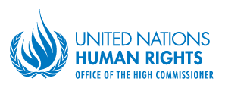

PROGRESS AND OBSTACLES IN THE FIGHT AGAINST IMPUNITY

FOR SEXUAL VIOLENCE

IN THE DEMOCRATIC REPUBLIC OF THE CONGO

APRIL 2014
table of contents

I. Summary…………………………………………………………………………………. 3

II. Introduction………………………………………………………………………….. 5

III. Methodology and constraints………………………………………………. 5

IV. Legal framework…………………………………………………………………... 6
4.1. International and regional obligations………………………………………………….. 6
4.2. National laws……………………………………………………………………………... 8

V. General trends in sexual violence………………………………………… 8

VI. Progress in the fight against impunity for sexual violence… 11
6.1. Recent commitments taken by the DRC Government……………………………….. 11
6.2. General trends on prosecutions of sexual violence…………………………………… 11

VII. Main obstacles in the fight against impunity for sexual violence………………………………………………………………………………... 13
7.1. Emblematic cases……………………………………………………………………….. 14
7.2. Shortcomings in the fight against impunity for sexual violence……………………... 16
7.2.1. Limited efforts of some Congolese authorities……………………………………… 17
7.2.2. Challenges within the judicial system and the legal framework……………………. 18
7.2.2.1. Legal restrictions in conducting prosecutions, especially against officers, in the military justice system……………………………………………………………. 18
7.2.2.2. Lack of resources and capacity in the judicial system……………………………. 19
7.2.2.3. Prison escapes…………………………………………………………………….. 19
7.2.3. Constraints in victims’ access to justice…………………………………………….. 20
7.2.3.1. Frequent recourse to out-of-court settlements by victims and perpetrators………. 20
7.2.3.2. Economic and logistical constraints for victims to get access to courts………….. 21
7.2.3.3. Lack of protection mechanisms for victims and witnesses………………………..21
7.2.3.4. The stigmatization of victims of sexual violence………………………………… 22
7.2.3.5. Lack of comprehensive medical and psychosocial support and lack of reparations for the victims…………………………………………………………………….. 22
7.2.4. Security and logistical challenges…………………………………………………… 23

VIII. Conclusions and recommendations………………………………….. 23

IX. ANNEX: REACTION OF THE MINISTER OF JUSTICE AND HUMAN RIGHTS.. 26

Summary

- Since its establishment in February 2008, the United Nations Joint Human Rights Office (UNJHRO) in the Democratic Republic of the Congo (DRC) has been engaged in the fight against impunity for perpetrators of sexual violence. This area of focus falls within the mandate of the UNJHRO, as laid out in Security Council Resolutions, and as per the Strategic Management Plan of the High Commissioner for Human Rights. In 2010, the Secretary-General, at the request of the Security Council in its Resolution 1888, appointed a Special Representative on Sexual Violence in Conflict to provide strategic leadership and coherent coordination on the issue. The Office of the Special Representative has been collaborating with the Office of the High Commissioner for Human Rights as well as with MONUSCO and the UNJHRO to address sexual violence in the DRC.

- The period between January 2010 and December 2013 analyzed in this report has been characterized by the persistence of incidents of sexual violence that were extremely serious due to their scale, their systematic nature and the number of victims. A high number of sexual violence crimes were committed by armed groups as well as by Congolese defense and security forces in the context of the conflict in the eastern part of the country. Incidents of sexual violence were mainly registered during attacks on villages, alongside other human rights violations, including killings, wounding, abductions and/or lootings. In some incidents in eastern DRC, large-scale rape has been used as a weapon of war or to punish civilians for their perceived collaboration with a rival party to the conflict in the struggle for power over areas rich in natural resources.

- In most recent years, some progress has been observed in the fight against impunity for sexual violence crimes. The UNJHRO has registered an increase in the number of prosecutions of State agents for sexual violence, resulting in part from the deployment of mobile court hearings and the provision of technical and logistical support by international actors, including MONUSCO, to military justice investigations. This has resulted in the conviction of a number of elements of the Armed Forces of the Democratic Republic of Congo (FARDC), including some senior officers. Other positive developments in the fight against impunity include the recent commitments taken by DRC authorities to engage on issues related to sexual violence at the highest level, including through the signature of a Joint Communiqué on addressing sexual violence signed with the United Nations in March 2013.

- Nonetheless, most cases of sexual violence are never investigated or prosecuted, and very few are even reported. One of the main obstacles is that many victims do not report incidents for fear of retaliation by the alleged perpetrators, stigmatization and/or rejection by their families and communities. Impunity for crimes of sexual violence is further exacerbated by various other factors such as the limited efforts of some Congolese authorities to prosecute such crimes, lack of financial, operational and human capacity as well as cases of corruption within the judicial system.

- Many women and girls who were raped suffer medical complications and severe mental trauma, but still lack access to medical and psycho-social assistance. Furthermore, notably because the DRC lacks a reparations fund, victims to whom compensation has been ordered rarely if ever receive such payments from their perpetrators or the State. As a result, victims have little motivation to pursue their cases in the courts taking into account the risks associated with their appearance. Victims also regularly face pressure from their families and community leaders to reach an out-of-court settlement with perpetrators.

- The report highlights progress and obstacles that remain in the fight against impunity for sexual violence and provides recommendations for the way forward.

Introduction

- The number of rapes and other crimes of sexual violence remains high in the DRC. A United Nations Panel of Experts, which visited the DRC in 2010, found that the unprecedented scale of rape, including by civilians, was a consequence of the war. Rape also continues to be used as a weapon of war in eastern DRC to intimidate the local communities as well as to punish civilians for their real or perceived collaboration with armed groups or the Congolese national army. Rape is also committed as a crime of opportunity alongside other human rights violations such as killings, wounding, abductions and/or lootings, in particular in eastern DRC. The Secretary-General of the United Nations has cited several parties to the DRC conflict for being credibly suspected of committing or being responsible for patterns of rape and other forms of sexual violence in situations of armed conflict in the annexes of his 2012 and 2013 Reports on Sexual Violence in Conflict.

- In its Resolution 24/27 of September 2013, the Human Rights Council (HRC) urged the Government of the DRC and the international community to redouble efforts to put an end to impunity, particularly for sexual violence and to ensure that victims receive compensation. The HRC decided to hold, at its twenty-fifth session in March 2014, a high-level dialogue on lessons learned and the continuing challenges in combating sexual violence in the DRC.

- The report presents an analysis of the trends in sexual violence in the DRC from January 2010 until December 2013. It describes progress made by Congolese authorities in prosecuting crimes of sexual violence, and identifies obstacles in the fight against impunity for such crimes. It also makes recommendations to overcome such obstacles. The report covers cases of sexual violence perpetrated by State agents and members of armed groups which were registered by the UNJHRO throughout the DRC territory.

Methodology and constraints

- The UNJHRO has been documenting cases of sexual violence through its 18 field offices deployed in the 11 provinces of the DRC and its headquarters in Kinshasa. The data presented in this report refer to cases of sexual violence which are considered as human rights violations, in particular those committed by State agents and armed groups, which the UNJHRO was able to document throughout the country. Given the large number of cases of sexual violence, this report only details an illustrative sample of these violations, and figures included in the report do not purport to represent the total number of cases of sexual violence in the country.

- UNJHRO statistics regarding crimes of sexual violence may differ from other sources, such as other United Nations agencies, non-governmental organisations (NGOs), and Congolese ministries, and are often lower due to different methodologies used. The UNJHRO does not collect data on cases of sexual violence committed by civilians, unlike other partners. As an example, statistics established on the basis of data gathered by the UNJHRO are therefore much lower than those for the reported cases of sexual and gender-based violence documented by the Ministry of Gender, Family, and Child which records all cases of sexual violence, including those committed by civilians in non-conflict areas. In addition, the statistics used by the UNJHRO include only those cases which were verified according to methods of collection and verification of information on human rights violations developed by the United Nations High Commissioner for Human Rights (OHCHR).

- Recording all cases of prosecutions for cases of sexual violence throughout the country has been difficult. Nevertheless, the UNJHRO has documented prosecutions of state agents and members of armed groups for sexual violence through monitoring and reporting activities from its 18 field offices and through its programme aimed at providing judicial assistance to victims. Thus, the UNJHRO statistics on prosecutions for sexual violence do not purport to represent the total number of cases.

Legal framework

International and regional obligations

- The DRC is a party to several international human rights instruments which require addressing crimes of sexual violence. More specifically, it is a party to the International Covenant on Civil and Political Rights (ICCPR) and its first Optional Protocol, the International Covenant on Economic, Social, and Cultural Rights (ICESCR), the Convention against Torture (CAT), the Convention on Elimination of All Forms of Discrimination against Women (CEDAW) and the Convention on the Rights of the Child (CRC) and its two Optional Protocols on the involvement of children in armed conflict and on the sale of children, child prostitution and child pornography. The DRC is also a party to the African Charter on Human and People’s Rights which guarantees “the elimination of every discrimination against women [...] and protection of the rights of the woman and the child” as well as the right to be free from “all forms of exploitation and degradation”. The DRC is therefore bound to respect the relevant human rights norms and standards and, inter alia, to take necessary measures to prevent and punish crimes of sexual violence committed by State agents, and those committed by non-State actors.

- Sexual violence is also prohibited under international humanitarian law and criminalized under international criminal law, which are binding on all actors involved in the conflict in the DRC, including the FARDC and non-State actors, such as armed groups. International humanitarian law, enshrined in the Geneva Conventions and their protocols and in customary law, ensures the protection of those who do not take a direct part in hostilities. Common article 3 to the four Geneva Conventions prohibits, among other acts, “violence to life and person” and “outrages upon personal dignity.” Additional Protocol II of 1977 to the Geneva Conventions relating to the Protection of Victims of Non-International Armed Conflicts, to which DRC has been a party since 2002, prohibits “outrages upon personal dignity, in particular humiliating and degrading treatment, rape and enforced prostitution and any form of indecent assault.” Rape is also explicitly qualified as a war crime both in international and non-international armed conflicts, as well as a crime against humanity in the Rome Statute of the International Criminal Court (ICC), an international treaty to which the DRC is a party.

- It is also important to highlight recommendations made by United Nations treaty bodies, which have consistently called for the Government of the DRC to step up efforts to eliminate the scourge of sexual violence. For example, the CEDAW Committee has called upon the Government to “prioritize the fight against impunity for sexual violence in conflict-affected areas, promptly complete effective and independent investigations into violations of women’s rights committed by the Congolese armed forces and armed groups and prosecute the perpetrators of such acts, including those who have command responsibility”. In November 2013, the CEDAW Committee issued General Recommendation No. 30 on Women in conflict prevention, conflict and post-conflict situations, which further elaborates upon positive obligations on State parties to protect women and girls from sexual violence in conflict and post-conflict situations. Specifically, it recommends that State parties “prevent, investigate and punish all forms of gender-based violence, in particular sexual violence perpetrated by State and non-State actors, and implement a policy of zero tolerance”.

National laws

- In addition to its international and regional obligations, the DRC has a duty to investigate and prosecute all cases of sexual violence under its own national laws. Sexual violence is criminalized under the Congolese Criminal Code. Important laws in this regard are the 2006 laws against sexual violence, which criminalize sexual violence and impose a penalty of five to 20 years of imprisonment for rape. They also define sexual relations with any person under 18 as statutory rape. Furthermore, the Child Protection Law of 2009 stipulates additional protection for sexual violence against children and imposes a penalty of seven to 20 years of imprisonment for the rape of a child.

- In accordance with the Congolese Constitution, the Military Judicial Code and the Military Criminal Code, the military justice system has exclusive jurisdiction over all acts of sexual violence committed by the army, the police and armed groups. While the Military Criminal Code does not specifically prohibit sexual violence, the Congolese Criminal Code and the laws against sexual violence are applicable to all persons tried in military courts. Furthermore, Article 15 of the Constitution states that sexual violence committed against any person in order to destabilize or to break up a family, or to bring about the disappearance of an entire people, constitutes a crime against humanity and is punishable under the law.

General trends in sexual violence

- Through its monitoring and reporting activities, the UNJHRO has found that sexual violence in the DRC remains a major human rights concern, both in its scope and the systematic nature of some incidents, particularly in the east of the country, where a large number of cases of rape are committed during armed attacks aimed at gaining control over territories rich in natural resources. Sexual violence is also perpetrated alongside other human rights violations, such as killings, wounding, abductions and lootings. Violence occurs mostly in villages, and in the agricultural fields where people work. Many women are raped in their homes or while carrying out daily chores, such as working on their farms, going to and from the market, or fetching water. Many incidents also take place around camps and sites where internally displaced persons live.

- From January 2010 to December 2013, the UNJHRO registered 3,635 victims of sexual violence throughout the DRC. Within this time period, armed groups were allegedly responsible for acts of sexual violence which affected a little more than half (1,820 victims) of the total number of victims documented, while State agents were reportedly responsible for sexual violence against a little less than half of the total number of victims (1,815 victims). Overall, for the reporting period, whilst all armed groups combined were the main perpetrators of sexual violence, as a single actor, the FARDC were reportedly responsible for rapes and other forms of sexual violence against the highest number of victims (1,281 victims), mainly committed in the context of military operations against armed groups in the conflict-stricken provinces of North Kivu, South Kivu and Orientale.

- Between January and December 2010, the UNJHRO registered 933 victims of sexual violence, including 582 by armed groups (62 per cent of the total number of victims). The high number of victims registered in 2010 is partly due to one large scale incident which occurred in July and August 2010, when a coalition of armed groups, mostly from the FDLR and Mayi Mayi Sheka groups, were reportedly involved in the rape of at least 387 persons in Walikale territory, North Kivu province. In 2010, State agents were reportedly responsible for crimes of sexual violence perpetrated upon 351 victims, including 212 by FARDC soldiers and 98 by PNC agents.

- Between January and December 2011, the UNJHRO observed a slight decrease in the number of victims of sexual violence with 861 victims registered for that period. Five-hundred and one individuals (58 per cent of the total number of victims) were victims of sexual violence reportedly committed by State agents, while 360 people were victims of sexual violence alleged to have been perpetrated by armed groups (42 per cent of the total number of victims).

- In 2012, an increase in the number of victims of sexual violence has been registered throughout the country by the UNJHRO with 1,017 victims. This increase can be explained by the high number of rapes documented during and after the occupation of Goma in November 2012. State agents were reportedly responsible for perpetrating acts of sexual violence against 655 victims (64 per cent of the total number of victims) and armed groups were allegedly responsible for 362 victims (36 per cent of the total number of victims).

- In 2013, the UNJHRO observed a significant decrease in the number of victims of sexual violence, in particular committed by State agents, compared to 2012 with a total of 824 victims of sexual violence registered throughout the whole country, but the trend in 2013 is almost similar to the one observed in 2011. More specifically, 516 victims of sexual violence were attributed to armed groups (63 per cent of the total number of victims), while State agents were reportedly responsible for sexual violence against 308 victims (37 per cent of the total number of victims).
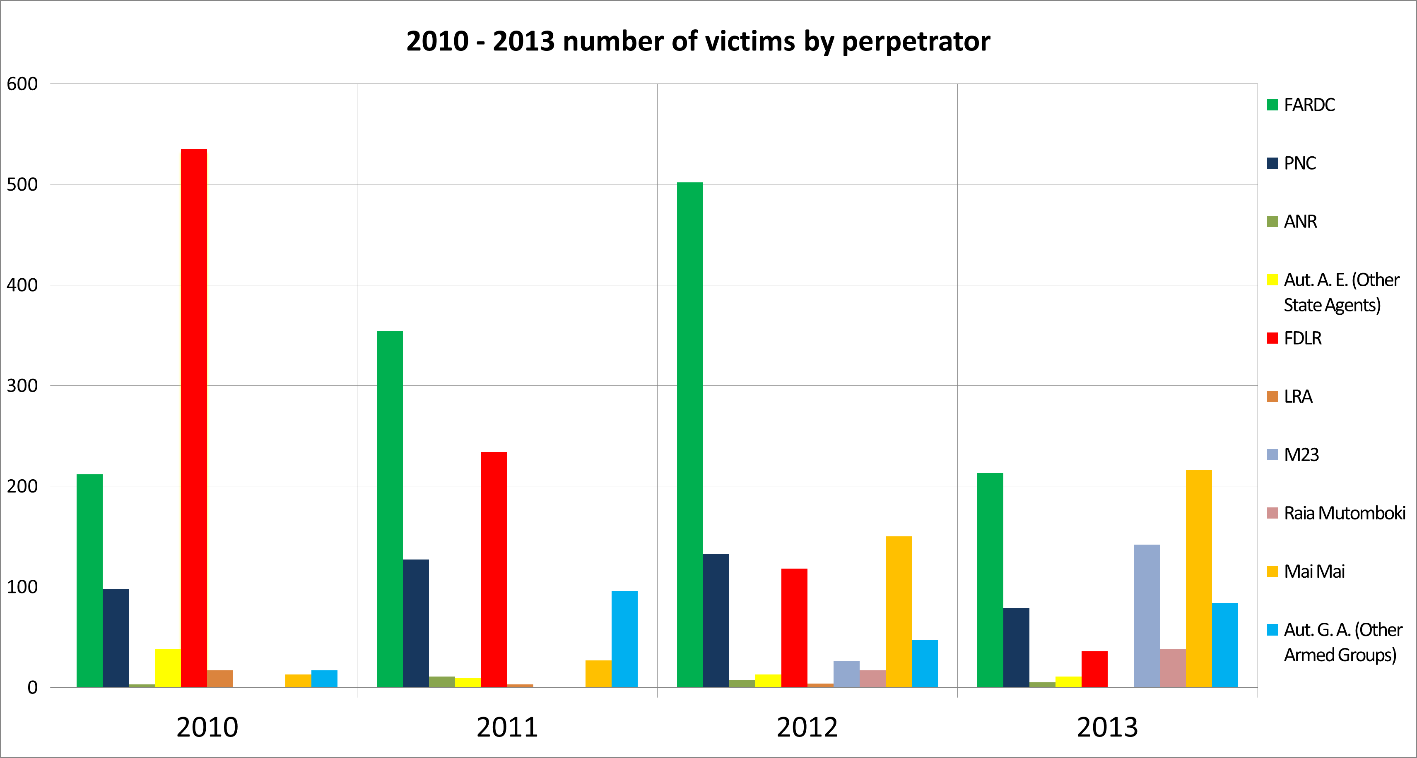
- Statistics collected by the UNJHRO from across its 18 field offices show that the incidence of sexual violence is higher in the conflict-stricken provinces of North Kivu, South Kivu and Orientale. In the past several years, the level of sexual violence in the eastern provinces has been alarming, particularly in North Kivu, where the majority of rape cases reportedly occurred. Of the 3,635 victims of sexual violence recorded by the UNJHRO from January 2010 to December 2013, 45 per cent (1,640 victims) were registered in North Kivu province.

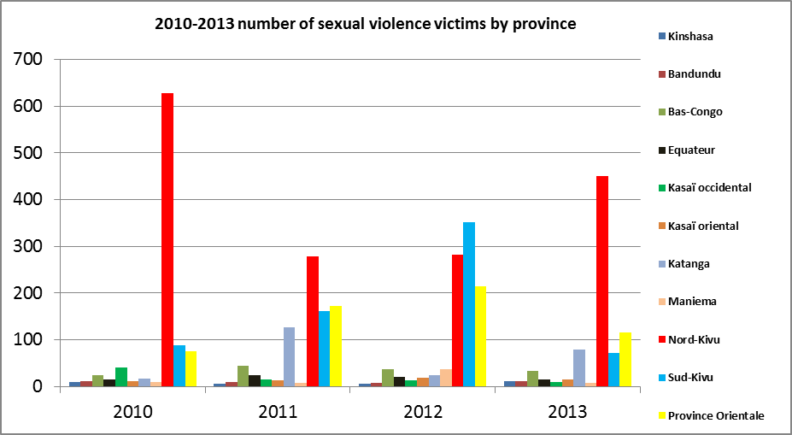

- Based on data collected by the UNJHRO, the majority of rape victims were women and girls. While much less reported, men were also victims of rape. From January 2010 to December 2013, of the 3,635 victims of sexual violence recorded, 73 per cent were women (2,648 victims), 25 per cent were children (906 victims) and 2 per cent were men (81 victims). According to information gathered by the UNJHRO, the age of the victims of sexual violence ranged from two to 80 years old.

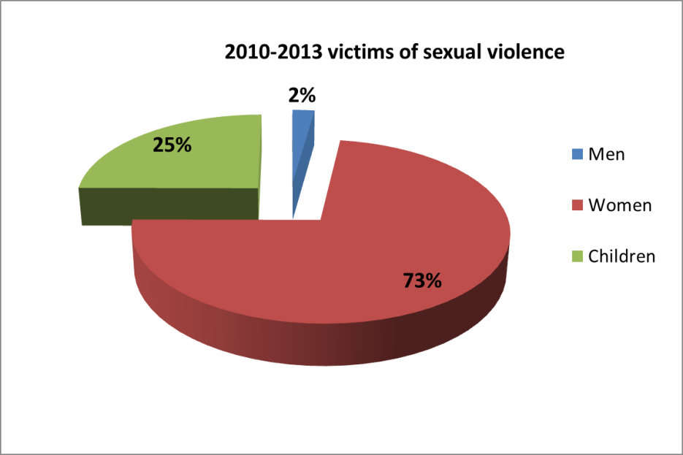

Progress in the fight against impunity for sexual violence

Recent commitments taken by the DRC Government

- In recent years, the DRC Government has made commitments to address impunity for sexual violence crimes, including through high-level engagements of President Kabila and other authorities with the Special Representative of the Secretary-General on Sexual Violence in Conflict. Of note, on 30 March 2013, the Government of the DRC and the United Nations signed a Joint Communiqué on Combating Conflict-related Sexual Violence in the DRC in which the Government expressed its commitment to ensure accountability for sexual violence crimes, including through the strengthening of the Special Police Units for the Protection of Women and Children. Other commendable efforts include the identification of high-level focal points within the Ministry of Defense to work with the United Nations and other partners to ensure appropriate prevention and response by the military; the creation by the Senate of a Special Commission on Conflict-related Sexual Violence to advocate for sexual violence prevention and response, and improve the legal frameworks where applicable; the announcement by the Head of State, during his address to the Nation on 23 October 2013, of his intention to soon appoint a Presidential Representative on Sexual Violence and Child Recruitment to lead the Government’s response and the development in July 2013 of a plan for the implementation of the Joint Communiqué, which identified a number of concrete actions to address impunity for sexual violence.

General trends on prosecutions of sexual violence

- In the absence of a systematic collection of judicial data, the UNJHRO has endeavored to document cases of prosecutions for crimes of sexual violence through its monitoring and reporting activities and the implementation of projects to provide assistance to victims of sexual violence. The UNJHRO has recorded cases of prosecutions for crimes of sexual violence within the military justice system.

- Since January 2010, the UNJHRO has observed slow but steady progress in prosecutions of crimes of sexual violence. From July 2011 to December 2013, it recorded 187 convictions by military courts for sexual violence, mostly for rape. Seventy-three per cent of the individuals convicted (136 individuals) were FARDC elements, 17 per cent (32 individuals) were PNC agents and 8 per cent (15 individuals) were other State agents. Only 2 per cent (4 individuals) of the total number of individuals convicted were members of armed groups. Sentences imposed on those convicted ranged from 10 months to 20 years of imprisonment. Most of the FARDC soldiers convicted were junior officers or low-ranking soldiers and only three of the 136 FARDC elements convicted were senior officers. However some senior FARDC officers are currently under prosecution for sexual violence, such as General Kakwavu.

- The UNJHRO works with partners on the implementation of projects to provide assistance to victims of sexual violence both within the military and the civilian jurisdictions. Based on information gathered from such projects, some progress has been observed: from July 2011 to June 2012, there were 269 judgments in cases of sexual violence and, from July 2012 to June 2013, 383 judgments were recorded in cases of sexual violence. These cases included the trial of both non-State actors and State agents alike.

- Regarding the Minova case, arrest warrants were issued in November and December 2013 against 39 FARDC soldiers including for crimes against humanity of rape. In addition, from May to July 2013, Congolese judicial authorities issued 13 arrest warrants for crimes under international law against alleged members of the Mouvement du 23 mars (M23) or their affiliates, including Jean-Marie Runiga, Brigadier General Bosco Ntaganda, Baudouin Ngaruye, Colonel Vianney Kazarama, Colonel Biyoyo, Colonel Innocent Kayina, Colonel Sabimana, Colonel Innocent Zimurinda, Colonel Ruzandiza alias "Makenga Sultani", Colonel Eric Badege, Colonel Kahasha, Colonel Bernard Byamungu and Colonel Saddam. Out of the 13 arrest warrants, at least 10 were issued for crimes against humanity, including of rape and sexual slavery. Extradition requests for four M23 elements, namely Jean-Marie Runiga and Colonels Zimurinda, Ngaruye, and Badege, were addressed to the Government of Rwanda in July 2013 after they fled into Rwanda in March 2013.

- During the period covered by the present report, many prosecutions took place through the organisation of mobile court hearings organized with the support of the United Nations and other partners. On a regular basis, judicial authorities benefited from the support of MONUSCO, including the UNJHRO, in the conduct of investigations and the organization of mobile hearings, especially in the eastern part of the country. In support to these efforts, the United Nations Team of Experts on Rule of Law and Sexual Violence in Conflict deployed a sexual violence investigations expert to support the government through Prosecutions Support Cells.

EXAMPLE:
On 1-2 January 2011, soldiers from the 43rd FARDC Sector, commanded by Lieutenant Colonel Mutuare Daniel Kibibi, attacked the town of Fizi, South Kivu province, and raped more than 50 women, in what was believed to be an act of vengeance against the civilian population following the killing of a FARDC soldier belonging to the same unit. As a result of mobile hearings held in
Baraka in February 2011, with MONUSCO technical and logistical support, as well as the support from other international and national actors, the South Kivu Military Court tried and convicted nine soldiers of the 43rd FARDC Sector for crimes against humanity, including of rape.
Of those convicted, four, including Lieutenant-colonel Kibibi Mutware, were sentenced to 20 years of imprisonment, two were sentenced to 15 years, and three were sentenced to 10 years. They are still serving their sentences to date.

Main obstacles in the fight against impunity for sexual violence

- The UNJHRO welcomes the Government’s increased efforts to prosecute members of the defense and security forces who are alleged to have committed crimes of sexual violence. However, the improvement of the political will at the highest level is not sufficiently translated on the ground.

- Despite increased efforts by Congolese authorities to arrest and try alleged perpetrators of crimes of sexual violence, many such cases never reach a court of law. Indeed, many cases are not investigated, or if they are, trials are not held, or sentences are not served by the perpetrators for various reasons, including the problem of escapes from prisons. Of particular concern is the impunity enjoyed by a number of high-ranking officers alleged to be responsible for crimes of sexual violence. Proceedings only very rarely target higher-ranking FARDC officers. In addition, when cases do make it to trial, the outcome is at times influenced by corrupt judicial officials and/or political figures. For those who are convicted and imprisoned, some manage to escape due to the dilapidated conditions and poor security in prisons across the country.

- There is also concern about the difficulties to prosecute members of armed groups. Although members of armed groups are allegedly responsible for more than half of the reported cases of sexual violence, few of them are ever arrested or prosecuted. Elements from armed groups commit crimes of sexual violence mostly in very remote areas where there is no State authority. This results in difficulties in arresting and prosecuting them. In addition, it is difficult for victims to identify perpetrators particularly if they are members of armed groups as they are often less static than State actors and establishing their affiliations and chain of command is harder for ordinary civilians. They are therefore less known by victims and harder to identify through their respective hierarchies, in contrast to perpetrators within the FARDC.

- At the same time, military judicial authorities have not systematically investigated and charged armed group leaders and their members for sexual violence. A common view expressed from prosecutors and investigators seems to be that members of armed groups are beyond the reach of justice, even in cases when they could be easily identified, charged and arrested. Military prosecutors have also expressed reservations about charging or arresting members of armed groups for sexual violence for fear that it will escalate tensions and lead to more violence.

Emblematic cases

- The following cases represent some of the most egregious incidents of sexual violence since July 2010 and highlight the lack of progress in prosecution and related actions.

Walikale case file
Date: 30 July – 2 August 2010
Alleged perpetrators: various members of armed groups
Number of victims: at least 387 persons

- Between 30 July and 2 August 2010, at least 387 people were reportedly raped by a coalition of FDLR and Mayi Mayi Sheka combatants, as well as combatants of Colonel Emmanuel Nsengiyumva (a former FARDC soldier who formed his own armed group in 2010) in 13 villages along the Mpofi-Kibua axis, Walikale territory, North Kivu province. The UNJHRO issued two public reports on these mass rapes and other human rights violations, and urged the authorities to take appropriate measures to investigate and prosecute the alleged perpetrators. MONUSCO and other partners provided support to the investigation. Only two alleged perpetrators were arrested, but one died of illness in prison while the second fled during the mass escape from Goma prison when it was occupied by the M23 in November 2012. One of the armed group leaders who allegedly planned the attack, the Mayi Mayi Sheka leader known as Sheka Ntabo Ntaberi, ran as a candidate for the National Assembly in the Walikale electoral district in November 2011 despite an outstanding warrant for his arrest, which was issued in January 2011 in connection with the crimes committed in Walikale. FDLR and Mayi Mayi Sheka combatants remain active in eastern DRC, which makes their arrest and prosecution difficult.

Bushani and Kalambahiro case file
Date: 31 December 2010 – 1 January 2011
Alleged perpetrators: FARDC soldiers
Number of victims: at least 47 persons

- On the night of 31 December 2010 and 1 January 2011, at least 46 women and one girl were reportedly victims of rape or other acts of sexual violence by a group of armed men believed to be FARDC soldiers in the villages of Bushani and Kalambahiro, Masisi territory, North Kivu province. On 22 July 2011, the UNJHRO issued a public report on the case requesting the Congolese authorities to take appropriate actions to bring the alleged perpetrators to justice. Although the Military Prosecutor’s office opened a file into the case and some FARDC soldiers were questioned, the North Kivu justice authorities had not proceeded with investigations or prosecutions of the alleged perpetrators of the crimes.

Mutongo case file
Date: 9 - 15 June 2011
Alleged perpetrators: Alliance des Patriotes pour un Congo Libre et Souverain (APCLS)
Number of victims: at least 80 persons

- Between 9 and 25 June 2011, in Mutongo and surrounding villages, Walikale territory, North Kivu province, during clashes between Mayi Mayi Sheka and APCLS combatants, at least 80 people, including 12 girls and a man, were victims of rape and other crimes of sexual violence. Other human rights violations were committed during these events. The majority of the rape cases were reportedly committed by APCLS combatants who targeted Mutongo villagers in the forest after they had fled the fighting. Many of the victims were gang raped by two to five combatants and were reportedly targeted for belonging to the Nyanga ethnicity (the ethnicity of the Mayi Mayi Sheka group). The UNJHRO shared the findings of the investigation with military justice authorities and supported them in conducting investigations. After more than two years since the incident, no progress has been registered in the investigations. However, in September 2013, an arrest warrant was issued by the military prosecutor in North Kivu against the leader of the APCLS group, “General” Janvier Buingo Karairi, for crimes against humanity, including of rape and murder. APCLS combatants remain active in eastern DRC, which makes their arrest and prosecution difficult.

Minova case file
Date: 15 November – 2 December 2012
Alleged perpetrators: FARDC soldiers
Number of victims: at least 135 persons

- Between 15 November and 2 December 2012, serious violations of human rights and of international humanitarian law, including mass rape, were allegedly committed by FARDC soldiers as they were retreating from the front lines and regrouping in and around the town of Minova, Kalehe territory, South Kivu province, following fighting with M23 combatants and their occupation of Goma and Sake, North Kivu. In this context, at least 102 women and 33 girls were reportedly victims of rape or other acts of sexual violence. On 20 November 2013, in Goma, the Operational Military Court (CMO) of North Kivu held its first hearing in the Minova case. Thirty-nine FARDC elements, including seven senior officers, are accused of crimes against humanity and war crimes of rape, as well as other crimes and military offences. The trial is ongoing despite some delays due to lack of military judicial personnel.

Cases of the five senior officers accused of crimes of sexual violence and other human rights violations

- In May 2009, a Security Council delegation visiting the DRC requested President Kabila to take decisive action against impunity for sexual violence in the DRC, including sexual violence committed by State agents. In this context, the delegation handed over a list of five senior FARDC officers accused of sexual violence, including mass rape, and other serious human rights violations to the DRC Government. Two cases were already closed as one officer was acquitted (Colonel Safari Kizungu) and another officer died (Lieutenant-Colonel Papy, alias Pitchen). The UNJHRO has been advocating with judicial authorities to complete the investigations and conclude the trials in two of the cases, which have been ongoing for several years without any resolution. After a period of stagnation, some progress was made in the trial of General Kakwavu, accused of war crimes and crimes against humanity, with a field visit undertaken by judicial authorities in Ituri, from 18 November to 5 December 2013, to hear and examine witnesses and victims. His trial is ongoing. Lieutenant Colonel Bedi Mobuli Engangela (alias Colonel 106), accused of war crimes and crimes against humanity, was transferred on 2 April 2013 from Kinshasa to Bukavu prison. The Military Court of South Kivu is in the process of completing the investigation phase, and mobile court hearings are expected to take place, with MONUSCO support, during 2014. No arrest warrant or charges have been filed against Colonel J.C. Mosala and his whereabouts are reportedly unknown. Troops under his command allegedly committed serious human rights violations such as summary executions, mass rape and torture and other cruel, inhuman or degrading treatment.

Shortcomings in the fight against impunity for sexual violence

- Concerns remain about shortcomings in the conduct of thorough investigations into all cases of sexual violence and in the prosecutions of FARDC elements, including the most senior officers. The severe lack of resources and human capacity in the judicial system exacerbates impunity and other obstacles in the fight against impunity include the stigmatization of victims and their reluctance to pursue justice in the courts. Many victims prefer to resort to out-of-court settlements, which tend to be perpetrator-centered and generally ignore the needs of the victim. Moreover, many victims cannot afford the cost of legal fees and travel costs associated with formal legal proceedings. In cases where victims obtain legal victories, they do not receive the reparations which perpetrators and the State have been ordered to pay. Finally, most victims of rape lack access to critically important healthcare and psycho-social care, which are often necessary in order for a victim to be issued necessary medical reports to pursue her case in the judicial system.

Limited efforts of some Congolese authorities

- Tremendous delays observed from some military prosecutors and judges to arrest and prosecute suspects are one of the main reasons for the prevalent culture of impunity for sexual violence in the DRC. The UNJHRO has conducted human rights investigations into several cases of mass rape committed by security forces and armed groups, and has offered technical and logistical support to judicial authorities to take action in such cases. However, little progress has been registered in that regard. For example, investigations have been stalled concerning mass rapes committed in Bushani and Kalambahiro by alleged FARDC soldiers and in Walikale by members of armed groups. In these particular cases, few, if any, arrests have taken place and judicial authorities have not conducted thorough investigations.

- In some instances, Congolese authorities interfere in cases, or shield alleged perpetrators from prosecution. In addition, military prosecutors often fail to examine the culpability and command responsibility of superior officers when members of their unit commit acts of sexual violence during a military operation. In other cases, military and police commanders shield those under their command from prosecution and refuse to hand over the accused perpetrators to military justice officials. For example, in the case of the rapes reportedly committed by FARDC soldiers in Bushani and Kalambahiro, the UNJHRO has observed that the prosecution of the alleged perpetrators has been blocked for various reasons, including the lack of cooperation of the FARDC hierarchy. In addition, while some FARDC soldiers are facing trial for the rapes perpetrated in Minova in November 2012, the FARDC hierarchy was initially reluctant to hand them over to justice authorities, as they were allegedly needed in on-going critical military operations. There have also been instances where the military command specifically enjoins military prosecutors to desist from, or discontinue investigations against members of armed groups.

EXAMPLE:
Before March 2013, when General Bosco Ntaganda was handed over to the ICC, Government authorities had ignored the ICC requests to assist in his arrest, arguing that it would further exacerbate tensions in the east and constitute an obstacle to any peace deals.

- Challenges to thoroughly investigate crimes of sexual violence and timely prosecute perpetrators of these crimes can be explained by various factors. Firstly, it should be noted that, when the political transition began in 2003, Congolese national defense and security forces were constituted largely from former armed group elements with some commanders having de facto parallel structures within the army. Irrespective of the central hierarchy, officers have been able to protect their protégés from investigations. Secondly, judicial authorities have at times failed to take action against specific actors integrated into the army for their own safety, or on the grounds that this could push them back into armed group activity. A more problematic issue is the lack of independence of the military justice system, which has exclusive jurisdiction to prosecute members of the army, the police and of armed groups. It is structured in such a way that it sits within and reports to the military’s overall hierarchy, upon which it depends for resources and to obtain cooperation to conduct its work. The subservient relationship between the military justice system and the military hierarchy strains the will and independence of military judicial authorities to investigate, arrest and prosecute FARDC soldiers.

Challenges within the judicial system and the legal framework

Legal restrictions in conducting prosecutions, especially against officers, in the military justice system

- The jurisdiction of military courts in the DRC is not limited to offenses of a strictly military nature committed by military personnel. Under the 2006 Constitution, FARDC and PNC agents accused of having committed criminal offences are to be tried by military courts. This means that all soldiers in the DRC are tried by the military justice for any criminal offense they may have committed, even if off-duty and unconnected to their military service. Rape, like many other human rights violations, is not an offence specific to military law. However, the DRC rules of exclusive jurisdiction mean that, irrespective of how unconnected the circumstances of the offence are to military service, only military courts can try soldiers. The military justice system is thus over-burdened with a backlog of cases and insufficient resources to deal with all the cases under its competence. The DRC has also not yet established a mechanism, separate from the military justice system, with jurisdiction to try soldiers or members of armed groups who commit acts of rape amounting to war crimes or crimes against humanity.

- The jurisdiction of the various military courts also depends on the rank of the accused. In the first instance, military garrison tribunals may only prosecute soldiers up to the rank of captain and the highest ranking officers (generals) may only be tried by the High Military Court. Furthermore, judges and military prosecutors participating in court proceedings must be of an equal or higher rank than the soldier facing justice. As a result, a lack of investigations may arise from the fact that some military justice authorities are not in a position to investigate and sit in judgment over higher-ranking officers. As a consequence, some of the highest-ranking officers may benefit from de facto immunity from prosecution because of the lack of military magistrates of equal or superior ranks. While it is possible for military justice personnel to be “commissioned” to a higher rank to resolve this structural issue, this temporary solution depends on the will of the authorities and, in some instances, of the President of the DRC himself to commission judges to the rank of general. However, it should be noted that nominations of new magistrates in 2013, including at the senior level, might partially improve the situation.

Lack of resources and capacity in the judicial system

- The fight against impunity for sexual violence requires law enforcement institutions with sufficient resources and capacity and, in this regard, the UNJHRO has observed many deficiencies within the judicial system. The lack of infrastructure and resources within the military jurisdictions presents a major obstacle to holding alleged perpetrators of sexual violence accountable. The judicial system has an insufficient number of magistrates and infrastructure to cover the vast territory of the DRC, although, during the period covered by this report, a significant number of magistrates were deployed to the field and a large number of judicial infrastructures were constructed. Judicial authorities are poorly paid and many districts remain without courts and/or judicial authorities. In addition, in most regions, there are no designated juvenile courts, although cases of sexual violence involve defendants who must be tried in a juvenile court. Judicial infrastructure is generally in poor condition and lacks adequate equipment. For example, most courts lack computers and electricity for archiving files, which forces them to resort to paper filing. Consequently, files can be easily lost or stolen, as in November 2012, when legal files were burned and/or destroyed by M23 combatants in the tribunals and courts in Goma, North Kivu, when they took control of this area.

- Furthermore, prosecutors and magistrates often lack the financial and operational means to properly conduct investigations and to interview victims and witness of crimes of sexual violence, and thus often rely on support provided by international partners, such as the United Nations and international NGOs. Some judicial authorities lack knowledge of the 2006 laws on sexual violence and also lack training or specialized skills for the prosecution of sexual violence crimes. The United Nations and partners have been conducting trainings for judicial authorities on how to handle sexual violence cases in an effort to fill such gap.

EXAMPLE:
In February 2013, the UNJHRO, through its field offices, conducted a survey to assess the resources available to military judicial authorities, especially on means of transport available to judicial investigators to conduct investigations and interview victims and witnesses. Out of the seven provinces covered in the survey, comprising a total of 46 military prosecutor offices, only
one office had a motorcycle in functioning order, four offices had motorcycles in poor working order, while the other 41 military prosecutor offices had no dedicated means of transport or mobility.

Prison escapes

- Due to the dire state of disrepair of prisons and poor security, escapes, including mass break-outs, are frequent throughout the DRC. Some of the prison escapes are organized in collusion with prison officials, who are sometimes bribed for the release of inmates. Among escapees, there are individuals who were held in pre-trial detention for, and those convicted for crimes of sexual violence. For example, in September 2011, in Lubumbashi, Katanga province, 967 prisoners, mostly civilians, escaped from Kasapa prison following an attack on the prison by armed men. Amongst those who escaped, 271 had been detained in connection with crimes of sexual violence, including 116 who had been convicted for rape and sentenced to prison terms ranging from 5 to 20 years. In another example, during the night of 21 to 22 September 2013, a lieutenant colonel of the FARDC, Félix Djela alias Bravo Tango, escaped with another military inmate from Bukavu central prison by climbing the wall after cutting down the railings of his window cell. He had been sentenced, following a mobile court hearing in Uvira, South Kivu province, to life in prison for acts that were found to amount to serious human rights violations, including murder and rape. Given its scale, the phenomenon of prison escapes constitutes a serious obstacle to justice and contributes to the persistence of impunity throughout the country.

Constraints in victims’ access to justice

Frequent recourse to out-of-court settlements by victims and perpetrators

- In many regions in the DRC, many cases of sexual violence are mediated in out-of-court settlements which are often perceived as being more effective than any formal type of judicial proceedings. However, such mechanisms are not victim-centered. In many cases of sexual violence, families of the victim, PNC agents and judicial authorities encourage the victim to settle the case with the perpetrator, even cases where the perpetrator is a State agent. In this scenario, it is usually the head of the victim’s family and the head of the alleged perpetrator’s family who lead the settlement, leaving the victim outside of the process. Such settlements usually involve payment by the family of the perpetrator to the family of the victim, generally in cash or in kind contribution. In some cases, the victim can get an offer of marriage by the perpetrator, considered as a form of compensation as she would otherwise be considered unmarriageable due to stigmatization. Forced marriage between the victim and the alleged perpetrator is an additional violation of the victim’s fundamental rights. The victim may be pressured into such an agreement to satisfy her family or may be persuaded by economic concerns to accept monetary payment by the perpetrator.

EXAMPLE:
In 2013, a UNJHRO legal clinic partner in South Kivu received a case involving a girl who was raped by a civilian. After an interview with the family of the victim, the victim’s lawyer filed a complaint. However, the day the victim was supposed to give her testimony to the police, her father informed the lawyer that she wished to withdraw her complaint because the perpetrator had agreed to give her a cow. The family noted that the procedure for justice would take a lot of

time, that it did not expect to receive anything, and therefore that this immediate arrangement would be better than any remedy the court could allocate. The legal clinic wanted to advocate for the continuation of the case, but learned that the settlement was facilitated by the police investigator of the prosecutor’s office. The case was closed and the parties agreed to the out-of-court settlement.

Economic and logistical constraints for victims to get access to courts

- Many victims of crimes of sexual violence are not able to access justice due to prohibitive financial constraints and cannot afford to leave their income-generating activities during the time required for the legal procedures. Indeed, if a victim decides to file a complaint and pursue justice in court, she must pay for various costs and fees, including court fees, transport costs, medical requisitions and the costs associated with staying in the city where the court is located to attend the hearings. Travel costs can be high in a country where the majority of the population lives on less than one dollar a day. Courts outside the main cities are few and far between. If, despite the problem of distance, victims take it upon themselves to travel to a location where there is a court and file a complaint, delays in the process generally discourage them from returning to the court periodically, with no assurance that the alleged perpetrator or witnesses will appear for the hearing, nor any assurance of the court’s readiness to hear the case.

- In addition, most victims of sexual violence cannot afford to pay a lawyer and must rely on the assistance provided by legal clinics or NGOs providing pro-bono legal assistance. Such programmes, however, are unable to meet the demands of all those who need legal assistance. Furthermore, NGOs and other organizations which provide legal assistance are located in town centres and cannot provide service to clients in remote areas. As an example, in Walikale territory, North Kivu province, an area where there is an especially high rate of sexual violence, there are no legal clinics available to victims.

EXAMPLE:
In the Kivus, many victims are forced to travel long distance to access legal services. In one case in 2013, three girls who were victims of sexual violence walked to a small town where there was a legal clinic. They were forced to stay in makeshift housing pending the resolution of their case. One girl developed a severe medical problem as a result of the sexual assault and had to stay at the medical clinic in town. Their case has been put on hold because the alleged perpetrators,
members of an armed group, fled to the forest.

Lack of protection mechanisms for victims and witnesses

- In the DRC, there is no comprehensive protection programme for victims and witnesses established under national law, and there is no specific unit working on this issue in the judicial system. Furthermore there is no legal provision criminalizing intimidation and threats against victims. Congolese law only stipulates that judges have wide discretionary power to take action to protect victims and witnesses in sexual violence cases. Article 74 bis of the Sexual Violence law requires judges to take all necessary measures to ensure the safety, physical and mental well-being, as well as the privacy and dignity of victims or any other persons involved in the trial. However, the UNJHRO has found that judges have been often unwilling to take even very basic measures to protect victims and witnesses, such as removing the names of victims from depositions. As an example, judges often read out the names of victims in court. Lastly, judges rarely allow for closed hearings when victims feel threatened. The government has acknowledged the need to establish protection mechanisms for victims, witnesses and justice officials, and has made this as a key commitment in the Joint Communiqué. In this regard, the government has requested the United Nations Team of Experts on Rule of Law and Sexual Violence in Conflict to help national efforts towards the establishment of mechanisms for the protection of victims, witnesses as well as judges and other actors working on the issue of sexual violence.

The stigmatization of victims of sexual violence

- The stigma placed on rape victims, rather than on perpetrators, is undeniably one of the main factors for the persistence of widespread impunity. Social stigma is one of the principal barriers for victims to seek access to justice. Due to the stigma associated with rape, victims are often ostracized by their own husbands, families and communities. As a consequence, in many cases in the DRC, victims of crimes of sexual violence prefer to stay silent to avoid further victimization, humiliation, banishment, social incrimination, or withdrawal of economic support. Shifting the stigma from the victims to the perpetrators would have a huge impact on the ability of victims to reclaim their dignity and rebuild their lives. Efforts by UN agencies and other partners at behavior change in this regard have so far been insufficient.

EXAMPLE:
From June 2012 to July 2013, with the financial support of the Government of Brazil, the UNJHRO provided assistance, including economic and psycho-social assistance, to 39 women in South Kivu province who had been abandoned by their husbands and expelled from their homes
after being raped.

Lack of comprehensive medical and psychosocial support and lack of reparations for the victims

- Victims of sexual violence are especially in need of urgent medical care within 72 hours of rape to prevent possible consequences, such as unwanted pregnancy and exposure to HIV. However the majority of rape victims in the DRC do not have access to medical or psycho-social care. The Government of the DRC has not allocated adequate financial resources to the health care system for that purpose despite the scale of the issue. As a consequence, national and provincial public institutions lack sufficient personnel, financial resources, medical equipment, and medicines to provide care and assistance to victims. Furthermore, medical doctors lack training on how to conduct medical examinations on rape victims and collect medical evidence of sexual violence. This is particularly important given that medical examinations must preferably take place within the first few days after the rape in order to produce medical evidence as an important complement in support of legal proceedings. Without medical evidence, trials often rely solely on the testimony of the victims. Medical ethics are sometimes undermined in the judicial process as confidential medical data have sometimes been disclosed without the victim’s consent or have been seized by prosecutors. In other instances, prosecutors face challenges to subpoena medical service providers to produce medical evidence in court due to lack of procedural clarity. Additionally, victims have noted that the referral and counter-referral procedures between legal, medical, and psycho-social services are not always clear, leading some to give up on the process all together.

- In the DRC, victims of crimes of sexual violence have largely been denied their right to compensation and redress provided for by international human rights law. The Government has thus far not established a reparations fund for victims of crimes of sexual violence despite many recommendations issued in that respect by United Nations human rights mechanisms. Although the Ministry of Justice and Human Rights has drafted a law for the creation of such a fund in 2009, it has not yet been introduced to Parliament.

Security and logistical challenges

- Lack of security and logistical challenges in many districts throughout the country are obstacles to the fight against impunity for sexual violence. Poor security conditions affect whether victims can access courts and whether mobile court hearings can be organized in the area. This situation is notable of concern in Ituri district, where armed groups make road travel dangerous, and frequently-impose unofficial “taxes” in insecure zones, making road transport more expensive. Similarly, magistrates and investigators cannot be deployed to insecure areas where many violations have been committed.

Conclusions and recommendations

- In the DRC, crimes of sexual violence continue to be perpetrated by various armed groups, as well as by members of the army and the police. Such acts are punishable both under Congolese national law and international law, and the Government of the DRC has an obligation to investigate and prosecute all cases involving crimes of sexual violence. In the past decade, the Congolese authorities and the international community have increasingly given greater priority to the fight against impunity for sexual violence. However, progress has remained limited, and impunity continues to prevail. Many cases are not investigated or prosecuted due to various obstacles identified in this report, including the limited efforts of some Congolese authorities to prosecute crimes of sexual violence, infrastructural challenges and difficulties to prosecute crimes committed by armed groups. The number of proceedings remains low compared to the scale of the issue. Very few high-ranking officials have been held accountable, and very few members of armed groups have been punished for sexual violence crimes. The general deficiencies within the judicial system itself, including the lack of resources and capacity, also contribute to impunity for sexual violence. Additionally, the problem of prison escapes throughout the country exacerbates impunity for sexual violence in the DRC.

- In order to combat the impunity for crimes of sexual violence, the UNJHRO urges:

A. The Congolese authorities:

- To address the root causes of sexual violence, including by eliminating stereotypes and harmful practices that discriminate against women, conducting gender-sensitive training and adopting codes of conduct for the police and the military;

- To prioritize the fight against impunity for crimes of sexual violence in conflict-affected areas, promptly complete effective and independent investigations into such crimes, especially those committed by the Congolese army and armed groups, and prosecute the alleged perpetrators of such acts, including those responsible as commanders or superiors under the principle of command responsibility;

- To provide the justice system with more adequate human and financial resources, particularly to allow its officials to independently conduct investigations and prosecute alleged perpetrators;

- To accelerate reforms to create and empower specialized mixed chambers to prosecute the perpetrators of the worst human rights violations, including members of the security and defense forces or armed groups who commit acts of sexual violence amounting to war crimes or crimes against humanity;

- To ensure that all victims of sexual violence have access to courts and tribunals, and in particular:

- Provide free legal aid to victims of sexual violence;
- Strengthen anti-corruption mechanisms in order to enhance victims’ confidence in the judiciary system, including by an increase in the pay of judicial personnel;
- Raise awareness among victims concerning the laws governing crimes of sexual violence, and encourage them to file complaints rather than opting for mediation;
- Conduct awareness-raising campaigns to eliminate stigmatization of victims of sexual violence;
- Provide training to judges, prosecutors and lawyers on the application of legislation prohibiting discrimination and sexual violence;
- Support NGOs facilitating victims’ access to justice;

- To adopt, without delay, a law on the protection of victims and witnesses, including a specific provision criminalizing threats or intimidations of victims involved in judicial proceedings;

- To establish, as a matter of priority, a fund to support reparations for victims of sexual violence crimes, the governance of which could include representatives of the government, civil society, and survivors themselves to best ensure accountability for the allocation of funding and the expenditure of funds;

- To ensure access of victims to comprehensive medical treatment, mental health care and psychosocial support provided by health professionals who are trained to detect signs of sexual violence and to treat its consequences and ensure that victims are provided with medico-legal forms free of cost;

- To ensure that medical ethics and legal norms relating to the prosecution of cases of sexual violence are upheld at all times and the choices of the survivors are respected, including the release of personal data for judicial purposes;

- To develop a plan to ensure that judgments are executed, and to pursue those responsible for paying damages awarded to victims, including elements from the military and the police where applicable, or the State, in the case of indigence of the perpetrator and to prosecute those who are responsible to pay reparations to the victims;

- To implement the commitments contained in the Joint Communiqué signed with the United Nations in March 2013 on the occasion of the visit by the Special Representative on Sexual Violence in Conflict and continue to cooperate with the Team of Experts on the Rule of Law and Sexual Violence in order to strengthen the legal and institutional framework to ensure accountability for sexual violence;

B. The international community:

- To support DRC’s efforts to strengthen the justice system, including through capacity building activities for judges and prosecutors;

- To support the development and improvement of the justice infrastructure, including police stations, court rooms and prisons;

- To contribute to bridging the logistical constraints faced by officials in the justice system to enable them to promptly respond to crimes of sexual violence;

- To strengthen support to structural reforms of the legal system and to support and participate in the creation and distribution of a reparations fund;

- To continue supporting judicial investigations and mobile hearings and strengthening initiatives in support to victims of sexual violence through programmes that provide for free legal assistance, medical and psycho-social support to victims;

- To support the government in the materialization of the implementation plan of the Joint Communiqué on addressing sexual violence;

- To provide the necessary support to mechanisms established by the DRC Government to contribute to the fight against impunity, including the Special Commission on Conflict-related Sexual Violence of the Senate.

ANNEX: REACTION OF THE MINISTER OF JUSTICE AND HUMAN RIGHTS

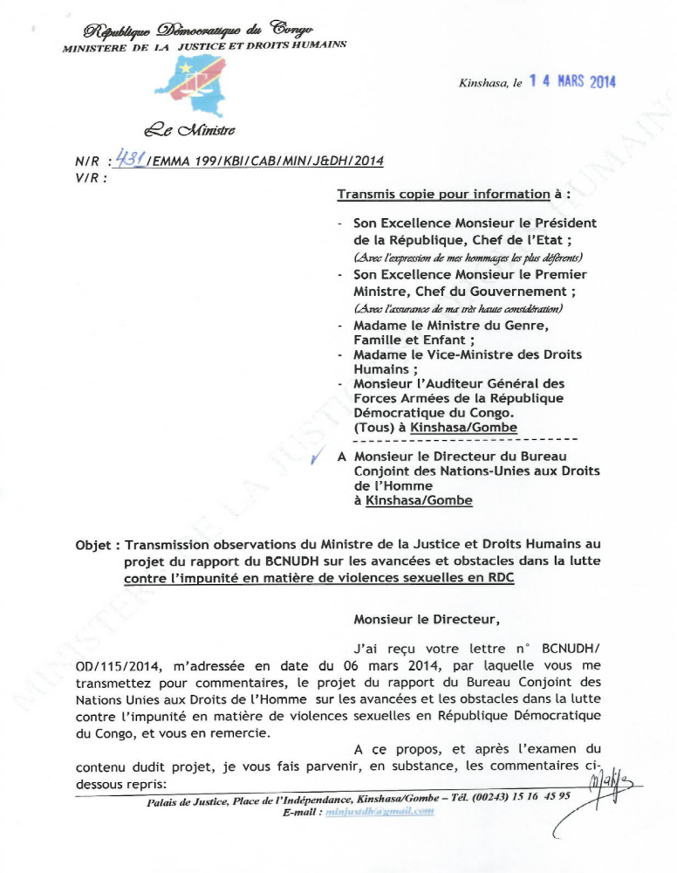
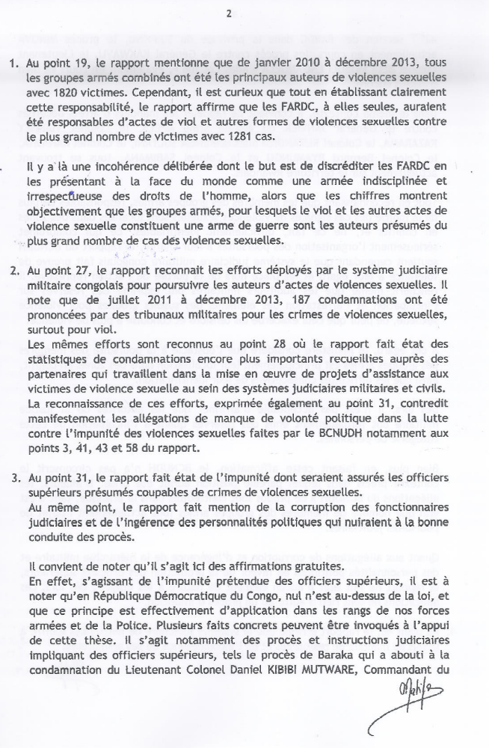
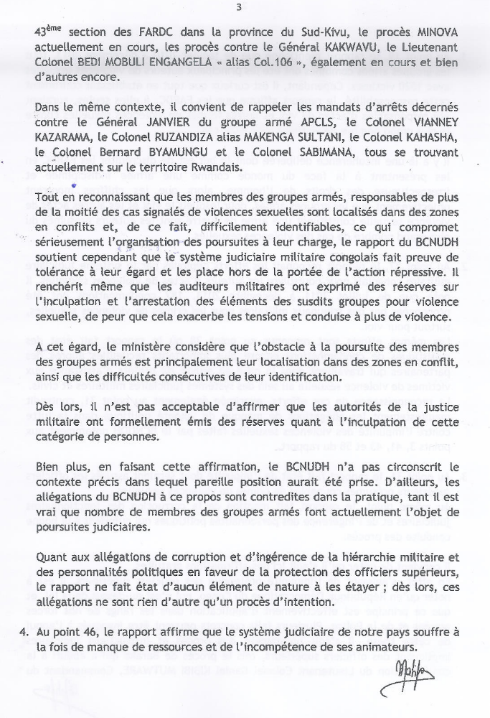
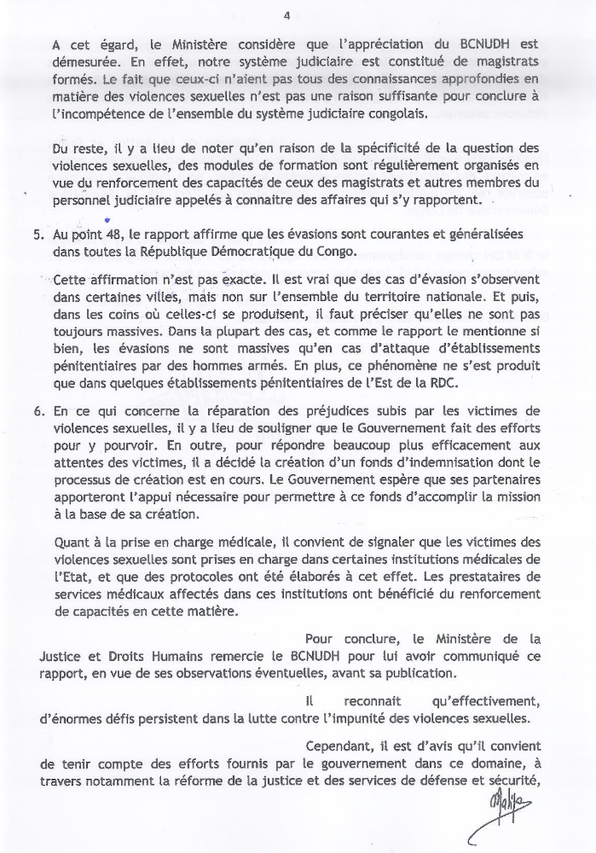
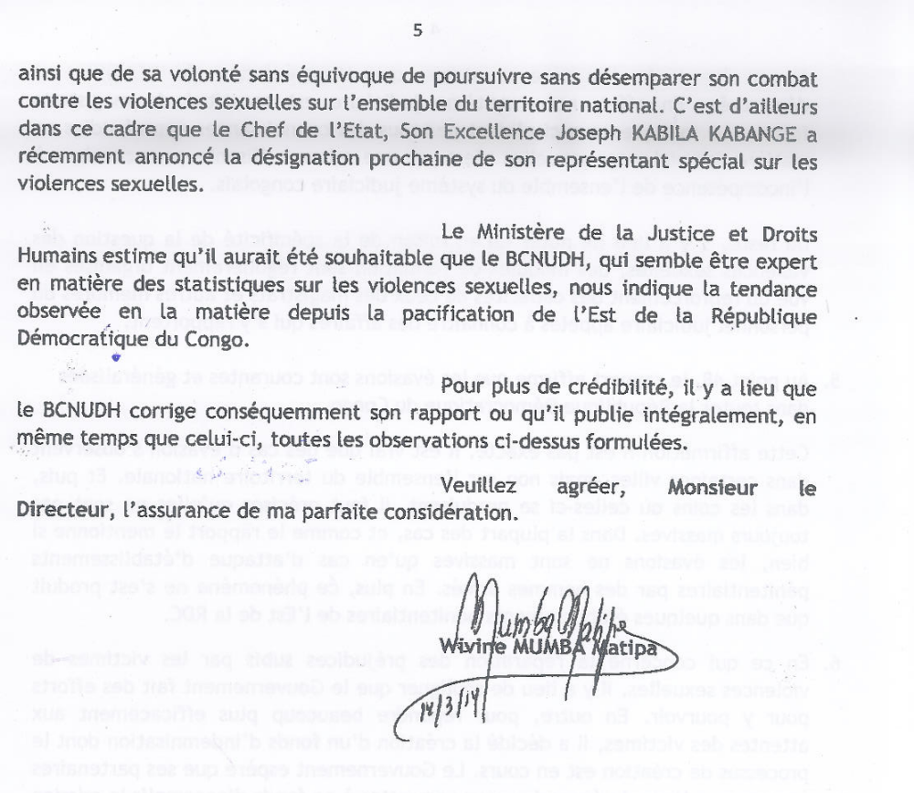

Office of the High Commissioner for Human Rights (OHCHR), Report of the Panel on Remedies and Reparations for Victims of Sexual Violence in the Democratic Republic of Congo to the High Commissioner of Human Rights, March 2011, para. 142.
See Report of the Secretary-General on conflict-related sexual violence, 13 January 2012, A/66/657*-S/2012/33*, page 32, and Report of the Secretary-General on conflict-related sexual violence, 14 March 2013, A/67/792-S/2013/149, pages 31 and 32.
Resolution adopted by the Human Rights Council, Technical assistance and capacity-building for human rights in the Democratic Republic of the Congo, 24th Session, 24 September 2013, A/HRC/24/L.9, para. 7
Ibid., para. 15.
It is however important to note that the State can bear responsibility for sexual violence committed by civilians under its obligation to protect and fulfill human rights.
In June 2013, the Ministry of Gender, Family, and Children published a report with the support of the UNFPA on the extent of sexual violence in the DRC. The report indicated that, in 2011 and 2012, 26,339 incidents of gender based violence were recorded in seven provinces. See Joint report by UNFPA and the Ministry of Gender, Family, and Children of the DRC, Ampleur des violences sexuelles en RDC et actions de lutte contre le phénomène de 2011 à 2012.
Article 2 of the ICCPR protects women’s right to be free from discrimination based on sex and Article 7 of the ICCPR prohibits torture and other cruel, inhuman or degrading treatment.
Article 2 of the ICESCR protects women’s right to be free from discrimination.
Article 2 of the Convention against Torture obligates States to effective legislative, administrative, judicial or other measures to prevent acts of torture in any territory under its jurisdiction; Article 16 obligates States to prevent in any territory under its jurisdiction other acts of cruel, inhuman or degrading treatment or punishment which do not amount to torture
Article 1 of the Convention on Elimination of All Forms of Discrimination against Women prohibits any distinction, exclusion or restriction made on the basis of sex which has the effect or purpose of impairing or nullifying the recognition, enjoyment or exercise by women, irrespective of their marital status, on a basis of equality of men and women, of human rights and fundamental freedoms in the political, economic, social, cultural, civil or any other field.
Article 34 of the Convention on the Rights of the Child protects children from all forms of sexual exploitation and sexual abuse; Article 37 provides for the right to freedom from torture or other cruel, inhuman or degrading treatment or punishment and guarantees the right to liberty and security of person.
Article 18 of the African [Banjul] Charter on Human and Peoples' Rights, adopted June 27, 1981, Organization of African Unity Doc. CAB/LEG/67/3 rev. 5. Congo ratified the charter on 20 July 1987.
Ibid. Article 5.
See also the Protocol to the African Charter on Human and Peoples’ Rights on the Rights of Women, Maputo, 11 July 2013 and the ICGLR Protocol on the Prevention and Suppression of Sexual Violence Against Women and Children (adopted in Nairobi in December 2006) which contains a comprehensive set of measures for tackling sexual violence in the region, from prosecution to compensation, and expands the range of acts which can form the subject of criminal penalty in international and national law.
See the four Geneva Conventions of 1949 and the two 1977 Additional Protocols to the Geneva Conventions (Protocols I & II). The DRC ratified the 1949 Geneva Conventions in 1961, Protocol I in 1982, and Protocol II in 2002.
Article 3(1)(a) of Common article 3.
Article 3(1)(c) of Common article 3.
Article 4(2)(e) of Additional Protocol II to the Geneva Conventions relating to the Protection of Victims of Non-International Armed Conflicts.
The Rome Statute provides in its Article 7 that, when committed as part of a widespread or systematic attack directed against any civilian population,“ rape, sexual slavery, enforced prostitution, forced pregnancy, enforced sterilization, or any other form of sexual violence of comparable gravity” constitute crimes against humanity. Where there is no evidence of a widespread or systematic attack directed against a civilian population, rape may still be characterized a war crime under Article 8 of the Rome Statute. In the context of an international armed conflict, Article 8 defines war crimes as including the commission of “rape, sexual slavery, enforced prostitution, forced pregnancy […], enforced sterilization, or any other form of sexual violence also constituting a grave breach of the Geneva Conventions.”? In the context of “an armed conflict not of an international character”, Article 8 defines war crimes as including the commission of “rape, sexual slavery, enforced prostitution, forced pregnancy […], enforced sterilization, and any other form of sexual violence also constituting a serious violation of article 3 common to the four Geneva Conventions.”
The Rome Statute of the International Criminal Court has not been incorporated in the Congolese national legislation to date.
CEDAW/C/COD/CO/6-7, 23 July 2013, para. 10(b).
General recommendation No. 30 on women in conflict prevention, conflict and post-conflict situations, CEDAW/C/GC/30, 1 November 2013, para 38(b).
Loi n° 06/018 du 20 juillet 2006 modifiant et complétant le Décret du 30 janvier 1940 portant Code pénal congolais and Loi n° 06/19 du 20 juillet 2006 modifiant et complétant le Décret du 06 août 1959 portant Code de procédure pénale congolais.
Article 170 of the Loi n° 06/018 du 20 juillet 2006 modifiant et complétant le Décret du 30 janvier 1940 portant Code pénal congolais.
Article 170 of the Loi No 001/2009 du 10 janvier 2009 portant protection de l'enfant.
Article 156 of the DRC Constitution, Kinshasa, February 2006.
Article 15 of the DRC Constitution, Kinshasa, February 2006.
Most cases of sexual violence documented in this report are cases of rape.
It has to be underlined that most armed groups commit human rights violations, including rape, in very remote areas leading to under-reporting the number of the rape cases by such groups of perpetrators.
See Final report of the fact-finding missions of the United Nations Joint Human Rights Office into the mass rapes and other human rights violations committed by a coalition of armed groups along the Kibua-Mpofi axis in Walikale territory, North Kivu, from 30 July to 2 August 2010, released on 6 July 2011.
See Report of the United Nations Joint Human Rights Office on human rights violations perpetrated by soldiers of the Congolese Armed Forces and combatants of the M23 in Goma and Sake, North Kivu province, and in and around Minova, South Kivu province, from 15 November to 2 December 2012, released on 8 May 2013.
The UNJHRO started the compilation of data on prosecutions of sexual violence by judicial authorities in July 2011.
See paragraph 41 of the report.
Such projects include legal assistance programmes, support to the judiciary for investigations and mobile court hearings, training of judges, magistrates, and forensic medicine experts, as well as community awareness events. UNJHRO partners also provide holistic care for victims of sexual violence, including safe houses, psychological care, medical care, and training on income-generating activities. Such projects operate in nine provinces throughout the DRC. They have been and will be funded with the assistance of the Governments of Brazil, Canada, the United Kingdom and Sweden.
In November 2012, after the M23 took over Goma, FARDC soldiers retreated to Minova in South Kivu province, where they committed mass rape and other human rights violations over a period of 10 days.
Among these partners: American Bar Association (ABA), Avocats Sans Frontières (ASF) and local NGOS.
See Final report of the fact-finding missions of the United Nations Joint Human Rights Office into the mass rapes and other human rights violations committed by a coalition of armed groups along the Kibua-Mpofi axis in Walikale territory, North Kivu, from 30 July to 2 August 2010, released on 6 July 2011; see also Preliminary report of the fact-finding mission of the United Nations Joint Human Rights Office into mass rapes and other human rights violations by a coalition of armed groups along the Kibua-Mpofi road in Walkikale, North Kivu, from 30 July to 2 August 2010, released on 24 September 2010.
Human Rights Watch, “DR Congo: Arrest Candidate Wanted for Mass Rape”, 2 November 2011, http://www.hrw.org/news/2011/11/02/dr-congo-arrest-candidate-wanted-mass-rape.
See Report of the investigation missions of the United Nations Joint Human Rights Office into the mass rapes and other human rights violations committed in the villages of Bushani and Kalambahiro, in Masisi territory, North Kivu, on 31 December 2010 and 1 January 2011, released on 22 July 2011.
From 26 to 30 September 2011, the UNJHRO supported the deployment of six military investigators from the Military prosecutor’s office of North Kivu to Pinga. National and international NGOs participated in the mission and provided legal and psycho-social assistance to the victims.
See Report of the United Nations Joint Human Rights Office on human rights violations perpetrated by soldiers of the Congolese Armed Forces and combatants of the M23 in Goma and Sake, North Kivu province, and in and around Minova, South Kivu province, from 15 November to 2 December 2012, released on 8 May 2013.
The UNJHRO has some concerns as the procedures in force in front of the CMO do not respect international standards since they do not respect the right to a fair trial, including the right to appeal.
See paragraph 38 of the present report.
See paragraph 37 of the present report.
See paragraphs 37 to 41 of the present report.
See paragraph 38 of the present report
See paragraph 40 of the present report.
It should be noted that, in many countries, military justice is increasingly being made independent of the military command in order to ensure its independence and free reign to prosecute soldiers.
Article 156 of the DRC Constitution, Kinshasa, February 2006.
Some 400 military magistrates (approx. 140 judges and 260 prosecutors) who staff 50 military courts and a number of secondary military justice outposts are expected to try all crimes committed by the Congolese army (105,000 soldiers) and the Congolese National Police (110,000 officers) in addition to thousands of armed group members.
From January 2010 – December 2013, the UNJHRO trained at least 555 judicial authorities in nine provinces through support from the governments of Brazil, Canada, and Sweden.
The Special Rapporteur on violence against women, its causes and consequences in the DRC found, in 2008, during her mission to the DRC that “in the absence of an accessible and functioning justice system, the local population often refers rape cases to traditional authorities, local administrators or armed actors. Amicable settlements brokered by such figures typically disregard the victims’ interests”. See UN Human Rights Council, Report of the Special Rapporteur on violence against women, its causes and consequences, Yakin Ertürk : addendum : mission to the Democratic Republic of the Congo, 28 February 2008, A/HRC/7/6/Add.4, para. 72, available at: http://www.refworld.org/docid/47d545b72.html.
Article 74 bis of the Loi n° 06/018 du 20 juillet 2006 modifiant et complétant le Décret du 30 janvier 1940 portant Code de procédure pénale congolais.
Concluding observations of the Committee on Economic, Social and Cultural Rights, Democratic Republic of the Congo, 16 December 2009, E/C.12/COD/CO/4, para. 16: “The Committee is also concerned about the continuous decrease over the past decade of the resources allocated to social sectors, notably health and social protection, whereas budgetary allocations to defence and public security have increased considerably to reach 30 per cent of State expenditures. The Committee is even more concerned that only a small part of the low budgetary allocations to the social sectors are actually disbursed. The Committee considers that mismanagement of international cooperation aid and unbalanced budgetary allocations constitute serious breaches in the obligations of the State party under article 2.1 of the Covenant. (article 2.1)” ; Ibid, para, 25: “The Committee is alarmed that men accused of rape are often granted bail or released as a result of out-of-court settlements or corrupt practices, while survivors of sexual violence end up rejected by their families, without health care, socio-economic reintegration support or compensation being provided to them by the State party.”

