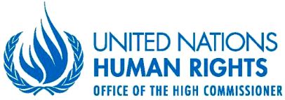
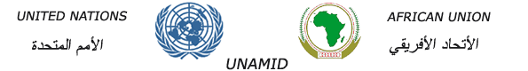

------------------------------------------------------------------------------------------------------------------------------------------------------------

The Human Rights Situation of Internally Displaced Persons in Darfur

2014 - 2016
------------------------------------------------------------------------------------------------------------------------------------------------------------

Contents
Page
ACRONYMS iv
I. Executive Summary 1
II. Introduction 2
III. Definition and methodology 3
IV. Context and overview of the armed conflict in Darfur 4
V. Legal Framework 6
VI. Protection and Security Challenges of Displaced Persons 9
VII. Violations of the economic and social rights of IDPs 16
VIII. Return, Resettlement and Reintegration of Displaced Persons 20
IX. Institutional Responses, Challenges and Gaps 22
X. Conclusion 25
XI. Recommendations 26

ACRONYMS
AU African Union
AUHIP African Union High Implementation Panel
CPA Comprehensive Peace Agreement
CRP Central Reserve Police
DCPSF Darfur Community Peace Support Fund
DDPD Doha Document for Peace in Darfur
DDS Darfur Development Strategy
DRA Darfur Regional Authority
DJAM Darfur Joint Assessment Mission
FAO Food and Agriculture Organization
GII Gender Inequality Index
HAC Humanitarian Aid Commission
HDI Human Development Index
IASC Interagency Standing Committee
IFPT Integrated Field Protection Team
ISF Integrated Strategic Framework
JPG Joint Protection Group
LJM Liberation and Justice Movement
MI Military Intelligence (Sudan Armed Forces)
NGO Non-Governmental Organization(s)
NHRC Sudan National Human Rights Commission
NISS National Intelligence and Security Services
OCHA United Nations Office for the Coordination of Humanitarian Affairs
OHCHR Office of the United Nations High Commissioner for Human Rights
QIP Quick Impact Project
RRC Resettlement and Reintegration Commission
SAF Sudan Armed Forces
SLA/AW Sudan Liberation Army-Abdul Wahid
SLA/MM Sudan Liberation Army-Minni Minawi
SRCS Sudan Red Crescent Society
UNAMID African Union-United United Nations Hybrid Operation in Darfur
UNCT United Nations Country Team
UNDP United Nations Development Programme
UNHCR United Nations High Commission for Refugees
UNICEF United Nations International Children’s Emergency Fund
VRC Voluntary Return Commission
WFP World Food Programme

- Executive Summary
- This report is jointly issued by the Office of the United Nations High Commissioner for Human Rights (OHCHR) and the African Union-United Nations Hybrid Operations in Darfur (UNAMID). It presents the analysis and findings of OHCHR and UNAMID with regards to the situation of internally displaced persons (IDPs) within the context of the armed conflict in Darfur. It highlights the difficulties and challenges of protecting the human rights of IDPs and assisting them in a constantly evolving and volatile security environment.
- The report covers the human rights situation of IDPs, including human rights violations and violations of international humanitarian law, and abuses committed by all parties to the conflict against IDPs, as documented by UNAMID from January 2014 to December 2016. The report recognizes that the current cessation of hostilities creates opportunities for the return of IDPs or their long-term reintegration into host communities.
- The report describes a range of human rights violations and abuses suffered by IDPs as a direct consequence of the conflict in Darfur and due to inter-communal conflicts and localized violence. The report also underscores interventions by UNAMID and the United Nations country team (UNCT) in providing humanitarian assistance to improve the conditions of IDPs. The report concludes that, despite the cessation of hostilities between the Government of the Sudan and opposition armed groups since June 2016, the situation of IDPs remains challenging due to a combination of factors, such as generalized insecurity and targeted attacks by a multiplicity of armed actors. The report also highlights the effects of uncoordinated Government policies resulting in negligible investment in public services and the creation of social and economic opportunities, which leaves IDPs dependent on aid and limit their enjoyment of economic and social rights.
- The report provides recommendations to the Government of the Sudan and the remaining armed opposition movements operating in Darfur to respect and protect the rights of IDPs, including by taking proactive steps toward preventing civilian displacement. In order to ensure that durable solutions are found to improve the situation of IDPs in Darfur, the report calls on the Government of the Sudan to address systemic impunity by, among other things, strengthening judicial and other remedial institutions in Darfur, and improving access to them, particularly for displaced women and girls, and ensuring victims their right to an effective remedy, including gender-sensitive reparations. The report also calls on the Government to facilitate a programme of sustainable return for IDPs.
- In order to create an enabling and safe environment for the return of IDPs to their areas of origin or their reintegration into host communities, the report calls for the prompt and comprehensive disarmament of pro-Government armed militias. It also underlines the need for extensive consultations with IDPs to ensure that their return and reintegration is done in full respect of their rights, as mandated by international law, with an emphasis on transparency, inclusivity and sustainability. Among other recommendations, the report also underscores the need for land reform and conflict resolution as key to the durable resolution of the IDP situation in Darfur. UNAMID is mandated by Security Council resolution 2296 to ensure public reporting on allegations of violations and abuses of human rights and international humanitarian law with the cooperation and assistance of the Government of the Sudan.
- Introduction
- This report is issued jointly by the Office of the United Nations High Commissioner for Human Rights (OHCHR) and the African Union-United Nations Hybrid Operations in Darfur (UNAMID). It is based on the work of the UNAMID Human Rights Section, which is guided by United Nations Security Council resolution 2296 of June 2016. Among other things, the resolution calls for an adequate human rights presence in Darfur to monitor, verify and draw to the attention of the authorities’ abuses and violations of human rights, including those committed against women and children, and violations of international humanitarian law. The resolution further urges the Government of the Sudan to extend full cooperation with UNAMID in the implementation of its monitoring mandate and to provide accountability and justice for victims.
- The focus of Security Council resolutions relating to the UNAMID mandate has varied in response to the changing dynamics of the conflict in Darfur. Nonetheless, the protection of civilians and sustained engagement with the Government of the Sudan and international partners for the improvement of the security, social and economic conditions of IDPs have been repeatedly emphasized in all resolutions. In this regard, UNAMID has been working with the Government at different levels and has provided technical assistance to State institutions to address challenges faced by IDPs in Darfur.
- The aim of this report is to provide an assessment of the protection and human rights challenges faced by IDPs in the context of the conflict in Darfur. The focus on IDPs is motivated by the absence of any major study on their general human rights situation, including the state of enforcement of economic and social rights. The report covers January 2014 to December 2016. Most of this period was characterized by the pursuit of a military campaign by the Government of the Sudan against armed opposition movements in Darfur. The campaign led to mass civilian displacement, with detrimental impact on the lives and livelihoods of IDPs. UNAMID data shows that over 80 per cent of human rights violations and abuses documented between January 2014 and December 2016 were related to attacks against IDPs while they were undertaking livelihood activities such as farming, water and firewood collection. Following the relative victory of the military campaign, armed conflict between the Government and armed opposition movements decreased significantly towards the end of this period. The current cessation of hostilities, which started on 17 June 2016, has created new opportunities for the return or reintegration of IDPs, but many challenges remain, including insecurity due to the continued proliferation of weapons and armed groups as well as the need for durable solutions to the problem of land tenure.
- In June 2016, the United Nations Office for the Coordination of Humanitarian Affairs (OCHA) estimated that 2.6 million civilians had been displaced since the outbreak of the Darfur conflict in 2003. Fighting between Government forces and armed opposition movements from 2014 to 2016 triggered significant displacements. Data collected by United Nations humanitarian agencies and the International Organization for Migration (IOM) indicated that 774,000 civilians were newly displaced between January 2014 and December 2016. It also shows that 430,000 civilians were displaced in 2014 alone—the highest number in a single year since the outbreak of the conflict. While the numbers of displacement in 2015 were half of those of 2014, displacement caused by inter-communal conflicts increased. For example, in 2015, two major inter-communal conflicts, between the Ma’alia and the Reizeigat in East Darfur, and between the Berti and Ziyadiah in North Darfur, resulted in the displacement of 94,000 civilians. Further displacements triggered by inter-communal violence were documented in West Darfur in 2016.
- In October 2016, UNAMID, together with humanitarian partners, initiated a desk review of the protection situation in IDP camps finding that a total of 2.6 million IDPs resided in 174 locations, namely 66 IDP camps, 33 gathering sites and 75 host communities. Of these locations, 29 per cent ranked as facing a serious risk level to their protection. The situation in Jebel Marra, in Central Darfur, was identified to be of utmost concern, particularly in light of past humanitarian access restrictions.
- Definition and methodology
- In this report, the term “internally displaced persons” (IDPs) is drawn from the United Nations Guiding Principles on Internal Displacement (Guiding Principles) which define IDPs as "persons or groups of persons who have been forced or obliged to flee or to leave their homes or places of habitual residence, in particular as a result of or in order to avoid the effects of armed conflict, situations of generalized violence, violations of human rights or natural or human made disasters, and who have not crossed an internationally recognized State border.” The Guiding Principles call on all authorities and international actors to “respect and ensure respect for their obligations under international law, including human rights and humanitarian law, in all circumstances, so as to prevent and avoid conditions that might lead to displacement of persons.”
- In line with its mandate, UNAMID monitors human rights and evaluates compliance with international humanitarian law, including through monitoring and fact-finding missions, and interviews with victims and witnesses of human rights violations and abuses and serious violations of international humanitarian law. Monitoring activities offer UNAMID with on-the-ground perspectives and facilitate engagements with displaced communities, civil society groups and local actors. Findings from monitoring work informs the early warning and protection of civilians strategies and advocacy initiatives of UNAMID, which also contribute to highlighting institutional gaps and weaknesses in the law enforcement and justice sectors in Darfur. Between January 2014 and December 2016, UNAMID undertook 1,078 monitoring and fact-finding missions to IDP camps. The documentation was carried out through interviews with victims, witnesses of human rights violations and abuses and their families, and visits to places where human rights violations and abuses allegedly occurred. UNAMID ensured that gender related issues were given focused attention throughout the entire assessment, in particular in planning processes, information gathering, analysis and reporting in order to ensure that sexual and gender-based violence as well as the gender-specific impact of all violations on women and men were properly investigated.
- UNAMID engaged regularly with State and law enforcement authorities, such as the police, locality commissioners and prosecution authorities, as part of its information gathering and verification process. Such engagement was sometimes helpful in getting timely access to victims and sites of alleged human rights violations and abuses and serious violations of international humanitarian law. It also allowed for constructive dialogue with the authorities towards addressing human rights concerns, especially with regards to the security and well-being of IDPs. However, access to areas where IDPs faced protection challenges was sometimes restricted.
- During its monitoring missions conducted during the period under review, UNAMID documented 1,286 allegations of human rights violations and abuses involving 3,358 victims, including 2,108 women and 299 children. The allegations related, inter alia, to violations of the right to life and personal integrity, sexual and gender-based violence, arbitrary arrests and detention, abductions, and violations of the rights to freedom of movement, expression, peaceful assembly and association. Data collected by UNAMID shows that IDPs have remained a major category of victims due to their vulnerability and the prevalent weakness of State mechanisms to protect them.
- While occasional support from law enforcement entities, coupled with cooperation with international partners optimized the collection and verification of information, the hostile security situation and poor geographic terrain made it difficult to obtain accounts from victims in many incidents. In cases relating to sexual violence, obtaining accounts proved challenging, in part due to the personal circumstances and trauma suffered by victims in addition to their reluctance to report for fear of reprisal attacks and stigmatization. On the basis of these challenges, UNAMID adopted a standard of proof based on reasonable grounds to believe that an incident or pattern of violations or abuses, some of which may amount to violations of international law, occurred when there is a credible body of information, consistent with other information from various sources, indicating their occurrence. This standard of proof is sufficiently high to call for judicial investigations into possible violations and abuses of international human rights and humanitarian law as well as possible international crimes.
- Even when victims and witnesses were accessible to human rights monitors, several factors, including social stigma and fear of reprisals, would discourage them from reporting violations of human rights and abuses to UNAMID and law enforcement authorities. This was especially common amongst IDPs, whose location and particular vulnerabilities tend to alienate them from law enforcement institutions and judicial processes. In 2015, a mapping exercise of the justice sector completed by UNAMID highlighted that due to the prolonged nature of the conflict, there were only 52 formal courts and 74 police stations in the 65 localities of Darfur. Due to this thin presence of judicial and law enforcement institutions, UNAMID observed a pattern of increased resort by victims to traditional social processes for settlement of human rights concerns and other grievances, including in cases relating to sexual violence. UNAMID has developed advocacy and community outreach initiatives which focus on encouraging victims to report cases and seek redress through the formal justice system.
- Context and overview of the armed conflict in Darfur
- The conflict in Darfur erupted in February 2003 with attacks against Government installations by the Sudan Liberation Movement (SLM). The conflict gave rise to violations and abuses of human rights and international humanitarian law as well as abuses by all parties to the conflict, and led to mass internal displacement. In the years following the outbreak of the conflict, IDPs were the primary victims of human rights violations and abuses and serious violations of international humanitarian law. Over the years, the conflict took on new dimensions, largely brought about by the increasing number of armed actors who took advantage of the situation of lawlessness, inflicting extensive suffering on IDPs. The disruption of civilian life by the conflict for over 13 years greatly limited IDPs’ enjoyment of their economic, social and cultural rights. Since the conflict began, a majority of IDPs have remained confined in overcrowded camps in a context of shrinking humanitarian assistance.
- In 2011, international mediation efforts led to the signature of the Doha Document for Peace in Darfur (DDPD), facilitated by the Government of Qatar. The document contains a detailed framework of measures to be implemented to bring peace back to Darfur, but was not signed by all armed opposition actors. The DDPD was subsequently incorporated into the interim Constitution of the Sudan. In September 2016, the Government announced the dissolution of the Darfur Regional Authority and all institutions established thereunder with the exception of five commissions and one fund which would continue to operate from Khartoum under the Office of the Sudanese Presidency.
- Engagement between the Government of the Sudan and the Darfur armed movements that had not signed the DDPD continued under the auspices of the African Union High-level Implementation Panel (AUHIP) on promoting negotiations and support for the Darfur-based internal dialogue and consultations. In 2016, the Government, the Justice and Equality Movement (JEM) and the Sudan Liberation Army/Minni Minawi (SLA/MM) signed the Roadmap Agreement providing for further talks on the cessation of hostilities, humanitarian access and modalities for ensuring an inclusive National Dialogue. Since the signing of the agreement, the AUHIP, UNAMID and other international partners have continued engaging with the parties on moving this process forward. Unlike the others, SLA/AW, the only armed movement with a military presence in Darfur since mid-2015, did not participate in the negotiations leading to the Roadmap Agreement.
- In October 2015, President Omar Al Bashir launched a national dialogue with the aim of promoting national reconciliation. The process concluded in October 2016 and resulted in a “National Document” that is to serve as the basis for drafting a new constitution and for a national reform strategy. The main opposition groups did not participate in this process in the absence of an agreement with the Government on how to ensure its inclusivity and on the content and format of the dialogue.
- While negotiations between the Government and armed actors was unfolding and the Sudanese launched the national dialogue initiative, Government forces and armed opposition movements continued to battle over territory through protracted hostilities, with detrimental implications for the safety and security of civilians. In February 2014, the Government of the Sudan embarked on a military campaign labelled “Operation Decisive Summer,” arguing it was necessary to end the rebellion in Darfur, the Blue Nile State, and Kordofan. In January 2016, fighting erupted around the Jebel Marra corridor, which borders parts of North, South, and Central Darfur States. Hostilities included aerial bombardment and large-scale deployment of Government forces, which led to the reported retreat of the Abdul Wahid faction of the Sudan Liberation Army (SLA/AW) to the hinterland of Jebel Marra.
- On the basis of available information from IDPs, UNAMID can affirm that there are reasonable grounds to believe that the military operations resulted in serious human rights and international humanitarian law violations, including indiscriminate killings, targeted attacks against IDPs, destruction and burning of villages, abductions, sexual violence against women and girls, as well as large-scale displacement of civilians. In response to concerns raised by UNAMID and international partners on the impact of the military campaign on civilians, the Government justified the operation by emphasizing the need to end the rebellion in Darfur and restore order and formal State authority.
- During the period under review, tensions between ethnic groups continued to surface, often erupting in violence and triggering civilian displacement. Between 2014 and 2016, UNAMID documented 77 incidents of inter-communal conflicts. In 2015, inter-communal violence accounted for 32 per cent of the 1,626 civilian deaths documented by UNAMID. The frequency and scale of killings in the context of inter-communal violence during this period shows that inter-communal conflicts remain a major feature of the conflict in Darfur. State governments, native administrations and traditional leaders have undertaken considerable efforts to prevent and respond to such occurrences through security measures, engagement with stakeholders and the facilitation of reconciliation process, which resulted in a relative decrease in fighting. Nonetheless, the underlying causes of such conflicts, in particular competition over land, water and other resources, have not been adequately addressed and the situation remains exacerbated by overall impunity and a weak rule of law.
- Legal Framework
- The legal framework used for this report includes international human rights law, international humanitarian law and international criminal law as well as Sudanese law. This legal framework imposes obligations on the Government of the Sudan, to ensure full protection of human rights and fundamental freedoms for all people in any territory under its jurisdiction, including IDPs. The obligation to protect civilians in situations of armed conflict is well established in international humanitarian law. The Universal Declaration of Human Rights, the International Covenant on Civil and Political Rights, and the International Covenant on Economic, Social and Cultural Rights as well as the United Nations Guiding Principles on Internal Displacement and the DDPD are particularly relevant to the protection of IDPs rights in Darfur.
- Sudan’s obligations under international human rights law
- Under international human rights law, the Sudan has obligations to respect, protect and fulfill the human rights of all individuals—including IDPs—without discrimination of any kind. The Sudan is a party to the International Covenant on Civil and Political Rights, the International Covenant on Economic, Social and Cultural Rights, the Convention on the Rights of the Child and its first Optional Protocol on the involvement of children in armed conflict, the International Convention on the Elimination of All Forms of Racial Discrimination, and the Convention on the Rights of Persons with Disabilities and its Optional Protocol. The Sudan is also a party to the Convention on the Prevention and Punishment of the Crime of Genocide. It has also ratified the African Charter of Human and Peoples’ Rights. Other relevant instruments ratified by the Sudan include the Pact on Security, Stability and Development in Africa’s Great Lakes Region and its related Protocols on the Protection and Assistance to Internally Displaced Persons and on the Property Rights of Returning Persons. The latter requires States parties to respect and integrate the United Nations Guiding Principles on Internal Displacement into their national legislation.
- The United Nations Guiding Principles on Internal Displacement provide guidance to States with regard to their legal obligations to protect IDPs and their property. Principle 5 stipulates that “all authorities and international actors shall respect and ensure respect for their obligations under international law, including human rights and humanitarian law, in all circumstances, so as to prevent and avoid conditions that might lead to displacement of persons.” Principle 6 provides that “every human being shall have the right to be protected against being arbitrarily displaced from his or her home or place of habitual residence.” According to Principle 3, “national authorities have the primary duty and responsibility to provide protection and humanitarian assistance to internally displaced persons within their jurisdiction.”
- Obligations under international humanitarian law
- The Sudan has ratified the four Geneva Conventions of 1949, and the two 1977 Protocols Additional to the Geneva Conventions relating to the Protection of Victims of Non-International Armed Conflicts and to the Protection of Victims of International Armed Conflicts, respectively. It has also ratified the Optional Protocol to the Convention on the Rights of the Child on the involvement of children in armed conflict. The Protocol Additional to the Geneva Conventions of 1949, and relating to the Protection of Victims of Non-International Armed Conflicts (Protocol II), (1977) provides minimum threshold of protection of civilians in circumstances or areas where there are military operations. Article 13 of the Protocol states that “the civilian population and individual civilians shall enjoy general protection against the dangers arising from military operations. To give effect to this protection, States and non-state actors are obligated to observe minimum protection rules in all circumstances.”
- International humanitarian law prohibits any party to an armed conflict from ordering the displacement of civilian populations for reasons related to the conflict, unless required on the basis of the security of the civilians involved or imperative military reasons, with adequate safeguards. The parties to the conflict must take all possible measures to ensure that family members are not separated and that the displaced population is received under satisfactory conditions of shelter, hygiene, heath, safety and nutrition. Moreover, such evacuations must be temporary with those affected granted the right to return safely to their homes as soon as the reasons for their displacement cease to exist. If displacement occurs, IDPs, like other civilians, are entitled to protection and assistance without discrimination in respect of religion, sex, ethnicity or political persuasions.
- Obligations under international criminal law
- The Sudan signed the Rome Statute of the International Criminal Court on 8 September 2000, but it has not ratified it. The Sudan is obliged to refrain from acts that would “defeat the objects and purpose of [the] treaty” pursuant to the Vienna Convention on the Law of Treaties, acceded to by the Sudan. The Rome Statute defines four categories of international crimes: genocide, war crimes, crimes against humanity and the crime of aggression. Article 8(2)(e) (i) of the Rome Statute imposes obligations on States to investigate and prosecute violations relating to direct intentional and direct attacks against the civilian population “or against individual civilians not taking direct part in hostilities.”
- Obligations under Sudan national law
- Article 27(3) of the Sudan’s Interim National Constitution of 2005 stipulates that all international human rights treaties ratified by the Government of the Sudan form an “integral” part of the Bill of Rights of the Constitution. Article 1(2) of the constitution states that the Sudan is committed “to the respect and promotion of human dignity.” Article 10(1) provides that “the overarching aims of economic development shall be eradication of poverty, attainment of the Millennium Development Goals, guaranteeing the equitable distribution of wealth, redressing imbalances of income and achieving a decent standard of life for all citizens.” Article 10(2) states that the “State shall develop and manage the national economy in order to achieve prosperity through policies aimed at increasing production [and] creating an efficient and self-reliant economy…”
- Article 7(1b) and (1c) of the Sudan Armed Forces Act 2007 stipulates that members of the armed forces shall comply with human rights and international humanitarian law, while Article 155 prohibits attacks on civilians by military personnel. Sudan’s Criminal Code (Amendment) Act of 2008, which amended the 1991 Criminal Code, includes Chapter 18 with provisions for ‘crimes against humanity, genocide, and war crimes’ Articles 187 and 189 of Amendment Act also criminalize offences relating to sexual and gender-based violence.
- In addition, the DDPD articulates the road map for peace and development in Darfur and incorporates strong provisions on human rights and international humanitarian law, including guidance on the return and resettlement of IDPs. Article 42, paragraph 217, of the DDPD states that all parties to the conflict must ensure “respect for, protection and fulfilment of the rights of IDPs, refugees and all victims of conflict in accordance with international human rights law, international humanitarian law, and international refugee law and all other international and regional instruments to which Sudan is a Party.” In addition, through paragraph 224 of the DDPD, the Parties agreed to observe the United Nations Guiding Principles on Internal Displacement. The DDPD was enshrined in the Sudan Interim Constitution through the Amendments to the Constitution ratified by Parliament and signed by the National Legislative Council and the President of the Republic of Sudan, on 4 January 2015. The Amendments added a new article (226) to the Constitution which provides that “in what does not contradict previous clauses in this constitution, the Doha Document for Peace in Darfur becomes an integral part of this Constitution.”
- In January 2009, the Sudan adopted a National Policy on Internally Displaced Persons in response to international concerns over the security and economic conditions of IDPs in Darfur as well as in the Kordofan and Blue Nile States. The policy covers the stages of displacement due to conflict or natural disasters including human-made, and describes the rights of IDPs, including the right to security and inclusion in development programmes, promotes the principles of participation, voluntariness and freedom of choice with respect to durable solutions. It also establishes the Government’s responsibilities through all phases of displacement, specifying the roles of all levels of Government in matters relating to the well-being and concerns of IDPs. The Humanitarian Aid Commission is the governmental body responsible for the coordination of programmes for IDPs across the Sudan. However, the implementation of the National Policy on Internally Displaced Persons has been slow due to several factors, including poor coordination, lack of political will, and limited capacity of the Humanitarian Aid Commission.
- Protection and Security Challenges of Displaced Persons
- The prevalence of insecurity in Darfur has affected communities well beyond the frontline of the conflict. The thin presence and, in some instances, the absence of law enforcement and judicial institutions in locations where IDPs are settled have exposed them to human rights violations and abuses and serious violations of international humanitarian law by all parties to the conflict. The persistent impunity on human rights violations has also encouraged the perpetration of such acts by all parties to the conflict. This chapter reviews the impact of the “Decisive Summer” military campaign and targeted attacks by pro-government armed militia on the IDP population.
- Impact of military campaign on civilians
- In November 2013, the Government of the Sudan announced its plans to launch a military campaign to eliminate the rebel movements in Darfur, Blue Nile and Kordofan regions. The first phase of the campaign, called “Decisive Summer”, lasted from late February to June 2014 and was largely concentrated in North and South Darfur and, to a lesser degree, in Central Darfur. In December 2014, the second phase was launched and continued until March 2015, with most intense fighting taking place along the so-called Jebel Marra corridor.
- The security and human rights situation deteriorated dramatically in February 2014 with the launch of the first phase of the campaign. Fighting between Government forces and the factions of SLA/AW and SLA/MM intensified. Victims and witnesses told UNAMID that civilians, including women and children, came under attack indiscriminately by the Rapid Support Forces and pro-government militia, while fleeing for safety. The accounts of victims and witnesses also suggested patterns of the burning of villages and temporary IDP shelters, looting of property and destruction of sources of livelihood. Indiscriminate attacks that resulted in the killing and injury of civilians were also documented on 19 and 20 May 2014, when Government forces attacked several villages in the Tawilla locality, North Darfur, in an attempt to dislodge the Sudan Liberation Army/Ali Karbino faction from the area. A public market outside Tawilla, which served as an important source of livelihood and trade for IDPs, was also destroyed during the same period. Local sources informed UNAMID that the escalation of hostilities in Golo, in June 2014, also caused the destruction of at least 30 houses whose occupants fled to IDP camps in Nertiti and Zalingei, in Central Darfur.
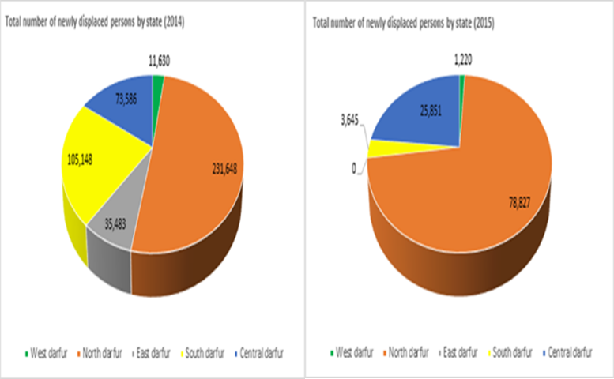

- After a temporary interruption of hostilities between June and November 2014, the second phase of the military campaign resumed in December 2014. In January 2015, hostilities intensified between Government forces and armed opposition movements in North Darfur. Reports indicated that at least six civilians were killed, three were abducted and five others were declared missing during attacks by the Rapid Support Forces against 13 villages in Tawilla and Um Baru localities, on 5 January 2015. On 7 January 2015, the Sudanese Air Force bombed the Abuleha village outside Um Baru, which was confirmed by a UNAMID fact-finding team that visited the site on 14 January 2015. On 27 January 2015, a Member of Parliament from Um Baru and Karnoi constituencies in North Darfur expressed concern in the media about the impact of hostilities on civilians. The military campaign continued until June 2015 with various reports of attacks against IDPs.
- In January 2016, hostilities between Government forces and SLA/AW spread to Jebel Marra, including the villages of Kutrum, Golo and Sorrong, located in Central Darfur. Aerial bombardment by the Sudanese Armed Forces reportedly resulted in the destruction of dozens of villages and the killing of at least 15 civilians. From 5 January to 16 May 2016, UNAMID gathered accounts from IDPs who had fled from 42 villages in east and west Jebel Marra, which were allegedly attacked, looted and burnt down by the Rapid Support Forces. A group of IDPs at the Rwanda IDP camp in Tawilla informed UNAMID monitors that their displacement was triggered by hostilities between SLA/AW and Government forces in Jebel Marra. They noted that, due to the intensity of hostilities, at least 3,000 civilians were stranded for several days in Jebel Marra, with little or no food. Those who had attempted to leave the mountains for safety were allegedly attacked by the Rapid Support Forces who also seized control of vital entry routes to Sortoni and Shangil Tobaya, where 30,000 IDPs had converged to access humanitarian assistance by March 2016.
- UNAMID corroborated information from various sources on the impact of the Jebel Marra hostilities on civilians, including displaced communities, showing that most displacements were preceded by violations of human rights and of international humanitarian law, notably targeted killings and physical injury of civilians by the Rapid Support Forces. On 21 April 2016, UNAMID monitors interviewed 50 out of 500 IDPs at the Otash IDP camp in Nyala, South Darfur, who reported having witnessed the killing of 42 civilians, including 21 women and two children, by the Rapid Support Forces in Feina and Sabonnalfagour villages, in Jebal Marra, on 15 March 2016. They recounted that the killings had occurred while civilians were fleeing the villages, and that the Rapid Support Forces also looted civilian property and burned down houses. Witnesses provided UNAMID the names of all the civilians allegedly killed during the attack. The accounts gathered by UNAMID provide reasonable grounds to believe that the Rapid Support Forces exploited civilian vulnerabilities and used force to possibly inflict maximum damage.
- UNAMID documented further patterns of targeted attacks against IDPs between March and May 2016. On 13 April 2016, UNAMID gathered information from various local sources on serious human rights violations in west Jebel Marra following hostilities between Government forces and SLA/AW fighters. Sources informed UNAMID that on 8 and 9 April 2016, the Sudanese Armed Forces, assisted by the Rapid Support Forces, launched an attack on Sorrong village, which was hitherto under the control of SLA/AW fighters. The sources stated that Government forces suffered casualties, including the killing of a senior commander, following the capture of Sorrong, and, on 8 April 2016 embarked on what appeared to be reprisal attacks against civilians, including pockets of displaced communities around Saga, Tibon, Daya, and Jartaga villages. Sources informed UNAMID that 90 civilians were allegedly killed and that an undetermined number of houses were burnt down by the Rapid Support Forces. Despite the serious nature of the allegations, UNAMID monitors were denied access to the affected villages and displaced communities by the Government.
- The continuation of hostilities in Jebel Marra in 2016 exacerbated the precariousness of security conditions for IDPs. By the first half of January 2016, an estimated 97,000 civilians had been recently displaced by the hostilities in the area, according to data gathered by UNAMID and OCHA. The movement of IDPs was concentrated in South, Central, and North Darfur States, which are located on the exit routes from the Jebel Marra corridor. While hostilities continued, with reports of aerial bombardment between January and February 2016, civilian displacement increased, with large numbers of IDPs hosted in Nertiti, in Central Darfur, and Sortoni, Shangil Tobaya and Tawilla, in North Darfur. From January to the end of February 2016, an estimated 30,000 IDPs were temporarily sheltered outside the UNAMID base in Sortoni, and this figure gradually increased to 58,000 by the end of March 2016. UNAMID documented additional displacements in the Nyala and Kass localities, in South Darfur. In Central Darfur, an estimated 127,000 civilians were reportedly displaced, though UNAMID could not verify this number due to restrictions of access imposed by the Government authorities. The influx of IDPs to Sortoni overwhelmed the capacity of available services, including those provided by UNAMID and humanitarian agencies.
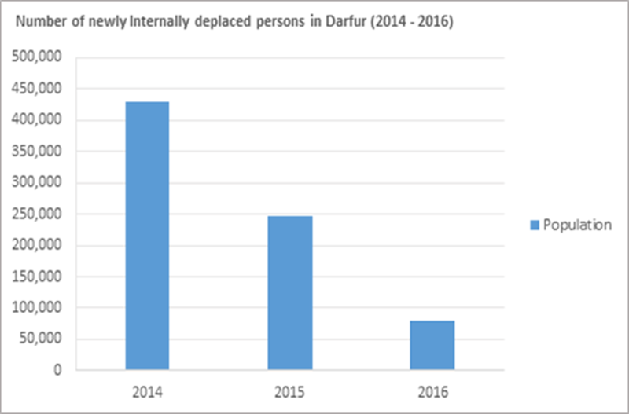

- As fighting continued, UNAMID intensified its engagement with Government authorities to highlight the human rights and humanitarian implications of the hostilities, especially its concerns relating to patterns of attacks against IDPs by the Rapid Support Forces. UNAMID continued to emphasize the primary responsibility of the Government of the Sudan to address the security and humanitarian needs of civilians in accordance with international human rights and humanitarian law. UNAMID also regularly communicated its commitment to providing assistance to the Government to fulfil its obligations to protect civilians, including IDPs. Proposed initiatives included launching of joint patrols to IDP camps, such as Abu Shouk and Zamzam in North Darfur, as deterrence to attacks, and confidence-building measures. Responses from Government authorities, while occasionally encouraging, were rarely backed by effective follow-up action.
- Despite these challenges, UNAMID sustained its engagement with Government authorities in accordance with its mandate to protect civilians. It thus met with the Acting Government police commander in Nertiti, on 25 May 2016, to discuss the security, human rights and humanitarian concerns of IDPs in the context of the Jebel Marra hostilities. The commander denied reports of human rights violations and abuses, and claimed that incidents reported to the police only concerned criminal activities with no connection to the armed conflict. He stated that hostilities in Jebel Marra had ended, and that Sudanese Armed Forces personnel had been deployed to protect IDPs in Nertiti as well as to de-escalate tensions between Arab nomads and local farmers.
- Restrictions of access to Jebel Marra imposed by the Sudanese authorities and SLA/AW have prevented UNAMID and United Nations agencies to conduct essential monitoring work and humanitarian needs assessments in areas where hostilities were largely concentrated. However, accounts of victims and witnesses and other information gathered and verified from various credible sources, indicated that the parties to the conflict appeared to have committed violations of international human rights law and abuses and serious violations of international humanitarian law in the context of the Jebel Marra conflict. In particular, hostilities provided cover to the Rapid Support Forces and pro-government armed militia to target IDPs, with no prospect for remedial action.
- Attacks against IDPs by pro-Government Armed Militia
- UNAMID documented numerous incidents of attacks against IDPs carried out by pro-government armed militia. On 15 January 2014, a group of IDPs who were returning to their farms were attacked by 25 members of a pro-government armed militia in Khabasha village, in the outskirts of Nyala town, South Darfur. The perpetrators killed two IDPs and abducted seven. Later in the evening, the same armed militia attacked 60 IDPs around Kalma, South Darfur. Some of the victims told UNAMID monitors that 35 female IDPs were assaulted and their personal belongings were taken away at gunpoint. While the IDPs reported the incident to the local police, the latter failed to initiate an investigation. In subsequent weeks, UNAMID documented further attacks on IDPs committed by pro-government armed militia in North, West and Central Darfur states.
- On 1 December 2015, Border Guards and pro-government armed militia on board 20 land cruiser vehicles drove through Anka and Um Rai villages, in North Darfur, and indiscriminately opened fire, killing two civilians and injuring a dozen others. Eight villages and communal gathering areas around Anka and Um Rai were burnt and the livestock and food reserves looted. The attacks left hundreds of civilians homeless, with at least 150 families fleeing to IDP camps in Kutum and Shangil Tobaya. On 24 January 2016, UNAMID visited Anka and Um Rai to assess the humanitarian conditions as well as to provide assurances of the Mission’s commitment to improving the protection of civilians, including IDPs.
- On 7 December 2015, UNAMID held a meeting with State authorities in Kutum to follow up on reports of human rights violations and abuses committed by Border Guards and pro-Government armed militia during their attacks in Anka and Um Rai villages. The officials acknowledged the security challenges in Anka, Um Rai and surrounding villages, and noted that a delegation of community leaders from the Anka area had visited the Kutum locality commissioner in August 2015 to discuss security and human rights concerns. The failure of the authorities to take preventive measures in advance of the attacks reinforced the perception that the Government of the Sudan may be falling short on its legal obligation to protect civilians, including IDPs. As of December 2016, no action had been taken to bring the alleged perpetrators of the attacks in Anka and Um Rai to justice.
- Attacks on IDPs, which were reportedly jointly undertaken by Government forces and pro-Government armed militia, often utilized Government resources, including vehicles and heavy weaponry. For instance, on 20 October 2014, five Central Reserve Police (CRP) members reportedly attempted to rob IDPs at the Zamzam IDP camp, in North Darfur. The IDPs resisted and, in the ensuing confrontation, one CRP member was killed. On 21 October, a group of heavily armed CRP members, who were accompanied by dozens of members of a pro-government militia, set ablaze 50 IDP shelters in a reprisal attack at the Zamzam IDP camp. Personal belongings of IDPs, including essential food reserves, were destroyed. A police investigation, which was initiated on 23 October 2014, did not lead to any arrest and the victims were never compensated for the destruction of their property. Only limited food supplies were handed to victims of the attack by the Darfur Regional Authority (DRA).
- On 9 May 2016, a pro-government militia attacked the temporary IDP camp outside the UNAMID base in Sortoni, killing eight people and injuring six others, including a United Nations peacekeeper. One of the injured IDPs subsequently died in hospital. On 9 May 2016, UNAMID military personnel apprehended two suspects and handed them over to Sudanese authorities in El Fasher, North Darfur. UNAMID also provided logistical support, including transportation to Sortoni, for an investigation team from the Office of the Special Prosecutor for Crimes in Darfur. On 21 June 2016, the latter announced that it had concluded preliminary investigations into the incident and that further action was expected from judicial authorities. To date, however, no progress has been made in prosecuting the alleged perpetrators, and no law enforcement personnel has been deployed in Sortoni despite repeated reports of targeted continued attacks on IDPs by pro-Government militias.
- On 20 June 2016, a dozen armed individuals from a pro-government militia arrived at the Thur East IDP camp in Nertiti, Central Darfur, and were reported to have indiscriminately fired shots at IDPs, most of whom were awaiting to break their fast during the month of Ramadan. In the morning of 21 June 2016, the same pro-government militia group returned to the camp and burnt down shelters and the local market, looting food and personal belongings of IDPs. UNAMID monitors visited the site of the attacks on 21 June, and heard witnesses confirming that four IDPs were killed and seven others injured. The attack forced at least 400 IDPs, including women and children, to seek refuge outside the Sudanese Armed Forces base in Nertiti. Following UNAMID engagement with local authorities regarding the security concerns of IDPs, a delegation, which comprised the deputy Wali (Governor) of Central Darfur as well as senior police and military commanders, visited Thur to assess the damage. In subsequent visits to Thur by UNAMID monitors, IDPs continued to highlight security concerns and the failure by State authorities to address them. As of December 2016, no action had been taken by local authorities to apprehend the perpetrators, to provide security or to compensate the victims of the attack.
- The vulnerability of IDPs is also a concern within IDP camps. During routine monitoring visits undertaken by UNAMID, community leaders consistently complained about insecurity and the proliferation of small arms and light weapons inside IDP camps. In incidents documented by UNAMID, camps continued to be targeted by the Rapid Support Forces and pro-Government militias who accused IDPs of supporting armed opposition movements. In the majority of the 66 IDP camps across Darfur, UNAMID continued to document cases of random shootings at night, acts of criminality and harassment of displaced persons by pro-government armed militias.
- Sexual and gender-based violence against IDPs
- Displaced women and girls in Darfur remain particularly vulnerable and are continuously exposed to sexual and gender-based violence, including conflict-related sexual violence. Through its monitoring activities, UNAMID has received reports indicating that sexual violence, often in the form of rape, attempted rape, and sexual harassment, is common within and around IDP camps and farmlands.
- From January 2014 to December 2016, UNAMID documented 297 cases of sexual violence involving 533 victims, including 530 girls and three boys. The age of victims ranged from two to 70 years. In two cases, six women were killed for having resisted attempted rape and 43 per cent of the recorded rape survivors sustained serious physical injuries. Although the survivors received treatment in hospital for physical injuries, they had no access to psychosocial care. UNAMID also documented the case of a 14-year-old survivor who became pregnant as a result of a rape and who was married to the perpetrator as a form of traditional settlement. Rape constituted 82 per cent of the total cases of sexual gender-based violence reported between January 2014 and December 2016. Thirty per cent of the cases of rape occurred during displacement.
- During the first and second phases of the military campaign in 2014 and the early part of 2015, the prevailing insecurity made IDPs particularly vulnerable to sexual violence. In at least 45 per cent of documented cases of sexual violence from January 2014 to December 2016, victims cited the absence of police stations, lack of confidence in authorities, social stigma associated with sexual violence, and/or fear of reprisal attacks by the alleged perpetrator as reasons for not reporting attacks to the police. On 2 March 2016, in El Geneina, West Darfur, UNAMID monitored the trial of a man accused of stabbing a woman to death on 25 September 2013 for having filed a case of attempted rape against him, which illustrates the kind of reprisals victims of rape can suffer.
- The capacity deficit of the justice sector, including the lack of adequate and effective legal aid services coupled with a very limited awareness of human rights among the population, has major implications on access to justice in Darfur. This is the case in most parts of Darfur where high incidence of poverty, low literacy levels and marginalization of vulnerable groups are steeped in the region’s history. As a result, large portions of the population remain alienated from the basic outlets of the justice sector, and their ability to access and seek remedies is therefore limited.
- Even in instances when cases were reported, little action was taken to bring perpetrators to justice. Moreover, where cases concern members of the national security forces, immunity from prosecution for acts committed in the course of operational duties has provided a basis for delaying and denying justice. As a result, victims have increasingly resorted to traditional mechanisms as avenues to mediating sexual violence cases. In 2014, 63 cases of sexual violence were reported to the police, but only 20 of these cases were investigated, resulting in 14 arrests. Only two cases were taken to court and led to convictions.
- Victims of sexual violence have expressed concern over the seeming lack of interest by the police in investigating cases. During interactions with UNAMID monitors, law enforcement authorities pointed to the underreporting of cases, owing to the limited reach of law enforcement and justice institutions as well as the lack of capacity, as obstacles to the timely investigation of cases. Despite some progress in the documentation of sexual violence cases, the available data does not reflect the actual magnitude of violations due to limitations created by stigma, fear of reprisals, the limited presence of law enforcement and a denial of access to places of incidents of alleged sexual violence.
- Access to victims of sexual violence remains challenging due to restrictions imposed by Government authorities and armed opposition movements. In Central Darfur, for example, allegations of mass rape following attacks by the Rapid Support Forces on Golo, in January 2015, have been raised with the Government, but little progress has been made in gaining access to the area in order to corroborate the accounts. Moreover, allegations of the mass rape of an estimated 200 women and girls over a period of 36 hours, beginning on 30 October 2014, by the Sudanese armed forces in Thabit, North Darfur, have still not been investigated to date. These restrictions and lack of cooperation from Government authorities have deprived victims of their right to redress and reparation.
- The highest number of documented cases of sexual violence occurred during the “Decisive Summer” military campaign, as well as at the onset of the migratory season for armed Arab herdsmen, and during the farming season for IDP farmers. A total of 25 per cent of sexual violence cases documented by UNAMID were attributed to members of the national security apparatus, including the Sudanese Armed Forces, while men in civilian attire, both armed and unarmed, were identified as the perpetrators in 33 per cent of the cases. Some victims indicated that their attackers were either associated with proxy forces supported by the Government or were armed men in military uniform. For instance, on 13 May 2015, armed men allegedly raped a bride and her sister who were on their way to a wedding, in the presence of their relatives and neighbours. The identification of such men is complicated, however, by the fact that military uniforms can be purchased at local markets. In the remaining instances, perpetrators were either unidentified or were civilians known to the victim.
- Even when there is adequate evidence, the police do not consistently pursue formal prosecutions for rape, frequently leaving communities to resort to traditional justice. For example, on 13 May 2015, a 16-year-old displaced girl was raped by a police officer while gathering firewood near Khamsa Dagaig camp. A complaint was filed, but the investigation was discontinued and the suspect released pursuant to a traditional settlement whereby it was decided that he should marry the victim.
- An adequate response to incidents of sexual violence necessarily requires a long-term commitment and sufficient resources. In 2015, in an effort to extend the reach of the law in general, the Ministry of Justice appointed new prosecutors in all the states of Darfur and deployed police to new areas in North Darfur. In February 2015, the Criminal Act of 1991 was amended to include a definition of rape that is in line with international standards, and UNAMID and UNDP have been supporting the establishment of a victim and witness protection programme. Sexual violence has a long term impact on victims, and requires the provision of access to prompt, full and effective reparation, including physical and psychosocial support. UNAMID has continued to undertake gender-focused initiatives, such as conducting patrols for the livelihood activities of women and girls. UNICEF continued to support family and child protection units in Darfur. United Nations Population Fund (FPA) provided training for service providers in clinical management of rape and distributed kits through the Ministry of Health. Other initiatives included collaboration between the United Nations Development Programme (UNDP), UNAMID and State authorities to train personnel in the justice sector on women’s rights.
- Violations of the economic and social rights of IDPs
- In the 13 years of the conflict in Darfur, the social and economic conditions of IDPs have significantly worsened. This has adversely affected the conditions necessary for the enjoyment of basic rights, such as the rights to food, housing, health, water, sanitation and education. Land occupation and land use issues have been a chronic problem in all parts of Darfur. In particular, issues of access to land often trigger inter-communal conflicts. The Sudan’s Human Development Index value for 2015 stagnated at 0.490, which put the country in the low human development category, positioning it at 165 out of 188 countries and territories. IDPs, particularly women, by virtue of their vulnerabilities and social status, and as a result of traditional norms and customs, have been facing increased discrimination, which has had a negative impact on their enjoyment of economic and social rights. The Sudan’s Gender Equality Index has thus also been very low.
- UNAMID monitoring as well as needs assessments carried out by UNCT and international non-governmental organizations (NGOs) have consistently observed high levels of food insecurity and malnutrition in Darfur. According to the Government’s Food Security Technical Secretariat (FSTS), in 2016, the level of food insecurity in the Sudan reached crisis or emergency levels, with an estimated 4.6 million people affected, with IDPs being disproportionately impacted.
- The prolongation of the conflict has added to the socio-economic challenges faced by IDPs. In its 2016 Humanitarian Needs Overview for the Sudan, OCHA indicated that the scale and conditions of IDPs had not been matched by economic opportunities. Large-scale displacement that has occurred yearly in Darfur since 2003 has disrupted social institutions that provide resilience and community safety nets. UNAMID and UNCT assessments found that the vulnerability of IDPs has been amplified by their reduced access to resources, such as land, water and social services. Vulnerable groups, such as women and children, have been particularly impacted by the scarcity of resources and weak infrastructure.
- Data gathered by United Nations agencies in 2016 indicated that children accounted for 60 per cent of the 2.6 million IDPs in Darfur. In addition to 4.6 million people suffering from crisis-level food insecurity across the Sudan, at least two million children were then diagnosed with acute malnutrition. The data also shows that 45 per cent of all deaths among children under the age of five were directly linked to malnutrition. From 2014 to 2016, UNAMID documented the death of children from malnutrition, diarrhoea and other preventable diseases in IDP camps in South, East, and North Darfur States. Due to overcrowding and the absence of standardized sanitation systems, these camps are receptacles for diseases and have resulted in long-term health damage to IDPs.
- The poor state of health facilities in the region has had negative implications for IDPs. Data collected by UNAMID and United Nations agencies in 2016 indicated that 30 per cent of primary health care facilities across Darfur were either closed, damaged or not fully functional. This situation is due to a combination of factors, including inadequate funding and staff attrition, attacks against medical facilities and displacement of medical personnel. Health facilities in IDP camps are typically provided for and funded by international NGOs. However, funding challenges faced by international NGOs and insecurity conditions have affected the provision of basic health care across IDP camps. For instance, in Kulbus locality, West Darfur, seven health clinics were forced to shut down in 2015 due to the departure of an international NGO which had experienced funding difficulties. Four other international medical NGOs have ceased operations in West Darfur since July 2015. In 2016, the World Health Organization (WHO) indicated that 769,000 peoples, including IDPs and host communities in Darfur and other regions in the Sudan, were likely to face significant difficulties in accessing primary health care services due to funding shortages.
- The challenges for IDPs to access health care, education and other essential services have been accentuated by inadequacies in the Sudan’s institutional and policy architecture. While the Government has achieved some progress in upgrading health and school infrastructure in some parts of Darfur, substantive efforts are needed to make the Sudan compliant with its obligations under the International Covenant on Economic, Social and Cultural Rights. In its concluding observations issued in 2015 on the second periodic report of the Sudan, the Committee on Economic, Social and Cultural Rights noted with concern the significant disparity in the enjoyment of such rights in some regions of the Sudan, including Darfur. The Committee recommended, among other things, that the Sudan “allocate adequate budgetary resources to close regional disparities in the level of enjoyment of economic, social and cultural rights.” In Darfur, IDPs have been significantly affected by these disparities.
- Formal education and traditional learning cycles continued to be disrupted by the protracted conflict and the destruction of educational facilities and institutions. For IDPs, access to education has been further restricted by limited resources and inadequate facilities in IDP camps, which have led to poor quality or even no education at all for children. Schools in IDP camps are typically overcrowded with few or no qualified teaching staff. While school enrolment for displaced children has improved, poor resources and material difficulties experienced by families continued to hinder progress in advancing access to universal primary education in Darfur. In 2015, UNAMID conducted a survey to assess accessibility to education in IDP camps in Darfur. The findings revealed an acute shortage of resources and poor pupil-teacher ratio. For example, two schools with 4,000 pupils at Nifasher and Shaddad IDP camps, in North Darfur, had only two professional teachers each. Despite their commitment, the services of the teachers were seriously inadequate to cater for the educational needs of a large number of pupils. In the IDP camps of Kalma, Krinding and Hassa Hissa, respectively located in South, West and Central Darfur, volunteers who are not trained teachers have been relied upon to address gaps. Their lack of training and specialized skills has affected the quality of education. In Nifasher and Shaddad IDP camps, some funding was sourced from Plan Sudan International NGO, but the programme ended prematurely, leaving beneficiary schools in great financial difficulties. Moreover, the high cost of tuition is beyond the reach of most displaced families, resulting in the denial of access to education for thousands of displaced children across Darfur. UNAMID has continued to highlight these concerns with Government authorities and has been working closely with UNICEF to improve access to education for displaced children.
- From 2014 to 2016, the increasing demand for water and land resources resulting from displacement and movement of nomadic communities continued to ignite tension and violence within and amongst communities. IDPs often face difficulties in accessing land and water resources. Figures from OCHA indicate that, in 2016, in 18 of the 60 IDP camps in Darfur, civilians had access to less than 7.5 litres of water per person per day, which is considered significantly below minimum emergency standards. Due to the scarcity of water outlets and the frequent damage to water pumps by pro-Government armed militia, IDPs would generally travel 15 miles on average to collect water for cooking and sanitation. Such movements come with serious risks of attacks, including sexual violence.
- In addition to the disruption of farming activities, the civilian population, including IDPs continued to experience incidents of crop destruction by animals belonging to Arab nomads, which were often released to graze farmlands and destroy crops in acts of antagonism. Attempts by IDPs to protect their farms have been met with violence by pro-government armed militia, including physical assaults, killings and sexual attacks in the form of rape. During the farming season, pro-government armed militia were implicated in incidents of violent seizure of farm harvests belonging to displaced persons in Central, West, and South Darfur States. UNAMID documented incidents of extortion by pro-Government armed militia who sought undertakings from displaced farmers to share harvests in exchange for security and access to farmlands. These experiences have aggravated the security and well-being of displaced persons and their right to food security.
- Insecurity and attacks by militias severely limit the freedom of movement of IDPs and their ability to leave the camps to farm land or undertake livelihood activities, severely undermining their access to food and income. UNAMID continued to organize military escorts for displaced farmers to undertake farming and livelihood activities.
- The reduced capacity of aid workers directly impacts the availability of humanitarian assistance. At the beginning of 2009, 17,700 aid workers were active in Darfur, representing dozens of international NGOs and a broad spectrum of humanitarian intervention. As of May 2016, 4,446 aid workers (97 per cent of whom were Sudanese nationals) were conducting humanitarian action in Darfur, according to data gathered by OCHA. The Sudan’s Humanitarian Aid Commission (HAC), in collaboration with the Sudan Red Crescent, has expanded its activities and humanitarian assistance to IDPs since 2014. However, its role as the national coordinating body for humanitarian relief has been limited by funding challenges and a thin physical presence in critical areas, including where there are large IDP presences.
- In 2015, the World Food Programme (WFP) completed a household-level economic census with the aim of re-prioritizing assistance on the basis of a needs assessment. The study led to the introduction of assessment criteria which focused on identifying vulnerabilities as opposed to status, which previously assumed that all IDPs were in need and entitled to humanitarian assistance. Access to basic social services was used as a common denominator to determine vulnerability. This led to a reduction in the numbers of IDPs eligible for assistance. Following this change, UNAMID documented increased numbers of complaints by displaced communities whose food supplies had been discontinued following the introduction of WFP food ration policy. While some displaced communities adjusted, a significant number of others interpreted the new policy as disregard for their plight by the international community.
- The delivery of medicine and food in a hostile terrain such as Darfur requires coordination with Government authorities but also with armed opposition movements. During the 2014-2016 hostilities, UNAMID and UNCT continued to be denied access to most of Jebel Marra, where an estimated 150,000 civilians requiring urgent humanitarian assistance were stranded in villages and mountainous areas. Where limited access was granted, such as in Guldo, in Central Darfur, humanitarian agencies could not operate freely to deliver humanitarian assistance. In other areas of displacement, such as Fanga Suk, which lies on an axis linking Central and North Darfur States, IDPs continued to express concern over the humanitarian relief gaps and related delays in the delivery of much needed relief. During massive displacement in March 2014, similar challenges were encountered in Saraf Omra, where WFP was repeatedly denied access by Government authorities.
- Despite initiatives by the Government and funding of social enterprises by international partners, the general conditions of the social infrastructure remain precarious. The humanitarian needs of IDPs cannot be solely addressed by humanitarian agencies whose role is complementary to that of the Government. The Sudan is obligated to respect the human rights of IDPs, including by allocating “resources necessary to ensure the satisfaction of the minimum essential level of food required for everyone to be free from hunger.”
- Return, Resettlement and Reintegration of Displaced Persons
- In 2012, the Darfur Joint Assessment Mission (DJAM), composed of representatives from UNAMID, UNCT and international partners, was established to initiate consultations and make assessments of key development priorities for the people of Darfur. It recommended the elaboration of the Darfur Development Strategy (DDS) as the reference point for reconstruction and development initiatives in Darfur, with a projected budget of US$7 billion. On 8 April 2013, DDS was validated at an international donor conference for Darfur, with pledges of US$2.6 billion from the Government of the Sudan and US$3.6 billion from international partners. The Government of Qatar pledged US$88.5 million to finance social development projects, including the creation of voluntary return communities and model villages across all five Darfur States.
- Under the DDPD and DDS provisions, model villages have been built in some localities in Darfur with funding from the League of Arab States, the Governments of Qatar, Kuwait and the Kingdom of Saudi Arabia. The first of the model villages in North Darfur was inaugurated in Thabit, in January 2016 by the Deputy Prime Minister of Qatar. According to data obtained from HAC, five model villages (one in each state) were established for voluntary returnees in 2014, and 10 (two in each state) were expected to be completed in 2016, with funds from the Government of Qatar and the League of Arab States. These villages have become central to the evolving Government policy on return and reintegration.
- With the exception of the Government of Qatar, pledges made at the 2013 conference were not fulfilled. As part of the implementation of DDS, the Government of the Sudan disbursed US$165 million to facilitate the creation of an institutional architecture for policy arrangements for the return and reintegration of IDPs in Darfur. This included the creation of the Voluntary Return and Reintegration Commission (VRRC) in 2011, comprising the Voluntary Return Committee (VRC), the Property Claims and Restitution Committee (PCRC), the Resettlement and Reintegration Committee (RRC) and the Compensation Fund. According to VRRC, since 2012, a total of 192 “voluntary return villages” have been established in South Darfur, 79 in Central Darfur, 94 in East Darfur, 134 in West Darfur, and 204 in North Darfur.
- In September 2015, while a temporary pause of a military campaign was being observed, the Government of the Sudan issued several statements in the media to reiterate its commitment to facilitating the return of Darfur IDPs to their villages of origin. In January 2016, during a tour of Darfur, the Sudan’s Vice President asserted that the Government will ensure that no IDPs would remain in camps by 2017. He laid out three options for displaced persons, namely voluntarily return to their homes of origin, resettlement in their areas of displacement and integration into host communities, or relocation to other areas across the Sudan. These statements were echoed by HAC, which announced in 2016 that it planned to conduct an intention survey among IDPs in Darfur. The survey consisted of a questionnaire which provided the three options listed by the Sudan’s Vice President. However, HAC was only able to conduct the survey in a limited number of IDP camps. The results of the survey have not been made public to date. According to OCHA, from January 2014 to December 2016, a total of 230,000 IDPs and refugees had returned to their places of origin, out of 2.6 million IDPs from Darfur.
- UNAMID and United Nations agencies continued to engage with Government authorities to encourage the implementation of a durable and transparent policy regarding the voluntary return of IDPs to their homes of origin. In particular, it made calls for a coherent policy on return, guided by international human rights and humanitarian law and the Inter-Agency Standing Committee (IASC) principles. Despite the expressed commitment of the Government to the return and reintegration of IDPs, UNAMID and international partners remain concerned about the ad hoc nature of what appears to be an evolving policy and about its impact on displaced communities, not least in view of the changing dynamics of the Darfur conflict and their implications on the social and economic conditions of civilians.
- While IDPs in some localities have returned to their homes of origin (See table below), UNAMID has continued to highlight three major concerns regarding the Government’s approach on return and reintegration.
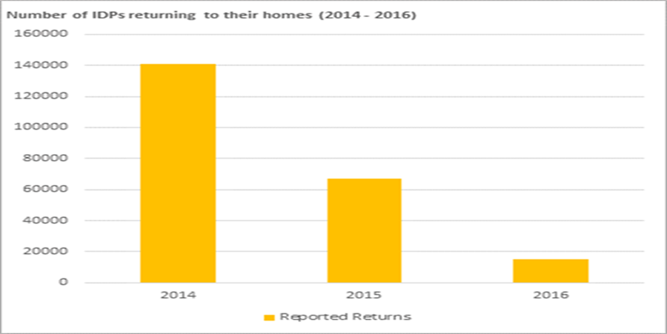

- First, insecurity is a major factor preventing displaced communities from returning to their villages of origin. In some instances, violence, including killings, sexual violence and abduction, was reportedly perpetrated by pro-Government armed militia to forcefully evict IDPs from their land, to which they had returned. This is the main preoccupation of IDPs, as consistently conveyed to UNAMID. However, the Government has not taken any measures to ensure the security of IDPs while encouraging returns.
- Second, Darfur remains affected by land occupation by pro-government armed militia as well as communities affiliated with the Government, which is another factor preventing / discouraging return. In 2015, UNAMID documented cases in West and North Darfur States where Arab communities presented documents to IDPs and demanded that they forfeit ownership of their land. During routine interaction with UNAMID monitors, IDPs regularly expressed concern over the occupation of their villages and farmlands by pro-Government armed militia, which has negatively impacted their right to food security and prospects for return.
- In July 2016, UNAMID completed a mapping of model villages to assess the level of preparedness and suitability for a durable return and reintegration programme. The mapping shows that, in the completed model villages in North, East, West and Central Darfur States, some critical infrastructure in the form of schools, hospitals, police stations and other State institutions have been developed. However, model villages surveyed by UNAMID remain largely empty, with little evidence of the presence of returnees. For example, in Rongatas, Central Darfur, the model village only houses law enforcement institutions but there are no residents. A significant number of IDPs have resisted moving to model villages. UNAMID has gathered that the process has been slow, with only 150,000 out of 2.6 million IDPs registered for model villages by the end of 2015.
- There is therefore a need for a more effective, transparent and inclusive return and reintegration policy with clear provisions for the effective participation of IDPs in the planning and management of durable solutions, in accordance with the United Nations Guiding Principles on Internal Displacement.
- Institutional Responses, Challenges and Gaps
- Years of conflict and disruption of State institutions have obviously impacted the social and economic spheres in Darfur. This has especially aggravated the plight of vulnerable groups, such as IDPs, whose access to resources and ability to freely carry out livelihood activities have been limited. IDPs remained heavily dependent on the services and support from UNAMID and humanitarian agencies for their security, well-being and humanitarian needs. While such services are limited due to security and other challenges, they nonetheless offer critical lifelines for displaced communities. From January 2014 to December 2016, various institutional responses and interventions were undertaken by UNAMID, UNCT and State authorities to mitigate some of the challenges faced by IDPs.
- National Response
- The primary responsibility to protect civilians in Darfur, including IDPs, lies with the Government of the Sudan. Throughout the conflict, IDPs have been particularly vulnerable to human rights violations and abuses, but the thin presence of law enforcement and judicial institutions across Darfur has facilitated the perpetuation of such acts and led to impunity. From 2014 to 2015, the Government launched an initiative to address the capacity deficit in law enforcement institutions and the justice sector. In 2015, at least 30 prosecutors and judges were thus deployed to Darfur to improve access to justice, while the capacity of rural court judges was enhanced through tailored training on human rights and international humanitarian law, with the support and collaboration of UNDP and UNAMID. In 2015, two police stations were reopened in Saraf Omra and Tawilla, in North Darfur, following advocacy by UNAMID.
- On 4 January 2015, the Government effected constitutional amendments which granted authority to the President of the Republic of the Sudan to appoint Walis (Governors) in Darfur. Following national elections in 2015, President Bashir replaced four of the five Walis in Darfur in a presented drive to re-energize management structures and leadership at the State levels. Presidential directives were subsequently issued to the Walis to address the security concerns of civilians and take initiatives to tackle the root causes of displacement and inter-communal conflicts. Walis in North, South and West Darfur enacted executive decrees on various security measures, including banning of unlicensed vehicles and wearing masks in public. These measures were followed by President Bashir’s declaration of a three-month unilateral ceasefire, in September 2015, which was renewed in 2016 for a period of six months. Locally-driven initiatives were also launched, such as increased engagement by state governments with native administrations to address inter-communal disputes aimed at promoting peace and reconciliation.
- While much of the humanitarian delivery and support for the realization of economic and social rights have been led by UNCT, the Government’s intervention through its HAC, in collaboration with SRCS, alleviated some of the urgent needs of IDPs, notably the provision of food assistance. In February 2016, following reports of mass civilian displacement to Deribat, in South Darfur, HAC and SRCS undertook joint rapid needs assessment missions, followed by delivery of humanitarian assistance to displaced persons. In Central Darfur, HAC facilitated humanitarian assistance to displaced communities, while in El Daein, East Darfur, SRCS continued to provide essential support to South Sudanese refugees at the Khor Omer IDP camps.
- UNAMID Protection and Conflict Mitigation Responses
- UNAMID strategic priorities continued to inform the Mission’s responses and approaches to the humanitarian and human rights challenges faced by IDPs in Darfur. Through UNAMID monitoring work and early warning assessments, the Mission and UNCT continued to mobilize to enhance the physical protection of IDPs and improve delivery of humanitarian support to them. UNAMID military and police components intensified security patrols in and around IDP camps, including military escorts to farmlands for displaced farmers, especially women and girls. Community policing schemes involving the active participation of IDPs in security arrangements were introduced by UNAMID to help increase IDPs’ confidence and allow for the pursuit of livelihood activities. However, patrol and escorts have been subjected to restrictions from Government authorities and armed opposition movements, which have hampered the full implementation of the UNAMID protection mandate.
- Engagement with local and Government authorities remained crucial to build the capacities of communities in contributing to effective early warning mechanisms to tackle threats of violence. Regular meetings and advocacy with judicial authorities and accountability mechanisms, including the Special Court for Crimes in Darfur and the National Commission for Human Rights, continued to be held on human rights concerns and processes to improve security, promote accountability and ensure gender-sensitive reparations. Following patterns of attacks against IDPs in North Darfur in 2015 by pro-Government armed militia, UNAMID advocacy with Government authorities led to increased deployment of law enforcement and judicial authorities as of June 2015, especially in Kutum, Tawilla and Saraf Omra localities.
- UNAMID also contributed to the improvement of the social and economic livelihood conditions for civilians and displaced communities. During the period under review, UNAMID implemented 61 quick impact projects (QIPs) amounting to US$2 million. The QIPs targeted the health, education and services sectors, and also included the construction of water boreholes, secondary schools and vocational centres, which catered for the critical needs of displaced communities. Government institutions such as the police, prison and judiciary also benefitted from QIPs with the primary objective of mitigating their operational challenges.
- UNAMID pursued human rights mainstreaming and capacity building activities to promote human rights awareness and access to justice, particularly for IDPs, who remain on the margins of formal justice institutions and processes. In July 2015, UNAMID, in collaboration with the Sudan’s National Commission for Human Rights and the Programme on Women’s Economic, Social and Cultural Rights, conducted a workshop on engaging stakeholders on the monitoring of and reporting on economic, social and cultural rights. These training activities brought protection concerns of IDPs and their economic, social and cultural rights to the forefront of national and international engagements.
- Interventions and responses by United Nations Country Team
- UNAMID mandate continued to be progressively linked with the work of the UNCT. Joint initiatives between the UNCT and UNAMID continued to be undertaken in areas such as protection, access to justice, livelihood and food security, as well as delivery of humanitarian assistance for displaced communities and other civilians in need. Other areas of collaboration included the creation of a Joint Working Group on Mitigating Inter-communal Conflicts as part of the Integrated Strategic Framework (ISF), which became operational in March 2015.
- Given the scale of challenges faced by IDPs and the need for concerted engagement in addressing them, UNAMID and UNDP continued to collaborate on various initiatives, including coordination of programmes under the Darfur Community Peace and Stability Fund (DCPSF). Joint programming on rule of law and access to justice as well as technical support to the transitional justice mechanisms in Darfur have helped in highlighting key human rights concerns of displaced persons and underscored the value of constructive engagement with the Government of the Sudan on major protection issues in Darfur. Since 2013, a total of 21 police stations in return or displacement areas were built or rehabilitated with the support of the United Nations High Commissioner for Refugees (UNHCR). UNAMID continued to intensify its collaboration with the UNCT to maximize collective impact on the protection of displaced communities and to minimize risks of conflict and violent threats to civilians.
- Interventions by the UNCT have been critical in the provision of humanitarian support and improved livelihoods, through enhancement of skills, promotion of gender equality and local ownership of development initiatives, with financial support from international partners. The specialized skill sets, capacities and access to targeted funding pools have been optimized by the UNCT to promote programmatic interventions in ameliorating economic, social and humanitarian conditions of displaced communities. Programmes and projects implemented by OCHA, WFP, and the Food and Agricultural Organization (FAO) continued to be critical in expanding access to humanitarian assistance and facilitating locally-driven improvements to land tenure rights and land use management in Darfur.
- From January to October 2014, FAO implemented a project under DCPSF that enabled displaced farmers and herding communities to undertake livelihood activities with corresponding economic and social benefits. In collaboration with UNAMID and Government institutions, FAO launched crop and livestock protection peace initiatives to promote common understanding between local farming and herding communities. Conflict resolution mechanisms and peace committees were created to provide platforms for dialogue regarding disputes over access to farming areas and grazing rights of livestock. During the project’s lifespan, 15 disputes over access to and use of natural resources were resolved.
- With coordination from OCHA and logistical support from UNAMID and other entities, the most significant delivery of foodto the 62,000 civilians in Sortoni was made on 5 March 2016. This delivery was particularly important as humanitarian access had been repeatedly denied by the Government. Subsequent deliveries of medical supplies were made by OCHA in Tawilla, Sortoni and Kabkabiya between March and May 2016. Following reports of about 675 unaccompanied and/or separated children (UASC) in Sortoni, UNICEF deployed a team of child protection experts, in addition to a community-based child protection network. By the end of March 2016, 346 children were reunited, while 329 children were placed in alternative care. Moreover, in 2016, UNHCR provided 57,600 newly displaced persons (totaling 11,520 households) from Jebel Mara with emergency shelter and non-food items in Tawilla, Sortoni, Kabkabiya and Dar el Salam, North Darfur. Humanitarian agencies also provided support to women centres in Tawilla and Sortoni.
- Access restrictions imposed both by the Government of the Sudan and armed opposition movements have significantly hampered the international community’s responses to human rights concerns and humanitarian needs of IDPs. In addition, delays in granting access for critical humanitarian needs assessments by the UNCT and international NGOs have aggravated the conditions of civilians. Access restrictions imposed by the Government of the Sudan negatively impacted UNAMID support to UNCT operations, including the provision of military escorts for the delivery of humanitarian assistance. In this regard, UNAMID was unable to facilitate 133 of 542 access requests between January 2014 and July 2015, including 42 of 259 escort requests for food convoys; 71 of 244 requests for escorts in respect of programme delivery, monitoring field visits and logistics support; and 20 of 39 requests for inter-agency humanitarian needs assessment missions. Yet, in a positive development, revised guidelines providing for “Directives and Procedures for Humanitarian Action” were endorsed and released by HAC on 15 December 2016. The document reflects recommendations made by the Humanitarian Country Team in order to simplify procedures for travel authorization and facilitate humanitarian access, including for humanitarian protection partners.
- Conclusion
- Civilians in Darfur, including IDPs, continued to bear the brunt of the violence and instability, largely due to the inadequacies in national protection mechanisms. The human rights situation of IDPs remains a major concern. During the period under review, UNAMID documented attacks against civilians, abductions and sexual and gender-based violence. In addition, challenges in access to justice due to the limited presence or absence and weaknesses of law enforcement and judicial institutions have encouraged perpetrators to act with impunity. Displaced persons continue to express concerns about the lack of meaningful efforts by State authorities to address insecurity as well as human rights violations and abuses and serious violations of international humanitarian law.
- In the aftermath of attacks and other security threats from Government forces, civilians continued to seek shelter in IDP camps where they hoped to find protection against further violence. Their journeys in search of safety have been characterized by risks and threats of violence, with the Rapid Support Forces and pro-government armed militia often identified as alleged perpetrators of human rights violations and abuses, according to witness accounts documented by UNAMID. In addition, security conditions in many areas of displacement, including IDP camps and settlements, remained precarious, with risks of sexual and gender based violence, arbitrary arrest, extortion and looting from security forces, the Rapid Support Forces or other armed militias. The movement of IDPs in many areas has been severely limited as a result of insecurity, thereby curtailing their ability to access essential utilities and services and to recover their sources of livelihoods.
- The scale of displacements from 2014 to 2016 illustrates both the impact of the military campaign which took place during this period and the continued suffering of IDPs as a major category of victims of the Darfur conflict. The prospect for return and reintegration of displaced persons continued to be hampered by insecurity conditions and lack of rule of law in areas of return. Moreover, land occupation and use are recurring issues in Darfur, especially for IDPs. Disputes over access to land lead to tensions and fuel inter-communal conflict. While the entire population of Darfur has been affected by the crisis, IDP farmers, by virtue of their marginalization and difficulties in accessing land in their areas of displacement, face challenges in engaging in livelihood activities. These challenges negatively impact their enjoyment of economic and social rights.
- The cessation of hostilities provides a window of opportunity to focus on the return of IDPs or their reintegration into host communities. The implementation of key elements of the DDPD, in accordance with international standards, will assist in the development of durable solutions.
- Recommendations
- To the Government of the Sudan:
- Uphold and extend the ceasefire;
- Grant human rights and humanitarian actors unfettered and unimpeded access to the conflict affected areas, including in order to contribute to the effective protection of civilians and facilitation of humanitarian assistance;
- Conduct the prompt and comprehensive disarmament of pro-Government armed militias and other groups with links to the Government, and hold them accountable for human rights abuses as well as for serious violations of international humanitarian law, in accordance with provisions of the DDPD;
- Hold to account elements of the security forces responsible for indiscriminate attacks against civilians and serious violations of human rights and international humanitarian law during the military campaign;
- Address systemic impunity by, among other things, increasing access to and strengthening judicial and other remedial institutions in Darfur, in particular for women and girls, and ensuring victims their right to an adequate, prompt and effective remedy, including gender-sensitive reparations and access to all services, especially health and psychosocial counselling;
- Design and implement a comprehensive protection programme for survivors of gender based violence and witnesses as well as strengthen national human rights institutions and transitional justice mechanisms;
- Revisit the policy on return and reintegration, in cooperation with UNAMID and the UNCT, and consult extensively with IDPs to ensure it is inclusive, transparent, human rights-based and sustainable;
- Ensure that all IDPs recover their property, in line with the provisions stipulated in DDPD and in the United Nations Principles on Housing and Property;
- Constitute regional land commissions to investigate and address the issue of occupation of land belonging to IDPs, and initiate legislative reform on the land tenure system;
- Undertake a comprehensive age and gender-sensitive assessment of health, sanitary and education needs in IDP camps, and address concerns to the fullest capabilities of Government resources;
- Consider ratifying the Optional Protocol to the International Covenant on Economic, Social and Cultural Rights and the Convention on the Elimination of All Forms of Discrimination against Women, as well as the African Union Convention for the Protection and Assistance of Internally Displaced Persons in Africa (Kampala Convention);
- To the Armed Opposition Movements:
- While armed opposition movements are not parties to international treaties, they nonetheless have obligations under international human rights and humanitarian law to respect and protect the rights of civilians, including internally displaced persons. To this end, UNAMID and OHCHR recommend the following:

- Abide by obligations under international human rights norms and standards, and humanitarian law, and refrain from attacks against civilians, non-combatants, and civilian objects, habitats and sources of livelihood;
- Allow all human rights and humanitarian actors full, unhindered and timely access to all areas under their control, and ensure that no obstacles are imposed on UNAMID and humanitarian missions;
- Take necessary measures to prevent further civilian displacement, and where it occurs, facilitate full access to human rights monitors and humanitarian agencies to those displaced;
- Participate in, and abide by the spirit and provisions of DDPD, and fully engage in other international mediation initiatives so as to bring lasting peace to Darfur.
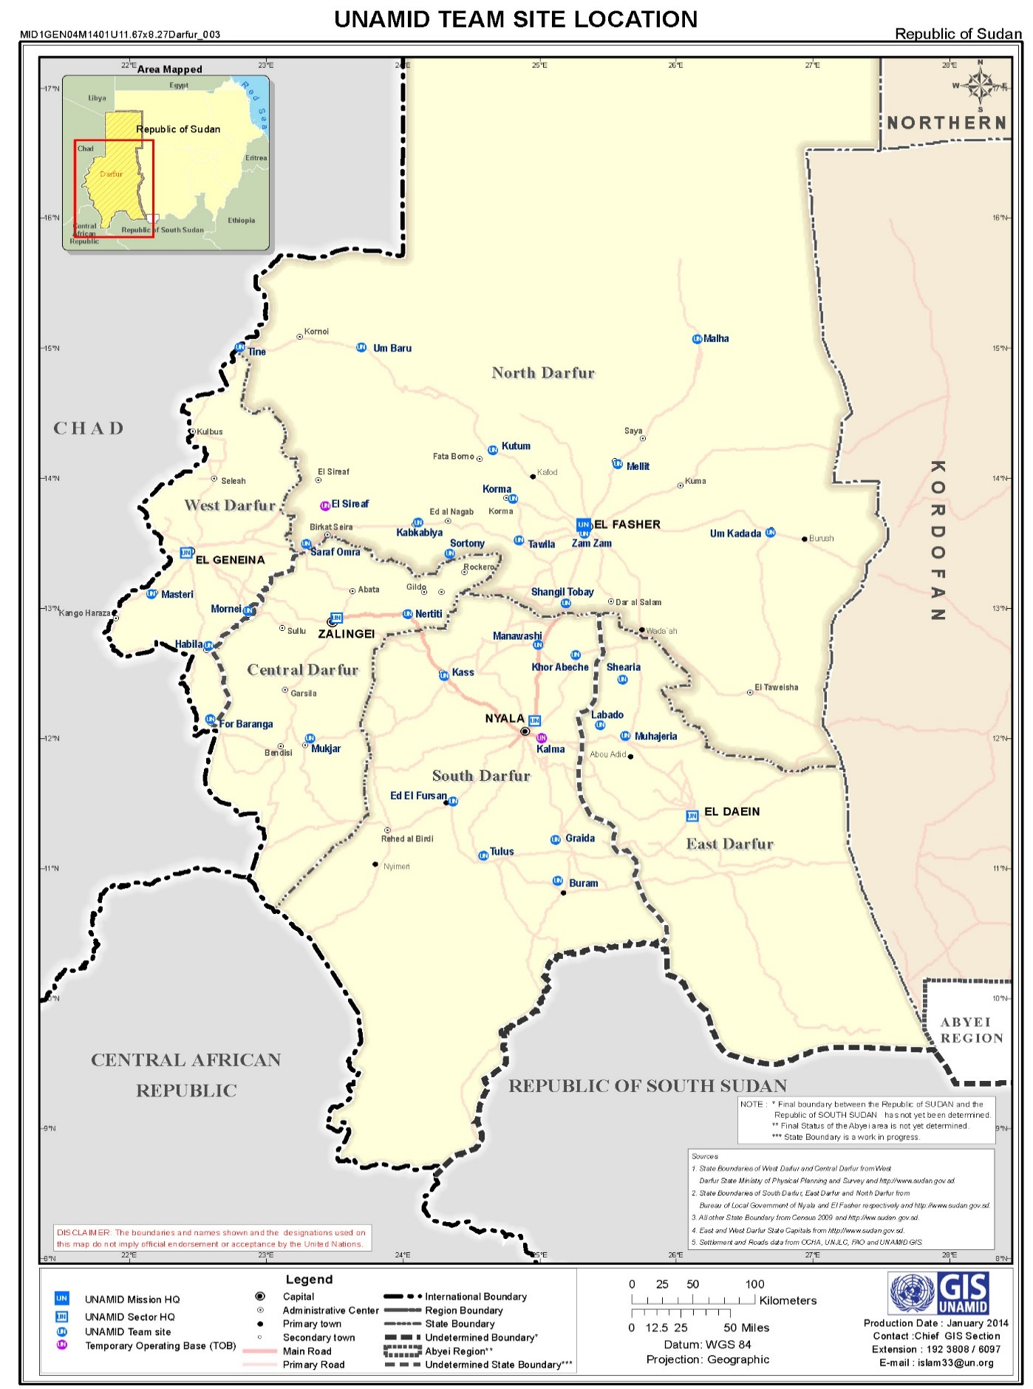

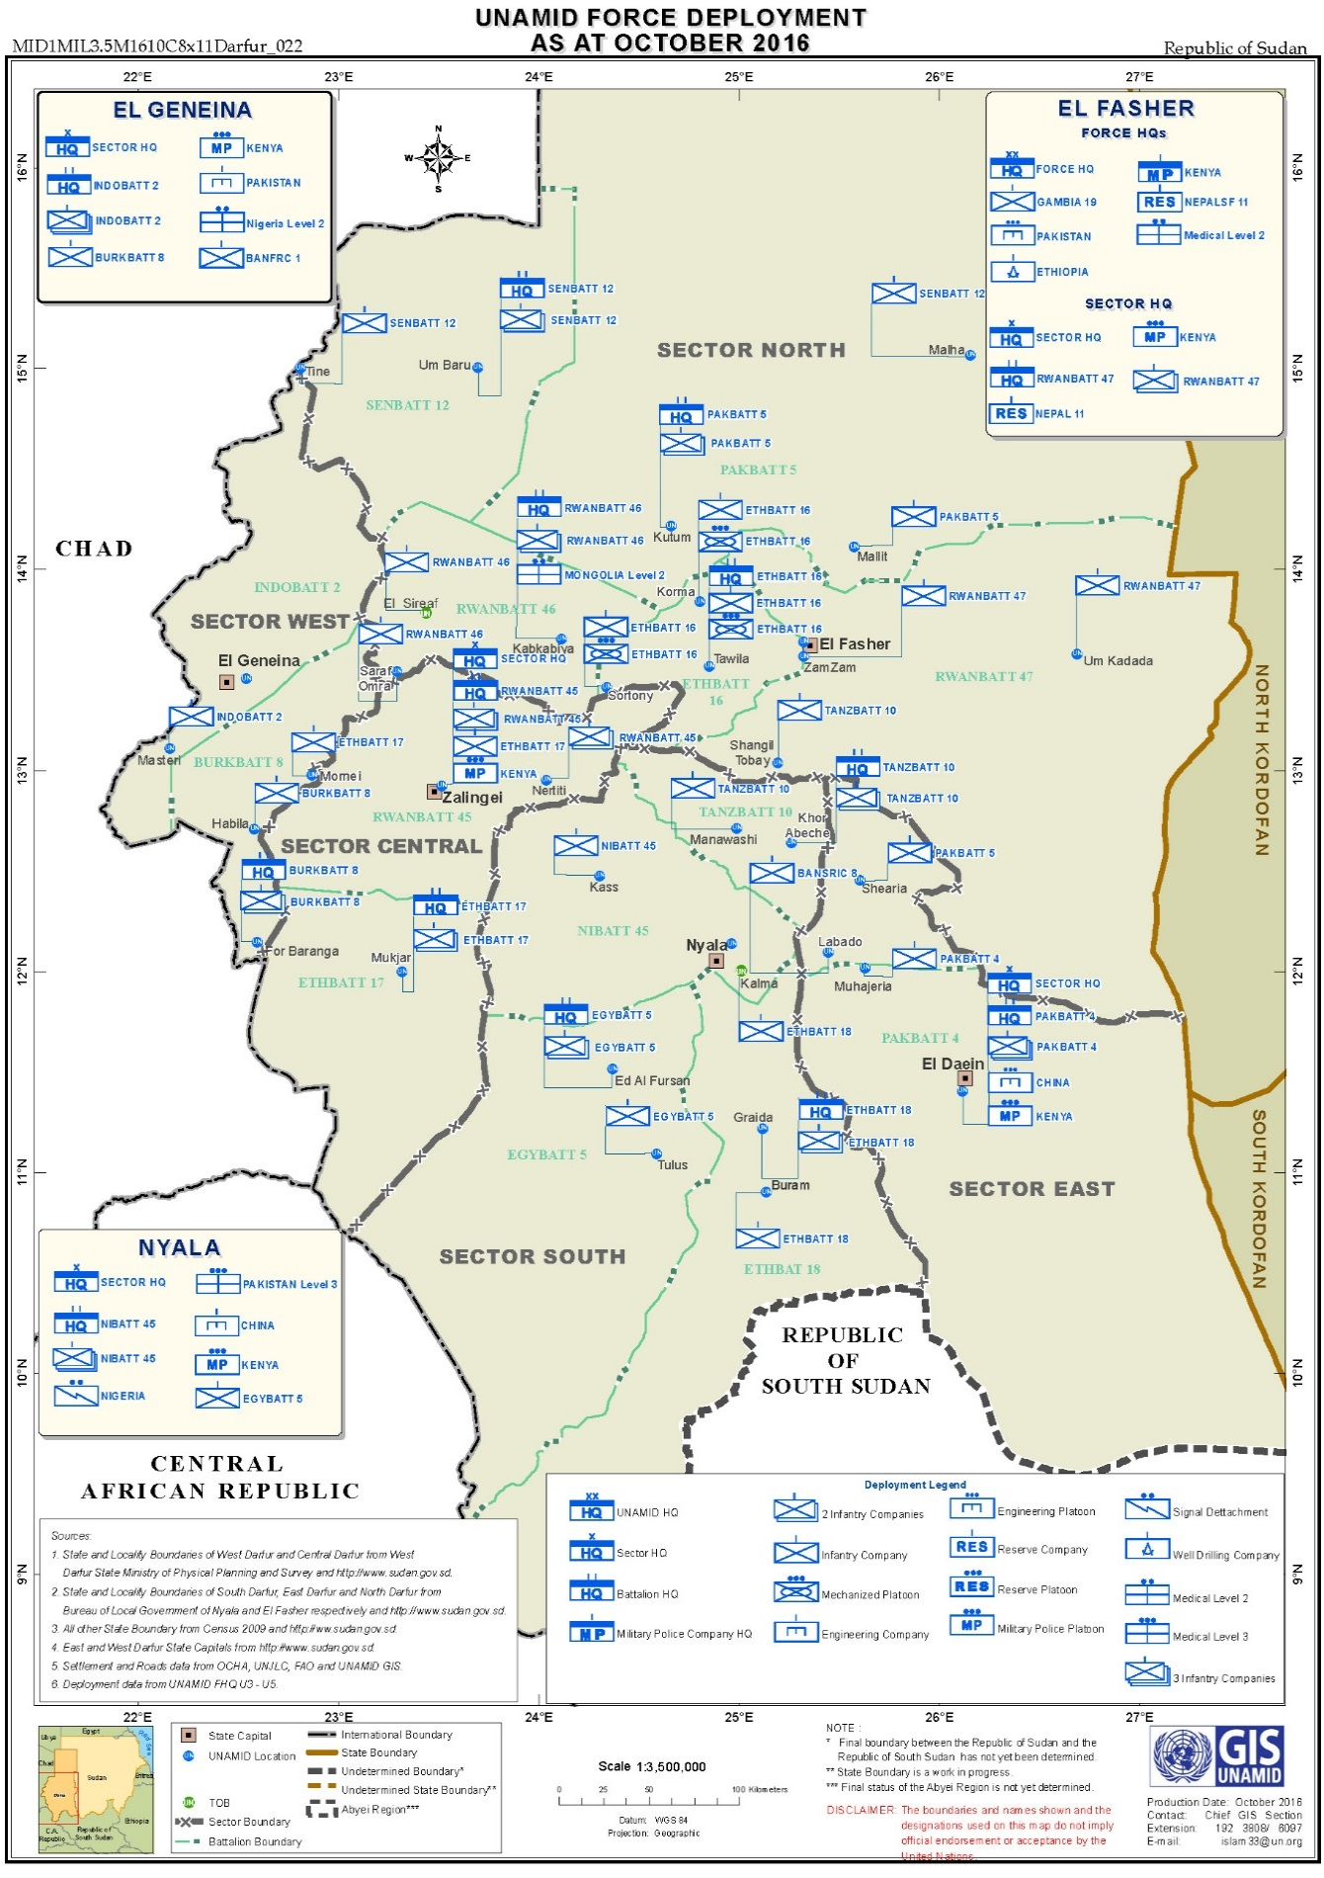
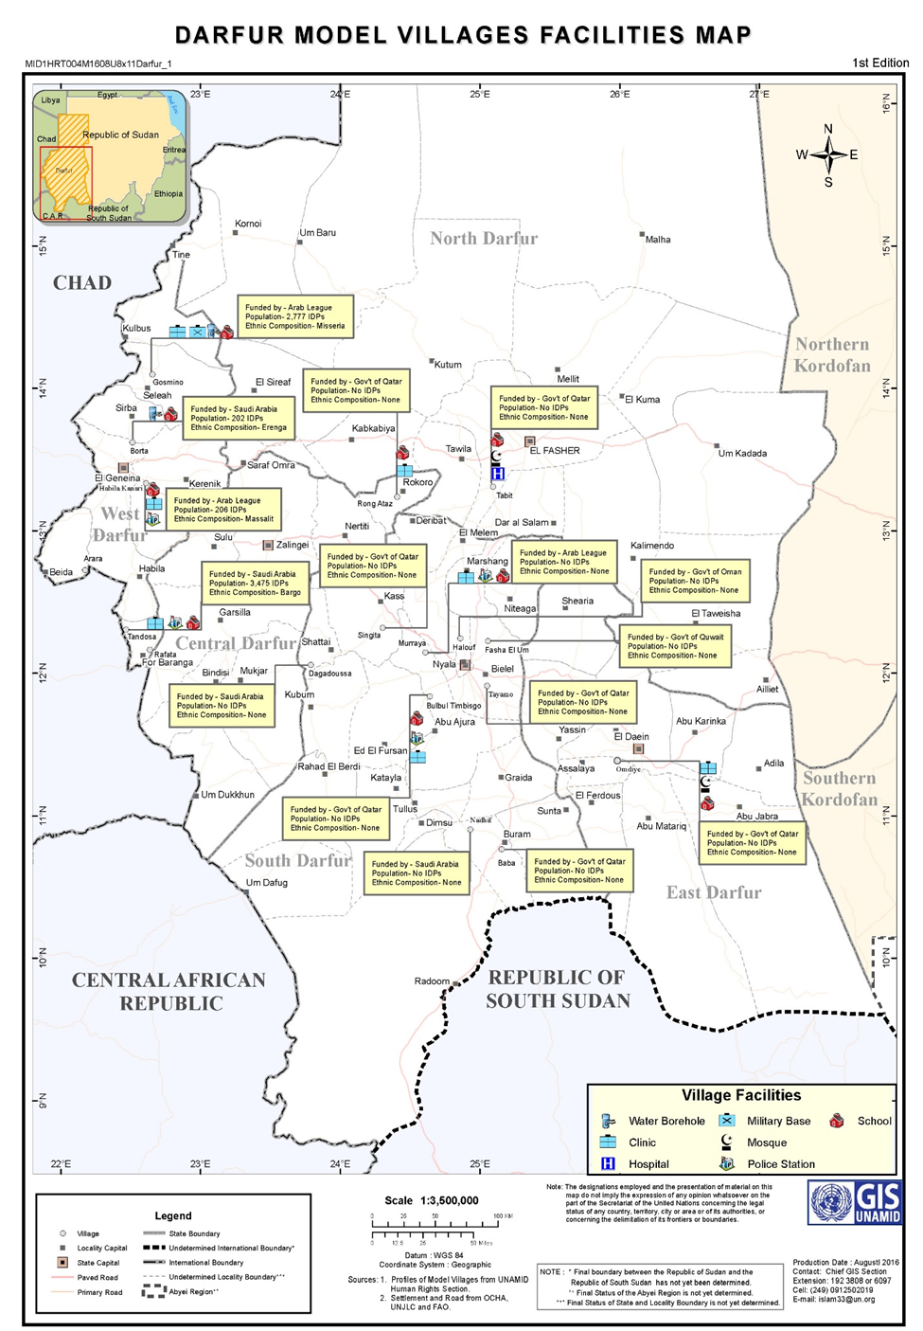

The terms “armed opposition movements” used in this report refer to the three main armed movements in Darfur, including the Sudan Liberation Army – Minni Minawi, the Sudan Liberation Army – Abdul Wahid, and the Justice and Equality Movement – Jibril Ibrahim. The report refers also to “armed groups” to designate other various armed groups and militias operating in Darfur.
Security Council resolution 2296, para. 23.
Security Council resolution 2296, para. 24.
OCHA, Darfur Humanitarian Overview, 1 January 2017., available at
Guiding Principles on Internal Displacement, E/CN.4/1998/53/Add.2, 11 February 1998. New York: United Nations.
Ibid, Principle 5.
The DDPD, also known as the Doha Agreement, was signed in July 2011 between the Government of the Sudan and the Liberation and Justice Movement. It seeks to address the root causes of the conflict and its consequences, including Power Sharing, Wealth Sharing, Human Rights, Justice and Reconciliation, Compensation and Return, and Internal Dialogue among others.
Guiding Principles on Internal Displacement, E/CN.4/1998/53/Add.2, 11 February 1998. New York: United Nations.
Guiding Principles on Internal Displacement, E/CN.4/1998/53/Add.2, 11 February 1998. New York: United Nations
See Rules 129-133 of Customary International Humanitarian Law: Volume I (ICRC, 2005). See also article 49 of the Fourth Geneva Convention and Article 17 of Additional Protocol II.
Republic of the Sudan, National Policy on Internally Displaced Persons, 2009.
The Jebel Marra corridor represents a stretch of mountainous area which runs through Central and North Darfur.
Located approximately 40 kilometres north-west of Manawashi and 45 kilometres northeast of Kass, in South Darfur, respectively.
Located 15 kilometres south-east of Golo town along the Jebel Marra corridor in Central Darfur.
Located 20 kilometres north-east of Golo in Central Darfur.
United Nations Principles and Guidelines on Access to Legal Aid in Criminal Justice Systems encourage Member States to consider, where appropriate, the provision of legal aid and to provide such aid to the maximum extent possible. (A/69/187)
Sudan’s Armed Forces Act 2007, which provides for penalties for serious violations of human rights and international humanitarian law, embodied an encouraging development to confront impunity. However, the Act is characterized by weaknesses which are cause for concern with implication on access to justice and victims’ right to remedy. Under the Act, military personnel are granted amnesty for offences committed in the course of their duties including prosecution by military or civilian courts unless immunity is waived by the president of the Sudan.
UNDP, Human Development Report 2016: the Sudan, available at http://hdr.undp.org/sites/default/files/2016_human_development_report.pdf.
United Nations Development Program, Human Development Reports: Gender Equality Index, available at http://hdr.undp.org/en/composite/GII.
See Global Food Security Cluster, available at http://fscluster.org/sudan/overview.
See OCHA: Humanitarian Needs Overview for the Sudan 2016, available at
OCHA, ibid
OCHA, ibid
OCHA Humanitarian Bulletin, the Sudan, Issue 46, 7-13 November 2016
Committee on Economic, Social and Cultural Rights: Concluding observations on the second periodic report of the Sudan, 27 October 2015. E/C.12/SDN/CO/2
Ibid, para. 22.
Average of 650 Sudanese pounds (US$43.00) annually
OCHA, Humanitarian Needs Overview 2016: Sudan
OCHA, ibid
Committee on Economic, Social and Cultural Rights: Concluding observations on the second periodic report of the Sudan, 27 October 2015. E/C.12/SDN/CO/2. Para 50
Representatives from UNAMID, UNCT and international partners constituted the Darfur Joint Assessment Mission
IASC framework on durable solutions for internally displaced persons, April 2010
The Sudan National Human Rights Commission (SNHRC) is a mechanism with relevance to access to justice in Darfur. It was established by presidential decree in January 2012, pursuant to Article 142 of Sudan’s Constitution. Its mandate includes receiving and examining individual complaints, advising State organs to address human rights issues, and raising public awareness about human rights issues.
See United Nations United Nations Principles on Housing and Property Restitution for Refugees and Displaced Persons

