|  |  |  |  |
| --- | --- | --- | --- |
|  |  | A/HRC/36/33 | |
|  | **Advance edited version** | | Distr.: General  13 September 2017  Original: English |

**Human Rights Council**

**Thirty-sixth session**

11-29 September 2017

Agenda items 2 and 10

**Annual report of the United Nations High Commissioner**

**for Human Rights and reports of the Office of the**

**High Commissioner and the Secretary-General**

**Technical assistance and capacity-building**

Situation of human rights in Yemen, including violations and abuses since September 2014

Report of the United Nations High Commissioner for  
Human Rights[1]*, [2]**

|  |
| --- |
| *Summary* |
| In the present report, submitted pursuant to Human Rights Council resolution 33/16, the United Nations High Commissioner for Human Rights provides an overview of the human rights situation in Yemen from 1 September 2014 to 30 June 2017 and describes new allegations of violations of international human rights law and international humanitarian law that reportedly occurred between 1 July 2016 and 30 June 2017, emphasizing the ongoing nature of many of those violations. The High Commissioner also provides an update on cooperation between the Yemen National Commission to Investigate Alleged Violations to Human Rights and the Office of the United Nations High Commissioner for Human Rights. He calls upon all stakeholders to implement the recommendations already made in previous reports. |
|  |

Contents

*Page*

I. Introduction 3

II. Methodology 3

III. Legal framework 3

IV. Context 4

V. National Commission 4

VI. Human rights situation 5

A. Conduct of hostilities 6

B. Arbitrary or illegal detention and violations of due process 13

C. Violations of freedom of expression 14

D. Violations of freedom of religion 14

E. Sexual and gender-based violence 14

F. Violations of economic and social rights 15

VII. Accountability 15

VIII. Conclusions and recommendations 16

Annexes

I. Additional information on the situation in Yemen 17

II. Photographs 21

III. Infographics 23

I. Introduction

1. The present report, submitted pursuant to Human Rights Council resolution 33/16, covers the period from 1 September 2014 to 30 June 2017.

2. In its resolution 33/16, the Council requested the United Nations High Commissioner for Human Rights to provide technical assistance and advice to the Yemen National Commission to Investigate Alleged Violations to Human Rights to enable it to fulfil its mandate in line with international standards and finalize its comprehensive report on its investigations; and to allocate additional international human rights experts to the Office of the United Nations High Commissioner for Human Rights (OHCHR) in Yemen to complement the investigatory work of the National Commission.

3. In the same resolution, the Council requested the High Commissioner to present to it, at its thirty-sixth session, a written report on the situation of human rights, including violations and abuses since September 2014, and on the implementation of technical assistance.

4. The present report examines the human rights situation in Yemen and provides an overview of recurring violations and abuses documented since September 2014. It describes new allegations of violations of international human rights law and international humanitarian law that reportedly occurred in the past year, between 1 July 2016 and 30 June 2017, and provides an update on cooperation between the National Commission and OHCHR, including in relation to technical assistance provided by the Office. It should be read in conjunction with the High Commissioner’s previous reports on the situation of human rights in Yemen.[3]

II. Methodology

5. The information contained in the report is based primarily on human rights monitoring conducted by OHCHR in Yemen, including interviews with survivors, witnesses, family members of victims and other relevant sources, site visits and meetings with authorities. The report also reflects credible information gathered from other United Nations entities and non-governmental organizations (NGOs), and indicates whether OHCHR was able to corroborate such information.

6. OHCHR employs a “reasonable grounds” standard in its assessment of incidents investigated and considers the credibility and reliability of the sources, taking into account their nature and objectivity. It draws conclusions in its assessment of incidents investigated only when this standard is met.

7. In the past year, the ability of OHCHR to monitor and report on violations was limited by numerous constraints, namely security restrictions, delays in the issuance of visas and inhibitive operational costs.

III. Legal framework

8. International human rights law and international humanitarian law are applicable in Yemen. The High Commissioner’s 2016 report on the situation of human rights in Yemen contains an outline of the applicable legal framework and the obligations of the various duty bearers,[4] namely the Government of Yemen, the States members of the coalition[5] forces and the de facto authorities in Sana’a.

IV. Context

9. The present report covers the period from September 2014 to June 2017, and focuses primarily on the conflict between the forces supporting President Abd Rabbo Mansour Hadi, including the coalition forces (together, “pro-Government forces”), and the Popular Committees affiliated with the Houthis and the army units loyal to the former President, Ali Abdullah Saleh (“Houthi/Saleh forces”).

10. From July 2016 through June 2017, almost 8,700 conflict-related incidents, including airstrikes, armed clashes, shelling and detonation of explosives, were reported throughout Yemen.[6] From January 2017, hostilities escalated with the launch of a campaign by the coalition forces that targeted the west coast. The average number of airstrikes per month in the Al-Hudaydah and Taizz governorates during the first three months of 2017 was almost double the average for the previous six months.[7] In that context, the pro-Government forces commenced operations against the southwestern port town of Al-Mukha, which they took in February, and thereafter pushed northwards along the coast. Since then, the coalition forces have signalled that they may commence operations on Al-Hudaydah. The High Commissioner has warned of the likely devastating consequences of such operations on both the city’s civilian population and the country’s largest port.[8] The city of Taizz remains a heavily contested area, as it has for the past two years.

11. Other armed actors continued to take advantage of the prevailing insecurity in Yemen. In the past year, extremist groups sustained and adapted their presences. For example, after being driven out of Al-Mukalla in Hadramaut Governorate in April 2016, Al-Qaida is now operational in Taizz city.

12. None of the attempts at humanitarian pauses and ceasefires over the years have held. Peace talks held in June and December 2015, in Switzerland, and from April to July 2016, in Kuwait, were unsuccessful. Although talks have not resumed, the Special Envoy of the Secretary-General for Yemen continues to pursue potential avenues for peace.

13. The humanitarian situation in Yemen continued to deteriorate. According to the United Nations Office for the Coordination of Humanitarian Affairs, as of June 2017, out of a population of 27.4 million, 18.8 million were in need of humanitarian assistance, including 10.3 million in acute need. There have been more than 500,000 suspected cases of cholera since April 2017 and 7.3 million people were on the brink of famine. More than 3 million people have been forced to flee their homes since the conflict began.[9] This catastrophe is entirely man-made.

V. National Commission

14. The mandate of the National Commission was extended for another year in presidential decree No. 97 of 24 August 2016. Pursuant to Human Rights Council resolution 33/16, OHCHR deployed five additional staff members to Sana’a, Yemen, Amman, Jordan, and Geneva, Switzerland, from April 2017 to provide the National Commission with technical assistance and advice, and to complement its investigatory work. Owing to security constraints, no OHCHR staff could be based in Aden, where the Commission sits.

15. In consultation with OHCHR, the National Commission identified a number of priority areas for technical assistance. OHCHR conducted a variety of activities, including a workshop with members of the Commission on 21 and 22 February 2017 in Doha, Qatar, at which it presented regional best practices for commissions of inquiry; a working visit to the National Commission headquarters in Aden from 23 to 25 May 2017 to provide technical expertise on the development of databases, including on information management, protection protocols and archiving; training for staff of the Commission on 7 and 8 July 2017 in Amman, Jordan, on international humanitarian law, interviewing techniques, gender and databases. Future activities envisaged include more specialized targeted training workshops. However, those activities are limited by security and logistical constraints. For example, owing to operational constraints — airport closures, abrupt cancellation of flights and restrictions on United Nations travel owing to the deteriorating security situation — the location and dates of the training provided had to be adjusted repeatedly.

16. Additional factors, including political constraints, detrimentally affected the work of the National Commission. The de facto authorities are unwilling to cooperate with and provide access to the Commission, which comprises members appointed by the other party to the conflict, namely the Government of Yemen. The perceived partiality of the Commission and its limited access prevented it from executing its mandate comprehensively. Despite those challenges, the Commission did noteworthy work over the past year and issued a preliminary report covering events from August 2015 to 30 July 2016 and two interim reports covering 31 July 2016 to 31 January 2017 and September 2016 to June 2017. The Commission produced five monthly reports in 2016, which are available on its Arabic website. Of the more than 17,000 human rights violations reportedly documented, the Commission noted the completion of investigations into more than 10,000. In addition to its perceived partiality, the Commission appears to be lacking an instrument or a mandate that would enable it to channel its findings into a credible accountability mechanism. The complete absence of such a process will serve to further consolidate the climate of impunity in Yemen.

VI. Human rights situation

17. The population of Yemen continued to suffer the impact of armed conflict and violence along with other serious human rights violations and abuses. Airstrikes and shelling repeatedly struck areas populated by civilians. People faced continuing hardships owing to limited or no access to food and other basic goods, health care and education — circumstances caused by the parties to the conflict who had besieged cities, blockaded seaports and closed airports. Forced displacement and restrictions on movement, exacerbated by the presence of snipers or landmines, directly affected civilians, causing deaths, injuries, destruction of property, loss of livelihoods and prevention of access to essential services. Civilians who spoke out or otherwise opposed the parties to the conflict were subjected to harassment, intimidation, detention and, on occasion, torture and killing. Women, children, religious and social minorities, refugees, and internally displaced persons were disproportionately affected.

18. In the past year, conflict along the west coast of Yemen raised serious human rights concerns. During intense clashes in Al-Mukha over two weeks in late January and early February 2017, civilians were caught between the conflicting instructions of warring parties. Houthi/Saleh forces instructed civilians not to leave their homes while pro-Government forces demanded that they evacuate. OHCHR verified incidents of Houthi/Saleh snipers shooting at civilians trying to flee, which may indicate an attempt to use civilians as human shields, in violation of international humanitarian law.[10] OHCHR verified that at least 32 civilians were killed or injured over the two weeks of fighting, and more than 200 homes were damaged or destroyed.

19. Since February 2017, tension has risen in anticipation of similar armed operations against Al-Hudaydah. According to information gathered by OHCHR, airstrikes and attacks on boats at sea off the shores of Al-Hudaydah caused at least 98 civilian casualties (52 killed and 46 injured) over three weeks in March and April 2017. There are fears that a full-scale operation on Al-Hudaydah may lead to significant civilian casualties and increased displacement, while likely rendering the port inoperative, further limiting access to food, medicines, fuel and other supplies. The impact would be felt far beyond Al-Hudaydah, as most of the country is supplied by goods shipped through the port.

A. Conduct of hostilities

20. Since OHCHR began civilian casualty monitoring in March 2015, the Office has verified at least 13,520 civilian casualties, with 4,980 killed and 8,540 injured, in more than 1,000 incidents through June 2017.[11] Data collected by OHCHR showed that the most conflict-affected governorates were Aden, Al-Hudaydah, Sana’a and Taizz. Given the strict verification methodology applied by OHCHR and access constraints, the actual total of casualties is likely to be higher.

21. Some of the incidents involving the various parties to the conflict may amount to violations of international humanitarian law. In many cases, information obtained by OHCHR suggested that civilians might have been directly targeted, or that operations had been conducted heedless of their impact on civilians and without regard to the principles of distinction, proportionality and precautions in attack. In some cases, information suggested that no actions had been taken to mitigate the impact of operations on civilians. According to the Office’s findings, at no time were civilians given effective advance warning of the commencement of operations so as to have the opportunity to leave areas of operations safely, and their access to life-saving or life-sustaining humanitarian assistance was severely limited or, in some instances, prevented.

Shelling

22. Houthi/Saleh forces primarily relied on shelling in the conduct of their operations. Given their wide-area effects, the use of such weapons is frequently indiscriminate. OHCHR documented the recurrent use of shelling in densely populated civilian areas, such as residential neighbourhoods and markets, which had caused hundreds of civilian casualties and vast destruction to civilian objects.[12] Since July 2016, OHCHR documented that shelling by Houthi/Saleh forces had killed at least 178 civilians and injured 420. The city of Taizz has been particularly affected.

Shelling of Taizz

23. Throughout the conflict, the city of Taizz witnessed consistent shelling carried out by both sides of the conflict, intensifying at times, such as in January and May 2017. Due to denial of access to areas controlled by Houthi/Saleh forces in Taizz, OHCHR has rarely been able to verify incidents of shelling attributed to pro-government forces. The following are examples of shelling incidents verified by OHCHR that caused high numbers of civilian casualties.[13]

24. On 3 October 2016, in Beer Basha area, Al-Mudhaffar district, Taizz Governorate, a mortar shell struck a house, killing 10 civilians, including 6 children, and injuring 17 civilians, including 6 children and 3 women. The attack occurred in the vicinity of a public market at the busiest time of day. According to witnesses, the mortar shell was launched from an area under the control of Houthi/Saleh forces, while the market area was controlled by pro-Government forces.

25. On 18 January 2017, in Al-Noor area, Al-Mudhaffar district, Taizz Governorate, mortar shells fell among houses. About 15 minutes later, as residents gathered to assess the damage, another mortar shell struck the same area, killing nine civilians, including three children, and injuring nine civilians, including four children. Witnesses told OHCHR that the shells had been launched from an area controlled by Houthi/Saleh forces.

26. From 21 May to 6 June 2017, continuous shelling between forces in Taizz city impacted civilian residential areas, resulting in the killing of at least 26 civilians, including 4 children and 3 women, and injuring at least 61 civilians, including 29 children and 9 women. Based on witness testimonies and the locations of the impact, OHCHR attributed 19 killed and 59 injured to Houthi/Saleh forces and the remaining casualties to pro-Government forces. The shelling also damaged at least nine homes.

27. The shelling of Taizz has been unrelenting, even after the impact of those attacks on civilians and civilian objects had become apparent to the parties involved. The use of such tactics appeared to be in violation of the prohibition of indiscriminate attacks and of the obligation to take all feasible precautions to protect civilians and civilian objects.

Airstrikes

28. Coalition airstrikes continued to be the leading cause of civilian casualties in the conflict, killing at least 933 civilians and injuring 1,423, since July 2016.[14] As in past years, OHCHR continued to document airstrikes against targets that appeared to be of a civilian nature.[15] In addition to markets, residential areas and public and private infrastructure, the past year witnessed notable airstrikes against funeral gatherings and small civilian boats. Such incidents were widespread and continued to take place, once again, even after the impact of the attacks on civilians had become apparent. Directly targeting civilians and civilian objects or conducting disproportionate or indiscriminate attacks and the failure to take all necessary precautions to avoid and, in any event, minimize, the impact on civilians during air operations targeting military objectives, constitute serious violations of international humanitarian law.

Al-Kubra Hall

29. The most deadly incident of the conflict thus far occurred on 8 October 2016, when coalition airstrikes targeted the Al-Kubra Hall in Sana’a during the funeral of the father of a senior official, killing at least 132 civilians and injuring 695, including 24 boys. At the time of the attack, the hall — the largest such facility in Sana’a, with the capacity of holding more than 1,000 people — was full of mourners attending the funeral. Those present included military leaders affiliated with the Houthis and former President Saleh, but the majority were civilians.

30. OHCHR visited the site the same day and was told by survivors that they had heard aircraft hovering above the hall around 3.30 p.m. immediately prior to the two missiles that struck the hall only minutes apart. Many individuals fleeing the first strike had not yet exited the building when the second strike hit. The short interval between the strikes meant that those assisting victims of the first strike were hit by the second.

31. The points of impact of the two strikes were 15 to 20 metres apart.[16] Based on information available to OHCHR, the remnants of the munitions used revealed that they had been fitted with precision guidance units, indicating that the targeting of the hall had been deliberate. Based on the circumstances, including the prior announcement and public nature of the funeral, as well as the timing of the strike, coalition forces should have been aware of the high risk of civilian casualties inherent in carrying out such a strike. Despite initial denials of responsibility by the coalition forces, a subsequent investigation of the incident by the coalition’s Joint Incident Assessment Team (JIAT)[17] found that coalition aircraft had conducted the strike and that it had resulted in “several” casualties.[18] According to JIAT, the targeting was based on faulty intelligence provided by a party affiliated with the Government of Yemen, and the airstrike was conducted without proper approval or in non-compliance with coalition procedures.

32. OHCHR verified two other airstrike incidents against funeral gatherings in the past year.[19]

Attack on a boat carrying Somali migrants and refugees

33. As a result of military operations along the west coast of Yemen, the waters off Al-Hudaydah had become dangerous, with many boats coming under fire. OHCHR verified six incidents of attacks on fishermen in early 2017, three of which occurred on 15 and 16 March 2017.[20]

34. The most devastating attack was against a boat carrying 146 Somali migrants and refugees, along with 4 Yemeni crew members. Survivors told OHCHR that, on 15 March 2017, they saw ships and a helicopter near their boat. The following night, a ship fired on their boat and minutes later, a helicopter circled over the boat and opened fire. The survivors reported that they screamed, waved and shone flashlights in an effort to signal they were civilians, however, the shooting continued. Once the attack had ended and the helicopter had departed, the crew turned off the lights and the boat drifted to shore.[21] Forty-two civilians were killed, including 11 women, and 34 were injured, including 8 children.

35. Emirati State media reported that an official of the United Arab Emirates, a member of the coalition, had acknowledged that its forces had spotted the boat and, as it had been identified as a civilian vessel, had refrained from firing on it.[22] In an unprecedented move, the official welcomed an independent international investigation into the incident and denied that Emirati forces had been involved in the attack.[23] The Coalition also reportedly denied responsibility for the incident.[24] As of 31 July 2017, there had been no acknowledgement of responsibility for the attack, nor any explanation as to why the vessel, along with other civilian boats, had been attacked.

Restricted weapons

36. Owing to the ongoing armed conflict, a variety of explosives litter the landscape of Yemen, including anti-personnel and anti-vehicle landmines, improvised explosive devices, unexploded ordnance and cluster munitions. All of those explosives pose a danger to civilians, causing casualties and hindering the safe return of displaced populations. The legality of those weapons varies[25] but the use of anti-personnel landmines, victim-activated improvised explosive devices and cluster munitions may violate international humanitarian law, particularly in the absence of precautionary measures owing to their inherently indiscriminate nature.[26]

37. No comprehensive statistics are available on civilian casualties caused by those weapons, but credible reports from demining experts, medical professionals and local residents indicate that the danger is widespread and continuing. According to the United Nations Development Programme, deminers had cleared nearly 450,000 explosive remnants of war between February 2016 and June 2017, including thousands of anti-personnel mines and cluster munitions.[27] The vast majority of mines and explosive devices were reported in areas currently or previously controlled by Houthi/Saleh forces. Residents regularly told OHCHR that their areas had not been mined prior to the arrival of those forces. OHCHR had no evidence of any precautionary measures being taken, such as warnings or symbols, to indicate the presence of mines or explosive devices. Owing to access and capacity constraints, OHCHR was only able to verify a few cases of civilian casualties from such explosives, which had been sustained mostly by people going about their daily activities.[28]

38. As reported to the Human Rights Council in 2016, OHCHR found credible allegations of the use of cluster munitions by coalition forces dating back to December 2015. On 19 December 2016, the coalition acknowledged the use of cluster munitions and avowed that it would cease the use of British-manufactured BL-755 cluster munitions.[29] OHCHR documented two new apparent cases of the use of cluster munitions in Sa’ada Governorate, in December 2016 and May 2017.

Siege and blockade

39. Most movement of goods and people in and out of Yemen is by sea or air. Moving within the country by land requires crossing active conflict lines. The sieges and blockades imposed by the warring parties have had a devastating impact on civilians, preventing them from leaving areas affected by conflict to reach safety and, when they remain, preventing them from accessing goods necessary for survival, including life-sustaining or life-saving humanitarian assistance.

40. In August 2015, when pro-Government forces gained control of parts of the city of Taizz, Houthi/Saleh forces besieged the city, controlling the two main entrances and effectively blockading it until March 2016. OHCHR documented several incidents of Houthi guards at checkpoints preventing civilians from bringing essential items, such as food and medicine, into the city. Houthi/Saleh forces also denied passage to civilians trying to exit or enter the city for urgent health care. OHCHR documented the brutal tactics of the Houthi/Saleh forces in enforcing the siege of Taizz, including more than 20 incidents of beating and shooting of civilians at checkpoints.

41. In March 2016, pro-Government forces established control of a third entry point into the city. Accessible only via circuitous, arduous secondary roads, that entrance permitted civilians to move and to bring goods in and out of the city. As a result of international pressure and other factors, Houthi/Saleh forces intermittently allowed the passage of civilians and small quantities of civilian goods, including humanitarian aid, through the main entrances to the city. Nevertheless, access to Taizz city remains extremely limited and residents continue to suffer.

42. The prices of basic commodities in Taizz have skyrocketed, leaving civilians unable to afford basic essential items even if they are accessible or available. To access basic services, such as health care, residents have to traverse routes mined with explosives and are exposed to the constant risk of shelling, airstrikes and snipers. Residents reported that, if they managed to reach a location where health care might be available, they often found that the facilities had been destroyed or damaged in the fighting, or that they lacked even the most basic supplies. No public health-care facilities in the city and few private facilities are fully functional.[30]

43. Given the geography of Yemen, the powers exercised by the coalition forces along the land borders and coasts and in the airspace, enable the coalition to determine, to a great extent, the conditions of life in Yemen. Reportedly to enforce the United Nations-sanctioned arms embargo,[31] the coalition imposed de facto naval and aerial blockades. All ships entering ports under the control of Houthi/Saleh forces required prior authorization from the coalition. Few ships received such authorization; many were delayed, denied or rerouted. In one case, the non-governmental organization, Save the Children, issued a public statement alleging that the coalition’s prevention of three of its supply shipments from reaching Al-Hudaydah — by rerouting them to Aden and thereby delaying them for up to three months — killed children.[32]

44. Through a variety of mostly arbitrary regulatory restrictions, the coalition has strangled the entry of imports into the country. Prior to the conflict, Yemen imported 80 to 90 per cent of its food, medical supplies and fuel. Yet for most of the last two years, for example, only 20 to 30 per cent of the country’s estimated monthly fuel needs had been met.[33] As a result of such restrictions, as well as the danger of sailing in an active conflict zone, many commercial shipping companies were no longer willing to attempt shipments to Al-Hudaydah. Coupled with coalition airstrikes that significantly damaged Al-Hudaydah port, the effects of the naval blockade have been paralysing for the importation of essential supplies into the country.

45. Since March 2015, coalition restrictions on air access have also crippled the country, particularly in the north where the population is under Houthi/Saleh control. Sana’a international airport has remained closed to commercial aviation since 9 August 2016, when the Government of Yemen and the coalition forces closed the surrounding airspace.[34] The closure has prevented thousands of Yemenis from seeking medical care abroad, while the health-care system in Yemen has disintegrated. The aerial blockade has also further limited cargo importation into the country and severely restricted the ability of civilians to enter and leave those areas.

46. All parties to the conflict must do their utmost to ensure the respect and protection of the civilian population at all times and in all circumstances. In particular, the parties must allow and facilitate “rapid and unimpeded” passage of humanitarian relief, including food and other items essential to the survival of the civilian population.[35] They must do all they can to facilitate or ensure that civilians had access to essential humanitarian supplies and were able to leave areas affected by conflict in safety, dignity and in full compliance with humanitarian standards. In addition, the parties must also facilitate or ensure that humanitarian organizations, including the United Nations and the International Committee of the Red Cross/Red Crescent, had access to civilians.[36]

Forced displacement

47. Forced displacement of civilians was exploited as a tactic in the conflict in violation of international humanitarian law. In the past year, OHCHR verified two cases of entire villages that had been forcibly displaced by Houthi/Saleh forces.

48. On 1 November 2016, following weeks of harassment, movement restrictions and arrests, 175 families were forced to leave Al-Dabah Al-Rabe’ei village, in Taizz Governorate, after the Houthis threatened by loudspeaker that, if the villagers did not leave within 24 hours, all the men would be detained. On 18 February 2017, again following weeks of harassment and movement restrictions, two villagers were killed by sniper-fire while trying to leave Tabaysha’a village, in Taizz Governorate. The following day, armed Houthi/Saleh forces entered the village, destroyed homes and seized vehicles, while fighters positioned on the mountains overlooking the village opened fire on the residential areas. As a result of the violence, all the villagers — at least 250 families — fled the village waving white banners.

Specially protected persons and objects

49. Despite special protection afforded under international humanitarian law,[37] medical and education facilities and personnel, as well as cultural and religious sites, continued to be damaged or destroyed by coalition airstrikes and shelling by Houthi/Saleh forces.[38] Parties to the conflict had endangered the protected status of such objects by positioning military objectives within or around them. Extremist groups had carried out direct attacks against cultural and religious sites.

Medical facilities and personnel

50. The conflict has ravaged the health system. According to the World Health Organization, as of October 2016, at least 274 health facilities had been damaged or destroyed by fighting, and 13 health workers had been killed and 31 had been injured while performing their duties. Some of those incidents were reportedly the result of direct, targeted attacks, while others resulted from indiscriminate attacks or were incidental. As of June 2017, less than 45 per cent of health facilities in the country were fully functional. Furthermore, many health personnel had been forced to relocate owing to insecurity and the risks associated with carrying out their duties.

Abs Hospital

51. OHCHR investigated a coalition airstrike that took place on 15 August 2016 against Abs Hospital, in Hajjah Governorate.[39] Within minutes of a vehicle — whose occupants were reportedly unarmed and wearing civilian clothing — entering the hospital compound, an airstrike hit the grounds of the hospital complex, near the emergency ward, where the vehicle had stopped and where a large number of patients and caregivers were awaiting treatment.[40] OHCHR verified that 19 civilians, including 1 woman and 3 children were killed and 28 were injured, including 4 women and 4 children.

52. Reportedly, in a communication immediately following the airstrike, a General of the coalition forces stated that the airstrike had been intended to target the vehicle that had entered the hospital compound. JIAT found that coalition forces had targeted a gathering of Houthi armed leaders in the north of the city, and that a vehicle leaving the targeted site was pursued and struck[41] when it was near an unmarked building. Allegedly, the building was only later determined to be Abs Hospital. JIAT concluded that the incident was an “unintentional error”.

53. Following the attack, the hospital was out of service for 11 days. Once it reopened, many patients chose not to return to seek care for fear of future airstrikes. One survivor, who lost her husband in the attack, told OHCHR that she would not go to any hospital no matter how much pain she felt. As a consequence of that airstrike, inter alia, Médecins sans frontières evacuated its teams from six hospitals in Sa’ada and Hajjah governorates.[42]

Education facilities and cultural sites

54. According to the United Nations Children’s Fund (UNICEF), more than half of the schools in Yemen have been damaged in the conflict, with 28 attacks on schools documented in the past year by the country task force on monitoring and reporting.[43] In addition, parties to the conflict occupied and used schools as fighting positions, detention centres and arms depots. The following two incidents were verified by OHCHR in the past year.

55. On 13 August 2016, in Juma’a Bin Fadil village, Haydan district, Sa’ada Governorate, an airstrike hit a religious school, killing at least 7 children and injuring 19 others. The children, aged between 6 and 14 years, were studying at the time. According to local residents and witnesses, the school was used solely for religious instruction, and no military training activities were conducted there. JIAT reported that the closest site targeted by coalition forces that day was a weapons store 10 kilometres away.[44]

56. On 6 January 2017, in Al-Khameis area, Arhab district, Sana’a Governorate, several airstrikes damaged civilian objects, killing nine civilians, including five children, and injuring four other civilians. The first airstrike hit a school and, a few minutes later, a second airstrike hit a mosque. The facilities, which were 50 metres apart and empty at the time, were both damaged. Approximately one hour later, a third airstrike hit a vehicle transporting local civilians to the scene of the first two airstrikes to assess the damage. All those on board were killed or injured.

57. The cultural heritage of Yemen has been another casualty of this conflict. Since September 2014, cultural sites, including castles, ruins, shrines, museums and other historical buildings had sustained damage. Much of the damage was incidental, as all parties to the conflict failed to respect and take the required measures to protect cultural property when conducting hostilities. Nonetheless, OHCHR documented several cases of targeted attacks against cultural and religious sites during the course of the conflict. Most of those cases were attributed to armed groups affiliated with Al-Qaida or unknown actors. For example, on the evening of 29 July 2016, in the Old City, Al-Mudhaffar district, Taizz Governorate, four armed men were seen leaving an ancient mosque and tomb, just before an improvised explosive device detonated, destroying the site, and killing one civilian and injuring four others when a nearby home collapsed.

Child casualties and recruitment

58. Since March 2015, when documentation began, OHCHR has verified that 1,120 children have been killed and 1,541 injured in incidents of armed conflict.[45] Continuing the trend of recent years, more than half of the child casualties in the past year were the result of coalition airstrikes. Ground engagements, shelling, landmines and unexploded ordnance also resulted in child casualties. The casualty figures reflect the nature of the conflict; areas where children were present, such as residential areas, markets, schools and hospitals, continued to be affected by attacks carried out by all parties to the conflict.

59. Children also continued to be recruited and used in hostilities, contrary to international humanitarian law and human rights law.[46] Such violations remain challenging to document. Since March 2015, the country task force on monitoring and reporting documented 1,702 cases of child recruitment and use, 67 per cent of which were attributed to Houthi/Saleh forces and 20 per cent to pro-Government forces. In the past year, nearly one-quarter of the 488 documented cases were reportedly from Taizz Governorate. Approximately 100 of those children were reportedly younger than 15 years. OHCHR monitors frequently observed children as young as 10 years who were armed and uniformed and manning the checkpoints of Houthi/Saleh forces.

Drone attacks and raids

60. The ongoing conflict between Houthi/Saleh and pro-Government forces exacerbated security vacuums that had been increasingly exploited by extremist groups, including Al-Qaida. In its campaign against suspected Al-Qaida affiliates, the United States of America, in cooperation with the Government of Yemen, continued to conduct targeted drone attacks and raids. In one such incident, on 29 January 2017, in Yakla’a village, Rada’ district, Al-Bayda Governorate, a night raid by United States forces on suspected Al-Qaida operatives resulted in the killing of at least 10 children and 5 women. The operation destroyed more than 12 homes and public buildings, including a school, a mosque and a health facility. The United States acknowledged that civilians had “likely” been killed in the raid.[47]

B. Arbitrary or illegal detention and violations of due process

61. Since March 2015, OHCHR has documented 1,019 cases of arbitrary or illegal detention.[48] Of those, 82 per cent were attributed to Houthi/Saleh forces and their affiliates, and 15 per cent to pro-Government forces, with the remainder of cases being abductions attributed to extremist groups such as Al-Qaida and the so-called “Islamic State”. Throughout the conflict, OHCHR documented 51 cases that may amount to enforced disappearances, with the whereabouts of the victims still unknown.

62. OHCHR has conducted approximately 150 monitoring visits to detention facilities since March 2015. Conditions of detention had notably deteriorated; overcrowding, damaged facilities and shortages of food and medicines had all been exacerbated by the conflict. OHCHR was rarely able to access persons who were arbitrarily or illegally detained; it relied on interviews with released detainees, family members and lawyers, as well as information from authorities. In all the cases classified as arbitrary or illegal detention by OHCHR, the detainees had not been charged, did not have access to legal assistance and had not been brought before a court. Often, they were held in unofficial or secret facilities and prevented from contact with their families. In extreme cases, detainees appeared to have been subjected to torture or ill-treatment.

63. Since September 2014, the de facto authorities in Sana’a, affiliated with Houthi/Saleh forces, have engaged in widespread detention of individuals. Those perceived to be opposed to the de facto authorities — including political figures, activists, human rights defenders, journalists or private individuals — had been particularly targeted. Most detainees were held for several days, weeks or months before being released. Some remain detained indefinitely.

64. In addition to targeting individual opponents, the de facto authorities used mass detentions to instil fear among the wider population. Since July 2016, OHCHR has documented at least nine cases of mass detentions, in which more than ten individuals, including men, women and children, were taken in one operation. Most of them were held for a few days, then released.[49]

65. OHCHR monitored two trials of opponents in Sana’a by the de facto authorities that raised serious due process concerns. On 12 April 2017, a journalist was convicted and sentenced to death on charges of spying. He was not notified in advance of the trial and was not permitted to offer a defence. The trial lasted 15 minutes. In the second case, 36 individuals were accused in a mass trial, reportedly on terrorism charges. In open court, the detainees raised challenges about the use of video confessions, claiming that they were coerced and fabricated. As of June 2017, the procedure was ongoing.

66. Another development of concern was the preventive detention of migrants by the de facto authorities. According to the International Organization for Migration, in the past year, authorities in several governorates had begun to systematically detain migrants, invoking the security implications of high numbers of migrants, and for military recruitment. OHCHR had also observed this practice during visits to detention centres.

67. In the government-controlled south of the country, the official prisons had been significantly damaged and the criminal justice system remained largely defunct. Criminal justice was localized in the hands of militias, security actors and local authorities. In that context, OHCHR received numerous reports of arbitrary detention, possible enforced disappearances and torture. In 2017, allegations were mounted against both the Hadrami Elite Forces, in Hadramaut Governorate, and the Security Belt, in Aden, both Yemeni armed elements that emerged in the past year, supported by members of the coalition. Although it had limited access to detention facilities in the south, OHCHR verified 46 cases of arbitrary detention in the past year in Hadramaut and Aden.

C. Violations of freedom of expression

68. Since the beginning of the conflict, an effective campaign of repression has been waged by both the de facto authorities in Sana’a and the Government of Yemen against journalists, activists and other civil society actors through restrictions on freedom of expression, intimidation, arbitrary and illegal detentions, enforced disappearances and killings.

69. Since 2015, the de facto authorities in Sana’a had blocked 21 news websites, censored 7 television channels and banned 18 newspapers from publication. They also raided or closed the premises of 52 human rights and civil society organizations. Pro-Government forces censored seven television channels and raided seven organizations. Consequently, few avenues remain for free expression and a chilling effect has led to self-censorship. Many activists have left the country for fear of reprisals.

70. In a disturbing development, as of December 2016, the coalition has prevented the United Nations from providing seats on its flights into the country to journalists; this was extended to international human rights organizations in May 2017. Combined with the ban on commercial flights into Sana’a, those restrictions have served to minimize coverage of the conflict in the international media.[50]

71. Individual journalists and activists bore the brunt of the repression, with 74 arbitrarily or illegally detained by all parties. As of June 2017, at least 16 journalists remained detained, all by the de facto authorities. In one notable case, nine journalists taken by the de facto authorities in a single raid in Sana’a on 9 June 2015 remained in custody. The journalists had been held incommunicado for months and denied family visits at various stages of detention as they were transferred to different facilities. OHCHR was concerned that the journalists and other detainees faced a serious risk of torture or ill-treatment.

D. Violations of freedom of religion

72. The de facto authorities in Sana’a targeted the Baha’i community in Yemen, in what appeared to be “a persistent pattern of persecution”, which included raids, arrests and prolonged arbitrary or illegal detentions.[51] In the past year, OHCHR documented the mass arrest of 22 Baha’i, including women and children, at a public community event in Sana’a, in August 2016; the arrest of three Baha’i men in Al-Hudaydah and Sana’a, in April 2017; and threatening phone calls to tens of Baha’i in Sana’a from the Prosecutor of the Specialized Criminal Court, pressuring them to recant their faith or face arrest, in April 2017.

73. As of June 2017, five Baha’i remained in detention; one of them had been held for nearly four years, accused of apostasy, which carries the death penalty.

74. Although most Baha’i in Yemen live in areas controlled by the de facto authorities, the persecution of Baha’i is not limited to those authorities. On 17 January 2017, two Baha’i men attempting to leave the country were detained by security officials at Aden international airport; they were removed from the airport and their whereabouts remain unknown, despite OHCHR inquiries.

E. Sexual and gender-based violence

75. The ongoing conflict exacerbated the entrenched inequalities faced by women and girls in Yemen, leading to increased vulnerability. The breakdown of formal and informal protection mechanisms, together with large-scale displacement, gave rise to negative coping strategies, particularly child marriage. More than two thirds of Yemeni females marry before the age of 18, compared to half before the conflict.[52]

76. Sexual and gender-based violence was underreported owing to the stigma and risks associated with reporting. While no statistics were available, some information received by OHCHR indicated that migrants, refugees, internally displaced persons and detainees were all at increased risk of such violence.

F. Violations of economic and social rights

77. The ongoing armed conflict negatively impacted a range of economic and social rights, including the right to food, housing, education, health, and water and sanitation. The imposition by the parties to the conflict of sieges, blockades and restrictions on movement had a severe impact on the availability of goods and services and their accessibility by the civilian population. Public and private infrastructure collapsed and access to basic services remained low or non-existent. Factories and farms were damaged and food imports restricted. The non-payment of public sector salaries for most of the past year and the economic uncertainty caused by the relocation by the Government of the central bank to Aden further exacerbated the situation. Teachers, doctors and sanitation workers — and therefore schools, hospitals and city streets — were all affected. Less than half of the health facilities were functional. Many people could not purchase medicine or food, even where they were available. Those circumstances accelerated the spread of cholera and other diseases and increased the risk of famine. The population in Yemen was increasingly impoverished, hungry, displaced, sick, injured and/or dying, and people faced a desperate situation.

VII. Accountability

78. Impunity is both a cause and consequence of the current conflict in Yemen. The 2011 crisis and the eventual failure of the National Dialogue Conference were in part due to the unwillingness of the parties in Yemen and the international community to pursue accountability for past crimes and human rights violations and abuses.

79. International human rights law and international humanitarian law include obligations to investigate violations to ensure that the perpetrators are brought to justice and to provide victims with full and effective reparation. Despite the ongoing armed conflict, there have been some developments in that regard.

80. In August 2016, the coalition forces announced the establishment of JIAT, an investigative mechanism comprised of 14 individuals with military and legal experience from the member States.[53] As of June 2017, JIAT had released the findings on compliance by the coalition with international humanitarian law in 21 airstrikes since March 2015. In all but one of those cases, it found that the coalition was pursuing a legitimate military objective. Without necessarily acknowledging wrongdoing, JIAT suggested that the coalition should pay compensation or offer assistance to the victims in five incidents and take action against those responsible in two incidents. OHCHR requested more clarity and transparency on JIAT, including during a meeting between the Deputy High Commissioner for Human Rights and representatives of Saudi Arabia held in Geneva on 3 May 2017. Based on a review of the limited available findings by JIAT, OHCHR was concerned that the Team appeared to accept assertions that an intended target was a legitimate military objective as sufficient justification for carrying out attacks that resulted in civilian casualties and damage or destruction of civilian objects. Critically, to date, it appears that no concrete actions have been taken in relation to either prosecutions or reparations to the victims and survivors of such incidents.

81. On 22 June 2017, pursuant to Presidential Decree No. 115, the Government of Yemen opened an investigation into alleged torture and enforced disappearances by United Arab Emirates and its allied Yemeni forces in the south of the country.[54] As of mid-August 2017, the six-member committee conducting the investigation had not yet released its findings.

82. As far as OHCHR was aware, efforts by Houthi/Saleh forces to pursue accountability for violations and abuses were limited to a single incident, which took place on 31 July 2016, in Sha’ab Al-Shaqab valley, Al-Malagim district, Al-Bayda Governorate. That day a group of armed men affiliated with Houthi/Saleh forces went to the homes of four influential tribal leaders in the Al-Omer area, Dhi Na’im district and made demands. When the sheiks failed to acquiesce, they were abducted from their homes and taken to the valley, 20 kilometres away. Their bodies were found there three days later. Autopsies reportedly determined that they had been killed by multiple gunshot wounds, many in their backs. As a result of significant outrage within the community, criminal charges were filed against three of the individuals involved. As of June 2017, the case was still pending.

83. OHCHR acknowledges the efforts made towards accountability by the parties to the conflict, but notes that they are wholly insufficient to respond to the gravity of the violations and abuses that are continuing every day in Yemen.

VIII. Conclusions and recommendations

84. **The perpetuation of the conflict and its consequences on the population in Yemen continue to be devastating, with the situation in Yemen currently being the largest humanitarian crisis in the world.**[55] **At least 4,980 civilians have been killed and more than 8,540 injured since the beginning of the conflict. Millions, particularly the most vulnerable, face threats of cholera, famine and displacement. The economy teeters on the brink of collapse.**

85. **The conflict has given rise to unrelenting allegations of violations and abuses of international human rights law and violations of international humanitarian law. The degeneration of the situation has created security vacuums that are increasingly exploited, including by new armed groups in the south and groups affiliated with Al-Qaida.**

86. **The United Nations High Commissioner for Human Rights recognizes the attempts of the National Commission to document and report on violations and abuses. However, the National Commission is not perceived as being impartial and, in the absence of recognition by all parties to the conflict, it cannot deliver comprehensive impartial reporting on the human rights situation in Yemen.**

87. **The High Commissioner reiterates his call to the parties to the conflict and the international community to cease hostilities; reach a negotiated and durable solution to the conflict; adhere to the principles of international humanitarian law and international human rights law; and allow and facilitate rapid and unimpeded passage of humanitarian relief.**

88. **In that context, the High Commissioner urges all relevant actors to immediately implement all the recommendations made in his 2016 report to the Human Rights Council.**[56]

89. **In accordance with the findings of the present report and the overwhelming circumstances that continue to prevail in Yemen, the High Commissioner repeats his call upon the international community to establish an international, independent investigative body to carry out comprehensive investigations of violations and abuses of international human rights law and violations of international humanitarian law in Yemen.**

Annex I

Additional Information on the situation in Yemen

Humanitarian situation[57]

1. Since 27 April 2017, a cholera epidemic has swept through Yemen at an unprecedented scale. As of mid-August 2017, there were more than 500,000 suspected cases and 1,930 related deaths across the country. More than one third of all suspected cases affected children. The risk of the epidemic spreading further was significant, as health and sanitation systems had collapsed or were unable to cope. Nearly half of all health facilities were non-functional, with 14.8 million people lacking access to basic health care and 14.5 million people without consistent access to clean water and sanitation. Every 10 minutes, a child under the age of 5 died of a preventable disease such as cholera, measles or polio.

2. The current level of hunger in Yemen was also unprecedented. As of June 2017, 17.1 million people in the country were food insecure. Of those, 7.3 million — more than one in four — were severely food insecure, meaning that they relied entirely on external assistance and were on the brink of famine. In a country that was previously nearly 90 per cent dependent on imported food, there was no longer enough. Where food was available in the markets, people could not afford to buy. Malnutrition increased susceptibility to disease.

3. More than three million people had fled their homes to seek safety during the conflict; one million of them had returned, but often to find their homes and livelihoods destroyed, as well as lurking threats of unexploded ordnance. Of the two million who remained displaced, 81 per cent had been displaced for more than one year. Nearly 75 per cent of the displaced were from Taizz, Hajjah and Sa’ada governorates and Sana’a city, where the conflict had hit the hardest.

Shelling

4. On 5 July 2016, in Marib city, Marib Governorate, mortar shelling struck a residential neighbourhood, killing 8 children and injuring 12 other civilians, including 2 women and 7 children. Witnesses told OHCHR that the shelling had come from an area 25 kilometres to the west, where Houthi/Saleh forces were positioned. At the time, pro-Government forces controlled Marib city. Local residents told OHCHR that a military camp was located about 3 kilometres to the east of the area impacted. In addition to the civilian casualties, 5 homes were totally damaged and 30 were partially destroyed as a result of the attack.

5. On 16 January 2017, in Al-Mawjer village, Maqbanah district, Taizz Governorate, mortar shelling struck a residential building, killing five civilians, including two women and two children, and injuring five civilians, including two women and three children. The building was completely destroyed. Witnesses told OHCHR that the mortar came from the mountain, which was controlled at the time by Houthi/Saleh forces, while the area hit was controlled by pro-Government forces.

6. On 1 February 2017, in Majzar district, Marib Governorate, two mortar shells struck Al Khaniq camp for internally displaced persons, killing two civilians and injuring four others, including two women and two children. According to witnesses, the shelling, which struck three tents inside the camp, came from the Sareem area in a neighbouring district that was controlled by Houthi/Saleh forcest.

7. On 12 February 2017, in Qa’atabah city, Qa’atabah district, Al-Dhale’e governorate, mortar shelling struck a residential area, injuring four civilians, including three children who had been playing in front of their home. Two of the injured — one adult and one girl — succumbed to their injuries the following day. At the time, the Qa’atabah city was controlled by pro-Government forces and, according to local authorities, the shelling was launched from an area controlled by Houthi/Saleh forces.

8. On 24 February 2017, in Al-Mujama’a area, Marib city, Marib Governorate, mortar shelling struck a restaurant, killing three civilians, including 1 child, and injuring 12 civilians, including 1 child. According to witnesses, the shelling came from the Heylan mountain, which was controlled at the time by Houthi/Saleh forces.

Airstrikes

9. On 7 August 2016, in Al-Madeed village, Nihm district, Sana’a Governorate, two airstrikes hit residential and commercial buildings, killing 16 civilians, including 7 children, and injuring 24 civilians, including 13 children and 1 woman. Moreover, four houses were damaged and a pharmacy was destroyed. At around 7 p.m., the first airstrike hit two large houses belonging to two brothers; 29 members of the same extended family were among the casualties, while the remaining casualties were civilians in the vicinity. Two hours later, the second airstrike hit a shop that sold cooking gas canisters, which caused a massive explosion that burned down the pharmacy.

10. On 9 August 2016, in Al Sofan area, Ath’thaorah district, Sana’a Governorate, an airstrike destroyed a food factory, killing 10 factory workers — all civilians — including 3 women, and injuring 13 others. The bodies were so charred that the victims’ families had difficulty identifying them. Some survivors were stuck under rubble for hours before rescuers could pull them out. OHCHR had previously verified an airstrike against the same factory in January 2016. The factory stood adjacent to a military camp. In its response to allegations of the attack, JIAT reported that coalition forces had hit military objectives 7 to 10 kilometres away from the factory; it denied hitting the factory itself.[58]

11. On 10 September 2016, on the eve of Eid al-Adha, in Bait Sadan village, Arhab district, Sana’a Governorate, at least 10 airstrikes targeted the village, killing at least 31 civilians, including 2 children, and injuring 42 civilians, including 4 children. According to local witnesses, the first strike hit an artesian well-drilling machine around 2 a.m., killing five workers and injuring six others. Airstrikes then continued for the next 10 hours. Many of those killed and injured were participating in the rescue efforts from nearby villages. In addition to the civilian casualties, three buildings used for storing crops, as well as civilian cars and motorbikes were damaged.

12. On 20 September 2016, in Al-Mensaf area, Al-Matammah district, Al-Jawf Governorate, an airstrike hit a civilian vehicle, killing 15 civilians — 3 women and 12 children — and injuring 3 other children. The victims’ bodies were charred and torn into shreds except for the three injured children who had gotten out of the vehicle a few minutes before the attack. Local residents told OHCHR that the vehicle belonged to a farmer and the victims were on their way to work at the farm.

13. On 17 May 2017, in Shawba area, Al-Wazi’iyah district, Taizz Governorate, an airstrike hit a pickup truck serving as a taxi, killing 16 civilians, including 2 women and 4 children, and injuring 10 other civilians. According to witnesses, the vehicle was coming from the market at the time of the airstrike.

14. On 17 June 2017, at Al-Mashnaq market, Shad’aa district, Sa’ada Governorate, an airstrike hit a house, killing at least 23 civilians, including 8 children, and injuring another civilian. Reportedly, the house, which was located a few metres from the Yemen-Saudi Arabia border, was used by *qat* smugglers. According to local residents, those who survived the airstrike tried to flee the house, but came under machine gun fire from helicopters flying over the area about 10 minutes after the airstrike. Rescuers from neighbouring villages were unable to reach the market for one hour owing to continuing insecurity in the area.

Attacks on funeral gatherings

15. In addition to the attack on Al Kubra hall, OHCHR verified two other incidents involving airstrikes against funeral gatherings in the past year. On 21 September 2016, in Al Hunoud area, Al Hook district, Al-Hudaydah Governorate, an airstrike impacted a residential area in the city centre, killing at least 28 civilians, including 2 women and 8 children, and injuring 62 civilians, including 11 women and 3 children. At the time of the airstrike, civilians were gathering in a tent for a funeral procession of a local resident, which accounted for the high number of casualties. The attack also destroyed 6 houses and damaged 30 others. On 15 February 2017, in Al Shiraa village, Arhab district, Sana’a Governorate, an airstrike impacted a two-storey house, killing five women and one child, and injuring another eight women and two children. The house was completely destroyed. At the time of the attack, the women and children were participating in a funeral ceremony for the son of a community leader. Reportedly, the family of the deceased had no political affiliations. The affected area was residential and surrounded by *qat* farms.

Attacks against fishermen

16. OHCHR verified six incidents of attacks against fishermen off the shores of Al-Hudaydah in early 2017. On 3 February, a helicopter gunship fired on the tents and boats of fishermen gathered on an island off the shores of Al-Hudaydah, killing six civilian fishermen and injuring seven others. On 15 March, two different fishing boats were attacked in the waters off Al-Hudaydah. The first boat was fired upon by a helicopter: two fishermen were killed and five injured. Seeing their fellow fishermen attacked, the second boat of fishermen tried to escape from the area but was hit by a projectile fired from a nearby ship, which killed five civilians and injured three. Two of the casualties were boys — one was killed and the other was injured. The next day, another fishing boat went missing off the shores of Al-Hudaydah. The 10 civilian fishermen on board were still missing; parts of the boat were later found burned. On 5 April 2017, four fishermen were killed when their boat was attacked by a helicopter. On the same day, another fishing boat was damaged as result of an attack by a helicopter in the same area. No civilian casualties were reported as the fishermen managed to jump out of the boats as soon as the attack started.

Casualties caused by explosive weapons

17. On 8 July 2016, in Neijad village, Al-Qabbaytah district, Lahj Governorate, four civilians, including a woman, from one family were injured as a result of explosions along a secondary road. The victims were traveling on foot along a road that was too narrow for vehicle traffic. A witness told OHCHR that the first explosion triggered a second explosion nearby.

18. On 15 July 2016, near Al-Ma’sar village, Damt district, Al-Dhale’e Governorate, one child was severely injured when he stepped on an explosive while grazing his livestock.

19. On 9 August 2016, in Wadi Hanna village, Al-Wazi’iyah district, Taizz Governorate, an explosive planted in the road killed 10 civilians, including 6 children, and injured 9 civilians, including 4 children. All of the victims were travelling in the same pickup truck-taxi. The driver had safely used the same route earlier in the day to reach the same destination.

20. On 31 October 2016, in Al-Masar area, Damt district, Al-Dhale’e Governorate, an explosive planted in the road killed three children and injured another civilian. The children were riding in a pickup truck; the driver was injured.

21. On 5 November 2016, in Khour village, Jabal Habashy district, Taizz Governorate, two children were severely injured when one of them stepped on an explosive while grazing his livestock.

Mass detentions

22. On 10 August 2016, in Sana’a city, forces aligned with the de facto authorities detained 68 civilians, including 22 women and 2 children, who were attending a peaceful community event on youth development. Around 20 of those detained were followers of the Baha’i faith, including Iranian and Iraqi citizens. The civilians were never charged and most were released within one week. Two men, who had come to seek the release of their wives, were detained and held for months. One of them, who was born in the Islamic Republic of Iran and raised in Yemen, remained in detention at the time of drafting this report.

23. On 22 October 2016, in Haqib village, Damt district, Al-Dhale’e Governorate, 40 civilian men were detained by Houthi/Saleh forces. Witnesses told OHCHR that the forces conducted house-to-house searches and aggressive raids, and arrested civilians perceived as sympathizers of the pro-Government forces. The detainees were transferred to various unofficial or secret detention facilities in Ibb, Dhamar and Sana’a governorates; they were released after several days without charge. During their detention, their families did not know their whereabouts and were not able to visit or communicate with them.

24. On 4 December 2016, in Teiab village, Dhi Na’im district, Al-Bayda Governorate, Houthi/Saleh forces detained 61 civilians, including 19 boys. Sixty armed men, accompanied by armoured vehicles and a tank, conducted the operation on the main road, stopping and searching several vehicles passing the checkpoint. The arrested civilians were transferred to a secret prison. The mass arrest came after an attack by pro-Government forces on Houthi/Saleh military positions in the area, the day before. Reportedly, Houthi/Saleh forces accused local tribes in the area of failing to protect their military positions during the attack. During the detention, the families of the civilians were not able to visit or communicate with them. They were all released without charge — most of them on the same day — and 12 were released after several days.

25. On 11 February 2017, in Al-Rameid IDP camp, Al-Udayn district, Ibb Governorate, 82 civilians, including 7 boys, were detained by Houthi/Saleh forces. Armed men raided the homes in the middle of the night while the families were sleeping, causing severe panic among the women and children in the camp. The mass arrest followed the ambush and assassination of a Houthi military leader that morning, 10 kilometres from the camp. The civilians were transported to an unrecognized place of detention, where they were held — 40 detainees in a single cell. Their families had no access to them during their detention. They were released the following day without charge.

Annex II

Photographs

# Figure I

**Points of impact at Al Kubra Hall on 8 October 201**6[59]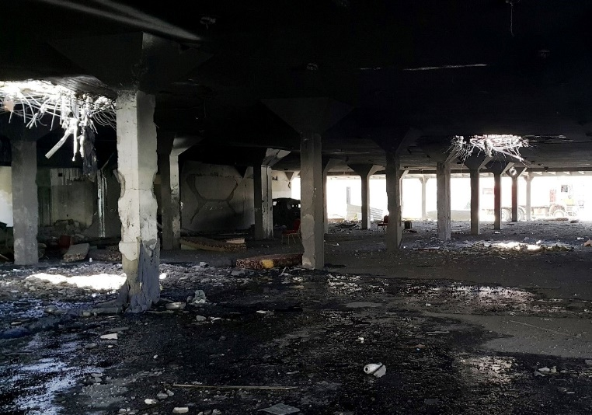

Figure II

**Destruction caused to Al Kubra Hall on 8 October 2016**[60]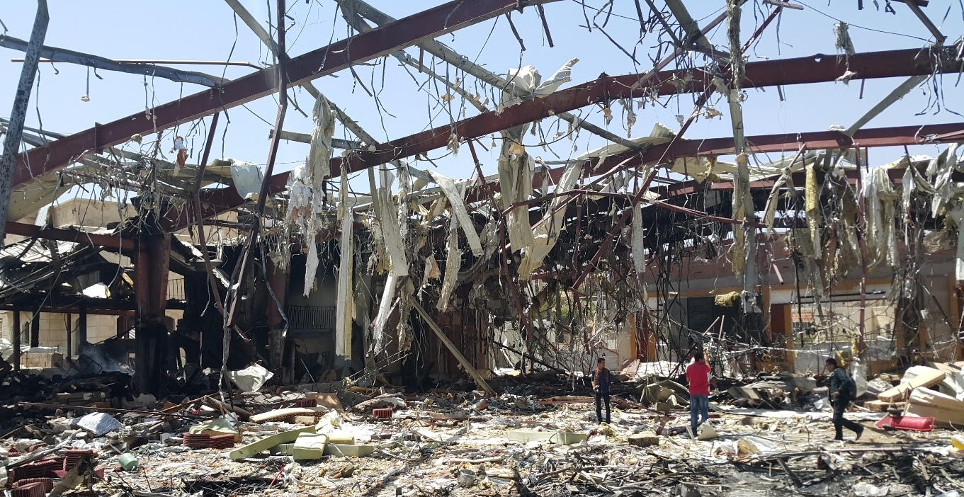

# Figure III

**Boat attacked the night of 16 March 2017 while carrying Somali refugees and migrants**[61]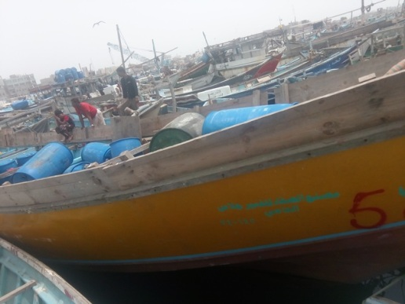Figure IV

**Destruction caused to Abs Hospital on 15 August 2016**[62]

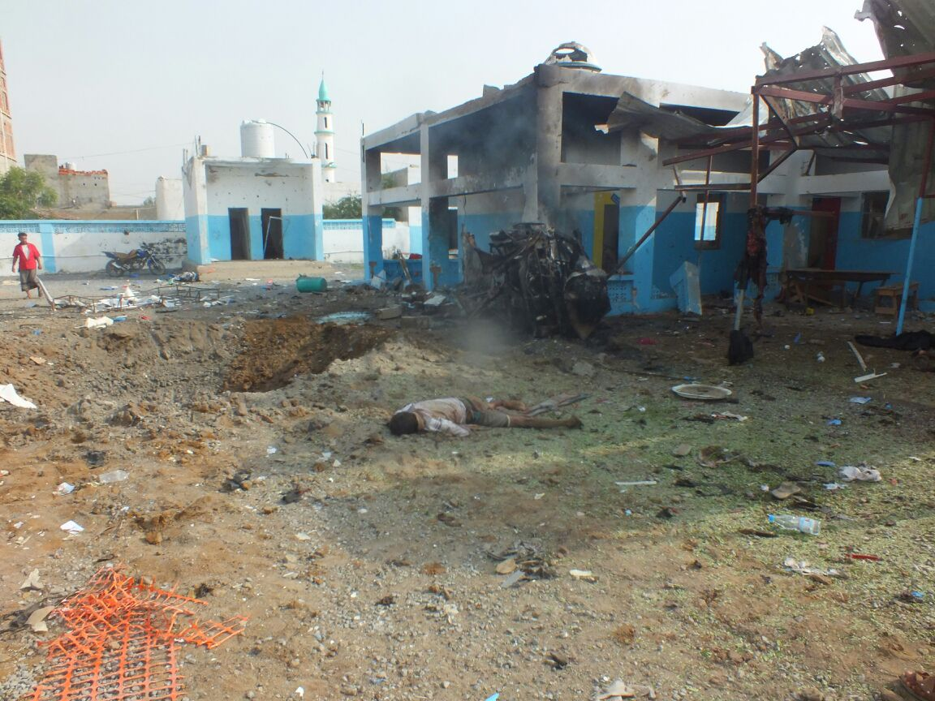

Annex III

Infographics



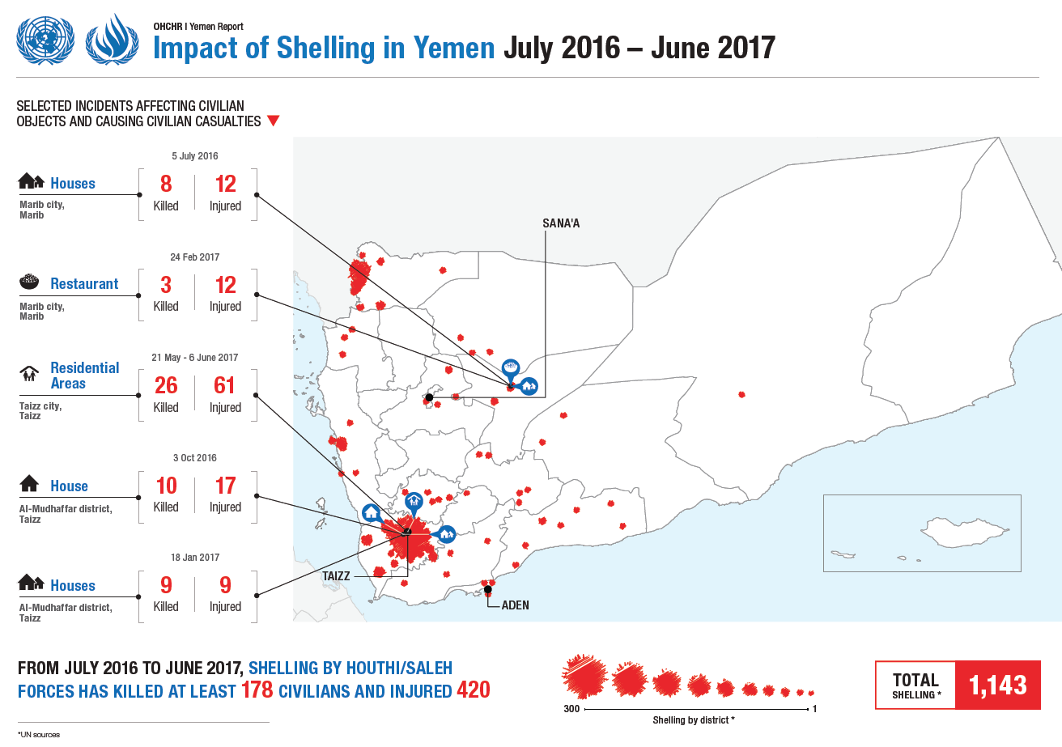





1. * The report was submitted after the deadline in order to reflect the most recent developments.
2. ** The annexes to the present report are circulated as received.
3. A/HRC/33/38 and A/HRC/30/31.
4. See A/HRC/33/38, paras. 8-10.
5. The Saudi Arabia-led coalition consists of Bahrain, Egypt, Jordan, Kuwait, Morocco, Senegal, the Sudan, the United Arab Emirates and, until June 2017, Qatar.
6. Information from United Nations sources.
7. Ibid.
8. See [www.reuters.com/article/us-yemen-security-un-idUSKBN17X1F1](http://www.reuters.com/article/us-yemen-security-un-idUSKBN17X1F1).
9. See annex I.
10. See International Committee of the Red Cross (ICRC), rule 97.
11. See annex III.
12. See A/HRC/30/31 and A/HRC/33/38, annex III.
13. See annex I.
14. See annex III.
15. See annex I.
16. See annex II, figure I.
17. See sect. VII below for additional information on the Joint Incident Assessment Team.
18. See [www.justsecurity.org/33615/full-text-saudi-led-coalitions-statement-explanation-funeral-hall-](http://www.justsecurity.org/33615/full-text-saudi-led-coalitions-statement-explanation-funeral-hall-)bombing-yemen/.
19. See annex I.
20. Ibid.
21. Ibid.
22. See http://wam.ae/en/details/1395302603973.
23. Ibid.
24. See <http://uk.reuters.com/article/uk-yemen-security-refugees-idUKKBN16O0WF>.
25. Yemen ratified the Convention on the Prohibition of the Use, Stockpiling, Production and Transfer of Anti-Personnel Mines and on Their Destruction; however, neither Yemen nor any coalition members, except Senegal, are parties to the Convention on Cluster Munitions.
26. See ICRC, rules 71 and 81.
27. Demining activities were limited prior to February 2016.
28. See annex I.
29. See http://www.spa.gov.sa/viewstory.php?lang=en&newsid=1571875.
30. See www.msf.org/sites/msf.org/files/healthcare_under_siege_in_taiz.pdf.
31. See Security Council resolution 2216 (2015).
32. See www.savethechildren.org.uk/2017-03/saudi-delays-yemen-aid-killing-children.
33. See www.logcluster.org/countries/YEM.
34. United Nations and international non-governmental organization flights have since resumed.
35. See ICRC, rule 55.
36. See ICRC, rule 56.
37. See ICRC, rules 25, 28, 38 and 39.
38. See annex III. Such attacks may also violate international human rights law, including the International Covenant on Economic, Social and Cultural Rights, arts. 12, 13 and 15.
39. OHCHR findings corroborate the findings of the internal investigation conducted by Médecins sans frontières, which ran the hospital, see [www.msf.org/sites/msf.org/files/yemen_abs_  
    investigation.pdf](http://www.msf.org/sites/msf.org/files/yemen_abs_investigation.pdf).
40. See annex II, figure IV.
41. See www.spa.gov.sa/viewstory.php?lang=en&newsid=1567351.
42. See www.msf.org/en/article/yemen-indiscriminate-bombings-and-unreliable-reassurances-saudi-led-coalition-force-msf.
43. The task force, established in the context of the monitoring and reporting mechanism on grave violations against children in situations of armed conflict, comprises 15 United Nations agencies and international non-governmental organizations.
44. See www.spa.gov.sa/viewstory.php?lang=en&newsid=1567371.
45. The country task force on monitoring and reporting documented 1,676 children killed and 2,760 injured. OHCHR is a member of the task force and contributes its casualty figures to these totals.
46. See ICRC, rules 136 and 137. Yemen ratified the Convention on the Rights of the Child and the Optional Protocol to the Convention on the Rights of the Child on the involvement of children in armed conflict.
47. See www.centcom.mil/MEDIA/PRESS-RELEASES/Press-Release-View/Article/1068267/us-central-command-statement-on-yemen-raid/.
48. See annex III.
49. See annex I.
50. As of 23 June 2017, there were no signs that the Government of Yemen would allow journalists into the country.
51. See [www.ohchr.org/EN/NewsEvents/Pages/DisplayNews.aspx?NewsID=21643&LangID=E](http://www.ohchr.org/EN/NewsEvents/Pages/DisplayNews.aspx?NewsID=21643&LangID=E).
52. See www.unicef.org/videoaudio/PDFs/Yemen_2_Years_-_children_falling_through_the_  
    cracks_FINAL.pdf.
53. See www.spa.gov.sa/viewstory.php?lang=en&newsid=1524799.
54. See www.reuters.com/article/us-yemen-security-abuse-idUSKBN19F08D?il=0.
55. See http://reliefweb.int/report/yemen/usgerc-stephen-o-brien-statement-security-council-missions-yemen-south-sudan-somalia.
56. See A/HRC/33/38, paras. 71-74.
57. All the information in this section was provided by the United Nations Office for the Coordination of Humanitarian Affairs.
58. See www.spa.gov.sa/viewstory.php?lang=en&newsid=1567371.
59. Photograph taken by OHCHR staff on 9 October 2016.
60. Photograph taken by OHCHR staff on 9 October 2016.
61. Photograph taken by OHCHR staff on 18 March 2017.
62. Photograph taken by OHCHR staff on 15 August 2016.