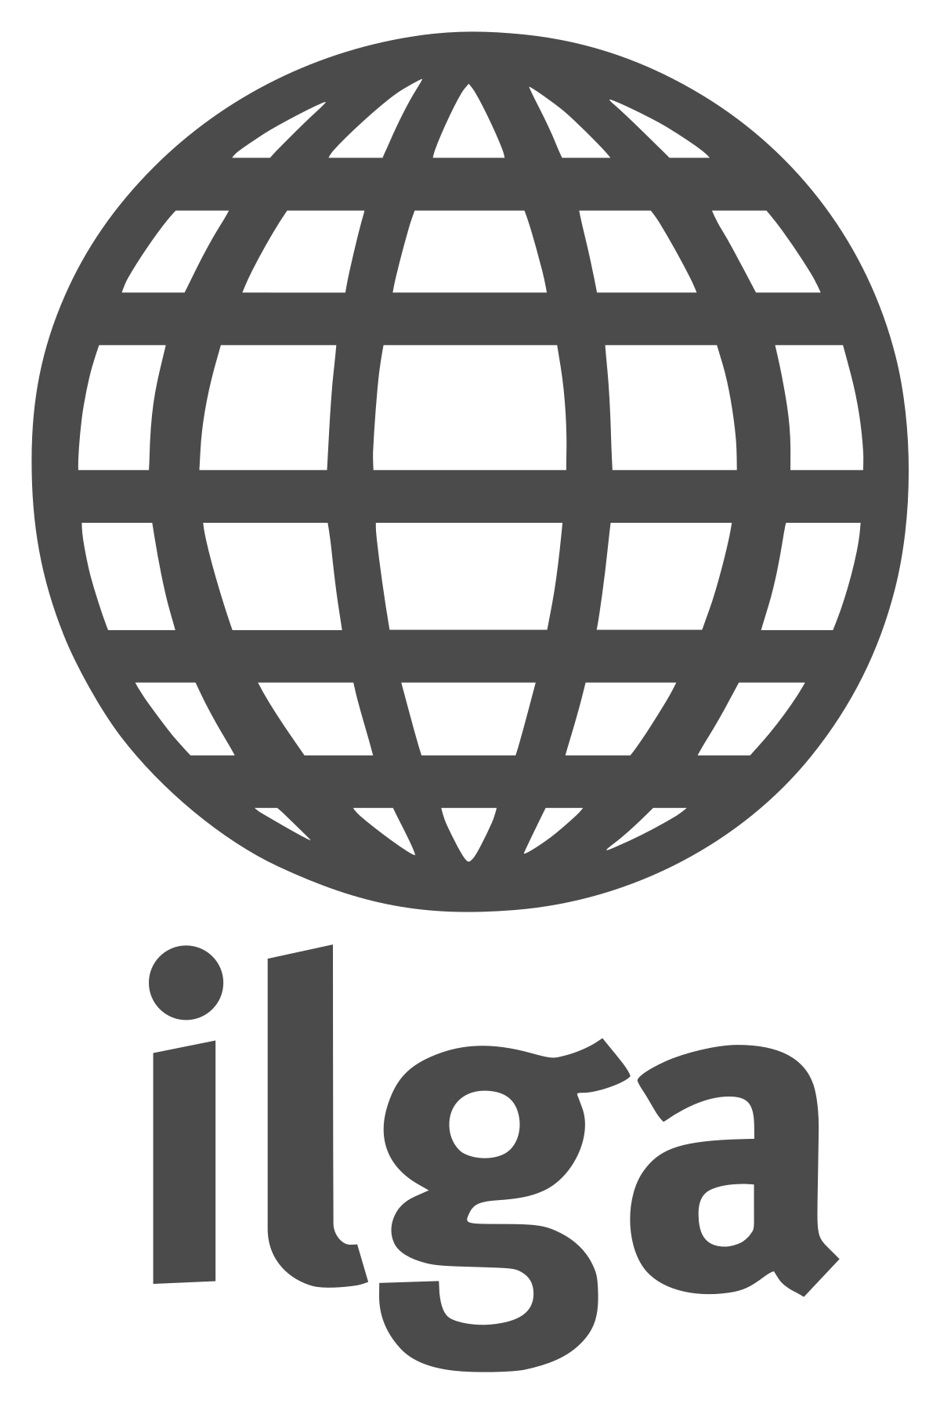
General Discussion on the Draft Revised General Comment on the implementation of article 3 of the Convention in the context of article 22
Oral statement on behalf of the International Lesbian, Gay, Bisexual, Trans and Intersex Association (ILGA)

To be delivered by:
Kseniya Kirichenko, ILGA’s UN Programme Officer

ILGA World welcomes the progress that has been achieved by the Committee against Torture on the protection of rights of lesbian, gay, bisexual, trans and intersex (LGBTI) persons, such as including references to sexual orientation, gender identity and expression and sex characteristics (SOGIESC) in the Committee’s concluding observations and general comments, as well as its decisions on cases where complainants faced risk of torture because of their sexual orientation upon return to countries of origin.
LGBTI persons living in different regions faced risk of persecution because of their SOGIESC immanent characteristics. Today, 73 states in the world criminalized same-sex sexual activity, including 45 where the law are applied to women as well as men. The number of the UN States (or parts thereof) where the death penalty might have been applied for same-sex sexual acts stood at 13.
In 2017 already, a group of national and international NGOs called on the UN mechanisms to response to the abuse and detention of gay men in Chechnya, one of the Russian regions. More than 100 men there were detained simply for being perceived to be gay. Several UN Special Procedures, including the Special Rapporteur on extrajudicial, summary or arbitrary executions and the Special Rapporteur on torture and other cruel, inhumane and degrading treatment or punishment, made a joint statement on the situation in Chechnya, and local activists are organizing a system for evacuating gay people from the region to safe countries.
Therefore, we highly appreciate further possible developments in the CAT’s standards, specifically the inclusion of sexual orientation and gender identity, among other indications of personal risk affecting the complainant, in para 48(e) of the Draft Revised General Comment.
Welcoming this provision, we would like to suggest the following additions that would ensure more comprehensive reflection of risks of torture faced by LGBTI persons in different countries throughout the world, as well as already existing practice and standards of different international institutions and bodies.
Firstly, we suggest to add SOGIESC characteristics in the list of those affecting victims’ individual experience of pain or suffering (para 17 of the draft General Comment).
Secondly, we would like to ask the Committee to include in the draft General Comment a specific paragraph describing the types of particular risks that LGBTI persons could face in their countries of origin because of their SOGIESC (para 30 of the General Comment). Among types of severe violations LGBTI people may face are: criminalization of consensual same-sex relations between adults, or criminalization of particular forms of gender expression, or activities aimed at promoting human rights of LGBTI persons; intrusive non-consensual forensic examinations as proof of same-sex sexual acts and so-called ‘conversion therapies’; hate crimes, corrective rapes, forced marriage and honour-based violence; aggravated violence against LGBTI persons in detention; non-consent gender reassignment surgeries or medical interventions aimed at determination of sex without effective consent of trans or intersex person affected.
Thank you for your attention.

