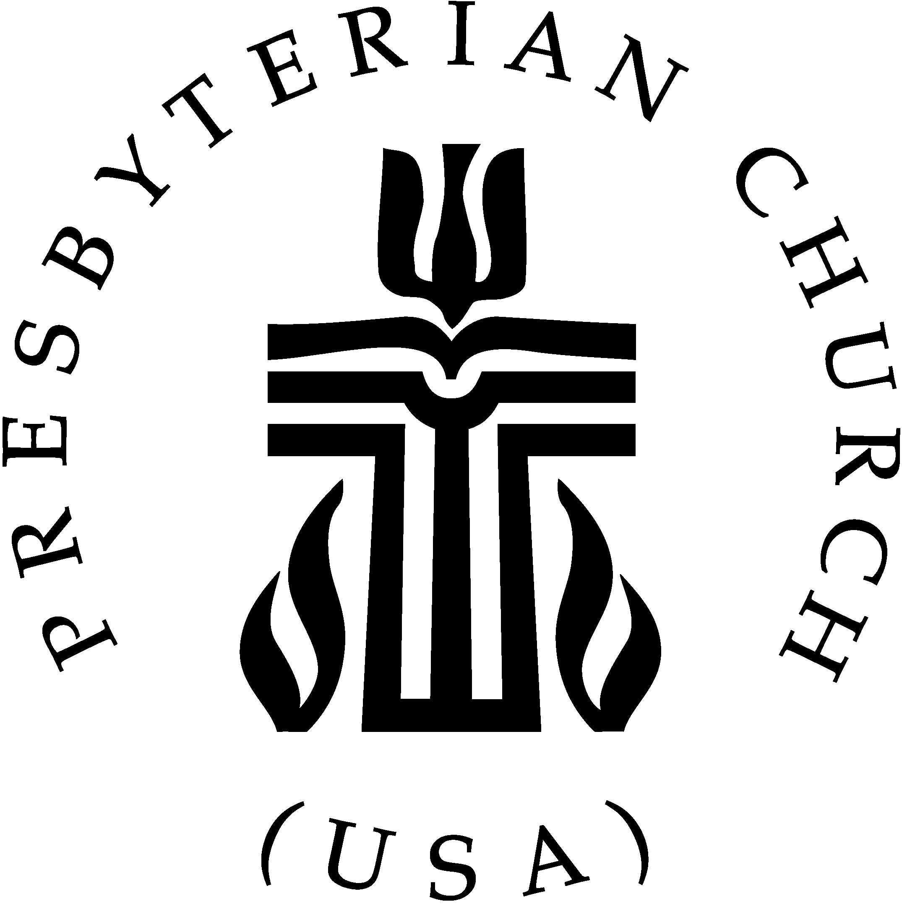

The Presbyterian Church (USA)
Written Submission for the General Discussion on the Preparation
for a General Comment on Article 6 (Right to Life)

The Presbyterian Church (USA) and its predecessor denominations have long supported international human rights mechanisms, including Article 6 of the International Covenant on Civil and Political Rights.

In 1959, the General Assembly of the United Presbyterian Church in the USA stated, “the use of the death penalty tends to brutalize the society that condones it.” In 1978, the General Assembly of the Presbyterian Church in the US went on record as saying, “Capital punishment is an expression of vengeance which contradicts the justice of God on the cross.” In 1985, the Presbyterian Church (USA), reaffirmed these positions and declared “its continuing opposition to capital punishment.” Most recently, in 2008 the General Assembly of the Presbyterian Church (USA) called for “an end to the death penalty.”

The Presbyterian Church (USA) recognizes inequitable treatment of minority communities can also endanger the right to life. Addressing these concerns, in 2014 the General Assembly of the Presbyterian Church (USA) recognized “the global crisis for lesbian, gay, bisexual and transgender (LGBT) persons and their families…and the impact of persecution that threatens their lives, health, and safety.” The rationale given observed, “Scripture, the Book of Confessions and the Book of Order of the Presbyterian Church (USA) inspire and require solidarity and ministry with the LGBT people and their families around the world whose well-being and very lives are threatened by the laws of their own countries and the resulting experiences of oppression and persecution.”

In 1978, the United Presbyterian Church in the United States of America stated, “Vigilance must be exercised to oppose federal, state, and local legislation that discriminates against persons on the basis of sexual orientation and to initiate and support federal, state, or local legislation that prohibits discrimination against persons on the basis of sexual orientation in employment, housing, and public accommodations.”

The 2004 General Assembly of the Presbyterian Church (USA) affirmed the policy, Transforming Families, that ends with a vision of a church and society “which welcomes and nurtures all persons regardless of their family circumstances” and a church that rejects “attitudes or practices that value some more highly than others- based on gender, age, class, ability, ethnic origin, sexual orientation, or any outward condition.”

The Presbyterian Church (USA) also recognizes that one’s religious affiliation is a fundamental human right and considers “the rights of private judgment, in all matters that respect religion, as universal and inalienable,”: the Presbyterian Church (USA) does “not even wish to see any religious constitution aided by the civil power, further than may be necessary for protection and security, and at the same time, be equal and common to all others.”

The Presbyterian Church (USA) asks the Committee to join us in recognizing and affirming the right of all to live and the right to equality and non-discrimination for all persons, with particular attention to minority populations, especially religious minorities and lesbian, gay, bisexual and transgender persons, as well as all others disadvantaged and marginalized because of their minority status.

The Presbyterian Church (USA) recognizes “There is therefore no place in the life of the Church for discrimination against any person,” and that the equal enjoyment of the right to life by those whose life is placed at risk by states’ failures to take positive measures to address poverty and to ensure full access to healthcare, housing, food, especially for groups who are marginalized and disadvantaged including those who are homeless and groups such as migrants, children, people with disabilities, racial and ethnic minorities, religious minorities and lesbian, gay, bisexual and transgender persons.
We believe that advocating for the right to life is inherent in our beliefs. The Church’s task is “participating in God’s mission to care for the needs of the sick, poor, and lonely; to free people from sin, suffering, and oppression; and to establish Christ’s just, loving, and peaceable rule in the world.”

Presbyterian Mission Agency. Online. Capital Punishment. 24 June 2015. http://www.presbyterianmission.org/ministries/101/capital-punishment/
09-20 Commissioner Resolution. On the Global Crisis for LGBT People and Their Families: A Presbyterian Church (U.S.A.) Response.
Ibid
1978 Policy Statement and Recommendation on Homosexuality, United Presbyterian Church in the United States of America
10-06 Transforming Families, GA Minutes page 747
PC(USA) Book of Order, G-1.0301
PC(USA) Book of Order, F-1.0403
PC(USA) Book of Order, F-1.03

