CAIR is America's largest Muslim civil liberties and advocacy organization. Its mission is to enhance the understanding of Islam, encourage dialogue, protect civil liberties, empower American Muslims, and build coalitions that promote justice and mutual understanding.
CAIR believes Islamophobia in the United States is a current manifestation of the issue of prejudice that has plagued our nation since its earliest days. It is the same old hate, just with a relatively new target. Muslims, like Malcolm X, have been involved in historical U.S. movements combatting prejudice, but only after the 9/11 terror attacks did they become a primary focus for purveyors of hate. With this in mind, CAIR is dedicated to countering prejudice in general.
We recognize that while Muslims are a primary focus of hate today, it will one day pass to another group. We continue to work to ensure social and legal protections for all Americans, inspired by the sacrifices and ongoing struggles of African American Muslims and Christians as well as other minorities who have been marginalized including Japanese Americans, Jews, Catholics and others.
While this site calls attention to the groups and individuals promoting Islamophobia in the United States, we hope users will find the materials developed to counter prejudice can be used to counter hate against other groups as well.
Islamophobia is closed-minded prejudice against or hatred of Islam and Muslims. An Islamophobe is an individual who holds a closed-minded view of Islam and promotes prejudice against or hatred of Muslims.
In the one week since Donald Trump became President-elect, there has been a spike in bias incidents targeting minorities across the United States. CAIR has recorded a preliminary 111* incidents specifically targeting Muslims.
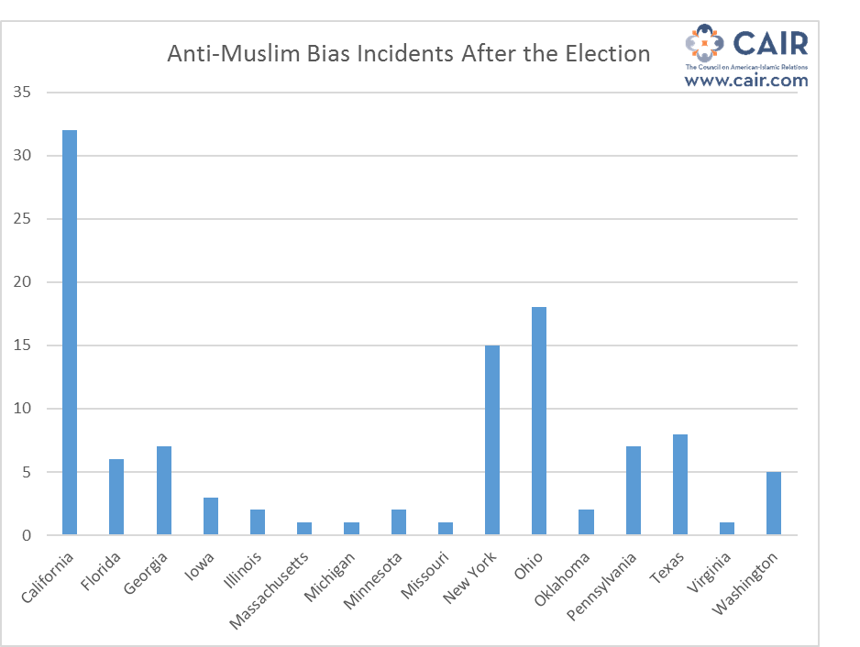
The chronological list below does not include all recorded cases. Many were withheld to guarantee client confidentiality.
11/09/16; A woman approached Maha Abdul Gawad, pulled her scarf off, and said "this is not allowed anymore, so go hang yourself with it around your neck not on your head"
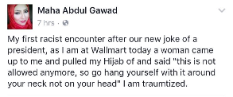
11/09/16; San Diego, Calif.; A scarf wearing Muslim student was robbed at San Diego State University and may have had her car stolen by two men who made disparaging remarks about Muslims and mentioned Trump.
11/09/16; Plano, Texas; A Muslim girl at Plano East High School reported that "a random white boy just came up to me pats and rubs my hijab and says 'good morning' with a dirty look."
11/09/16; Plano, Texas; Students at Plano East High School also reported that a group of boys took off a girl's hijab
11/09/16; Virginia; A man ran past a young woman wearing a scarf and shouted, "What are you still doing here? Don't you know Donald Trump is going to slaughter you ragheads."
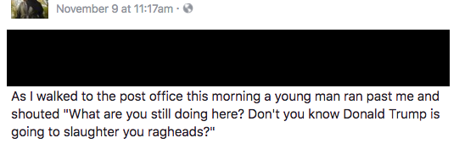
11/09/16; N.Y.; A woman wearing a scarf walked pass a man on a metro platform who said to her, "Your time's up girlie."
11/09/16; Los Angeles, Calif.; Mariam Nomair, a 16 year-old Muslim student at El Camino High School, was attacked twice on Wednesday. In one instance, a male student walked up to her as and tried to rip her hijab off and called her a terrorist. She said, “He like grabbed me by my bun and my hijab and tried to pull it off." She continued, "He was like, "You shouldn't be wearing that, you towelhead. You're not American. This isn't America. This isn't what America stands for."
11/09/16; San Jose, Calif.; Esra Altun, 19, was walking back to her car at San Jose State University on Wednesday afternoon when someone grabbed her hijab from behind and yanked it backward, choking her. Altun fought back by leaning forward, and when her attacker let go she fell hard to her knees.
11/09/16; Chicago, Ill.; A Muslim woman had a knife pulled on her by a Trump supporter while on a bus by University of Illinois Urbana Champagne.
11/09/16; Illinois; A student in a Trump T-shirt went down halls of the high school saying, "BYE!" to girls in hijabs and anyone who appeared to be of Mexican descent.
11/10/16; Queens, N.Y.; Fariha Nizam, a 19-year-old college student from Bellerose, Queens, was yelled at by a white, middle-aged couple to take off her hijab on the bus. The woman was screaming "She has to f**king take it off." She started grabbing Nizam’s head and tried it pull her scarf off.
11/11/16; Gwinnet, Ga.; High school teacher, Mairah Teli, was left a note in class Friday telling her that her Muslim headscarf "isn't allowed anymore." The note said, "Why don’t you tie it around your neck & hang yourself with it” and was signed "America!
11/11/16; Ann Arbor, Mich.; A woman was forced to remove her hijab after a man threatened to set her on fire with a lighter near the University of Michigan campus in Ann Arbor.
11/11/16; Brooklyn, N.Y.; A vandal defaced the door of the prayer room of the NYU MSA with a simple “Trump!” at the Tandon School of Engineering in downtown Brooklyn.
11/11/16; Dallas, Texas; Bikers and truckers circled the Council on American-Islamic Relations DFW building 5 or 6 times. They were wearing masks and displaying the 3 Percenter logo. They shouted obscenities and made lewd gestures.
11/11/16; Dallas; Texas; The Council on American-Islamic Relations DFW received a threatening phone call prior to a community outreach event, where they were referred to as “terrorists.”
11/11/16; New Paltz, N.Y.; "Isis is Calling. Muslims Can Leave" was found written on a women's stall at SUNY New Paltz.
11/11/16; Brooksville, Fla.; A truck with the signs: "All Muslims are Terrorists." "Deport them All" "I Hate Muslims" was witnessed driving around.
11/11/16; Fla.; Florida Transportation Commission member John Browning posted to Facebook his reservations about getting on a plane with a man of apparent Middle Eastern descent. The public post includes a photo of a man sitting in a wheelchair and wearing a headscarf with the caption: “Ever want to get off a plane whe (sic) loading.”
11/11/16; Iowa City, Iowa; Someone left a hate note outside the home of a Sudanese-American family. It said, "You can go home now, we don't want n------ and terrorists here, #trump."
11/12/16; Columbus, Ohio; A Muslim woman reported that a man stormed up to her car and began banging on the window. He then began to shout obscenities at the woman and her family. He shouted, "C**t, you don't belong in this country,” and "Go back to your f**king country." The man took pictures of the children in her car.
11/12/16; Minnesota; Anti-Somali signs were put up in homes in Minnesota. They said, "Take your Muslim Somalian Diaspora and put it where the sun doesn't shine."
11/13/16; Cambridge, Mass.; A Sikh man was called a "f***ing Muslim" inside a store. The aggressor followed him to the checkout counter, aggressively asking him where he was from.
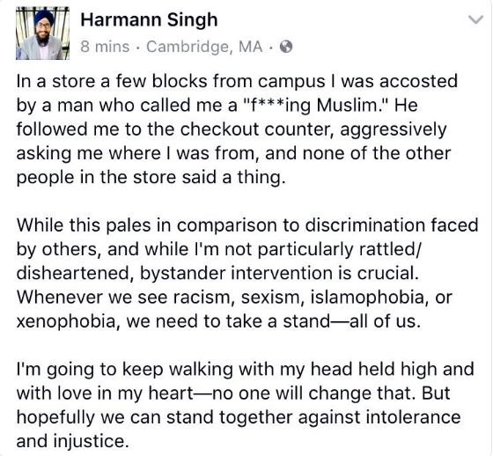
11/13/16; Riverside, Calif.; An instructor at Riverside Community College received a private message saying "You dirty allah worshipping trash, gratefully out (sic) new president is going to make you leave the USA or die! You do nothing at RCC but promote ugly radical islam (sic) and we are sick of it)
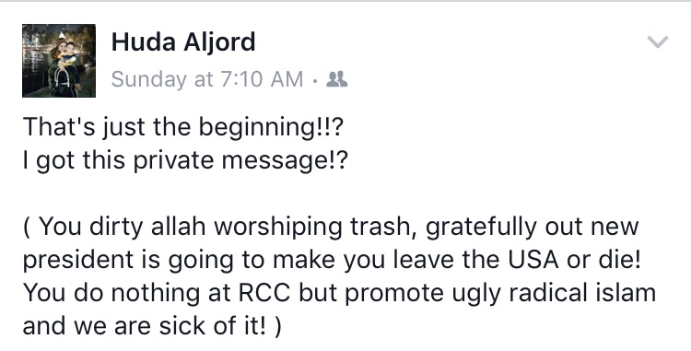
11/?/16; Trenton, Penn. ; A passer-by threw hot coffee on a female college student wearing a hijab.
11/?/16; Penn.; Four men shouted out their car windows at a Muslim woman to remove her scarf or leave the country.
11/13/16; Berkeley, Calif.; At UC Berkeley, a student was targeted by a couple of men who walked by threatening to pull off her head scarf, taunting her that Donald Trump had been elected.
11/14/16; Columbus, Ohio; An established patient of a Muslim doctor called the doctor’s office to say he wanted to speak to a, “white, English speaking, American doctor”. He then went on to state that “people like the doctor should be killed and thrown out of the country” and that he’s “so glad that Donald Trump has won the presidency."

*This number is likely only a fraction of the total incidents that have occurred as many victims may not report their experience and some cases have not been verified.

