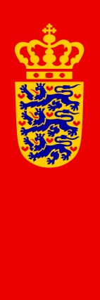 |  |  | Asiatisk Plads 2  DK-1448 Copenhagen K  Denmark  Phone +45 33 92 00 00  Fax +45 32 54 05 33  E-mail: um@um.dk  http://www.um.dk
Enclosure(s) | Case/ID No. | Department | Date
 | 2016 - 46329 / 2054634 | International Law and Human Rights (JTFM) | 19-01-2017

Submission of the Government of the Kingdom of Denmark

General Discussion on the Draft General Comment on State Obligations under the International Covenant on Economic, Social and Cultural Rights in the Context of Business Activities

The Danish Government presents its compliments to the United Nations Committee on Economic, Social and Cultural Rights (the Committee), and has the honor to refer to the Committee’s invitation of 8 November 2016 to submit written contributions to the General Discussion on the draft General Comment on State Obligations under the International Covenant on Economic, Social and Cultural Rights in the Context of Business Activities, to be held on 21 February 2017.

Denmark has been a party to the International Covenant on Economic, Social and Cultural Rights since 1972 and confirms its commitment to fully comply with its treaty obligations. The Danish Government welcomes this opportunity to submit its observations on the Committee’s draft General Comment on State obligations under the Covenant in the context of business activities.

The Danish Government wish in that regard to express its full support to the written observations submitted to the Committee on 18 January 2017 by the Norwegian Government.

At this stage the Danish Government has no further observations or contributions to the draft General Comment. This should, however, not be interpreted as either agreement or disagreement with the substance of the draft General Comment which is not specifically addressed in the observations submitted by the Norwegian Government.

