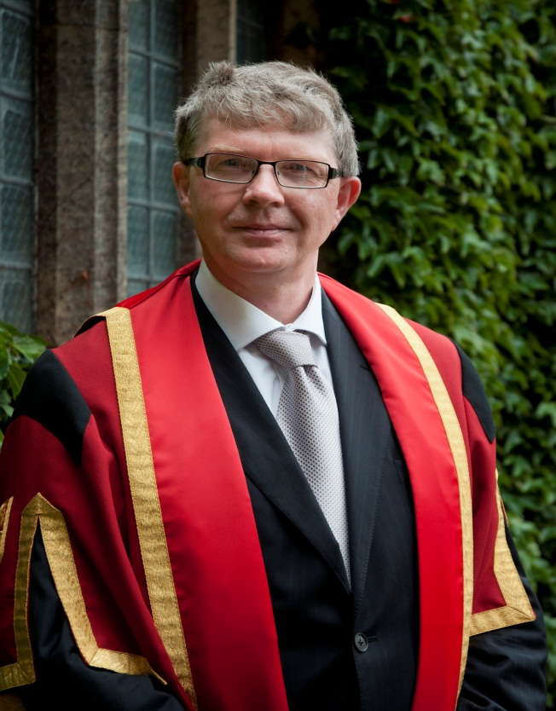

Professor Sir Malcolm D Evans KCMG OBE

Malcolm Evans is Professor of Public International Law at the University of Bristol, UK where he has taught since 1988. His areas of legal specialism include both international human rights protection and the international law of the sea. In the field of human rights his particular interests concern torture and torture prevention and the protection of religious liberty under international law, on both of which he was written extensively. He became a member of the UN Subcommittee for the Prevention of Torture (the SPT) in 2009 and since 2011 has been serving as its Chair. From 2014-2015 he was the Chairperson of the Meeting of Chairs of UN Human Rights Treaty Bodies.

From 2002 – 2013 he was a member of the OSCE ODIHR Advisory Council on the Freedom of Religion or Belief. He is also a member of the UK Foreign Secretary’s Human Rights Advisory Group. He has acted as an independent advisor and consultant for numerous international organisations over many years. From 2003-5 he was Head of the School of Law and from 2005-2009 Dean of the Faculty of Social Sciences and Law at the University of Bristol.

He is General Editor of the International and Comparative Law Quarterly and Co-Editor in Chief of the Oxford Journal of Law and Religion. Major published works include: Religious Liberty and International Law in Europe (CUP, 1997), Preventing Torture (OUP, 1998), Combating Torture in Europe (Council of Europe, 2002), Manual on the Wearing of Religious Symbols in Public Areas (Council of Europe/Brill, 2009), The Optional Protocol to the UN Convention against Torture (OUP, 2011), The Changing Nature of Religious Rights under International Law (ed) (OUP, 2015). He is Editor of International Law (OUP, 4th ed, 2014) and Blackstone’s International Law Documents (OUP, 12th ed, 2015).

