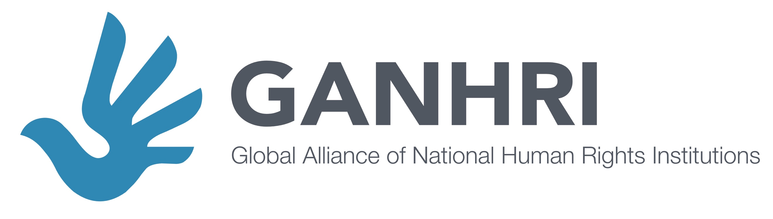

Committee on the Rights of Persons with Disabilities
Lunch Briefing at the Day of General Discussion on Article 5 of the CRPD - 18th Session

"SDG-CRPD implementation for equality for persons with disabilities: the role of organisations of persons with disabilities and National Human Rights Institutions"

Date: Friday, 25 August, 2017 – 1.30 pm to 2.45 pm
Place: Room XVII, Palais des Nations, Geneva

draft
Concept note
I. Background

The Sustainable Development Agenda entails a high political commitment by all UN member States. Its motto “Leave no one behind” evidences its inclusive aim. In contrast to the Millennium Development Goals, the Sustainable Development Goals (SDGs) and its targets include explicit references to persons with disabilities and use language related to the Convention on the Rights of Persons with Disabilities (CRPD) (e.g. “inclusive”). States have committed to develop policies and frameworks to achieve these goals including, among others, Goal 10 Reduced inequality within and among countries. They have also underlined that this needs to be done in line with their obligations under international law.

The CRPD represents the most advanced international standards on the rights of persons with disabilities. Its Article 5 requires measures both to advance equality for persons with disabilities, including specific measures under paragraph 4, and to protect persons with disabilities from discrimination on the basis of disability and other grounds. The CRPD acknowledges that persons with disabilities face inequality and structural discrimination.

Building the bridge between the SDGs and the CRPD obligations, development and human rights, is therefore key to ensure that all policies directed to implement SDGs are guided by and comply with CRPD legal standards, including Article 5. This will allow for human rights-based SDG-CRPD implementation which promotes equality for persons with disabilities and protects them from discrimination.

II- Ensuring participation of persons with disabilities in SDG-CRPD implementation and monitoring, and the role of national human rights institutions
The CRPD contains provisions recognising the key roles at national and international levels of organisations of persons with disabilities (DPOs) and national human rights institutions (NHRIs). Article 4.3 requires that States closely consult and actively involve persons with disabilities, through their representative organisations, in the design, implementation and evaluation of policies that concern them. Further, Article 33.3 calls for the participation of civil society in the monitoring of CRPD implementation. As representative of the right-holders, DPOs are highly interested on SDGs and CRPD implementation, as shown by the active participation at the international level.
NHRIs, as independent state bodies, are mandated under the Principles relating to the Status of National Institutions (The Paris Principles) to promote and monitor implementation of all international human rights standards, including CRPD, at the national and local levels. This also relates to promoting and monitoring CRPD-specific national action plans and other mechanisms, such as those relating to SDGs implementation. In line with Article 33.2 of the CRPD, NHRIs can also be appointed as national independent monitoring mechanisms.
NHRIs through their various functions have a key role in ensuring and promoting inclusive and participatory implementation and monitoring processes of their respective states’ legal obligations and comitments. Through their advisory role, NHRIs can advocate with governments for the inclusion and participation of persons with disabilities in SDG-CRPD implementation. NHRIs can and should also adopt measures for the effective participation of DPOs in their monitoring functions. NHRIs with a a complaint-handling mandate can help enforce equality and non-discrimination in individual cases. NHRIs can also advise on, and monitor the, adoption of specific measures by states under Article 5.4.
The International Disability Alliance (IDA) and the Global Alliance of National Human Rights Institutions (GANHRI), representing the networks of the respective stakeholders (DPOs and NHRIs), are aware of the importance to promote, develop and strengthen collaboration and fostering synergies between DPOs and NHRIs, notably at the national level, with due respect for the institutional role of each.
NHRIs and DPOs have developed effective measures for cooperation. Building on these practices, IDA and GANHRI will continue to support DPOs and NHRIs in moving forward SDG-CRPD implementation in coordination and constructive dialogue with States, while monitoring gaps and advancements, notably when it comes to policies for equality and non-discrimination.

III. Objective and Panel

IDA and GANHRI propose a panel that will present the perspectives of States, DPOs, NHRIs and other stakeholders on ways of collaboration and involvement in SDG-CRPD implementation and monitoring, with a particular focus on measures directed to promote and enforce equality and non-discrimination. In this way, we hope to nourish the debates towards a general comment no. 6 on Article 5 of the CRPD, which would hopefully be assertive when it comes to put in motion the machinery for its implementation and monitoring, taking into consideration the key roles of DPOs and NHRIs.

Proposed panel:

The panel would include a total of 30 minutes of presentations by the speakers, followed by an interactive dialogue with the audience:

- Moderator: Mr. Victoria Lee, OHCHR Disability Team

- Ms. Theresia Degener, Chairperson of the CRPD Committee

- Representative of State friend to CRPD (maybe New Zealand or Mexico)
- Kagwiria Mbogori, Chairperson, Kenya National Commission on Human Rights

- Ekaete Judith Umoh, National President of Joint National Association of Persons with Disabilities Nigeria

- Martha Stickings, Social Research Officer, Equality and Citizens' Rights Department, European Union Agency for Fundamental Rights

Captioning and International Sign will be provided.

The event will be Webcasted.

