_unlogo

**United Nations Convention on the Rights**

**of Persons with Disabilities**

**The right of people with disabilities to get a good education**

**in the same places as people without a disability**

**This is called Inclusive Education**

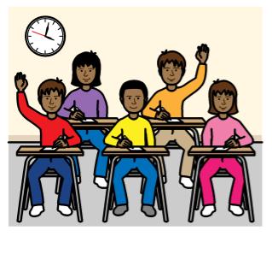

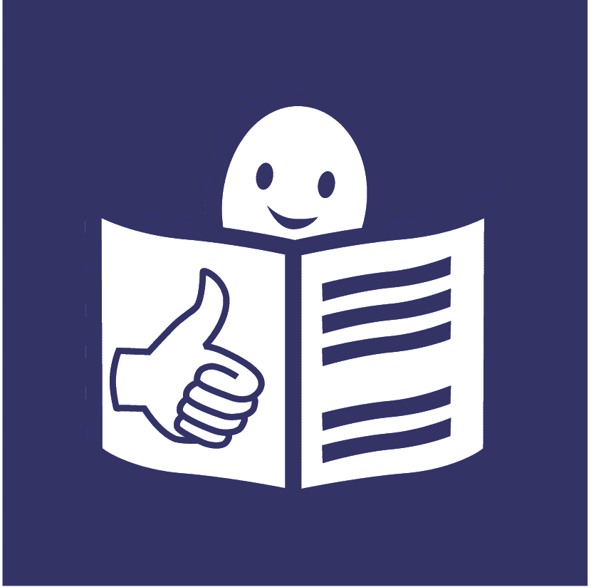

**What is this document about?**



This document is about the right of all people with disabilities to get a good education in the same places as people without disabilities.

This is called **Inclusive Education**.



It is when people with disabilities and people without disabilities learn together.

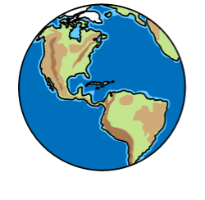

Lots of countries have agreed to make this happen.

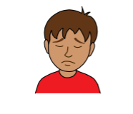

Some good work has already been done.

But there are still many problems.

For example, many people with disabilities get a bad education or no education at all.

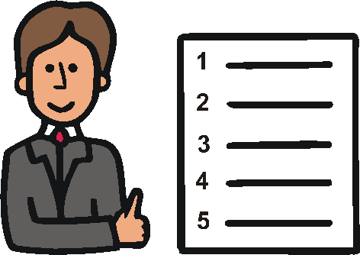This document will help everyone know:

* what inclusive education is
* what countries must do to make it happen

**What is inclusive education?**

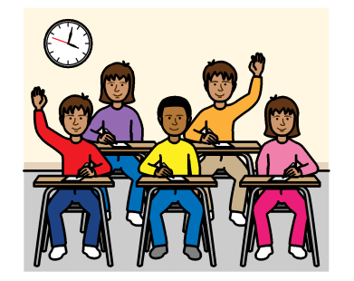

It is when people with disabilities learn together with people without disabilities.

Everyone learns together in the same classroom at school, college or university.



This means people with disabilities are not sent to other schools or classrooms away from other people.

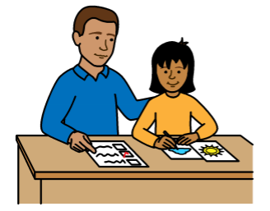

People with disabilities should get:

* the same good education as everyone else at all times
* the support they need to learn, join in and do well in the future

**Why is inclusive education important?**

Inclusive education is very important.

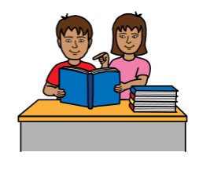

It can help people with disabilities:

* get a good education that is right for them

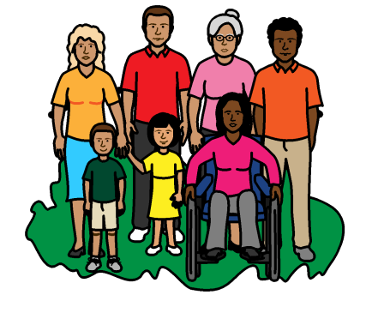

* do more on their own and learn more skills
* join in and be part of things

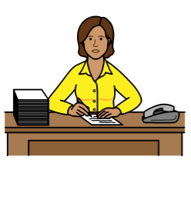

* get a job later on and do well in their lives

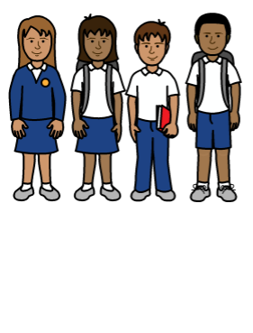Inclusive education can help everyone:

* get a better education
* learn about each other and get on well together

**What needs to happen?**

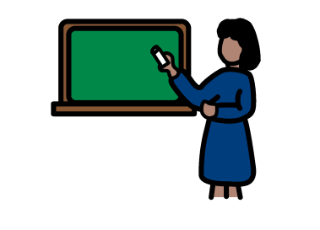

Countries need to change how education works so that everyone can get a good education and learn together.

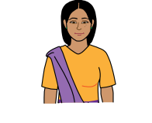This means making sure:

* everyone with disabilities is treated fairly and is safe from violence and abuse

This means women and girls too



* everyone with disabilities gets a good education near where they live



* 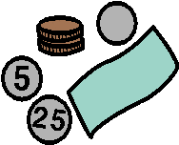everyone gets primary and secondary education

Primary education must be free and countries should work to make secondary education free

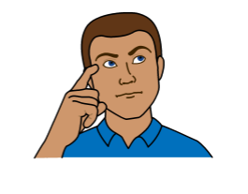Countries should make sure:

* they look at everything that needs to change about education, like laws and the way schools work

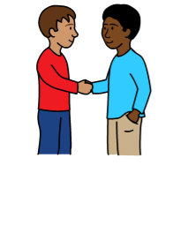

* they help people feel good about people with disabilities and their rights



* there is good information about people with disabilities and education

This will help countries make good plans and rules

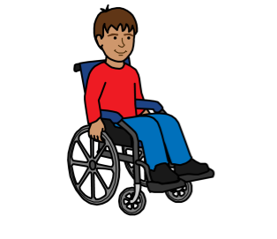

* everything is easy for people with disabilities to use

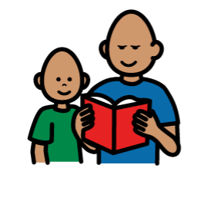

Like buildings, classrooms, toilets, books, information, and transport to school

Countries should make sure:

* children with disabilities get help early on to look at what support they need with their education



* everyone gets the support they need to learn, join in and do the best they can

Support can be lots of things like special computers, easy information or support from someone in the classroom

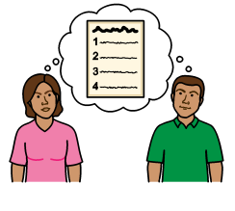

* education places make changes where they can to help every person with a disability to get the right support

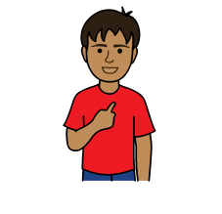

* everyone can learn in the best way for them. This may be different for each person

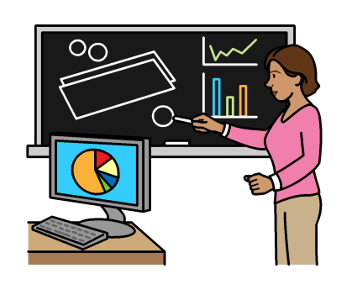Countries should make sure:

* teachers and staff get all the training and support they need to make inclusive education happen

E:\images\To zip\meeting room.wmf

There are lots of ideas for how to do this

For example, working with local groups, parents and children to get their advice and support



* there is nothing to stop people with disabilities getting a good education

For example, bad laws or rules

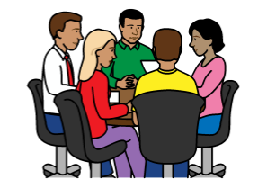

* education people work together with local groups, people with disabilities and their families to make education good for everyone

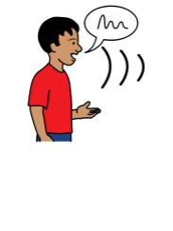Countries should make sure:

* children and adults with disabilities know their education rights and can have a say in what happens

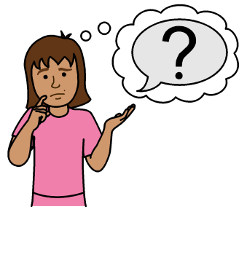

* there is an easy way for people to complain if they do not get their education rights

E:\images\To zip\meeting room.wmf

* there are good ways to check how everything is working and what needs to change

Children and adults with disabilities should be part of this

**Other things**

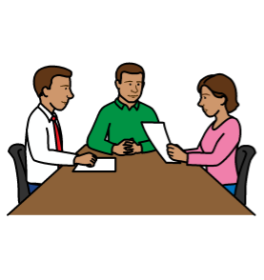

Countries should also make sure that:

* all parts of the government work together to make inclusive education happen

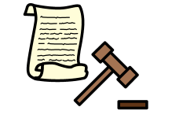

* there are good laws and a plan about inclusive education
* the laws say the right things about people’s rights



* there is enough money to make inclusive education happen

People with disabilities should not have to pay for changes that are made.

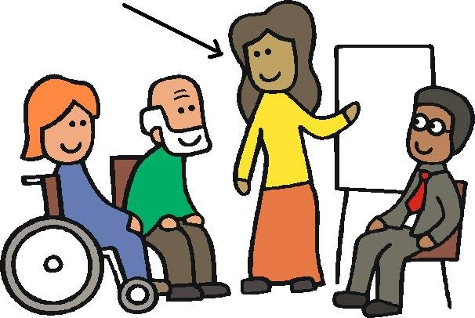Countries should also make sure:

* staff get training about the law and the rights of people with disabilities



Inclusive education is very important on its own.

But countries have to look at everything that people with disabilities need to have a good life.

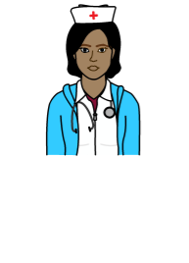

This may be good healthcare and transport that is easy to use.

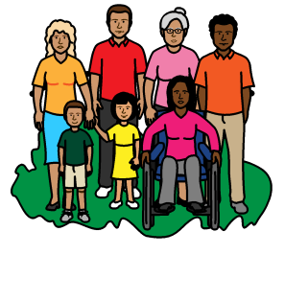

And making sure people with disabilities can live in the community like everyone else.

Not in homes far away.

**What countries have to do now**

E:\images\To zip\list.jpg

Countries may not be able to do everything at once.

But there are some things they should do straight away.



For example, making sure:

* all people with disabilities can get an education



* education places change things where possible so that people with disabilities get the support they need





* everyone gets free primary education



* there is a plan about good education for everyone

**The Picture Communication Symbols ©1981–2016 by Mayer-Johnson LLC a Tobii Dynavox company. All Rights Reserved Worldwide. Thousands of resources available for free at** [**www.boardmakeronline.com**](http://www.boardmakeronline.com/)