34th Session of the United Nations Human Rights Council

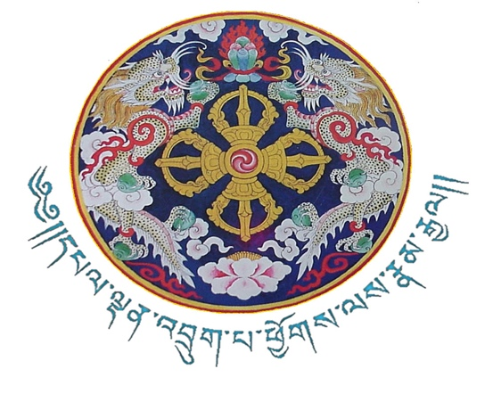

Joint Statement delivered by
Thinlay Norbu,
Kingdom of Bhutan

On behalf of the 11 LDCs/SIDS beneficiary of the Voluntary Technical Assistance Trust Fund to Support the Participation of Least Developed Countries (LDCs) and Small Island Developing States in the work of the Human Rights

GENERAL DEBATE ON ITEM # 10
Geneva, 22 March 2017

Mr. President, Excellencies and distinguished delegates;

I have the honor to speak on behalf of the eleven beneficiaries from Cabo Verde, Jamaica, Marshall Islands, Federated States of Micronesia, Myanmar, Papua New Guinea, Senegal, Timor-Leste, Tonga, Trinidad and Tobago and my own country, Bhutan.

We would like to convey our sincere appreciation and gratitude to the donor countries and friends of LDCs and SIDS for the generous funding contributions that they continue to provide through the Voluntary Technical Assistance Trust Fund to Support the Participation of Least Developed Countries and Small Island Developing States in the work of the Human Rights Council.

The Trust Fund for LDCs and SIDS not only enables our participation in the Council but more importantly it ensures that we are not left behind in the context of the evolving human rights work in the Council. We appreciate the recognition of gender equality in the representation of delegates over the years as it echoes the gender mainstreaming efforts of the HRC, and we are optimistic that this will continue.

The past few weeks here in the Human Rights Council (HRC) has been intensive and a steep learning process. Being the first-ever occasion for most of us to be directly involved in the Council meeting has enabled us to better appreciate and comprehend, not only the challenges in promoting and protecting human rights worldwide but more importantly the fundamental importance of knowing better that Human Rights does indeed matter and for all of humanity.

The challenge for us, going forward, is to translate and share with our authorities and people what we have learnt from this Council session and to ensure that the investment, trust and confidence placed in us by our respective governments yields human rights dividends in the long-term.

Mr President,

As we commemorate the Fifth Anniversary of the Trust Fund, which is another key milestone, we would like to pay tribute for the foresight and vision it laid down and the value added it has been for the cause of human rights protection and promotion, especially in LDCs and SIDS.

In this regard, we also urge you to lend your valued support for the resolution on Promoting the Voluntary Technical Assistance Trust Fund to Support the Participation of Least Developed Countries and Small Island Developing States in the work of the Human Rights Council.

On this note, we convey our deep gratitude to the delegation of Maldives and other distinguished Friends of SIDS for the exemplary, tireless and dedicated commitment in coordinating, articulating and securing the interests of SIDS in the Council. Be rest assured that you have our unreserved support.

Finally, we would also like to express our profound appreciation to the Office of the High Commissioner for Human Rights (OHCHR), particularly to the coordination of the implementation of the Trust Fund, for the remarkable work they have been doing over the past five years. We are testimonies of their commitment and attachment to this program. Together, and in dignity, we can make a real difference for the cause of human rights for all.

I Thank you Mr. President

