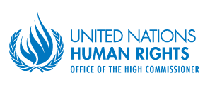

BIOGRAPHIES OF THE FELLOWS

Voluntary Technical Assistance Trust Fund to support the participation of LDCs/SIDS in the work of the Human Rights Council

Mr. Damas Mutagoma, Human Rights Treaty Body Reporting Specialist, Ministry of Justice (MINIJUST), Rwanda

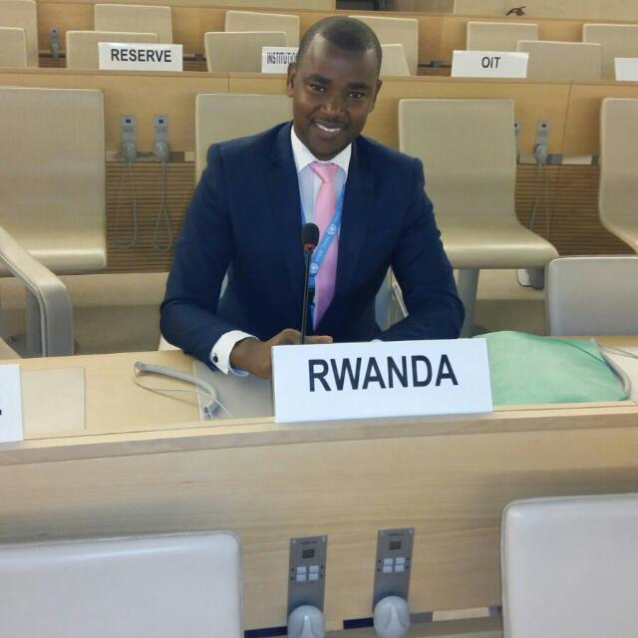
Mr. Mutagoma is a Human Rights and Treaty Body Reporting Specialist in the Ministry of Justice (MINIJUST) of the Government of Rwanda. He is a focal point for all human rights issues and he is responsible on the issues related to international justice and judicial cooperation.
Prior to joining MINIJUST, Mr. Mutagoma had worked at the Rwandan Parliament in the legal drafting department. He is doing a master’s Degree in Public International Law at Kigali Independent University and has completed the Bachelor’s degree at the same university.
Subject of the Fellowship research study: Integrating a gender perspective in the Universal Periodic Review Follow up
Ms. Jolina Tausinga, Senior Desk Officer, Solomon Islands

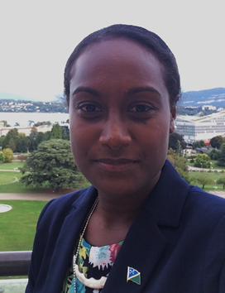
Ms. Tausinga is the Senior Desk Officer under the UN and Americas Branch at the Solomon Islands Ministry of Foreign Affairs and External Trade. Her duties in the division are to liaise with Ministries, Diplomatic Missions on matters relating to the UN and Americas Branch. Providing assistance to the Assistant Secretary in policy paper, briefs, reports, country statements, delegations attending international conferences, monthly and quarter report and other duties as delegated. Prior to joining the MFAET she graduated with a Bachelor of Arts majoring in international relations at Griffith University in Brisbane, Australia.

Subject of the Fellowship research study: “Assessment of Solomon Islands' past contribution to HRC discussions and decisions and of SIDS challenges in that respect: Options for thematic areas in the HRC that Solomon Islands can actively engage in and during the HRC sessions”.

Ms. Bynta Ernest, Foreign Service Officer in the Ministry of External Affairs, International Trade and Civil Aviation, Saint Lucia

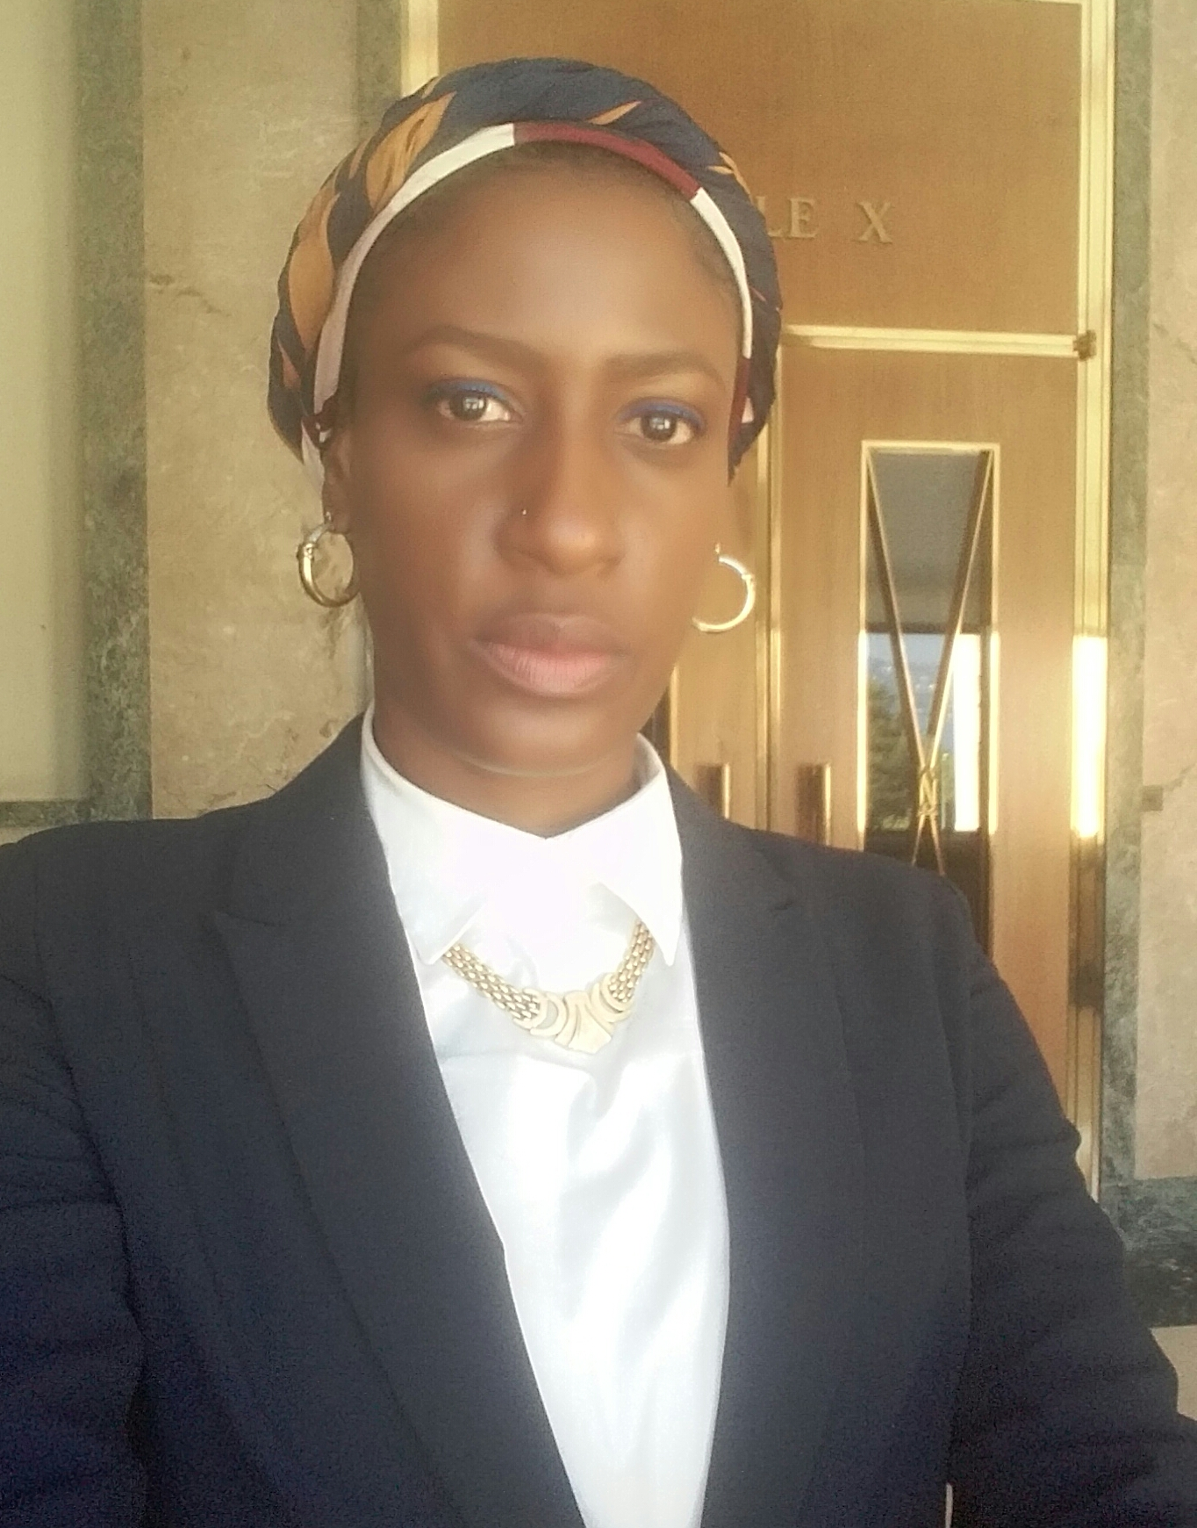
I am here on this Fellowship in the capacity of a Foreign Service Officer in the Ministry of External Affairs, International Trade and Civil Aviation. I was chosen to participate as I most recently assisted in the compilation of the information which went into the formulation of Saint Lucia’s national report for the Universal Periodic Review.

My background is Communication, and I hope to use it to effectively transfer the knowledge acquired during my tenure as a Fellow. My desire is that Saint Lucia is more active in the Human Rights Council as well as establishes the necessary domestic mechanisms that will assist in making this possible, in addition to improving its human rights situation.
Subject of the Fellowship research study: “Strategic Plan for Saint Lucia Permanent Mission’s engagement in the work of Human Rights Council: Options for defining priorities”.

Mr. Rajendra Thapa, Legal Officer, Ministry of Foreign Affairs, Nepal

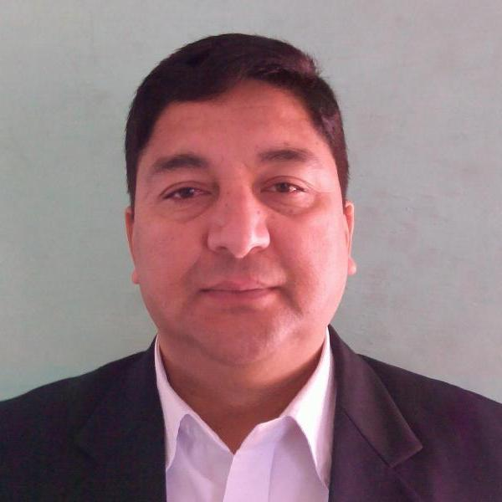
Mr. Thapa is Legal Officer at the Ministry of Foreign Affairs of Government of Nepal. He is responsible on the issues related to the international law, inter-governmental organizations including UN, human rights law, national obligations and commitments concerning implementation of international conventions, treaties and programs. He also involves in preparing country reports, legislative drafting and in providing legal opinion on legal and policy issues. He has twenty five years of working experience in Nepalese Civil Service. Mr. Thapa is a recent graduate in Masters of Laws (LL.M.) from American University Washington College of Law with specialization in International Human Rights Law. He has also completed LLM and MA in Anthropology from Tribhuvan University in Kathmandu and MPA from SKKU, Seoul South Korea.

Subject of the Fellowship research study: “Assessment of Nepal’s past contribution to HRC discussions and decisions: Options for building on current strengths and enhancing Nepal´s participation in the work of Human Rights Council.”

Ms. Kerry Bonamy, Foreign Service Officer, The Bahamas
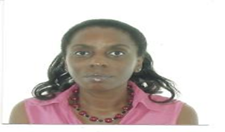

Ms. Kerry Bonamy, an employee of the Ministry of Foreign Affairs and Immigration of the Government of the Commonwealth of The Bahamas for 18 years, as a Foreign Service Officer in a number of capacities. On behalf of her country, Ms. Bonamy has had the pleasure of working at three (3) overseas missions for The Bahamas, namely, Canada, Haiti, Washington, D.C., USA as well as short term training opportunities in a number of countries. Current responsibilities are oversight of the Legal Division at The Ministry. A core responsibility of the Division being bilateral and multilateral Treaties, an important element is the reporting aspect, another, is the relational aspect of national policy regarding these Treaties, Agreements and evaluating the impact associated to existing legal structures or whether any exist at all.

Subject of the Fellowship research study: “An assessment of HCR mechanisms on Migration: respective roles and parameters for the Bahamas ‘engagement with them.”

Ms. Cassandra Labor-Bangura, Legal Expert, Ministry of Foreign Affairs and International Cooperation, Sierra Leone

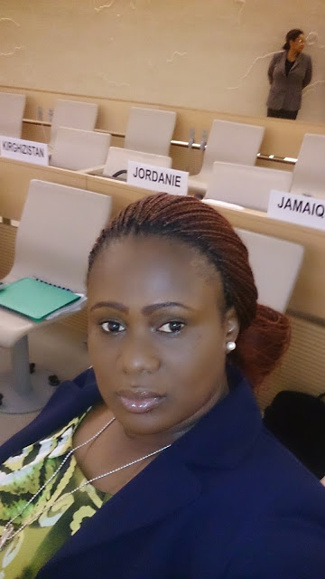
Cassandra Labor-Bangura is the Legal Expert in the Ministry of Foreign Affairs and International Cooperation. She has had over six years’ experience with working in this Ministry and has been the Head of the Human Rights Secretariat, in the Ministry, for two years. The focus of her work with the Ministry has been ensuring compliance with international norms, reporting on formal and informal commitments/obligations that concerns human rights and assisting with cooperation between line-ministries, agencies, civil society groups and the Human Rights Commission. She was responsible for drafting the first national report to the UPR, the CCPR and CAT reports to the treaty bodies and the ACHPR report. She has interacted reacted with the HRC in three regular sessions and the first cycle of the UPR and has also participated in a treaty body review. Ms Labor-Bangura is a Lawyer by trade and has practiced law in the High Courts of Sierra Leone, the Special Court for Sierra Leone and the Ministry of Justice in the Gambia.

Subject of the Fellowship research study: “Framework for an active engagement of an LDC member of the HRC: efficient cooperation between the Permanent Mission of Sierra Leone in Geneva and its capital.”

-----

