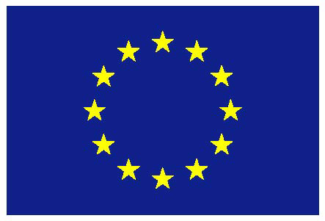

European Union

UNITED NATIONS

6th session of the Open-ended intergovernmental working group to consider the possibility of elaborating an international regulatory framework on the regulation, monitoring and oversight of the activities of private military and security companies

Intervention by the European Union

Geneva, 22 May 2017
- CHECK AGAINST DELIVERY -

UNITED NATIONS
(22 May 2017)
6th session of the Open-ended intergovernmental working group to consider the possibility of elaborating an international regulatory framework on the regulation, monitoring and oversight of the activities of private military and security companies
EU intervention

The European Union would like to thank the Chairperson-Rapporteur and the Secretariat for the work in preparation of this session and during the session.

The EU has actively and constructively engaged in the discussion of this Intergovernmental Working Group over the past six years. As the 5th session ended, we indicated that it was time to take stock. We are pleased that the Program of Work for the 6th session has been developed to meet this objective. We also welcome the willingness of the Chairperson-Rapporteur to explore a direction of work which can hopefully be agreeable to all. In this context, we welcome the circulation by the Chairperson-Rapporteur prior to the session of a "discussion document: elements for an international regulatory framework on the regulation, monitoring and oversight of the activities of private military and security companies".

We see this as a concrete way forward in the direction suggested by the EU since the 4th session when we called for the "Consideration of the range of options to be explored to further develop an international regulatory framework, including international standards setting, development of guidelines, possibly actions plans or model laws, contract templates based on the Montreux Document, good practices and mutual legal assistance programmes".

The industry is complex, and fast evolving, and we need a multifaceted response to the challenges. A range of obligations for States already exists, as well as several processes to set new standards, to elaborate concrete guidance for specific sectors, and to ensure oversight and accountability. This is illustrated for instance by:
- progress made in the Montreux Document Forum with the 3rd plenary on 27-28 April 2017 – the EU is pleased to be a member of the Group of Friends of the co-Chair (Switzerland, ICRC) along with China, Costa Rica, Madagascar and the US;

- the operationalisation of the Geneva-based International Code of Conduct Association as an oversight mechanism, as well as the new standards elaborated by ISO;

- the tools developed by the Geneva Centre for the Democratic Control of Armed (DCAF) such as the " Legislative Guidance Tool for States to Regulate Private Military and Security Companies" as well as a "Contract Guidance Tool" which will be useful for clients, not only States and international organisations, but also potentially for others such as humanitarian NGOs hiring or considering a private security company (PSC) to ensure the security of their operations.

The European Union is also pleased with the increased recognition of the relevance across sectors, including in the case of Private Security Companies, of the UN Guiding Principles on Business and Human Rights, and their implementation. The High Commissioner's report "Improving accountability and access to remedy for victims of business-related human rights abuse" and the Accountability and Remedy Project developed by OHCHR are particularly useful for further progress on access to remedy. They were recognized in the Council Conclusions on Business and Human Rights adopted on 20 June 2016. We were pleased to see the adoption by consensus of resolution 32/10 presented by the core group (Argentina, Ghana, Norway, Russian Federation) as a follow-up to the High Commissioner’s report (A/HRC/32/19 and Add.1).

Against this background, we consider the "discussion document" as a useful basis for future work in the framework of an Intergovernmental Working Group if we collectively decide to recommend such a way forward to the Human Rights Council. It would be a breakthrough and a much needed sign that we can collectively make progress on this issue.

The European Union believes that private security companies need to respect international humanitarian law and international human rights law. We should not lose sight of our shared objective to prevent abuses, and provide remedy when abuses occur. The companies, and their clients, need a predictable environment to operate in respect of international human rights law and international humanitarian law. Human rights defenders and victims need reliable avenues for access to remedy, be it through judicial or non-judicial mechanisms. We hope that the development of an international regulatory framework can complement and strengthen existing initiatives such as the Montreux Document Forum and the International Code of Conduct Association.

