 | Male | Female | Total | % Geographic distribution
African States | 11 | 7 | 18 | 22.50%
Asian States | 7 | 6 | 13 | 16.25%
EEG | 5 | 5 | 10 | 12.50%
GRULAC | 10 | 4 | 14 | 17.50%
WEOG | 13 | 12 | 25 | 31.25%
Grand total | 46 | 34 | 80 | 100%
Gender balance | 57.50% | 42.50%

Regional distribution of mandate holders including gender composition
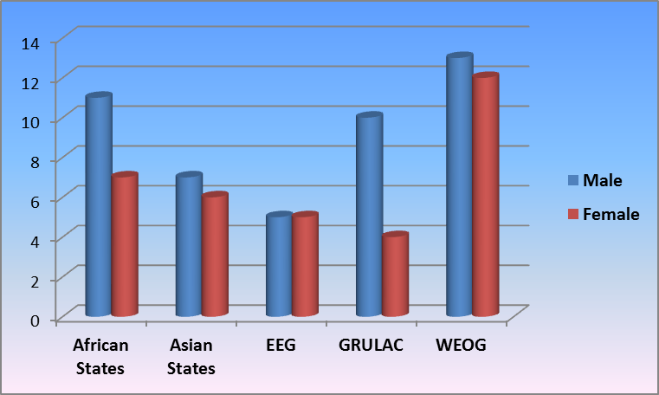
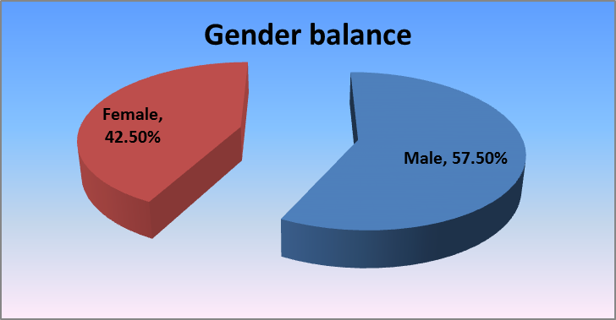

Geographic distribution in percentage
