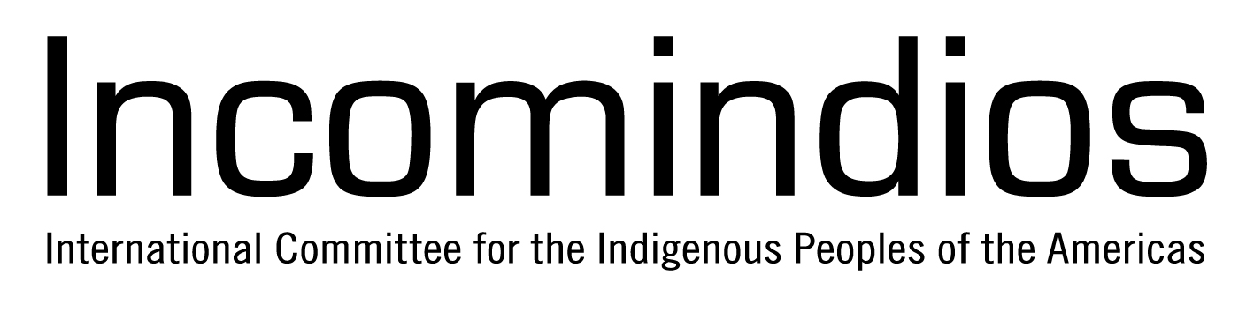
AIPNEE
Asia Indigenous Peoples Network on Extractive Industries and Energy
3rd Business and Human Rights Forum
Side Event
02 December 2014
14:30 - 16:00
Palais des Nations (Room to be announced)

Indigenous Peoples and Extractive Activities:
Challenges and the FPIC as an approach to solution

Extractive industries and corporate exploitation is one of the gravest and most urgent threats facing Indigenous Peoples and their communities in the region and around the world. This situation is based on the fact that a lot of the world’s natural resources are found on indigenous ancestral lands. Corporations oftentimes in cooperation with government extract these resources without the consent of the respective Indigenous Peoples.

The entry of destructive projects in indigenous communities gravely violates Indigenous Peoples’ collective rights to lands, territories and resources. Many Indigenous Peoples’ communities affected by extractive industries face forced eviction from their ancestral lands, loss of livelihood, disintegration of communal ties and militarization, these circumstances lead to a serious loss of culture and lowering of the living standard for the affected communities.

In the UN Permanent Forum on Indigenous Issues (UNFPII) problems and rights violations related to mining, oil and gas have consistently been among the most common issues raised. The UN Declaration on the Rights of Indigenous Peoples (UNDRIP) emphasizes the right to ‘free prior informed consent’ (FPIC) - a way to establish a balanced dialogue between the parties involved. The States are required to consult and cooperate in good faith with the Indigenous Peoples in order to obtain their consent. Various international bodies have also expressed concern and initiated processes to address the negative impact of extractive industries. These include the establishment of the UN Working Group on Business and Human Rights, the focus of the UN Special Rapporteur on the rights of Indigenous Peoples on the impacts of extractive industries on Indigenous Peoples’ territories and other initiatives by civil society groups.

The objectives of the side-event:

1. Present the general situation of Indigenous Peoples in the different regions in regard to extractive and energy industries by sharing selected case studies and introducing recent publications.
2. Provide a space for stakeholders involved in and affected by the extractive and energy industries (States, companies, Indigenous Peoples, international organizations etc.) to discuss and promote the practice of FPIC. The discussion aims at possible approaches to solution for the effective implementation of FPIC with focus on steps to be taken by the different stakeholders.

Panelists:

June Lorenzo, Laguna-Acoma Coalition for a Safe Environment (Navajo, U.S.A.)
Joan Carling, Asia Indigenous Peoples Pact, indigenous expert member UNPFII (Igorot, Cordillera, Philippines)
Saro Legborsi, Movement for Survival of Ogoni People (Ogoni, Nigeria)

Moderator:

Helena Nyberg, Incomindios (Switzerland)

Interpretation, snacks and refreshments will be provided.

Co-Facilitators

Incomindios  The International Committee for the Indigenous Peoples of the Americas (Incomindios) was founded in Geneva in 1974 at the suggestion of the International Indian Treaty Council (IITC). The original purpose of the organization was to provide Indigenous Peoples better access to the United Nations in Geneva. Today, we are part of an extensive network, evolved through close contact with Indigenous Peoples and their representatives. As one of the leading NGOs for indigenous rights, we advocate for indigenous issues worldwide and specifically focus on North, Central and South America. Since 2003, Incomindios holds consultative status at the UN (ECOSOC). See more at: www.incomindios.ch | AIPNEE  Indigenous Peoples in Asia initiated the establishment of the Asia Indigenous Peoples Network on Extractive Industries and Energy (AIPNEE) in Kuala Lumpur, Malaysia on March 2013. It is a regional platform for solidarity and support for and among indigenous communities affected by State and corporate projects implemented in our territories. The network aims to expose abuses of Indigenous Peoples’ rights, particularly violations to land rights and work for substantial improvement in industry policies, standards and practice as well as the national and international frameworks in which these operate. The AIPNEE also aims to unite with other initiatives in support of land rights and indigenous concerns.

