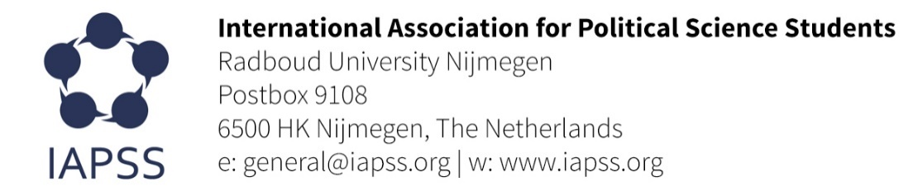
UN Forum on Human Rights, Democracy and Rule of Law: the role of youth in public decision-making
21-22 November 2016 | Geneva, Switzerland

STATEMENT FROM THE INTERNATIONAL ASSOCIATION FOR POLITICAL SCIENCE STUDENTS (IAPSS)-ELENI KRIKELI
My name is Eleni Krikeli and I represent the University of Melbourne as well as the International Association for Political Science Students (IAPSS). First of all, I would like to thank the panellists for their enlightening presentations and the honourable delegations for their participation and inputs during the Forum.
IAPSS is a platform for political science students and young people interested in political affairs. The association aims to have a global impact in the political science as well as to strengthen the academic profile and skills of all members by offering them various unique opportunities.
IAPSS currently embraces over 10 association members and almost 1,000 individual members worldwide. It coordinates projects and activities that aim to help young people engage with political studies, and gives them the opportunity to create a more sustainable political and social environment. Thus, we believe that the interest of youth in political affairs is very essential not only in a domestic level but also on a broader, global scale.
During the two first sessions of the Forum, the participation of young people in decision-making process was mainly discussed. Indeed, the inclusion of youth in the parliamentary system will be beneficial because it will enhance the participation and motivation of young people in political affairs. But this can happen only in countries in which democratic values are highly respected and promoted. This cannot be achieved in countries that not only disregard any political initiative from young people or organizations but their governments do not give them the proper resources either, such as education, information and safe environment.
Therefore, my question is the following: Can the international system provide assistance to those organizations and individuals in order to achieve their goals? Also, can the international community play the role of the median between the governments and youth in order to close their gap, especially in countries that I mentioned above?

Thank you for your attention.

