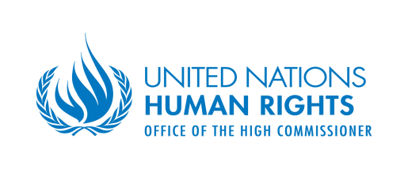 | 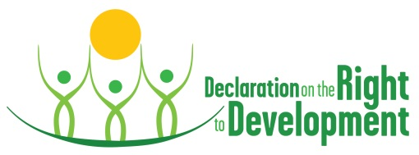
PANEL EVENT: DECLARATION ON THE RIGHT TO DEVELOPMENT AT 30
Development Frontlines: of rights, justice and fairness
19 October, 13:15-14:30
United Nations HQ, New York, Room CR.E

Background
Thirty years ago the UN General Assembly adopted the Declaration on the Right to Development. This anniversary panel will explore the ramifications of this Declaration in the context of exigent, contemporary development challenges that continue to pose obstacles and threats to delivering on the promise of this Declaration. The panel will explore a myriad of issues ranging from current debates on trade and investment to those surrounding tax and climate justice. By providing a snapshot of what these challenges are and how solutions are being fashioned in response, we hope to invigorate a discussion on how the implementation of this Declaration can be reimagined for this increasingly globalized world.
Objectives
- To examine and analyse contemporary development challenges
- To discuss how innovative development solutions are being forged at varying levels and scales
- To address legitimacy and accountability deficits in global governance and in the economic realm
Substance
The panel event will feature four presentations on the following topics: (1) Declaration on the Right to Development at 30, (2) Trade and investment agreements, (3) Tax justice and the “Panama Papers” investigation, and (4) Climate Justice.
- Declaration on the Right to Development at 30
This presentation will cover the key aspects of this Declaration and the political and legal challenges that it has faced over its 30 year history. How can this Declaration frame current development debates and agendas, including the 2030 agenda over its implementation? How can this Declaration be revived and reinvigorated over the next decade, so as to result in transformative change?
- Trade and investment agreements
Historically trade deals focused narrowly on tariffs but both within the multilateral context of the WTO and increasingly in bilateral and regional Free Trade agreements (FTAs). This has expanded to regulations relating to services and also rules regarding intellectual property, investment and many other issues. A recent trend has been the rise of mega-regionals, such as the Transpacific Partnership (TPP) agreement which has now been signed in and the Transatlantic Trade and Investment Partnership (TTIP) agreement between the EU and the US which has spurred a great deal of contention. These pacts are framed as partnerships covering a broad range of areas and with clear impacts on regulatory power and governance. But these mega-regional agreements also pose a threat to the enjoyment of a suite of both substantive and procedural human rights.
How do we confront the challenges brought by these kinds of plurilateral trade and investment arrangements? What are the impacts on the right to development and human rights more broadly? How can the Declaration on the Right to Development aid in this frontline?
- Climate justice
Climate justice seeks to address the environmental impacts of climate change through attention to human rights and development interests. This approach ensures that as the international community takes steps to mitigate and adapt to climate change, the rights of all people are protected, particularly those of individuals and groups in the most vulnerable situations. Successive findings and actions have established a connection between human rights and climate change, as well as international obligations to protect human rights in connection with climate action. Climate justice is a critical perspective for further strengthening the links between human rights and climate change so as to assess the impacts and develop effective frameworks and tools for action.
Guided by both science and ethical consideration for human rights, there must be greater understanding of the impacts of climate change on human rights through data gathering, information sharing, and compiling of best practices. Development and implementation of policies and practices for effective climate mitigation and adaptation should be made thorough consideration and provision for protection of human rights. Policies, decisions, and actions should be inclusive and taken with care to protect against multiple discrimination. Free, active and meaningful participation of those most affected by climate change must be ensured, particularly those in vulnerable situations, and provisions made to protect the enjoyment of human rights for future generations.
How do we confront the challenges brought by climate change and its impacts? How can the Declaration on the Right to Development aid in this frontline?
- Tax justice and cooperation
A just taxation system is necessary for the enhancement of human rights. Taxes do not only represent an important economic source for governments, but they also are one of the most essential instruments to make governments accountable to their people for delivering on human rights. Recent research has shown that one of the main factors attributed to financial constraints, particularly in the developing world is tax abuse. To ensure a transparent taxation system among developed states and developing states the UN adopted the Model Double Taxation Convention to avert tax evasion and double taxation through different sets of rules. The new revision of the Convention aims for developing countries to participate more in bilateral tax treaties to advance on the SDG’s. The latest global revelation of business and tax corruption is the Panama Papers. It has been one of the biggest investigative collaborations in history, in which journalists from all around the world worked together in more than 25 different languages. The search and analysis of not only the Panama Papers, but many other global accounts on tax fraud and corruption continues as a crucial measure to human and economic development and human rights. Tax abuse through the operation of tax havens, financial secrecy and other fraudulent networks are detrimental to the realization of human rights, and undercuts the provision of the Covenant on Economic, Social and Cultural Rights requiring the state to allocate maximum available resources to implement these rights.
Continued work is needed toward building an international framework of collaboration between the tax justice and human rights communities. Such a framework is necessary in order to hold duty-bearers and governments responsible for addressing and mitigating the negative impacts of broken taxation regulations.
How do we confront the challenges brought by tax abuse? How can the Declaration on the Right to Development aid in this frontline?

