Check against delivery

Human Rights Council 32nd Session
Panel discussion on the promotion and protection of the right to development: Commemoration of the 30th anniversary of the Declaration on the Right to Development

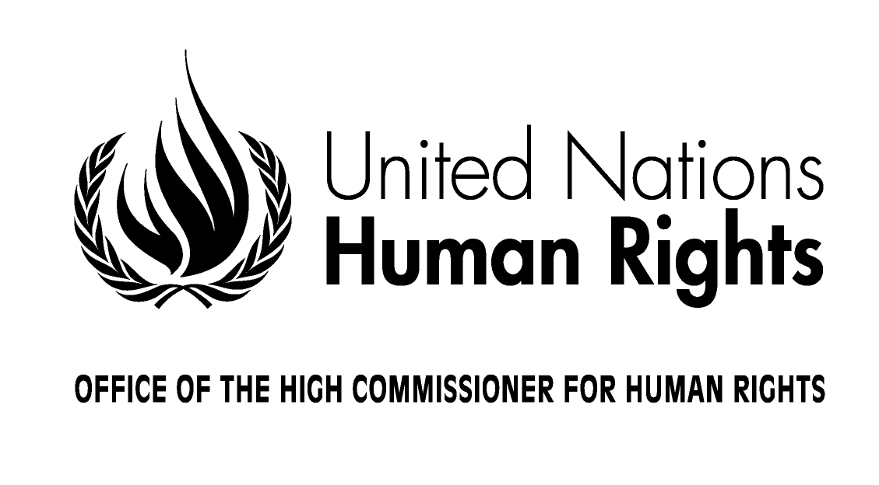

Opening Statement by
Zeid Ra'ad Al Hussein
United Nations High Commissioner for Human Rights

Geneva, 15 June 2016
Excellencies,

We are here to celebrate the Declaration on the Right to Development, which thirty years ago broke new ground in the struggle for greater freedom, equality and justice.
It acclaimed long-lost freedoms and independence, and re-asserted equality for all nations and peoples – including their right to self-determination and their right to sovereignty over natural resources. But the Declaration’s central focus was on the human person. Placing individuals at the heart of the development process, it called for every member of society to be empowered to participate fully and freely in vital decisions. It demanded equal opportunities, and the equitable distribution of economic resources, including for people traditionally marginalized, disempowered and excluded from development, such as women, minorities, indigenous peoples, migrants, older persons, persons with disabilities and the poor.
Bridging human rights with international relations, and building on the intrinsic interactions of human rights and development with peace and security, the Declaration demanded better governance of the international economic framework and re-defined development as far deeper, broader and more complex than the narrow, growth-and-profit focus of previous decades.
The wisdom of this multidimensional approach has stood the test of time. Today, the local and the global have become ever more connected, and from communication technology to climate change, global supply and value chains to access to medicines, the right to development is manifestly relevant.
Amid today’s slow global economic growth and low commodity prices, this thirtieth anniversary should remind the international community of development’s true purpose: to improve the well-being of all members of society. True development generates greater social justice, not deeper exploitation; and it reduces the towering inequalities which confiscate the fundamental rights of those who are marginalised and poor.
Some progress has been made in global efforts towards realising the vision of the Declaration on the right to development. But that progress has been uneven, particularly for people in Africa, least developed countries, landlocked developing countries, small island developing States, and most other developing countries, as well as for disadvantaged people in both the Global North and South. Insufficiently regulated globalization, persistent poverty and rising inequalities continue to rob people of their rights, and they fuel multiple crises and conflicts. That violence in turn destroys hard-won development progress, and kills and displaces people wantonly, in a terrible downward spiral of avoidable suffering.
In contrast, the 2030 Agenda for Sustainable Development, the Addis Ababa Action Agenda on Financing for Development and the Paris Climate Agreement set forth detailed and realistic programmes that build on each other with the potential to transform the realisation of human rights for millions of people. The 2030 Agenda, which promises to end extreme poverty within our generation, promotes an integrated vision of development with responsibilities that are shared by both the global North and South. This vision is clearly born of the Declaration on the right to development, which offers much needed prevention, since it promises solutions for root causes, including structural challenges, at all levels.
Most evidently, the right to development forcefully calls for individuals to be free to participate in vital decisions. At the international level, it addresses multiple challenges which originate in our failure to adequately regulate globalization. The engines of globalization – among them, trade, investment, finance, and intellectual property - must be made compatible with the human rights obligations of States. Global development cannot mean that people are denied access to essential medicines, that small- farmers are denied fair earnings, or that already impoverished people are further burdened with unsustainable national debt.
Thus the 2030 Agenda addresses many of these systemic obstructions that disadvantage the poor – among them, distorted trade frameworks and weak international governance over powerful transnational actors, including the vectors of financial speculation. It promises better regulation of global financial markets, and an enhanced voice for developing countries in international economic and financial institutions. It commits all States to cooperate in fostering international development and endorses the principle of special and differential treatment for developing countries, in particular least developed countries.
Recognizing that all human rights work together – and that together, they build the core conditions for development and peace – the Agenda makes strong commitments to provide access to justice for all, with effective, accountable and inclusive institutions at all levels, and an end to corruption. This echoes the Declaration's emphatic call for "equal attention and urgent consideration" to the implementation, promotion and protection of all civil, political, economic, social and cultural rights – and its insistence that the promotion of, respect for and enjoyment of one so-called “category” of human rights “cannot justify the denial of other human rights and fundamental freedoms”.
The 2030 Agenda is a child of the right to development. As such, it must not be stunted by indifferent action, malnourished by failed commitments or denied safe passage to its fullest realization. But the right to development extends even beyond the massive global agenda of the Sustainable Development Goals. It offers a framework in which to address gaps and failures in responsibility, accountability and regulation in both national and global governance.
Trade and investment policies and agreements can have profound implications on the realisation of human rights, with potential adverse impacts in relation to food, water and sanitation, health, indigenous persons, equity and democratic decision-making. Both within the multilateral context and increasingly in bilateral and regional Free Trade agreements, we are also seeing similar regulations relating to services, intellectual property, investment and trade plus issues. Recently, sprawling modern pacts known as mega-regionals have begun changing the landscapes of trade and investment in quite unprecedented ways. The right to development guides the international community, and individual States, to ensure human rights in this context.
For our part, my Office will continue to reach out to all States and stakeholders to carry out our individual and collective obligations in realizing the right to development. As the Declaration so clearly states, everyone, without distinction, is entitled to a social and international order in which human rights and freedoms can be realised. That includes the millions of youth facing unemployment in countries both North and South. The people of formerly affluent nations now crumbling under the burdens created by economic and financial crises. The millions of women, men and children locked in the prison of poverty, and those suffering war and displacement.

The thirtieth anniversary of the Declaration on the right to development must renew in us the spirit of multilateral action for the common good – which is our only hope for survival on this small and fragile planet that we share.

