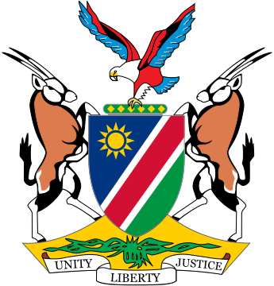

Statement by H.E. Sabine Böhlke-Möller, Ambassador/Permanent Representative, 32nd Session of the Human Rights Council, High Level Panel on the 30th Anniversary of the Declaration on the Right to Development, 15 June 2016

Mr. President,

We thank the panelists for their insightful presentations and align our statement to those read on behalf of the Africa Group and the NAM.

Namibia as a developing country is delighted to participate in this 30th anniversary panel on the Right to Development. Like all other developing countries across the world, Namibia strives to guarantee full realization of the right to development as an inalienable and independent human right by virtue of which all human rights can be fully realized and all people can enjoy economic, social, cultural, and political rights. We share the same desire and ambition, that is: to be able to provide adequately in the basic needs of our people thereby ensuring a dignified life for us all.

Mr. President,

The lack of development opportunities poses a serious threat to the well-being of the citizens of developing countries and contributes to instability and conflict. Without equal development opportunities we cannot adequately provide in the housing, health, education and nutritional needs of our people, which put us at risk of suffering major setbacks when we are faced with natural disasters, outbreak of disease or conflict.

Mr. President,

30 years ago, the GA adopted the Declaration on the Right to Development, saying,

“Bearing in mind the purposes and principles of the Charter of the United Nations relating to the achievement of international co-operation in solving international problems of an economic, social, cultural or humanitarian nature, and in promoting and encouraging respect for human rights and fundamental freedoms for all without distinction as to race, sex, language or religion”. We are of the opinion that the 2030 Agenda for Sustainable Development and its 17 goals is a tool for the implementation of this creed. We are delighted that we now have the opportunity to use an initiative, which we have all agreed to, in moving forward to achieving inclusive, equitable and sustainable development for all.

I thank you.