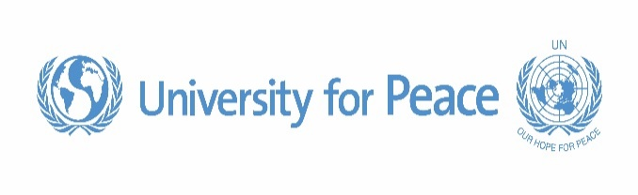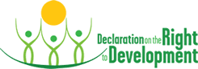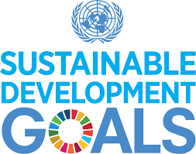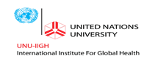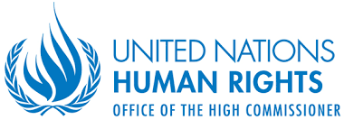

Application Deadline: 24 November 2017

* To enroll, fill up the application form at [www.upeace.org/specialforms/rtd-sdg](http://www.upeace.org/specialforms/rtd-sdg)
* Candidates will be selected on the basis of merit taking into account professional, regional, and gender diversity
* For more information, please visit <http://www.upeace.org/academic/other-studies-at-upeace/certificates-and-diplomas/rtd-sdg> or write to [hrc@upeace.org](mailto:hrc@upeace.org)

**Interactive E-Learning Module on**

**Operationalizing the Right to Development in**

**Implementing the Sustainable Development Goals**

Option One: 10 January to 6 February 2018

//OR///

Option Two: 4 April to 1 May 2018

Instructed by:

**Dr. Mihir Kanade**, Head of the Department of International Law and Director of the Human Rights Centre,

University for Peace, Costa Rica, and

**Dr. Priscila Schwartz**, Senior Lecturer and Director of the Energy and Natural Resources Law Programme, Royal Docks School of Business and Law at the University of East London, United Kingdom.

The Office of the United Nations High Commissioner for Human Rights, the University for Peace, and the United Nations University’s International Institute for Global Health are jointly offering a four-week interactive and instructor-led e-learning module to train stakeholders on the normative, theoretical and practical importance of and mechanisms for operationalizing the Right to Development in the implementation of the Sustainable Development Goals.

* No fee: The training is offered free of charge to participants.
* Expert Design: The module is designed by global experts from several countries.
* Flexibility: Apply either for Round One or Round Two.
* Ideal Class Size: The two rounds are limited to 50 participants each, allowing for instructor-participant and peer-to-peer learning and sharing of experiences.
* Dynamic pedagogy: Readings, multimedia, webinars, discussion forums, quizzes, and other cutting-edge tools.
* Balanced time management: Designed for working professionals; requires 3 to 5 hours per week as per convenience; course-weeks begin on Wednesdays to allow weekends to fall in the middle.
* Certification: Participants who successfully complete the module will be awarded a certificate of completion.

Who should apply: Staff of governmental, intergovernmental, and non-governmental organizations, human rights practitioners and defenders, development practitioners, academics, students, and others engaged in realizing the SDGs.