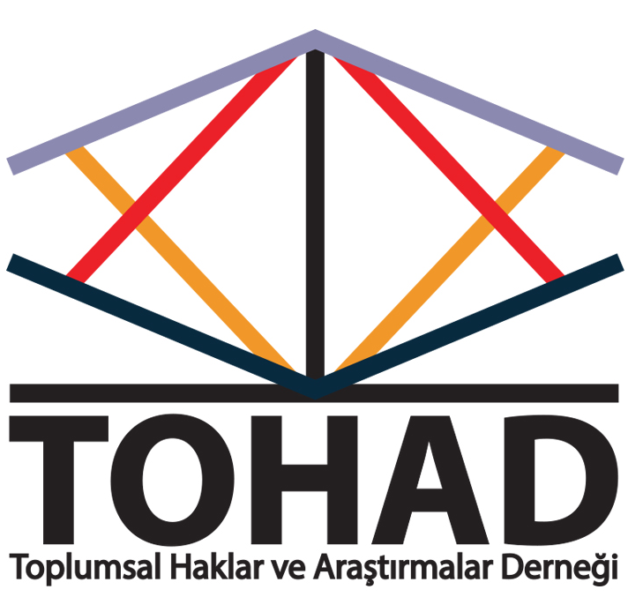
(Social Rights and Research Association-Turkey)
Submission to the “right of persons with disabilities to participate in decision-making”

Address:Cennet Mahallesi Turgutreis Caddesi No:18/K.D Küçükçekmece/İstanbul
Phone: +90 212 426 26 28
Email:bilgi@tohad.org
Web: www.tohad.org and http://www.engellihaklariizleme.org
Facebook: https://www.facebook.com/ENGELLIHAKLARIIZLEME?fref=ts
Twitter: https://twitter.com/hakizleme / https://twitter.com/tohad_bilgi
Contact: Süleyman Akbulut, Chair
This submission has been prepared by Suleyman Akbulut (Chair), Hakan Ozgul (General Secretary) and Idil Seda Ak (International Relations) on behalf of TOHAD.
Consultant: Idil Isil Gul, Assistant Professor, Faculty of Law, Istanbul Bilgi University

Status of Disabled Individuals in Turkey
According to a study conducted by the Prime Ministry Administration for Disabled People in 2002, population of the disabled people in Turkey is 12,29% (8.431.937) (including those with chronic diseases). On the other hand, according to the results of “2011 Population and Housing Survey”, percentage of the population with at least one disability (3 years of age or older) is 6.9% (4.876.000 people). While the percentage is 5,9% among men, it is 7,9% among women.”In the survey, persons with multiple impairments were not considered as a separate category.
Social and economic data on individuals with disabilities were collected in the “Research on the Problems and Expectations of the Disabled – 2010” conducted by the General Directorate of Services for Persons with Disabilities and Elderly People and Turkish Statistical Institutions (TURKSTAT). According to this research, 41,6 % of disabled individuals registered in the database system are illiterate. 18,2% know how to read and write but do not have a primary school diploma. 22,3% are primary school graduates; 10,3% received education at the level of primary-secondary education and 7,7% received high school education or higher education.
Employment data for the disabled displays a similar profile. According to the above mentioned Research, only 14,3% of persons registered as having at least one impairment, is employed.
Participation of Disabled Individuals in Decision-Making Processes
There are two main sources of legislation introduced for the disabled in Turkey. These are:
1- Turkish Disability Act no. 5378 (introduced first in 2005 and revised in 2014),
2- UN Convention on the Rights of Persons with Disabilities (CRPD) which Turkey signed in 2007 and ratified in 2009.According to art. 90 of the Turkish Constitution, the Convention has the force of law.
Turkish Disability Act no. 5378 introduced in 2005 was based on a medical approach. However, in 2014 (after the ratification of the UNCRPD) the Act was revised in accordance with the Convention. Thus, the text in force today is based on a human rights approach.
Turkish Disability Act no. 5378 adopts the participation of non-governmental organizations in policy-making processes as a principle. Article 4, paragraph (i) of the Turkish Disability Act no. 5378 guarantees the participation of persons with disabilities, their families and DPOs in policy making, decision making and in the provision of services. On the other hand, another provision in the Act stipulates that Ministry of Family and Social Policies (MFSP) shall be consulted on legislation regarding persons with disabilities.
Even though participation of persons with disabilities, their families and DPOs is included as a principle in the legislation, it is not possible to say that participation takes place at the desired level. Reasons and indicators relating to this can be listed as follows:
1-Lack of mainstreaming and coordination:
While persons with disabilities might have a say on decisions or services “exclusively” about persons with disabilities, persons with disabilities are not consulted in mainstream decision making processes or in the design of mainstream services.
Many Ministries consider disability related issues as irrelevant to their functions. They see all disability related issues as the responsibility of the Ministry of Family and Social Policies or the Ministry of Health. Consequently, these Ministries neither coordinate with other Ministries, nor consult persons with disabilities in their work.
2- Participation Range and Representation Problem
NGOs carrying out activities for the disabled in Turkey are sometimes involved in decision-making and implementation mechanisms, though limited. Commissions that are provided with funds for projects for the disabled by Turkish Labour Agency and Accessibility Monitoring and Inspection Boards (EİDK) are typical examples to it. However, only “confederations”, which are higher-level organizations, are involved in those mechanisms where decisions are taken for implementation.
There are 107.809 active non-governmental organizations in Turkey. 1.394 of them are so-called disability NGOs. Many of these are charity organizations. A study conducted by the State Supervisory Council of the Presidency (DDK) in 2009 states that: “There are generally two types of organizations for the disabled. First are the organisations supported but not managed by the disabled; the second are the self-help organizations managed by the disabled.” The study concludes that the organizations are quite weak and their level of institutionalization is also quite low.
Furthermore, there are federations formed by the associations and confederations formed by the federations in Turkey. Not all the associations are members of these higher structures in Turkey, where a total of three confederations exist. Participation of associations in these confederations is limited. Hence, representation of confederations is partial.
3- Problems regarding the Form and Content of Participation
Even when the Government technically consults persons with disabilities, there are problems. First of all, if the consultation is on a piece of draft legislation or a policy document, very short deadlines are given. Secondly, the process is not transparent and there is no sincere deliberation. The Government simply asks DPOs to send their comments; but no feedback is given on how these comments were taken into account (if they were at all). So when a final text appears, there is no information on how each article or policy was finalized. In such instances, the Government can feel free to claim that the text was finalized in consultation with persons with disabilities.
In many cases, the Government is inclined to act with total disregard of DPO input. For example, in 2013, Autism Platform (which contains 15 NGOs in itself) had the opportunity to work with the Ministry of Family and Social Policy on the draft of autism action plan. It was decided that the plan will be implemented by the Ministry of Family and Social Policy, in collaboration with the Ministry of Education, the Ministry of Health, the Ministry of Labor and Social Security, the Ministry of Youth and Sport and the Higher Education Board (YÖK).However, the Ministry of Family and Social Policy did not finalize the action plan with in the course of 2 years. And the efforts of NGOs (demonstrations, formal meetings etc.) alone were not sufficient to put enough pressure on the Ministry of Family and Social Policy to finalize the action plan over these years.
The attitude is not different with regard to the inclusion of persons with disabilities in monitoring either. The Government announced on October 30th, 2013 that the draft State Report to be submitted to the CRPD Committee is ready and asked NGOs to provide comments within 12 days. However, twelve day-period given for comments was not sufficient and many NGOs could not send their comments on the draft report. In any case, there is no procedure on how submitted comments are (if at all) are considered.
4-Procedural Problems in the Participated Areas
There are some areas in which the government cooperates with NGOs to fulfil its monitoring and inspection obligation. However, the impact of this cooperation is a matter of debate in terms of its outcomes. For instance, it is stipulated in the legal arrangements on monitoring and inspection of accessibility that monitoring and inspection are performed by a board. It is also stipulated that two persons from the confederations take part in this board.
Although abovementioned arrangement seemed like a positive development, results which were actually achieved were not at the expected level. According to the study conducted (until January 1st, 2015); 20 of the boards established in 81 provinces took no decisions and 60 of them took decisions on 2.273 buildings/structures. When it is considered that the number of public buildings only is more than a million, it is seen that the decisions taken are quite inadequate. According to the data obtained, 1 million 525 thousand 178 buildings are registered to accessibility building registration system and only 3 thousand 380 of them are 75% accessible.
On the other hand, as per Turkish Disability Act no 5378, boards were supposed to either give additional time to relevant private or legal persons to fix the situation created by the violation until July 7th, 2015 or impose administrative fines for the violation identified. Boards used their right to perform “unexceptional” extension in all violations and never imposed administrative fines. For this reason, impartiality of the decision taken is a matter of debate and it is considered that they may be political. 2 out of 6 members of existing boards are from NGOs while the remaining 4 are government representatives. Hence, independence of the boards is debated.
Fight Against Multiple Discrimination
CRPD encompasses a significant liability of taking measures for disabled persons with multiple disadvantages (woman-child etc.). However, whether or not Turkey has developed sufficiently effective policies on this area or taken efficient measures is disputable. Especially, certain issues identified in the legislation or in practice are an indication of this.
In comparison of the education level of male and female disabled persons, it is observed that the education level of men is higher than women. Illiteracy rate is 32,1% among men and 54,9% among women. The rate of literate non-graduates is 19,2% among men and 16,8% among women. The rate of primary school graduates is 26,3% among men and 16,5% among women. The rate of graduates of primary education or secondary school and equivalent is 12,5% among men and 7,1% among women. The rate of high school or higher is 9,8% among men and 4,7% among women.
According to the data of the Ministry of National Education (MoNE), a total number of 17 million 559 thousand 989 students benefit from organized education in 2014-2015 school year. As mentioned before, the ratio of the disabled population to the total population is 12.29% according to Turkey Disability Survey. However, considering the statistics of education, it is seen that disabled students constitute only 1.48% of total student population. It is obvious that disabled students are not able to access education under equal opportunities with their peers. With respect to female students, the picture is even more pessimistic. Again according to the statistics, of 14 million 950 thousand 897 students who receive education in public schools, 7 million 279 thousand 547 (48.7%) are female; and 7 million 671 thousand 350 (51.3%) are male students. Comparing the number of the students without disabilities on the basis of gender, it is observed that the difference between the female and male students is around 2.6%. However, it is a noticeable fact that the difference increases to 23% when the rates of female and male students are compared in inclusive students. When this data is taken into account, it is possible to say that disabled females are highly disadvantaged in access to the right of education. In the statistics published in 2002, the proportional difference between illiterate disabled females and disabled males is figured as 25%. It is clear that the situation has not changed in favor of disabled women and girls within the course of 13 years.
Employment rates involve similar indicators. For example, only 7.981 of 36.165 disabled civil servants are women. A similar situation is observed for disabled female workers. Inequality between women and men in job placement is evident in both 2013 and 2014. In both years, on average, only one woman finds employment opportunity for every five men placed for work.
The government does not yet have specific arrangements on the education of disabled girls or eliminating disadvantages of disabled women in employment.
Disabled women are more disadvantageous in certain aspects compared to women without disabilities. The government does not develop policies on this subject; on the contrary, it sustains the existing practices.
A typical example of this is the fact that disabled women are not admitted to the women shelters for victims of violence. In accordance with the provisions of Women’s Shelters Regulation they cannot get shelter support from these houses. In article 9of the mentioned regulation, section on Women not to be Admitted to the Women’s Shelter includes (d) women with mental disorders, (e) women with mental disabilities, and (g) elderly women in need of protection, care and aid; women with disabilities obstructing bodily functions and independently carrying out daily activities; women with contagious and severe diseases requiring continuous medical treatment, and women in need of similar special and continuous care are not admitted to the mentioned shelters.
Non-governmental organizations’ applications to MFSP since 2011 have not solved the problem. Within this period, although MFSP accepted the existence of the problem various times and stated that they were working on solving it, the fact that it has not been solved in 4 years shows that the government is not exerting sufficient effort to prevent multiple discrimination.

Population and Housing Survey-2011, http://eyh.gov.tr/yayin-ve-kaynaklar/arge-ve-istatistik/nufus-ve-konut-arastirmasi-2011 (date of access: 13.04.2014)
How Does the Society Understand Disability (Toplum Özürlülüğü Nasıl Anlıyor, ÖZİDA, 2009, http://www.eyh.gov.tr/upload/Node/8321/files/toplum_ozurlulugu_nasil_anliyor.pdf (date of access: 17.03.2014)
Ibid, p 4
Sub-paragraph (i) of Turkish Disability Act no 5378: Ensuring participation of the disabled, their families and non-governmental organizations representing them in the policy-making, decision-making and service provision processes for the disabled is taken as a principle.

