Questionnaire on Human Rights Council Resolution 31/06 – access to justice by persons with disabilities
Ministry of Justice,

Portugal

- Does your country have laws, policies or guidelines on access to justice, at any level of government, which ensure persons with disabilities, particularly women and children with disabilities:

- to participate in judicial and administrative proceedings on an equal basis with others in their role as witness, juror, complainant, defendant or other, including through the provision of procedural and age-appropriate accommodations (please identify and share the text of those provisions);

Yes, Portugal has laws and policies on access to justice which ensure persons with disabilities to participate in judicial and administrative proceedings on an equal basis with others.
According to article 71 of the Portuguese Constitution, citizens with physical or mental disabilities fully enjoy the rights and are subject to the duties enshrined in the Constitution, save for the exercise or fulfilment of those for which their condition renders them incapable.
Legal protection is the constitutionally and legally enshrined system ensuring that no one experiences difficulty or is prevented, due to their social or cultural status, or lack of financial means, from being informed of, exercising, or defending their rights (Law 34/2004, of 29 July, and Decree Law 71/2005, 17 March).
It consists of two types:
a. Legal information, which seeks to inform of one's rights and the legal system, providing for the optimum exercise of those rights and the fulfilment of the legally established duties, in particular by means of the gradual creation of services providing access to the courts and judicial services and;
b. Legal protection, which includes: legal advice, through law firms which it is intended will cover the entire national territory and which citizens may visit in order to receive free legal advice from legal professionals. Legal advice may involve carrying out extra-judicial steps or informal mechanisms of reconciliation.

- Does your country have laws, policies or guidelines on access to justice, at any level of government, which ensure persons with disabilities, particularly women and children with disabilities:

- to have individual legal standing in all administrative and judicial procedures, including the right to be heard as part of their right to fair trial;

Yes. Portugal has laws and policies on access to justice, which ensure persons with disabilities, to have individual legal standing in all administrative and judicial procedures, including the right to be heard as part of their right to fair trial.

According to the Portuguese Code of Civil Procedure

Article 20 | Representation of persons unable to receive the citation | 1 - People who, due to mental illness or other serious reason are unable to receive a citation shall be represented in their cause by a special guardian.  2 - The representation by the guardian ceases when it is deemed unnecessary, or when a document showing that the interdiction or disqualification has been declared, and a representative of the incapacitated has been appointed.  3 - The need for guardianship, whether original or supervening, is summarily appraised, at the request of the person under guardianship, which can produce any evidence.  4 - The appointed representative in the interdiction or disqualification action shall be summoned to occupy the place of guardian in the process.
Article 234 | De facto incapacity of the cited person | 1 - If the citation cannot be made because the person is unable to receive it, as a result of a notorious psychic anomaly or other de facto incapacity, the enforcement agent or the judicial officer shall report the occurrence, and the author of the citation shall be notified.  2 - Then, the process is forwarded to the judge that decides on the existence of disability, after the collecting the necessary information and produced the necessary evidence.  3 - After the temporary or permanent incapacity is recognized, a temporary guardian is appointed, to which the citation is made.
Article 495 | Ability to testify as witness | 1 - Are able to testify as witnesses all those who, not being prohibited by psychic anomaly, have physical and mental aptitude to testify on the facts that are the object of the evidence.  2 - It is for the judge to verify the natural capacity of the persons listed as witnesses, with a view to assessing the admissibility and credibility of their testimony.

According to the Portuguese Code of Criminal Procedure

Article 67-A | Victim | 1 b) 'Especially vulnerable victim' means a victim whose particular weakness is due in particular to his/her age, health status or disability, and the type, degree and duration of the victimization resulted in injuries with serious consequences on their psychological balance or on the conditions of their social integration;
Article 93 | Participation of the deaf person, hearing impaired or mute person | 1 - When a deaf person, a hearing impaired person or a mute person is required to make statements, the following rules shall be followed:  a) The deaf or hearing impaired person shall be appointed an interpreter of sign language, lip reading or written expression, as appropriate to the situation of the person concerned;  b) To the mute person, if he/she knows how to write, questions shall be asked orally and answered in writing. Otherwise, and whenever required, an appropriate interpreter is appointed.  2 – The lack of an interpreter implies the postponement of the diligence.  3 – The provisions of the preceding paragraphs shall apply at all stages of the proceedings and regardless of the position of the person concerned in the case.  4 – The provisions of paragraphs 3 to 5 of the previous article shall be correspondingly applicable.
Article 129 | Indirect statement | 1 – If the testimony results from what has been said to certain persons, the judge may call them to testify. If he does not do so, the testimony produced cannot serve as a means of proof to that party, unless it is not possible to do the inquiries of the persons indicated due to death, psychic anomaly or if the person cannot be found.  2 - The provisions of the previous paragraph apply to the case in which the testimony results from the reading of a document authored by a person other than the witness.  3 - In no case may the statement of anyone refusing or not being in a position to indicate the person or source through which he or she has become aware of the facts be considered as means of proof.
Article 131 | Capacity and duty to testify | 1 - Any person who is not prohibited due to a psychic anomaly has the capacity to be a witness and can only refuse to be one in the cases provided by law.  2 - The judicial authority shall verify the physical or mental ability of any person to give testimony when this is necessary to assess their credibility and if it can be done without delaying the normal course of the process.  3 - In the case of testimony under the age of 18 in crimes against freedom and sexual self-determination of minors, expertise may take place regarding their personality.  4 - The inquiries referred to in the previous numbers, ordered before the testimony, do not prevent this from occurring.
Article 154 | Order of the expertise | 1 - The expert's report shall be ordered, either officially or on request, by order of the judicial authority, indicating the subject of the expert's report and the items to be answered by the experts, as well as the name of the institution, laboratory or the name of the experts who will carry out the expertise.  2 - The judicial authority shall forward to the institution, the laboratory or the experts, as appropriate, all information relevant to the carrying out of the examination, as well as any subsequent updating, whenever any procedural changes modify the relevance of the application or the purpose of the examination, applying in the latter case the provisions of the previous paragraph regarding the formulation of questions.  3 - In the case of an expert's report on the physical or mental characteristics of a person who has not given consent, the decision provided for in the preceding paragraph is a matter for the judge, who considers that it is necessary to carry it out, taking into account the right to personal integrity and the privacy of the concerned person.  4 - The order shall be notified to the Public Prosecutor's Office, when it is not its author, the accused, the assistant and the civil parties, at least three days in advance of the date indicated for the conduct of the expertise.  5 - The provisions of the preceding paragraph refer to cases:  a) Where the expertise takes place during the course of the investigation and the judicial authority which orders it has reason to believe that the knowledge of the expertise or of its results by the accused, the assistant or the civil parties could prejudice the purpose of the investigation;  b) Of urgency or danger in the delay.
Article 160 | Expertise on personality | 1 - For the purpose of evaluating the personality and the danger that the defendant poses, there may be an examination of their psychic characteristics independent of pathological causes, as well as their degree of socialization. The expertise may be important, in particular for the decision on the revocation of custody, the fault of the agent and the determination of the sanction.  2 - The expertise should be deferred to specialized services, including social reintegration services, or, where this is not possible or convenient, specialists in criminology, psychology, sociology or psychiatry.  3 - The experts may request information on the defendant's criminal history, if they find the need for it.
Article 202 | Pre-trial detention | 2 – If it becomes clear that the defendant to be subject to pre-trial detention suffers from a psychic anomaly, the judge can impose, after hearing the defender and, whenever possible, a relative, that, as long as the anomaly persists, instead of going to prison, the defendant be admitted to a psychiatric or other suitable analogue establishment, taking the necessary precautions to prevent the dangers of escape and of committing new crimes.
Article 271 | Statements for future memory | 8 - The taking of statements under the terms of the preceding paragraphs is without prejudice to the provision of statements at a due process hearing, whenever this is possible and does not call into question the physical or mental health of the person who must render such statements.
Article 352 | Removal of the defendant during the declaration | 1 - The court orders the defendant to be removed from the courtroom during the making of statements if: c) if an expert is to be heard and there is reason to believe that his hearing in the presence of the accused could seriously harm his/her physical or mental integrity.
Article 356 | Permitted reproduction or reading of proceedings and statements | 4 - It is allowed to reproduce or read statements made before the judicial authority if the declarants were not able to attend due to death, psychic anomaly or lasting impossibility, in particular if, after exhausting the steps to determine their whereabouts, it was not possible to notify them to attend.

Another two important laws confer specific rights to especially vulnerable people, the victim’s statute, Law 130/2015, 4 September, and the witness protection act, Law 93/1999, 14 July .

- Does your country have laws, policies or guidelines on access to justice, at any level of government, which ensure persons with disabilities, particularly women and children with disabilities:

- to have access to effective remedies that are appropriately proportional to the right(s) infringed and tailored to their specific situation:

Please see our answer to question 1.
In addition, the Ministry of Justice when dealing with complaints, offers a separate treatment for complaints relating to discrimination on the grounds of disability.

In 2016, 20 complaints/exposures related to disabilities were presented in a universe of more than 439 services.
Most of the complaints are related to the reduced accessibility and/or lack of accessibility of disabled people to the premises.
This special attention to the complaints presented by persons with disabilities has led to the adoption of measures/actions to solve the issues raised, including the search for new facilities, opening of procedures for contracting integrated care projects and renovation work of some of the premises.

1.Does your country have laws, policies or guidelines on access to justice, at any level of government, which ensure persons with disabilities, particularly women and children with disabilities:

d). have effective access to justice in the context of disasters, migration and asylum-.secking, conflict and post-conflict situations and transitional justice, and formal or informal systems of customary, indigenous and community justice, among others

N/A

- Do you have examples from your country on
- How procedural and age appropriate accommodations are provided and applied ,including protocols and other guidelines ;

For example, an Attendance Support Guide is used in the Ministry of Justice - Directorate General for Justice Policy - available at http://www.dgpj.mj.pt/sections/informacao-e-eventos/2015/guia-de-atendimento-para/downloadFile/attachedFile_f0/GuiaAtendimentoNecessidadesEspeciais.pdf?nocache=1449077536.87

This guide is currently being adapted for another service in the Ministry - the Institute for Registries and Notary.
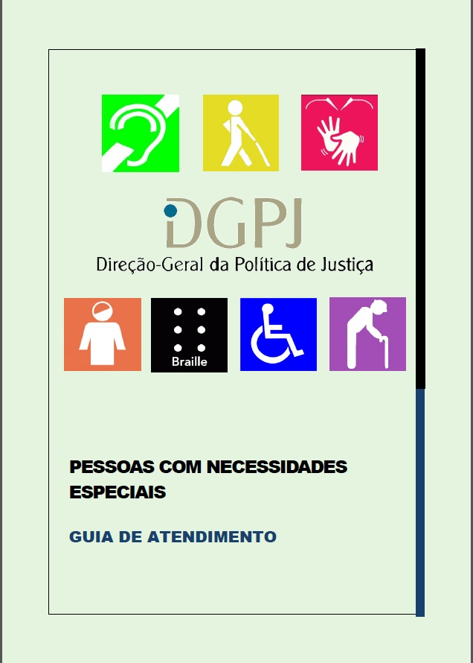

Please, see also the mention to the Protocol of collaboration between the Centre for Judicial Studies and the Portuguese Federation of Deaf Persons’ Associations, in question 2b).

- Do you have examples from your country on
- Training programmes on the right of access to justice for persons with disabilities for judges, lawyers, prosecutors, police, social workers, language and sign language interpreters, legal aid centres, other judicial and administrative bodies intervening in judicial or quasi-judicial instances;

The Ministry of Justice has invested in the area of training for people with disabilities.

Within the Ministry of Justice, we highlight the training in customer service at the Directorate General for the Administration of Justice, which covered in 2013, 288 trainees, and at the Institute for Registries and Notary, which in 2013 covered 48 trainees. Within the Judiciary Police, we can refer to the training on Human Rights.

In addition, we stand out the work developed by the Centre for Judicial Studies that provides training for magistrates and forensic professionals.

It is worth highlighting the training of 20 Portuguese sign language interpreters in 2012/2013, in order to enable them to collaborate with the judiciary, which took place in collaboration with several entities including the Portuguese Federation of Deaf Persons’ Associations.

The Centre for Judicial Studies also published an e-book in 2015 on "Interdiction and disqualification", available at
http://www.cej.mj.pt/cej/recursos/ebooks/civil/Interdicao_inabilitacao.pdf
and on “compulsive internment” available at
http://www.cej.mj.pt/cej/recursos/ebooks/civil/eb_Internamento_Compulsivo.pdf?id=9&username=guest

Lastly, we note the ongoing elaboration and online availability of the Legal Gestuary, which will include the words of the legal and judicial scope translated into Portuguese sign language, with an explanation of its meaning, as well as the "Manual of Good Practices in the Relationship of the Judiciary with Disability Situations".

- Do you have examples from your country on
- education programmes on the right of access to justice for persons with disabilities for law students as well as in schools of social work, sign language interpretation, forensic science, psychiatry and psychology, among other relevant faculties; and;

N/A to the Ministry of Justice.

- Do you have examples from your country on
- legal aid programmes, public and/or private, which include the right of access to justice for persons with disabilities in their practices, including the availability of support and liaison services for courts or other judicial or quasi-judicial instances.

N/A

4. Does your country monitor and collect disaggregated data with respect to access to judicial or quasi-judicial procedures concerning:
a. the participation of persons with disabilities in judicial or quasi-judicial procedures, including the number of complaints submitted, nature of complaints and outcomes;
b. persons with disabilities obtaining remedies and the nature of those remedies, whether they are adequate, effective, prompt and appropriate, responding to their specific situation;
c. persons with disabilities being convicted, the nature of their sentence, and whether they benefitted from safeguards of the right to fair trial on an equal basis with others; and
d. the opening and conduct of impartial and independent investigations of human rights violations of persons with disabilities, particularly those relating to the right to life, liberty and security of the person, freedom from violence, abuse and exploitation, and freedom from torture or cruel, inhuman or degrading treatment or punishment

The Ministry of Justice does not collect dada with these level of disaggregation.

Cfr http://www.pgdlisboa.pt/leis/lei_mostra_articulado.php?nid=1959&tabela=leis
Cfr http://www.pgdlisboa.pt/leis/lei_mostra_articulado.php?nid=199&tabela=leis
Cfr http://www.pgdlisboa.pt/leis/lei_mostra_articulado.php?nid=2394&so_miolo=&tabela=leis&nversao=
Cfr http://www.pgdlisboa.pt/leis/lei_mostra_estrutura.php?tabela=leis&nid=234&nversao=&tabela=leis

