Claiming Housing Rights
November 2017
Prepared by: Kadamay or Kalipunan ng Damayang Mahihirap (National Alliance of Filipino Urban Poor)
The State of Housing and the Homeless in the Philippines
The Philippines has the largest homeless population in South East Asia towering at around 4.5 million according to the National Statistics Office, which is already a cause for great alarm. Inevitably coupled with this is the fact that we also have the highest unemployment rate in the region says a recent World Bank study.
These two key factors, palpably seen upon practically any walk through the country, and its cities set the stage for the current housing crisis in the country. There are rampant evictions and demolitions enlarging the homeless population whilst corporate projects are prioritized by the government. Resettlement or relocation sites which are part of the socialized housing program have huge flaws, namely the occupancy rates, and the profiteering of contractors and developers also facilitated by the authorities. Meanwhile, overall spending on building homes and communities has dropped over the years and is set to be drastically reduced again in 2018 with an 84% slash in the budget.
All of this is forwarded under an antagonistic neo-liberal framework currently employed by policymakers who have put a premium on profit over the needs of the people. There are currently no signs of this trend letting up since the election of Rodrigo Duterte as President just over a year ago.
Demolitions
More than 1.5 million families in the Philippines are categorized as informal settlers or slum dwellers by the National Housing Authority (NHA) and the National Economic Development (NEDA).
These individuals, because of the lack of resources, are forced to find areas which are “habitable” for them to live in. But because of the aggressive infrastructure spending of corporations with government and unabated expansion of large properties, families are evicted forcedly.
While forced evictions may be the more popularly used term worldwide, demolitions is a more apt word for the domestic situation as these are usually accompanied by violence from state actors. Our organization has tallied 24 civilian deaths from encounters with police and SWAT teams used in forcefully tearing down communities.
Most of them, approximately 97.5% could be threatened with demolitions as they are categorized as living in areas that could easily be ordered taken down.
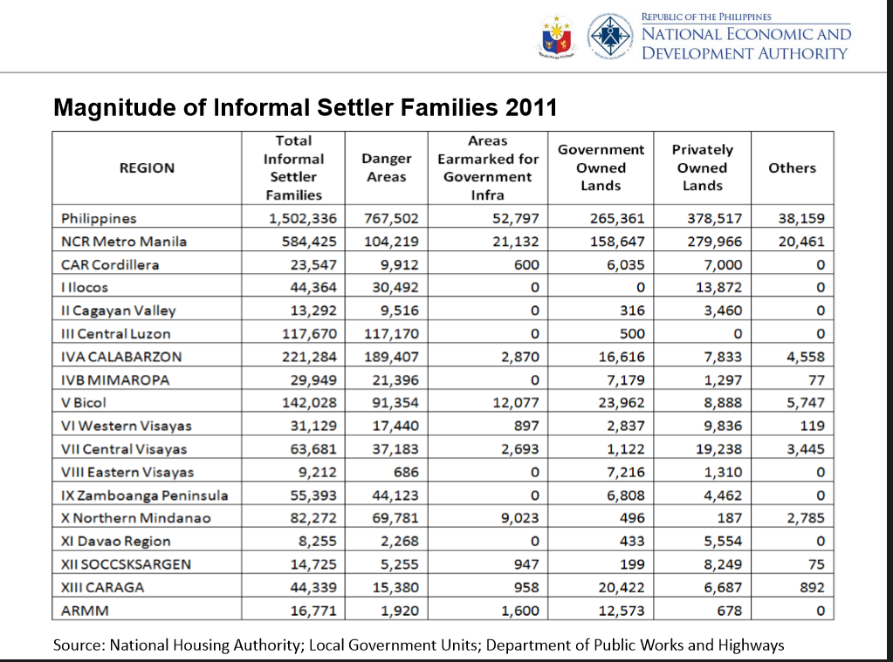
The term “danger areas” or danger zones is a particularly treacherous phrase. Originally used in the Urban Development and Housing Act of 1992, defined as communities living in areas near waterways, with makeshift materials and the like. Besides this, there is now sufficient legal mechanism to define what is hazardous to communities in relation to natural disasters.
Figure 1 Most families living in areas that could easily be pegged for demolitions.
Meaning that a community can arbitrarily be deemed ‘dangerous’ and automatically be approved for demolitions to suit the political and economic interests of local governments and their strategic, often corporate partners.

The demolition the Manggahan Floodway in Pasig City, Metro Manila started at the end of August 2017 and ended in the middle of October. The entire floodway spans two municipalities, both of which were declared habitable in 1994 by then President Fidel Ramos. Recently however, the part that sits in Pasig city was considered dangerous while the other half was affirmed as habitable.
Residents barricaded and braced for demolitions. Members of the community were periodically harassed and intimated with death threats, 41 of them were arrested and more 700 homes were eventually destroyed. The city government has yet to comment on its alleged ties to the San Miguel Corporation or what it intends to do with the public land now vacant aside from the evictees left with nowhere to go, holding their belongings in the gutters.
Other examples would be the case of Sitio San Roque in Quezon City, Metro Manila wherein more than 7,000 families lose their dwellings due to the Central Business District Project or CBD. The CBD is a 65 billion peso joint venture between the local government, the NHA and real estate tycoons the Ayala Land corporation. Barricades and scuffles with the authorities have been going on since 2010 and the only reason the community still stands is because of the continued resistance against this neo-liberal public-private partnership.
In both cases, the NHA has been directly involved in facilitating the dispossession of homes and communities from the Filipino urban poor, ironic for a shelter agency to do more work to reduce housing. Now, under Duterte’s “Build Build Build” program, more than 48 billion pesos will be allotted for “Right of Way” which is a better way of saying evictions. It was summed up by Budget Secretary Benjamin Diokno “Let us spend money so that informal settlers will get out of the way.”
Relocation areas
Some of the evicted are offered relocation programs, however this already opens up a slew of new problems for those who want to avail. The usual problems are that relocation sites are usually situated in far flung areas, that means a virtual absence of livelihood for those who have been scraping through the cities for a while. They are also built with substandard material.
An obvious indicator would be the occupancy rates. According to the latest report from the Commission on Audit, most of the housing units constructed from 2011-2016 wherein a large chunk of the national budget was funnelled into it, 112 billion pesos to be exact. The construction was an effort to meet the 5.5 million housing backlog set by the Housing and Urban Development Council (HUDCC).
 | Target | Completed | Occupied | % | Unoccupied | %
Military/Police Housing | 68,689 | 62,472 | 7143 | 11.43% | 55,329 | 88.57%
Informal Settler Families (ISF) | 108,265 | 85,342 | 57,410 | 67.27% | 27,932 | 32.73%
Haiyan/typhoon Victims Housing | 205,128 | 42,599 | 11,451 | 26.8% | 31,148 | 73.12%
Total | 382,082 | 190,413 | 76,004 |  | 114,409
Figure 2 Occupied vs Unoccupied housing units
The fundamental question was raised, why are there so many idle homes (114,000) amidst such a magnitude of homelessness? Police and military housing was rejected by the beneficiaries and left to rot for years. Units for typhoon Haiyan victims remain still under construction, 4 years later. And those for informal settlers, aside from being far from employment opportunities, bear heavy amortization costs.
According to the only study made by the government (Philippine Institute for Development Studies) into collection rates of amortization payments, off-city relocation sites only register a mere 4% of beneficiaries of socialized housing in off-city sites paying regularly, while the number is only a bit higher, 17%, for in-city sites. This reflects the gravity of hardship in government housing sites. Many cannot pay, have lost their jobs and are eventually evicted once again only to live on the streets. Amidst this, the NHA was still able to collect a significant amount from awardees and beneficiaries amounting to P10.2 billion.
In the COA report mentioned above, the NHA paid P15.2 billion to private developers and contractors in 2016 alone. Payments to contractors and developers were guaranteed yet shelter for the ‘beneficiaries’ was not. All in all, at the end of 2016, the NHA still managed to retain of P6.7 billion in its coffers. Essentially, amortization payments can be taken as funds used to pay off the profits of private developers and the revenue of the NHA. They are the real winners in this situation while amortization payments continue to pile up, occupancy rates are decreasing and more Filipinos are becoming homeless by the day. Poor beneficiaries are considered more as consumer clients rather than right bearing citizens.

Add to this the fact that private developers broker contracts in which they can have exclusive rights to utilities like water and electricity resulting in irregular and more expensive costs for the residents in relocation areas. That’s of there are any utilities at all.
The HUDCC chairperson last year admitted that over 50% of families in relocation sites do not have access to potable water. In our own tally, two children died last year due to diarrhoea caused by the contaminated water in relocation sites.
Mass Housing
Last March, Kadamay took it upon itself to lead the just and massive occupation of idle homes. Around 6,000 housing units were occupied and the state was forced to recognize at least to some extent the validity of the action. The occupation brought to light the glaring flaws in the housing system and also a claim for social justice, as leaving idle homes amidst massive homelessness was a misuse of public funds to say the least and criminal to say the most.
The government has a constitutional obligation to cater to the housing rights of the poor and underprivileged. Kadamay asserts that a comprehensive program for decent, affordable and mass housing program must be undertaken. An immediate step in the right direction would be to utilize the more than hundred thousand homes that are still idle to shelter those most in need. In truth, the best solutions are the simplest ones; providing affordable housing for the poor and the services or utilities that should rightly come with it.
Mass housing means correcting the blatant privatization and profiteering involved in the current shelter schemes. It also entails that the state should be the prime actor in subsidizing socialized housing, instead of prioritizing payments to contractors and corporations. Also, that informal settlements be recognized, developed and rehabilitated, affording them basic infrastructure and services.
Utilities like water and electricity should establish direct connections from the communities to legitimate service providers and keep out corporations from using their exclusive contracts to provide sub-par services.
The government must also seriously address the housing backlog. Concretely, at an average cost of P500,000 ($9,800) per housing unit or family which includes a socialized housing unit, social preparation and post-resettlement costs, the accumulated need of 1.4 million households would require a budgetary allocation of P700 billion ($13.7 billion) for a period of six years or P117 billion ($2.3 billion) annually. It is a hefty sum, but we have to start somewhere.
Meaningful Socio-economic Reforms are Human Rights
In truth, housing is usually never just about the house itself but the overall societal factors that give rise to policy making and the socio-economic conditions it is faced with. With this, decent living with sustainable employment and livable wages is a must. Simply put, what use is a house if there is no food, or other resources to make that space habitable.
As neoliberalism intensifies in its exclusions, the urban subaltern correspondingly advances increasingly-militant resistance strategies and counter-neoliberal histories and imaginaries for survival, and inclusive and humane development. At the same time, new narratives must be forwarded.
We need the Philippines to enact genuine land reform. This does three things in relation to what has been discussed. First it delivers the basic agricultural needs of the people by increasing productivity. This happens since production is wrestled from the land monopolies that have been held and rooted since the centuries of colonial history in the country. Second, it provides greater spaces for housing, especially idle lands held by landlords. Third, it de-congests the cities by genuinely developing the countryside’s productivity.
We need national industrialization to resolve the stark lack of domestic industries and unemployment in the country. This prevents forced migration and caters to domestic economic development, by extension the capacity to maintain a household and even gradually improve what it means to have ‘decent shelter.’
There needs to be a radical shift in policy making for the poor and homeless in the case of the Philippines. Social movements and supportive institutions will play a vital part in doing this. Homes and families must be defended as a space which holds our collective stories and shared sentiments for a better future. ###

http://www.napc.gov.ph/articles/maza-visits-%E2%80%98homeless-camp%E2%80%99-backs-urban-poor-amid-housing-crisis?throbber=1
http://globalnation.inquirer.net/155303/inquirerseven-fast-facts-asean-member-states
https://news.mb.com.ph/2017/08/26/lawmaker-hits-zero-budget-for-housing-for-the-poor-citing-nha-budget-cut/
http://www.nha.gov.ph/about_us/2015-pdf/RA7279.pdf
https://dirp4.pids.gov.ph/ris/dps/pidsdps1328.pdf
https://www.google.com.ph/search?q=no+water+relocation+sites&rlz=1C1GCEA_enPH751PH751&oq=no+water+relocation+sites&aqs=chrome..69i57.2845j0j4&sourceid=chrome&ie=UTF-8

