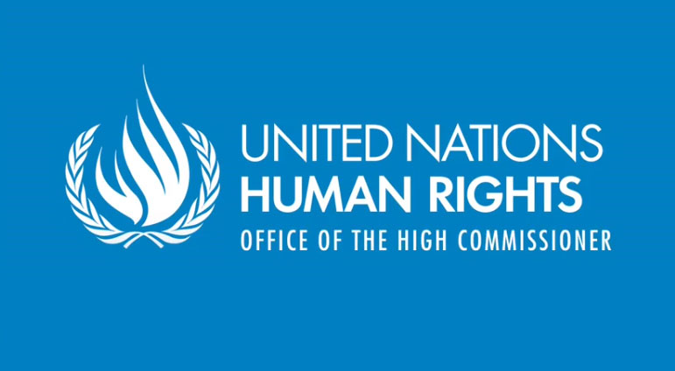

United Nations Special Rapporteur on the Rights of Indigenous Peoples to carry out official visit to the United States from 23 April to 4 May 2012

The United Nations Special Rapporteur on the Rights of Indigenous Peoples, Professor James Anaya, will carry out an official visit to the United States of America from 23 April to 4 May 2012.

The aim of the Special Rapporteur’s visit to the United States is to examine the human rights situation of the indigenous peoples of the country, that is, American Indians/Native Americans, Alaska Natives and Native Hawaiians. During the visit, the Special Rapporteur will hold meetings and consultations with federal and state government officials, as well as with indigenous nations and their representatives, in various locations.

Of particular relevance to the visit are the implications of the United States’ endorsement, in December 2010, of the United Nations Declaration on the Rights of Indigenous Peoples. The Special Rapporteur will assess the ways in which the standards of the Declaration are currently reflected in U.S. law and policy, both domestically and abroad, and identify needed reforms or areas that need further attention in light of the Declaration.

The results of this assessment will be reflected in a preliminary report that will be submitted to the United States for its comments and consideration. A final version of the report will be circulated publicly and presented to the United Nations Human Rights Council. The report will include recommendations to the United States, indigenous governing bodies and, possibly, other interested parties on how to address issues of ongoing concern to indigenous peoples.

The Special Rapporteur has tentatively planned to visit locations in the Southwest, Midwest, Alaska, and Washington, D.C. Further information and updates about the agenda of the Special Rapporteur as it becomes available will be made public on the websites of the Special Rapporteur maintained by the Office of the High Commissioner for Human Rights: http://www.ohchr.org/EN/Issues/IPeoples/SRIndigenousPeoples/Pages/SRIPeoplesIndex.aspx: and the University of Arizona: www.unsr.jamesanaya.org

Background information on the Special Rapporteur and his mandate from the UN Human Rights Council is available on these web sites.

The Special Rapporteur invites indigenous peoples and organizations, and other interested parties, to send information relevant to the visit to the United States or any other aspect of his mandate to: indigenous@ohchr.org

* * *

