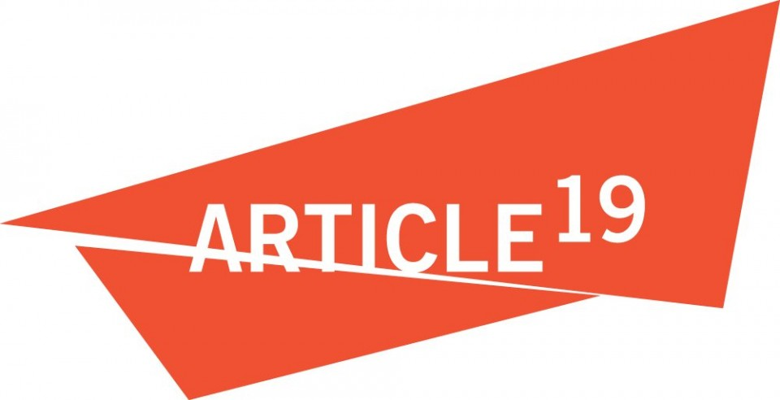
ARTICLE 19 Submission to
to OHCHR for the report “Safety of Journalists”

February 2016

ARTICLE 19 welcomes this opportunity to submit information to the OHCHR to assist in the preparation of the report on “Safety of Journalists and the Issue of Impunity” to be presented at the seventy-second session of the General Assembly pursuant to its Resolution 70/162 (December 2015).

1. Please identify the gender-specific obstacles and human right violations or risks thereof, faced by women journalists working in your country or abroad. Please elaborate on how these obstacles and violations manifest themselves in practice and how they differ from obstacles and human rights violations faced by their male counterparts.

Women journalists (WJ) throughout the world experience specific obstacles for the mere reason of their gender as well as a result of their work, including gender-specific threats and attacks that gender specific consequences. On a daily basis, women journalists are subject to gender-based censorship, on and offline, on the ground and in the newsrooms, in the public space and in their homes.

In many countries societal norms and gender expectations continue to be a major challenge to the safety and professional development of WJ. The social pressure, sometime so severe that it becomes a form of violence itself, from relatives, colleagues, employers and audiences, on and offline, creates a chilling effect on their right to freedom of expression as many have to resort to self-censorship or quit their work. While the majority of journalists killed as a result of their work worldwide in recent years are men, the gender divide is either leveled or even reversed when reviewing statistics available for other types of aggressions against journalists. Sexual violence and online harassment are more frequently linked to WJ, for example.

According to the testimonies and evidence collected by ARTICLE 19 in countries where journalism is a particularly dangerous activity, such as Mexico, Bangladesh, Brazil, Honduras and Russia, direct treats are the most recurrent challenge for journalists. In the case of men, threats are usually directed to their physical and psychological integrity, while in the case of WJ, threats also includes reputational smearing campaigns (often of a sexual nature) and potential physical attacks against members of their families. When these type of threats are delivered to WJ, the use of sexist and openly misogynist language is recurrent. According to our experience, unlike male journalists, WJ rarely share or publicize details of such incidents for fear of being treated differently by their colleagues or in the workplace.

Added to these challenges, female journalists and are disproportionately subjected to sexual threats and harassment on the Internet. Certainly this is a threat faced by all women and girls in cyberspace; in the case of the WJ it also results in a lack of representation in both media content and opinions pieces, acting as a kind of de facto censorship.

Reporting on protests have become an emerging threat to journalists in the last couple of years, significantly increasing the risk for journalists that are in a vulnerable position in countries such as Mexico, United States, Kenya, Brazil and Russia. Excessive use of force, confiscation of equipment and arbitrary detention are among the most recurrent threats by journalists covering protests in general. The chilling effect resulting from these threats when faced by WJ is greater as it increases the possibility of sexual violence due to lack of a proper gender perspective of States while policing protests. According to ARTICLE 19’s experience interviewing women journalists in our work, the vulnerability of WJ while interacting with police forces increases significantly as result of their gender. The HRC urged States to “pay particular attention to the safety and protection of women and women human rights defenders from acts of intimidation and harassment, as well as gender-based violence, including sexual assault, in the context of peaceful protests,” yet that has yet to be implemented on the ground in the majority of countries where we work.

2. Please indicate whether you monitor and collect information and disaggregated data (e.g. by sex, gender, identity, ethnicity, agen, online/offline, focus areas of work) specifically on the gender-specific obstacles and human rights violations, or risks thereof, faced by women journalists.

ARTICLE 19’s work on journalists safety is based in the documentation of attacks and incidents. In the case of Mexico, Brazil and Bangladesh we have established permanent monitoring systems. We collect firsthand information to feed three separate databases that are disaggregated by sex, gender, age, online/offline, type of reporting, topics researched, geographic location and type of media. In a case by case basis we include information regarding identity, religion, sexual orientation, ethnicity, number of dependents and marital status. .

3. What programmes and initiatives have your organisation adopted to address the issue of the safety of women journalists, including underlying causes of the obstacles and human rights violations, and harmful gender stereotypes, experienced by women journalists? How do these measures difference from those adopted to address the issue of safety of journalists more generally, or the safety of male journalists? Please elaborated on the impact of any measures adopted.

Apart from the documentation of cases related to WJ, for the past six years ARTICLE 19 have been engaged in providing security trainings to journalists in high risk countries such as Bangladesh, Mexico, Honduras, Brazil, Gambia, Kenya and Russia. After a review of our methodology, we have designed a specific syllabus exclusively for WJ that is currently being tested in Mexico. In Bangladesh, we worked for the past five years with women reporters and bloggers to increase their self-protection and professional capacities.

In Brazil and Mexico, ARTICLE 19 have fostered in conjunction with national partners, safe-space for WJ in order to provide an opportunity for peer-to-peer learning, exchange experiences and organize solidarity. These all-women spaces have proven to be better way to discuss sensitive issues related to VAW rather than in gender-mixed groups. These pilot activities have proven that ongoing engagement via peers results in a greater impact unlike the training provided without any follow-up.

In order to ensure the participation of WJ in the all the training opportunities, we will start to provide additional incentives and support to potential participants in Mexico, for example offering childcare. In our experience both within the safe spaces and the security workshops and trainings, it is crucial to provide recommendations for a proper safety and wellbeing network in case a participant requires it. We are partnering with women groups and trauma experts to ensure a proper response for each participant. We are also actively reaching out to WJ working in non-commercial media as this type of journalists are sometimes left out of training opportunities and subject to discrimination by the States and the traditional media.

4. Are the measures -if referred to in response to Q.3 above part of a “gender-sensitive approach” If so, what does this approach consist of?

In 2015, ARTICLE 19 designated a thematic lead on gender issues in order to lead a cross-cutting approach to gender, sexuality and its intersection with the right to freedom of expression. The increasing focus of ARTICLE 19 entailed specific change within the organisation, for example the research methodology and the model to respond to individual cases were reviewed by a group of experts on women’s rights that made concrete recommendations for planning and operational changes. This included trainings on gender sensitive techniques for monitoring and documenting, as well as on how to address cases related to sexual violence.

5. In the country/countries in which your organisation works, are there any specific laws and/or policies or initiatives (e.i. training, awareness-raising) to address harmful gender stereotypes, intersecting forms of discrimination and other human rights violations experienced by women journalists in the course of carrying out their work (e.g. in the workplace, in the filed, online? What is the impact of these laws, policies or initiatives?

In the majority of the countries where our work focused on VJ, the legal framework meets or at least addresses the international standards regarding women's rights. Despite this, there are numerous challenges in the effective implementation of these laws. The issue related to the challenges faced by WJ in their work space has not been adequately addressed by the States or sufficiently attended by civil society, since in many cases an inherent bias against women in visible professions like journalisms exists.

In the case of the internet, although many ISPs have expressed their concern about online harassment, actually policy change to improve the environment for women has been slow. A few companies, including Twitter in Latin America, are beginning to roll out serious responses, but more encouragement is needed.

6. I the country/countries in which your organisations works, are there any specific laws and/or policies or initiatives (i.g. Training, awareness-raising) to address violations of international humanitarian law committed against women journalists?

We work in countries where public security crises have reached alarming levels, particularly Mexico, but not in countries with outright armed conflict.

7. What mechanisms and/or networks do you have in place to share information and increase the protection of women journalists, particularly in situations of conflict or political instability?

ARTICLE 19 values the creation of spaces to cooperate with other organizations, including women’s rights organizations. As such we have especially focused in exchanging information, experiences and knowledge with objective of overcoming the apparent conflict between the protection of women’s rights and the right to freedom of expression. Both in Mexico and Brazil, ARTICLE 19 have created an information and safety informal networks that has improved significantly our capacity to monitor and react to any change in the political environment. This has proven to be an effective approach in context of political instability.

8. What gender-specific barriers have women journalists who are victims of human rights violations faced in obtaining an effective remedy?

Access to justice and proper remedies as well as the resulting impunity, are a major challenge for journalists and media houses in general, and in particular for WJ. According to ARTICLE 19’s experience, WJ usually refrain from resorting to the protection of the States due to a deep rooted lack of trust in judicial processes, fear of being publicly shamed and/or professionally ostracized. Due to the nature of the violations the risk of revictimization while pressing charges, even in countries where specific laws to protect women and girls are in place, is still quite high. In countries where States have put in place special protection mechanisms for WJ and women human rights defenders, such as Mexico, Brazil, Guatemala, Colombia and Honduras, there are specific challenges to effectively protect them, due to the absence of a gender sensitive approach in the design of the whole mechanism and its procedures. ARTICLE 19 pointed out the lack of gender perspective of these emergency mechanism and justice system in Mexico when assessing the risk and needs of WJ while seeking justice or requesting protection.

9. Please indicate if your organisation has developed specific initiatives for the safety of women journalists in light of the Sustainable Development Goals, in particular Goal 5 and Goal 16.
NA

International Women's Media Foundation (IWMF)/Violence and Harassment against Women in the News Media: A Global Picture 2014. http://www.iwmf.org/our-research/journalist-safety/violence-and-harassment-against-women-in-the-news-media-a-global-picture/
International News Safety Institute’s (INSI) annual Killing the Messenger report of journalism casualties from around the world http://newssafety.org/news/insi-news/insi-news/detail/115-journalists-killed-in-2016-year-begins-and-ends-with-mass-casualties-1827/
Committee to Protect Journalists, The silencing crime: Sexual violence and journalists https://cpj.org/reports/2011/06/silencing-crime-sexual-violence-journalists.php
Women’s rights, gender and Internet governance, APC 2015. http://www.apc.org/en/pubs/women%E2%80%99s-rights-gender-and-internet-governance
OSCE, Communiqué on the growing safety threat to female journalists online, 2015 http://www.osce.org/fom/139186
ARTICLE 19, Mexico: Police attack journalists and human rights defenders at protest over 43 missing students https://www.article19.org/resources.php/resource/37774/en/mexico:-police-attack-journalists-and-human-rights-defenders-at-protest-over-43-missing-students
Four more journalists get felony charges after covering inauguration unrest, The Guardian, 2017 https://www.theguardian.com/media/2017/jan/24/journalists-charged-felonies-trump-inauguration-unrest
Journalists protest media harassment in Kenya, DW, 2016. http://www.dw.com/en/journalists-protest-media-harassment-in-kenya/a-19566934
CIVICUS, A wave of anti-government protests in Brazil is being met with sustained police repression, 2016. https://monitor.civicus.org/newsfeed/2016/11/10/wave-protests-repressed-brazil/
ARTICLE 19 and others, Submission to ECtHR: Court must protect rights of those reporting on protests, 2016. https://www.article19.org/resources.php/resource/38269/en/ecthr:-court-must-protect-rights-of-those-reporting-on-protests
Mexico Annual Report 2015: Fear in the Newsroom https://www.article19.org/resources.php/resource/38304/en/mexico:-fear-in-the-newsroom
A/HRC/RES/25/38, The promotion and protection of human rights in the context of peaceful protests, 2014. http://www.ohchr.org/Documents/Issues/Executions/A-HRC-RES-25-38.pdf
Women, Action and the Media (WAM). Twitter’s Abuse Problem: Now With Actual Solutions And Science, http://www.womenactionmedia.org/twitter-report/
ARTICLE 19, States must end impunity for attacks on journalists 2015 https://www.article19.org/resources.php/resource/38477/en/un-hrc:-states-must-end-impunity-for-attacks-on-journalists
ARTICLE 19 takes takes the case of journalist and human rights defender Lydia Cacho to the UN Human Rights Committee, 2014. https://www.article19.org/resources.php/resource/37732/en/mexico:-article-19-takes-the-case-of-journalist-and-human-rights-defender-lydia-cacho-to-the-un-human-rights-committee
The cases of Mexican reporter Lydia Cacho, reporter Jineth Bedoya Lima in Colombia are crude examples on how gender plays a crucial role when exercising the right to freedom of expression and seeking justice as result of attempt to silence WJ.

