Private Actors in Warfare: Stories from victims of private military and security companies and foreign fighters
15 -30 September 2016
In front of Room XXIII, Palais des Nations
A project of the United Nations Working Group on the use of mercenaries as a means of violating human rights and impeding the exercise of the right of peoples to self-determination
VIEW THE VIRTUAL REALITY FILM
“CLOUDS OVER SIDRA”
In the 360 degree virtual reality film “Clouds over Sidra”, you will enter for 4 minutes into the vivid and true life of a 12 year old Syrian refugee girl displaced by the activities of foreign fighters in her home country, and who has lived for over a year in a refugee camp in Jordan.
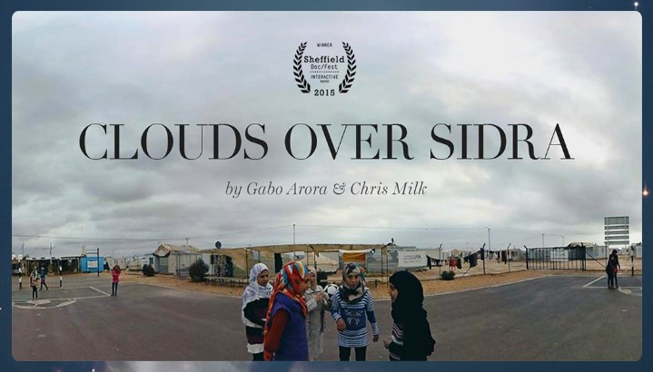
Background
The Working Group is mandated to monitor and report on mercenaries and mercenary-related activities in all their forms and manifestations in different parts of the world; to study and identify sources and causes, emerging issues, manifestations and trends regarding mercenaries or mercenary-related activities and their impact on human rights, particularly on the right of peoples to self-determination; and to monitor and study the effects on the enjoyment of human rights, particularly the right of peoples to self-determination, of the activities of private companies offering military assistance, consultancy and security services on the international market.

