“It’s a roll of the dice out here. You take your chances. If prostitution wasn’t illegal, it could be done so much easier and safer.” Philadelphia Red Umbrella Alliance member and sex worker, Terry Frames, described her experiences as a street-based sex worker and a survivor of violence at the hands of violent clients and police. Terry’s story of survival in a difficult and criminalized industry is not uncommon for many street-based sex workers in the Kensington neighborhood of Philadelphia and in the United States.

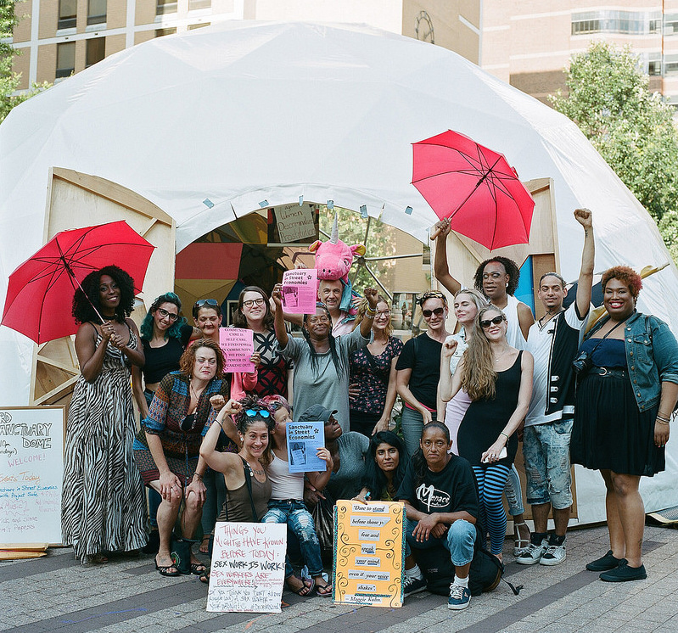
Sex worker rights advocates have long argued that sex work is work and should be free from criminal consequences. The criminalization of sex work, especially street-based sex work, increases community surveillance, safety risks, and discriminatory profiling that impact sex workers’ ability to fully enjoy their human rights and dignity. Street-based sex workers are often most at risk of encounters with the police, and these interactions can turn violent. Street-based workers and community members report being profiled for their appearance and their percieved income status complicating their encounters with law enforcement and further criminalizing poverty. Studies have shown the criminalization of sex work, forces street-based workers into unsafe environments and isolates them from public health supports increasing risks for violence and HIV. While prostitution is ususally a misdemeannor, under Pennsylvania law, engaging in sex work while HIV+ is a felony. When sex workers do face violence, the criminal justice system is slow to respond or does not respond at all. Too often sex workers are caught up in laws aimed at reducing human trafficking, but instead have the net effect of creating unsafe working conditions, hostile interactions with the criminal justice system, and are discriminatorily enforced.
Sex workers and allies gather in Philadelphia (2017)

Furthermore, once the criminal justice system identifies someone as a sex worker, the legal ramifications and stigma of sexual offenses make it extremely difficult for sex workers to realize their full social, cultural, economic rights. For example, sex workers or people profiled as such, can face discrimination in family court proceedings, in attaining an education, and in procuring employment.

The United States accepted a recommendation regarding sex work during its Universal Periodic Review in 2011. Recommendation 86, which provides, “to [u]ndertake awareness-raising campaigns for combating stereotypes and violence against [LGBT people], and ensure access to public services, paying attention to the special vulnerability of sex workers to violence and human rights abuses.” Many sex worker advocates have called on the U.S. government and local municipalities to effectively implement this recommendation. The U.S. has obligations to protect the rights of sex workers from violence and discriminatory policing and the right to organize under the Universal Declaration of Human Rights and the International Convenant on Civil and Political Rights. As signatories to the International Covenant on Economic, Social, and Cultural Rights, the U.S. has an obligation not to violate the economic, social, and cultural rights of sex workers including the right to practice their work free from harassment or discrimination, the right to health and healthcare, and the right to an education. In order to realize these rights:

The U.S. Government Should:
- Implement Recommendation 86, including repealing laws that criminalize or otherwise penalize people who sell sex and affirmatively creating programs that support the economic, social, and cultural rights of sex workers.
- Repeal laws targeted at addressing trafficking issues that criminalize sex workers and survival sex and limits access to resources for “trafficking victims.”

The City of Philadelphia Should:
- End the prosecution of people who engage in sex work or who are profiled as engaging in sex work.
- Ensure the “Public Nuisance Task Force” and other law enforcement agencies do not engage in unconstitutional profiling of people assumed to be sex workers.
- End the prosecution of people living with HIV for engaging in consensual sex.
- Create opportunities for expunging the records of those criminalized for engaging in sex work.
- Fully prosecute those who have non-consensual sexual activity with sex workers.
- Prosecute and prevent law enforcement from engaging in sexual activity with sex workers in entrapment cases or abusing positions of power to extort sexual services from sex workers.
- Ensure the rights of sex workers by ensuring that one’s status as a sex worker is not used against them in family court and domestic violence situations.

Courtenay Harris Bond, SAFE Haven: Project SAFE Doing its Part to Bring Sex Workers Out of the Shadows, Philadelphia Weekly, June 28, 2017, at http://www.philadelphiaweekly.com/news/safe-haven-project-safe-doing-its-part-to-bring-sex/article_57b61df2-5c2e-11e7-a480-27a2b7705e10.html.
Kate Shannon, Stephanie Strathdee, Jean Shoveller, Melanie Rusch, Thomas Kerr & Mark Tyndall, Structural and Environmental Barriers to Condom Use Negotiation With Clients Among Female Sex Workers: Implications for HIV-Prevention Strategies and Policy, 99(4) American J Public Health 659 (2009).
Felony Prostitution, 18 Pa.C.S. § 5902 (a)(4) (2012).
Amnesty International, Amnesty International Policy on State Obligations to Respect, Protect and Fufill the Human Rights of Sex Workers, Index number: POL 30/4062/2016 (26 May 2016).
See Id at 12-13.
Amy Lieberman, U.S. Sex Workers Hail Nation’s New Stance, WeNews, April 21, 2011, at http://womensenews.org/2011/04/us-sex-workers-hail-nations-new-stance/.
Human Rights Council, United Nations General Assembly. Geneva, 1-12 November, 2010. Draft Report of the Working Group on the Universal Periodic Review. http://lib.ohchr.org/HRBodies/UPR/Documents/session9/US/A_HRC_WG.6_9_L.9_USA.pdf
Best Practices Policy Project, Desiree Alliance & Sex Workers Outreach Project- NYC, Human Rights Violations of Sex Workers, People in the Sex Trades, and People Profiled as Such, (September 14, 2014), http://www.bestpracticespolicy.org/wp-content/uploads/2013/01/2014UPRReportBPPPDASWOPNYC1.pdf
Universal Declaration of Human Rights, G.A. Res. 217A (III), U.N. Doc. A/810 at 71 (1948).
International Covenant on Civil and Political Rights, art. Dec. 16, 1966, 999 U.N.T.S. 171.
International Covenant on Economic, Social, and Cultural Rights, art. 6,12,13, December 16, 1966, 993 U.N.T.S. 3.
Best Practices Policy Project, Desiree Alliance & Sex Workers Outreach Project- NYC Human Rights Violations of Sex Workers, People in the Sex Trades, and People Profiled as Such.
These policy initiatives were developed by and for street-based sex workers in Kensington in conjunction with the Philadelphia Red Umbrella Alliance Sex Worker Collective. Image: Jeffrey Stockbridge, Sex Workers and Drug Users Speak Out in Philadelphia, The Fix, July 27, 2017, at https://www.thefix.com/sex-workers-and-drug-users-speak-out-philadelphia.

