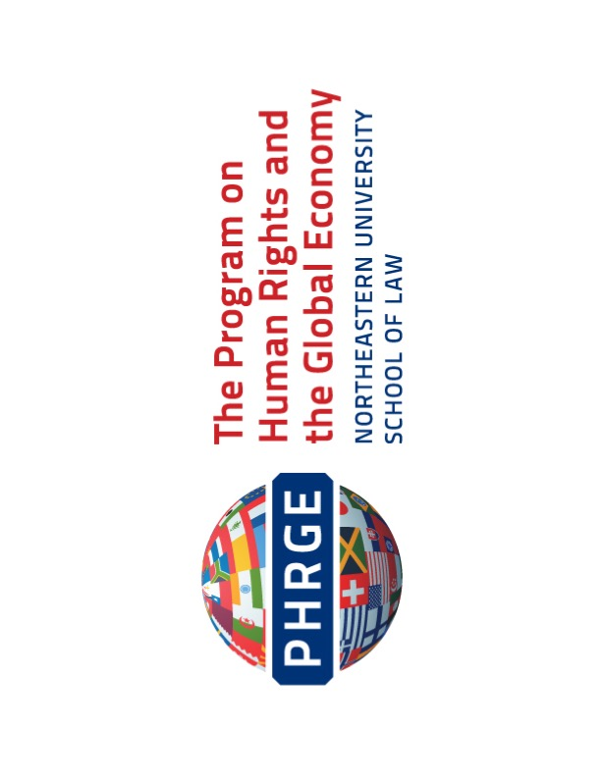
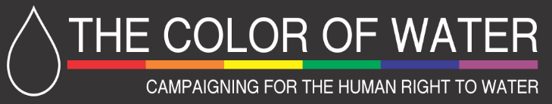

Special Rapporteur on Extreme Poverty and Human Rights
Office of the High Commissioner for Human Rights
Philip Alston
Re: Visit to the United States of America
October 4, 2017
Dear Professor Alston,
We welcome your upcoming visit to the United States in your capacity as the Special Rapporteur on Extreme Poverty and Human Rights. On behalf of the Color of Water and the Program on Human Rights and the Global Economy (PHRGE), thank you for your time and this opportunity to express specific concerns regarding the deep intersection in the United States between race, poverty, and the human right to water.

The Color of Water, a local, Boston-based NGO, has conducted significant research on the human right to water throughout Boston. Research compiled by the Color of Water contributed significantly to the report of the Special Rapporteur on the Right to Safe Drinking Water and Sanitation from her 2011 mission to the U.S. PHRGE, a human rights institute of Northeastern University School of Law in Boston, Massachusetts, has spent considerable time researching the human right to water, and recently drafted a primer on this right throughout the U.S.

These findings, along with national research, have underscored the glaring relationship between poverty and race across the U.S. and more specifically in Boston, and the impact of these factors on individual and community abilities to access and maintain affordable, safe, and continuous drinking water and sanitation services. During your upcoming visit, we respectfully urge you to more closely consider these correlations, both nationally, and through directed urban visits, such as to Boston.

International and National Obligations Regarding the Right to Water

As you are well aware, although the human right to water is not explicitly mentioned in the Universal Declaration of Human Rights, it is implicit throughout various human rights treaties and has, more recently, been explicitly recognized as a human right. In 2010, the U.N. General Assembly adopted a resolution recognizing the right to safe and clean drinking water and sanitation as a human right, and acknowledging the necessity of this right to ensure the full enjoyment of life and all human rights.
The human right to water is implicitly referenced in a number of other human rights treaties. Article 6(1) of the International Covenant on Civil and Political Rights (ICCPR) establishes an inherent right to life, and the Human Rights Committee’s further interpretation of the ICCPR in General Comment No. 6 requires that States must adopt positive measures to protect the right to life and ensure access to the means of survival.

Similarly, the International Convention on the Elimination of All Forms of Racial Discrimination (ICERD) requires that economic, social and cultural rights be fulfilled in a non-discriminatory manner. The treaty does not provide an all-inclusive list of protected rights, however, in 2014 the Committee on the Elimination of Racial Discrimination recognized the right to water as a component of both the right to housing and to health.

Although the U.S. federal government does not recognize the human right to water, some provisions of federal law promote particular aspects of the right. Both the Clean Water Act of 1972 and the Safe Drinking Water Act of 1974 address issues of water quality, but neither specifically identifies the right to safe drinking water for citizens. The U.S. also recognizes a multitude of anti-discrimination laws to address inequalities that disproportionately impact marginalized communities and their ability to access safe and affordable drinking water. In addition to regulating minimum quality standards for water, the Environmental Protection Agency (EPA) has regulatory responsibilities to monitor and investigate discrimination by any agency or organization receiving federal funding from the EPA. The EPA’s Office of Civil Rights investigates complaints of discrimination by fund recipients, and may then seek informal resolutions, or refer the matter to the Department of Justice which can withhold federal funds if compliance is not met.

National Impact of Race, Poverty, and Water Affordability in the U.S.

Despite the U.S.’s obligations under national legislation and international law, water affordability and accessibility, particularly at the intersection of race and socioeconomic status, remains a constant and frequently life-threating issue for many Americans across the country.

Racial discrimination continues to be a systemic and continuous national, one that is rooted in a deep economic model that denies development to the poorest African American communities. The Special Rapporteur on People of African Descent’s 2016 visit to the U.S. found that the cumulative impact of racial discrimination faced by African Americans in the enjoyment of their rights to education, housing, health, and other social, cultural, economic, and environmental rights has had serious consequences for their overall well-being.

Specifically, African American households experience disproportionate levels of poverty and have lower household income than their white, non-Hispanic counterparts. At $36,898, the median income for African American households sits significantly lower than white, non-Hispanic households ($62,950). As of the 2015 Census, poverty rates for American Americans (24%) were more than twice those of non-Hispanic whites (95%). Currently, at least 11% of all African Americans live in deep poverty (less than 50% of the federal poverty threshold) compared to 6% of all people in the U.S.

This extreme poverty and its intersection of race throughout the U.S. continues to drastically impact the ability of minority communities to fully realize their human right to an adequate standard of living, especially as it relates to the ability of these communities to access safe and affordable drinking water and sanitation facilities.

Much of this can be traced to increasing costs of infrastructure and subsequent costs to costumers nationally. Because the U.S. has historically used materials of diminishing quality in each expansion of water systems, much of the nation’s infrastructure is simultaneously reaching the end of its lifespan. Costs to replace these infrastructures over the next 25 years are estimated at billions or trillions of dollars. In the face of the massive required investments, water utilities have chosen to increase their costs locally, passing these costs on to customers and charging full-cost, or near full-cost rates.

Unsurprisingly, rate increases then fall on those with the least political influence, disproportionately impact low-income customers. Water infrastructure is crumbling most severely in the areas least able to absorb these costs. The people left in these most desperate cities and areas are predominately minorities. According to reports done by Circle of Blue, an NGO concerned with global water rights, the crisis is most acute in predominately minority communities.

This intersection of water accessibility, race, and poverty has become so pronounced in the U.S. that water affordability is becoming the subject of a new civil rights movement. Historical discrimination and related economic inequality are all too familiar to minority communities in the U.S. The continuation of “Jim Crow” laws—laws at the state and local level that reinforced racial segregation and persecution—perpetuated the political and social disenfranchisement and economic exploitation of African Americans long after Emancipation. Recent decades have seen the rise of a “New Jim Crow” era, characterized by the reinforcement and perpetuation of both traditional and new forms of economic and racial oppression. This, along with the great upheaval in the nation’s economic and political life, have now made the costs of food, housing, medical care, and notably water, unbearable and unattainable for many American incomes.

In the absence of assistance programs, low-income, homeless, and indigenous communities are denied the basic human right to water. Infrastructure deficits disproportionately impact groups that have historically suffered discrimination, and statistical data based on the U.S. census has indicated that communities of color are more likely to lack access to adequate infrastructure than white communities.

In response, local groups nationwide have mobilized to help the poorest residents maintain basic services, with grassroots activism markedly springing up across the Rust Belt and in New England.

Boston and the Right to Water

The dire situation of many urban centers regarding access to safe water in areas such as Flint and Detroit, Michigan, and Baltimore, Maryland has received national and international attention. However, many more cities across the country are also impacted by issues of extreme poverty and consequent inaccessibility of safe drinking water and sanitation, including, perhaps surprisingly, Boston.

Unlike better-known hot-spots of water crisis like Detroit or Baltimore, Boston does not face the same overarching economic difficulties. The city has faced neither recent harsh economic decline nor population loss, but it is characterized by a degree of economic inequality that outmatches even cities such as San Francisco and New York. In this context, life-threatening concerns over water accessibility are as critical in some areas in Boston as they are in its less affluent sister cities across the country.

The Color of Water has conducted extensive research on affordability and accessibility of water in Boston, particularly as it intersects with race, and with the entrenchment and perpetuation of severe poverty throughout the city. Data gathered by the Color of Water demonstrates that water accessibility (or the lack thereof) contributes to the perpetuation of poverty, and also that Boston residents in lower socioeconomic neighborhoods are disproportionately impacted by water shut-offs.

The Color of Water’s analyses were drawn from data collected from the Boston Water and Sewer Commission (BWSC), first in 2007, and then from 2008-2011. Based on this data, The Color of Water found that thousands of people are threatened with shutoffs to residential water service in Boston each year. Typically, these shutoffs are due to account delinquency, and lower-income neighborhoods—usually those that are home to larger concentrations of communities of color—are more likely to experience account delinquencies and the subsequent water insecurity that comes with these shutoffs. This effect is even more pronounced in neighborhoods with a higher concentration of multi-family dwellings.

This statistical data illuminated the distinct relationship between income, race, and threatened water shutoffs, finding that the increase of the risk of water shutoffs correlated with a decrease in socioeconomic status and an increase in the population of people of color. Significantly, every 2% increase in people of color in a Boston ward resulted in a 3% increase in shutoff notices in that ward. The data obtained from the BWSC indicated threatened shutoffs by land-use code, as well as by ward.

The Color of Water collected data from Boston’s 22 wards and found that an average of 55% of residents in a ward are people of color, but the full spectrums ranges across wards from 15% (South Boston, Ward 6) to 98% (parts of Roxbury, Dorchester, and Mattapan, Ward 14). Although diversity existed in race and income as it pertains to water disparities across the city, a strong persistent relationship was found between race—and, as such, socioeconomic status—and water accessibility.

This data analysis revealed specific correlations between race and low socioeconomic status more generally, but also aspects of water inaccessibility distinct to Boston itself. Water bills in Boston are significantly higher than in other U.S. cities, and the price of water is increasing. Data from 2014-2015 alone showed a 5.1% increase in the cost for a family of four using approximately 50 gallons of water, per person per day, although this increase has stagnated over the last year. Similarly, although Boston’s average per-capita income may be higher than that of other cities ($35,728 in 2015 dollars), the percentage of low income households is also significantly higher than other areas of the U.S. Statistics over the last several years have noted that more than 17% of households in Boston earn less than $15,000 annually, compared with less than 12% nationally.

The Color of Water has continued to collect relevant data from BWSC through 2015. Although BWSC declined to confirm specific aspects, the more recent data showed similar and consistent trends of the intersection and deep connection between race, economic status and water accessibility throughout the city. In meetings with the Color of Water, BWSC has stated that it is under no obligation to monitor the racial impacts of rate increases, although it does consider the problem of overall affordability. BWSC’s routine reporting only provides data on water shutoffs and threatened water shut off as aggregates for the entire city; this renders the actual situations faced by low-income residents and communities of color opaque.

The Color of Water‘s work described here takes place in the context of the emergence of the National Coalition on the Human Right to Water, an effort to bring together activities related to the human right to water occurring in various parts of the United States. The Color of Water was a founding member of that network. We have appended two reports highlighting the Coalition’s at work: a 2016 report summarizing the proceedings of a thematic hearing at the Inter-American Human Rights Commission, and a commentary by the Coalition on the EPA 2020 Action Plan. Please see the attached appendices for further information on these reports.

Boston as a Human Rights City

The fact that Boston, with a higher average income and significant economic and political resources, continues to struggle to provide universally affordable and accessible water only serves to underscore the deep entrenchment of poverty and racial discrimination across the country.

This deep-seated inequality along racial lines, and its consequences for water affordability and accessibility, is even further significant given Boston’s declaration of itself as one of the country’s Human Rights Cities. Human Rights Cities are emerging around the world to mobilize in creating infrastructures that realize and implement international human rights at the local level. These cities adopt human rights standards as a framework for substantive and procedural aspects of governance. Boston designated and announced itself as a Human Rights City in April 2011. As a designated Human Rights City, Boston commits itself to develop new local practices and policies to promote urban justice, and uphold the principles of democracy, nondiscrimination, and participation regardless of race, sex, cultural background or economic status.

Given its designation as a Human Rights City, and consequent commitment to promoting, protecting, and advocating for human rights at the local level, Boston’s deeply-rooted and distinct issues surrounding the intersection of race, poverty, and access to water are notable in the national conversation. Since Boston has made a special commitment to implement local human rights standards, the concerns raised by Color of Water regarding race, water, and poverty deserve critical attention.

Conclusion

Although Boston, like other U.S. cities, has initiated local activism efforts to address the severe lack of protection of the human right to water, there is still much to be done on both a local and national level. Given Boston’s unique economic position in comparison to other U.S. cities, its continued perpetuation of racial and economic inequality as it pertains to the right to water is indicative of a much larger and systemic issue throughout the country. As such, Boston’s situation is worthy of more direct and specific consideration against the backdrop of the national conversation on race, poverty, and water rights.

On behalf of the Color of Water and PHRGE, we respectfully urge you to consider the intersection of these factors and their impact on the human right to water in the U.S., both nationally and within Boston specifically. We urge you to include Boston in your official visit to the United States, and we are happy to assist and facilitate such a visit in any way possible, including by convening meetings with other local NGOs, and by meeting with you in person, either in advance or at the time of your visit. Thank you, again, for your time and attention to these important concerns as part of your upcoming visit.

Sincerely,

Dorotea Manuela
Coordinator, Color of Water
9A Hamilton Place, Boston, MA 02108-4701
+1 (617) 922-5744

Kevin Murray
Executive Director
Program on Human Rights and the Global Economy (PHRGE)
Northeastern University
School of Law
(617)373-4972

United Nations Department of Economic and Social Affairs, The human right to water and sanitation, Water for Life Decade, http://www.un.org/waterforlifedecade/human_right_to_water.shtml (last updated May 29, 2014); G.A. Res. 64/292, The Human Right to Water and Sanitation (July 28, 2010), http://www.un.org/es/comun/docs/?symbol=A/RES/64/292&lang=E.
Human Rights Committee, General Comment No. 6, art. 6 (16th Sess., 1982), Compilation of General Comments and General Recommendations Adopted by Human Rights Treaty Bodies, U.N. Doc. HRI\GEN\1\Rev.1, at 6 (1994).
Clean Water Act, 33 U.S.C. § 1251 (2012); Safe Drinking Water Act, 42 U.S.C. § 300f (2012).
40 C.F.R. § 7.30 (2015).
40 C.F.R. § 7.120; 7.130 (2015).
G.A. A/HRC/33/61/Add.2, Report of Working Group of Experts on People of African Descent on its mission to the United States of America, A/HRC/33/61/Add.2 (Aug., 18, 2016), p. 12, https://documents-dds-ny.un.org/doc/UNDOC/GEN/G16/183/30/PDF/G1618330.pdf?OpenElement.
African American Hunger Facts, FeedingAmerica.org (May 2017), http://www.feedingamerica.org/assets/pdfs/fact-sheets/african-american-hunger-fact-sheet.pdf.
Tapped Out: Threats to the Human Right to Water in the Urban United States, Georgetown Law Human Rights Institute (April 2013), p. 20, http://www.law.georgetown.edu/academics/centers-institutes/human-rights-institute/upload/HumanRightsFinal2013.pdf.
Id. at 21.
Water Affordability is a New Civil Rights Movement in the United States, Circle of Blue, (March 22, 2016), http://www.circleofblue.org/2016/water-policy-politics/water-rights-access/water-affordability-new-civil-rights-movement-united-states/.
Id.
G.A. A/HRC/33/61/Add.2, Report of Working Group of Experts on People of African Descent on its mission to the United States of America, A/HRC/33/61/Add.2 (Aug., 18, 2016), p. 3, https://documents-dds-ny.un.org/doc/UNDOC/GEN/G16/183/30/PDF/G1618330.pdf?OpenElement.
Supra note 11.
The Human Right to Water in the United States, submission by the International Human Rights Clinic at Santa Clara University School of Law before the Inter-American Commission on Human Rights (Sept. 15, 2015), p. 5, http://law.scu.edu/wp-content/uploads/150915_IACHR-Water-Rts-Questionnaire_United-States_Santa-Clara.pdf.
Supra note 11.
Wealth Divides: Exploring the stark diving lines between rich and poor in American cities, esri.com, http://storymaps.esri.com/stories/2016/wealth-divides/index.html (last accessed Sept. 29, 2017). Research by the Brookings Institute put Boston as the top city with the greatest inequality as compared to New Orleans, Atlanta, Cincinnati, Providence, New Haven, Washington D.C., Miami, San Francisco and New York.
A Report on the Human Right to Water in the City of Boston, The Color of Water, Massachusetts Global Action, available at http://www.colorofwater.net/materials.html (last accessed Sept. 25, 2017).
Id.
Id.
Id. at 1-2.
Price of Water 2016: Up 5 Percent in 30 Major U.S. Cities; 48 Percent Increase since 2010, Circle of Blue, http://www.circleofblue.org/2016/world/price-water-2016-5-percent-30-major-u-s-cities-48-percent-increase-since-2010-2/ (last accessed Sept. 25, 2017).
U.S. Census, Boston city, Massachusetts (2016), https://www.census.gov/quickfacts/fact/table/bostoncitymassachusetts/PST045216; Supra note 9, at 27.
Supra note 9, at 27.
Global Urban Justice: The Rise of Human Rights Cities (Barbara Oomen, Martha F. Davis, and Michele Grigolo eds. 2016).

