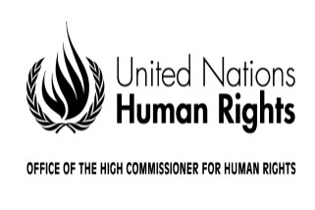REGISTRATION FORM

# 

|  |
| --- |
| **Regional consultation on draft guidelines on the effective implementation  of the right to participate in public affairs**  **Beirut**  **21-22 December 2017** |

Mr. or Ms.

Last name _________________________________________________________________________

First name_________________________________________________________________________

Official position_______________________________________________________________________

Country/organization/institution__________________________________________________________

Passport number_______________________________Nationality______________________________

Phone ______________________________Email__________________________________________

Attends the meeting as: (please check only one box)

🞐 Expert

🞐 Government representative

🞐 Representative of a United Nations agency, fund or programme

🞐 Representative of an intergovernmental organization

🞐 Representative of a regional organization

🞐 Representative of an international non-governmental organization

🞐 Representative of a national/regional non-governmental organization

🞐 Representative of a national human rights institution

Date ______________________________ Signature __________________________________

Note: **Please return this form, duly filled in, to** [fmorvay@ohchr.org](mailto:fmorvay@ohchr.org) **by 16 November 2017**. For further information please contact Ms. Federica Morvay at [fmorvay@ohchr.org](mailto:fmorvay@ohchr.org)