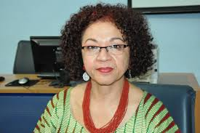

Edna Maria Santos Roland
Brazilian
Bachelor in Psychology by the UFMG - Federal University of Minas Gerais
Post Graduate Studies in Social Psychology
Visiting Researcher at the Harvard Center for Population and Development Studies
Rapporteur General of the III World Conference against Racism, Racial Discrimination Xenophobia and Related Intolerance
Coordinator for Racial Equality at the City of Guarulhos, a 1.300.000 inhabitants strong city in the Metropolitan Area of Sao Paulo from 2006 to 2016.
Member of the Eminent Experts Group for the implementation of the Durban Declaration and Program of Action

