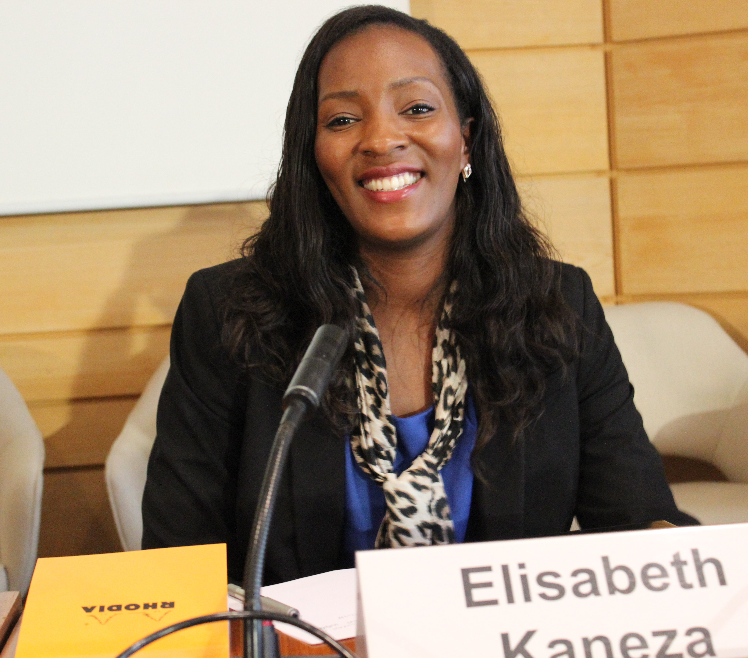

Elisabeth Kaneza is a human rights expert based in Berlin, Germany.

She is the founding President of the Kaneza Foundation for Dialogue and Empowerment, a registered civil society organisation with the mission to promote diversity by defending the human rights of ethnic minorities and creating platforms for social dialogue. Core activities of the Kaneza Foundation include human rights education and capacity-building projects for people of African descent as well as a Mentoring Programme for the personal development of young migrants.

As PhD Candidate at the Faculty of Law, University of Potsdam, Ms Kaneza analyses the impact of the Durban Declaration and Programme of Action on the legal status of people of African descent in Germany. Her research focuses especially on the development of anti racial discrimination law inter alia provisions targeting law enforcement practice.

In 2015 Ms Kaneza was selected as Fellow for the OHCHR’s Fellowship Programme for People of African Descent. Since then she has led activities for the implementation of the International Decade for People of African Descent. She has organised the German launch of the Decade at the Federal Ministry for Family, Senior Citizens, Women and Youths on 7 June 2016. She has further implemented expert meetings and trainings for community leaders throughout Germany with the aim to raise awareness for the Decade and increase capacities for CSOs. Furthermore, through her advocacy she engages governmental institutions and political leaders.

Most recently, Ms Kaneza coordinated the participation of civil society in the country visit by the United Nations Working Group of Experts on People of African Descent to Germany, 20 – 27 February 2017.

