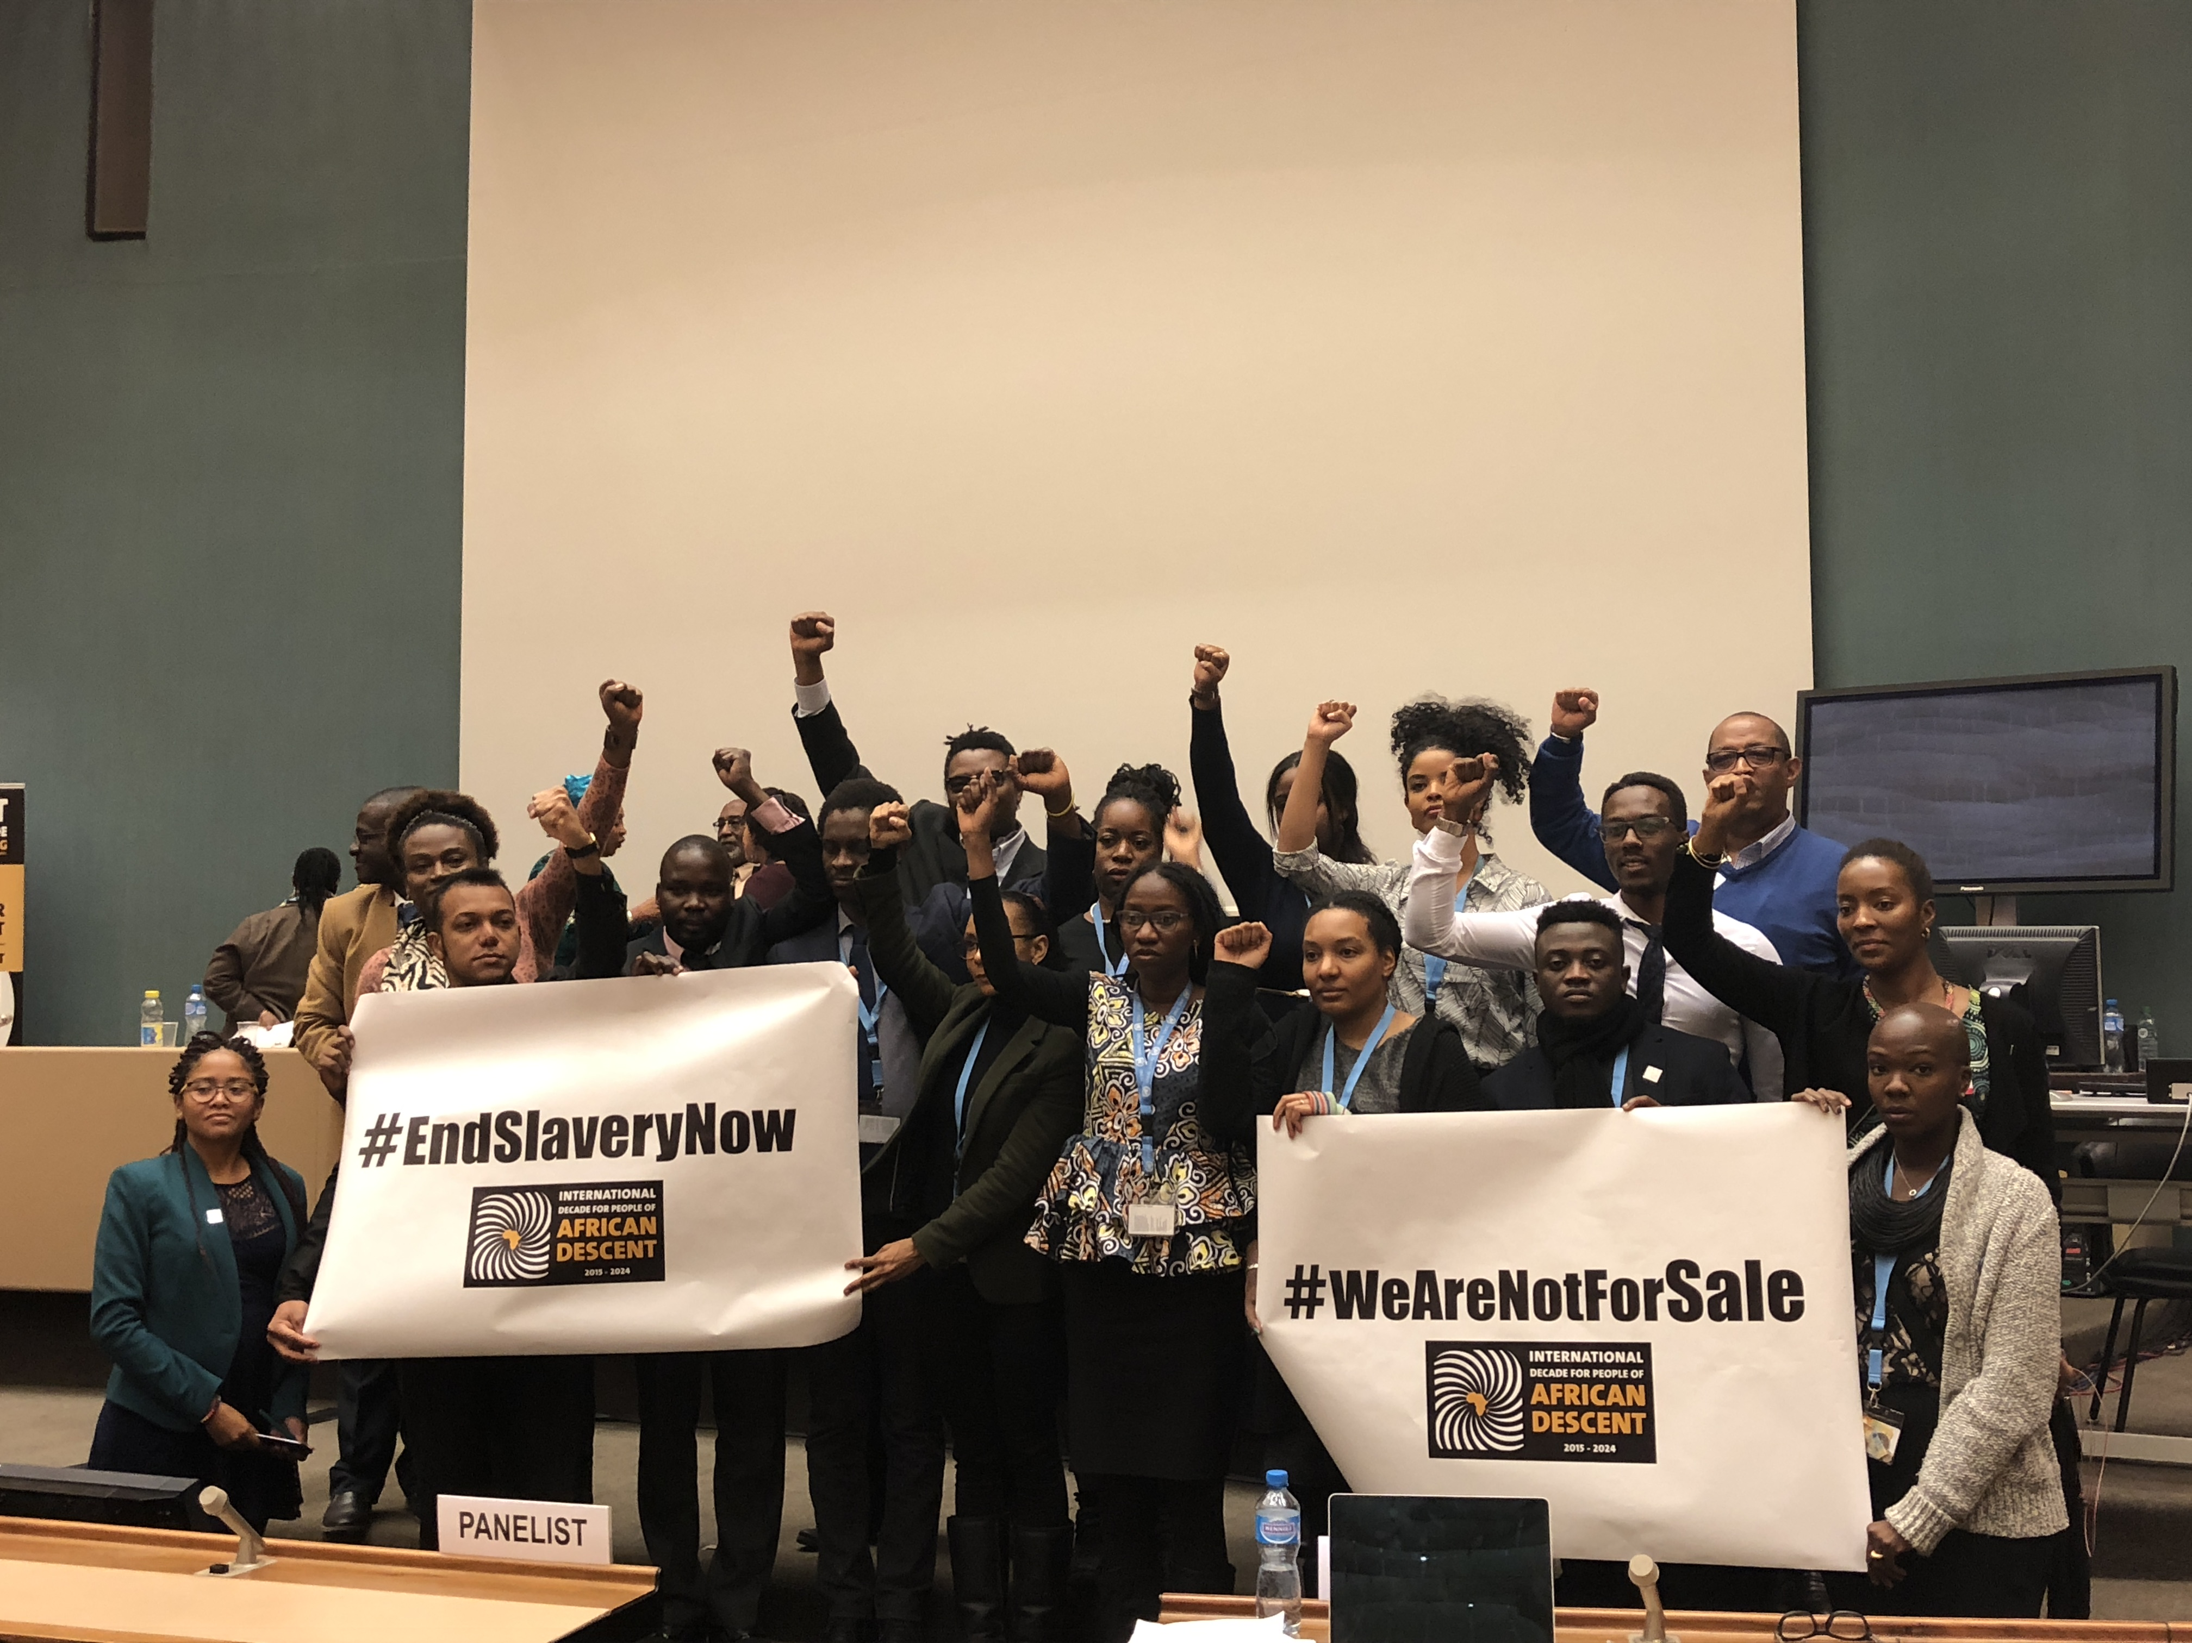

2017 Fellowship for People of African Descent Joint Statement
We, the People of African Descent, with profound shock condemn the proliferation of trafficking and slavery happening to people of African origin around the world.
These acts violate the core Human Rights treaties which obliges states to respect, protect and fulfill the rights of all persons within their territories.
One slave is too much. We cannot allow the silence of the international community when we are still nursing the painful past of the Trans-Atlantic slave trade.
We, therefore, call for the immediate intervention of the international community to address the issues of insecurity and human rights abuses of migrants and people of African descent.
We further emphasize that arbitrary detention, torture, sexual violence, extortion, human trafficking and slavery are crimes against humanity and must be given the utmost attention.
We also would like to challenge the United Nations to remind all states where these human rights violations have been reported, to investigate and bring the perpetrators to justice and award reparations to the victims with immediate effect.
We further advocate for non-repetition of slavery and stamping out all forms of racial discrimination against People of African Descent, to enable them to enjoy their fundamental and inalienable human rights as stipulated in the Universal Declaration of Human Rights.
We also appeal to all states to reaffirm their commitments to the International Decade for the People of African Descent, as well as to the Sustainable Development Goals. In doing so, we remind our international organizations and states of their responsibility in “transforming our world and leaving no one behind.”

ENDS

This 2017 Fellowship Joint Statement was issued by the People of African Descent from: Spain, the US, Colombia, the UK, Brazil, Italy, Canada, Guyana, Australia, Venezuela and the Netherlands.
Place: UNITED NATIONS OFFICE in Geneva, Switzerland
Date: Thursday, November 23, 2017

