Twelfth Session
Working Group of Experts on People of African Descent
UN Office of the High Commissioner for Human Rights

Geneva, Switzerland
April, 22 – 26, 2013

'The Transatlantic Trade in Africans:
Recognition through Data Analysis'

Dr. Ahmed Reid
Assistant Professor of History
City University of New York

Thank you madam chair of the Working Group of Experts on People of African Descent for your kind invitation to participate in this 12th Session and for your generous introduction. It is an honour for me to be here.

I wish to start this presentation with the words of Nobel Laureate Elie Wiesel that ‘the executioner kills twice, the second time with silence’. I was first led to reflect on this quote during the days leading up to the Bicentenary of the Abolition of the Transatlantic Trade in Africans in 2007 (hereafter TTA), as the many letters to the editors, newspaper articles, and public fora, all centered around the strength of the reparation claim, and the need to move on. The main questions were: why should the descendants of slave owners be held liable for acts committed by their forbears? Why should anyone be held liable for acts for which they are not personally responsible? For many, the TTA and slavery happened a long time ago, it is the past and we need to move on.

Many, if not all who are here today will agree that there can be no moral case for the enslavement of human beings. According to UNESCO, some 30 million Africans were forcibly removed from their homeland during the TTA. It is now widely acknowledged that the TTA, with its devastating consequences for people of African ancestry, is duly considered a crime against humanity. Therefore, the notion that we should move on and forget the past injustices meted out to the 30 million men, women, and children, is both unconscionable and untenable.
The TTA, I will remind you, was a state-sanctioned capitalist venture. There is no denying the fact that royal families throughout Europe developed financial interests in the trade and monarchs from King Louis XVI of France, King George 1 of England, The Duke of York, King Christian IV of Denmark and King Gustavus Adolphus of Sweden had maintained interest in the viability and prosperity of the trade. State-sponsored companies, from Portugal’s Cacheu, Maranhoa, and Pernambuco Companies to Holland’s West India Company, and Britain’s Royal Adventurers, Royal African Company and South Sea Company were granted exclusive licenses to operate in the transshipment of millions of Africans. With royal patronage, and the need to ensure a return on investment, the level of organization that went into the capture and subsequent enslavement of Africans was unmatched. The symbol of this greed, injustice, and indeed organizational efficiency was the establishment of forts along the African coast.
To sustain the TTA, millions of Africans were kidnapped or captured during war; millions died as a result; millions were physically and socially displaced, and millions carried psychological scars to the Americas. The TTA was a racialized trade that involved mainly Africans as victims and which denied them the basic notions of natural rights (the right to life, liberty and property). The TTA was a trade that provided the scaffold for Britain’s industrial advancement (and I will add that the recent University College of London’s Legacies of British Slave-ownership database substantiates this line of argument). It was also a trade that has left a legacy of marginalization and social and economic exclusion for people of African ancestry as expressed by British MP, Dawn Butler.

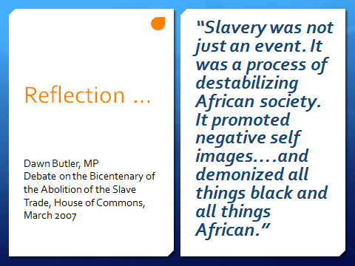

Facing or even accepting these difficult truths, according to Baroness Howells in her contribution to the British House of Lords Debate on the Bicentenary of the Abolition of the Slave Trade, is “always hard, especially if they have been ignored, willed away or relegated to an historical backwater.” Catherine Hall, in a recent article in England’s Guardian Newspaper, stated “…Forgetting the violence, pain and shame that is an inevitable part of any country’s historical record is a crucial aspect of a nation’s history.… The disavowal of the past is an active process. Forgetting Britain’s role in the slave trade began as soon as the trade was abolished in 1807”. This, she said, was done ‘deliberately by occluding the archival record’. In other words, there was a deliberate attempt to obfuscate Britain’s role during this period. Federico Mayor, then Director General of UNESCO, stated at the launch of UNESCO’s Slave Routes Project in 1994 that the TTA has ‘been passed over in silence”. He defines silence as “the failure to acknowledge the specific character of the slave trade”.
The silence that surrounds the trade therefore either suggests it is too painful to remember or was accorded little or no significance in the eyes of enslavers. Either case a denial of its existence and impact is not an appropriate response, but neither is the highly selective narrative, which was so prevalent during the bicentennial year and which continues to dominate the historiography. This narrative accords primacy to white male abolitionists (despite the presence of females in the abolitionist movement), shows disregard to black activism (despite the evidence that Africans resisted enslavement at every stage of the TTA). It also ignores the emerging historiographical trend that places abolition within the context of enslaved resistance and the political struggles in England.
My presentation here today is to continue the work of many distinguished scholars, past and present, who have worked to end the social and cultural forces that have conspired to create a wall of silence around the trade. In doing so the main goal is to preserve the public memory of the TTA. I will be using the recently created Voyages database to highlight the character of the trade and by extension to facilitate a much broader understanding of the experiences of enslaved Africans from West Africa to the Americas. I have supplemented the information contained in the database with primary documents as well as secondary sources.
I will use the database to highlight the experiences of those who were callously thrown overboard the Zong and other slavers while crossing the ‘bloody’ Atlantic. I will amplify the experiences of those children, some as young as 12 years old, who were shackled, forced to live for 64 days or more in an area no larger than a coffin, and forced to eat, sleep, and live in human excrement. I will talk about the experiences of women who had to live with sexual abuse all their lives. I will also highlight the experiences of those who stood on the right side of history and fought the injustices of slavery, and those who forged a lifestyle in the face of unimaginable brutality.
Counting the Dead
The major difficulty in the historiography of the trade in enslaved people is statistical in nature. This is evident in the varying estimates provided by scholars over the years to fundamental questions relating to the trade. There is no consensus, for example, on how many Africans were transported to the Americas during the course of the TTA. Also, there has been no agreement to date on the number of Africans who died between capture and enslavement in Africa. These are important questions to which we may never know the answer. Nevertheless, our understanding of the trade has been greatly advanced since the 1960’s; this is attributable to the collaborative work undertaken by scholars from Europe, Africa, North America, the Caribbean, and Brazil.
Phillip Curtin’s seminal work, The Atlantic Slave Trade: A Census, was the first real attempt to provide an estimate of the TTA. Curtin argued that 9.56 million Africans were shipped to the Americas. But, Joseph Inikori believes Curtin’s estimate of 9.56 million Africans is too conservative. Inikori stated that Curtin’s work is not solidly grounded in primary data but rather on a collection of secondary data sources that are themselves questionable. He maintains that it is incorrect for Curtin to assume that the size of the enslaved population in one colony could be applied to another colony. According to Inikori, colonies had different demographic experiences that were based on the relative date of colonization. Therefore, the rate of natural increase or decrease in Barbados’ slave population should not be assumed to be the same as that of St. Vincent since the former colony was first settled circa 1640 while the latter colony was ceded to Britain in 1763. In effect, Inikori contends that Curtin’s estimates are ‘unwarranted and misleading’. As such, Inikori revised upwards Curtin’s estimates by claiming that a total of 15.4 million Africans crossed the Atlantic during the TTA.
The publication of the Voyages database is the result of the collaborative work mentioned earlier by TTA scholars over the past four decades. The database contains records of 34,940 separate voyages between 1514 and 1866. It is far more expansive than the previously mentioned studies. It is arranged in 5, 25, and 100 years bands that cover ports of embarkation and disembarkation throughout the course of the trade. You can actually produce breakdowns by years or any time period you wish. This coverage allows for a much wider geographical and temporal analyses of the transatlantic trade. Information can be gleaned on the volume and demographic structure of the trade by region. And in turn it allows the study of the demographic, economic, and cultural changes that occurred on either side of the Atlantic World.
You will notice very early that while the database contains thousands of names of owners and ship captains it contains no names of the millions of Africans transported to the Americas. Let me quickly point out that this is no fault of the researchers who put this together. The TTA and slavery facilitated the reduction of the status of Africans to non-persons, more or less property. The ultimate aim was to destroy their sense of self and identity. But we also know that enslavers did not succeed in dehumanizing enslaved Africans, despite the attempts. Africans brought with them on the Middle Passage, their voices and memories to the Americas. In short, the Voyages database will help us answer historical questions with a greater degree of precision and rigor than was previously possible.

Structure and Volume
The TTA formed the backbone of British, Portuguese, French, and Spanish industry and commerce for centuries until its legal abolition by Denmark in 1803, and then Britain in 1807. According to the database an estimated 12.52 million Africans from the Senegambia in the northwest to the Indian Ocean island of Madagascar were transported to the Americas. It is evident that Portugal dominated the trade with 5.84 million or 46%, while Great Britain transported 3.25 million or 26%, France accounted for 1.38 million or 11%, and Spain 1.06 million or 8%, for a combined total of 11.53 million Africans or 92 % of the overall trade. Even more disturbing is the fact that this estimate of 12.52 million does not account for the hundreds of thousands of Africans who died between capture and enslavement in Africa, or the thriving illegal trade, which would have put the figure closer to UNESCO’s estimate of 30 million. One could also discern from the slide that Britain and Portugal transported nearly 75 % of the enslaved taken from Africa between 1626 and 1807 while Spain and Portugal transported over 80% between 1808 and 1867.
Of the overall trade, some 5.69 million, or 45.5%, embarked in West Central while the Bight of Benin accounted for 1.99 million or 16 %; the Bight of Biafra supplying 1.59 million or 12.7 % and the Gold Coast 9.7 %. Clearly, the regions that bore the brunt of this trade were West Central Africa and the Bights of Benin and Biafra.

Distribution of enslaved Africans during the Transatlantic Trade
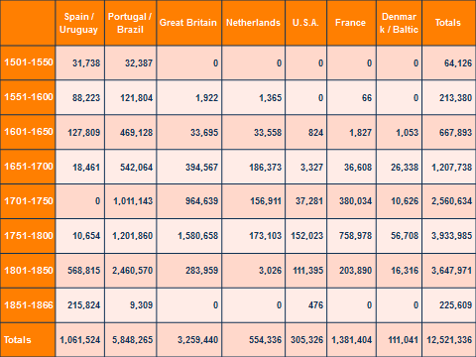
Source: slavevoyages.org

The rise of the sugar plantation system and its high concentration in some areas would determine the distribution of enslaved Africans in the Americas. A further explanation can be found in the inability of the enslaved population in these regions to reproduce thereby ensuring that the replacement demand for laborers was significantly high. In other words, Africans were imported to make up the demographic deficit on the plantations. Brazil, which had the largest sugar plantation economy, was the largest importer of Africans, accounting for 5.53 million or 44%, followed by the British Caribbean with 2.76 million or 22%. Overall, these two regions imported 8.26 million or 66% of total Africans transported. If I were to extend the analysis to South America and the foreign West Indies (which includes the French, Spanish, Dutch, and Danish-controlled territories) an estimated 95% of enslaved Africans disembarked in these regions.

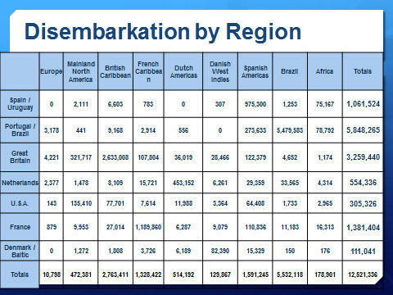
Source: slavevoyages.org

The structure of the TTA was heavily skewed. More men were traded than women. The slide shows the breakdown of men and children shipped from the various regions of Africa. Men made up 57.5 to 68.5 % of those embarked, while children accounted for 13.2 to 31.6 %. So, men and children together accounted for over 80% of the Africans shipped to the Americas. In regions like Sierra Leone and West Central Africa men and children accounted for over 91.5 % of the trade.
The imbalance between men and women is evident in most of the regions involved in the trade. Marginally, the only region which seemed to have had a relatively high ratio of females to males was the Bight of Biafra but even here 75% of enslaved exports were men and children. Most plantation societies in the British Caribbean imported more women towards the end of the eighteenth century and this trend continued until abolition in 1807. The debates in the Houses of Assembly suggest that the importation of women at this time was a strategic move by planters to encourage and promote reproduction within the enslaved population. The thinking was that having more women while simultaneously ameliorating the conditions of the enslaved population would facilitate natural growth.
One reason for the disparity in sex ratios is the parallel trans-Saharan trade to North Africa and the Middle East. The male dominance of the transatlantic crossing contrasted sharply with the trans-Saharan trade which had a higher ratio of women to men. This arose from the high demand for women as domestic laborers in North Africa and the Middle East. This demand led to a price differential between male and female. Females commanded a higher price than males along the African coast. In this context, trans-Atlantic traders opted for the cheaper alternative and transported a higher proportion of male to female slave across the ocean.
Capture in Africa
When confronting the issue of how many Africans died, there seems to be a narrow focus on deaths on the Atlantic crossing. But this is only one part of the mortality equation. Why such a narrow focus when there is evidence that the length of time it took to cross the Atlantic pales in comparison to the time it took Africans to reach the coast from the hinterland? The point I am making here is that the focus on Middle Passage mortality masks the full demographic cost of enslavement. Deaths occurred at every stage of the enslavement process, from capture in Africa to plantation labor in the Americas.
While we may never know how many Africans died between capture and embarkation, there is copious evidence from ship logs and evidence given by ship surgeons that paints a picture of this important, but less mentioned phase of the TTA. Noted abolitionist, Olaudah Equiano, provides some insight into this phase the trade. On being separated from his sister, Equiano stated,
…we were soon deprived of even the small comfort of weeping together. The next day proved a day of greater sorrow than I had yet experienced; for my sister and I were then separated, while we lay clasped in each other’s arms. It was in vain that we besought them not to part us; she was torn from me, and immediately carried away, while I was left in a state of distraction not to be described. I cried and grieved continually; and for several days I did not eat anything but what they forced into my mouth.
On his journey to the coast, continued,
Thus I continued to travel, sometimes by land, sometimes by water, through different countries and various nations, till, at the end of six or seven months after I had been kidnapped, I arrived at the sea coast.
As Equiano mentioned, the journey from the hinterland to the barracoons was a lengthy process that took a physical and psychological toll. Along with the length of time it took to get to the coast, one should also factor the months (sometimes upwards of 4) enslaved Africans spent in holding forts like Cape Coast Castle or Elmina Castle. What is becoming clear at this point is that many enslaved Africans would have spent well over a year in capture before the Atlantic crossing. There is evidence that a significantly high number lost their lives in the poorly ventilated and disease infested barracoons and holding forts while waiting to be shipped to the plantations in the Americas. We can also use the database to substantiate the claim that some slavers spent up to six months trawling the African coast so as to cross the Atlantic with a full load; this was also a period characterized by a significant loss of life as recorded in the journal kept by Peter Blake, captain of the slaver James. It is therefore not far-fetched, based on the evidence presented, that the time between capture in Africa and disembarkation in the Americas took close to 2 years.
Many, I am sure, have never contemplated what happened to those Africans who were deemed unsuitable by ship captains or surgeons. Clearly, not all captives were forced to take the Atlantic voyage and the treatment meted out to these victims of the TTA is indicative of the disregard for African lives. According to surgeon-turned-abolitionist, Alexander Falconbridge, rejected Africans were severely beaten by traders. ‘It matters not’, he stated, ‘whether they are refused on account of age, illness, deformity, or for any other reason’, the beatings were so severe that many died. “At New Calabar, in particular, the traders have frequently been known to put them to death”.
Atlantic Crossing
It is clear from the database that death characterized the TTA. In fact, one can see from the evidence presented that the slave ship was a deadly place. Of the estimated 12.52 million that embarked only 10.70 million or 85% made it to the Americas. Once you begin to deconstruct the trade and examine individual voyages, then one will get a fuller appreciation of how devastating the TTA was. The records presented here are for voyages to Jamaica and they show instances where the mortality rate was above 50%. The most damning revelation is the wide disparity between embarkation and disembarkation shown in the mortality per slaver column. Those ships that departed with the largest numbers of enslaved also, predictably, had the largest number of deaths. These ships include the East India Merchant, the Vyner, the Prosperous, the George, and Betty, all recording over three hundred or more deaths on a given voyage. This speaks volumes of the harsh conditions endured via the crossing as well as the blatant disregard for African life.
What is indisputable is that irrespective of ship size, capacity, or legal specifications, high mortality was a common and present feature of the Atlantic crossing. General overcrowding and the subsequent lack of sanitation was one factor. On most slavers, airborne pathogens like smallpox and tuberculosis, fecal to oral transmissions which led to dysentery and diarrhea, and yaws ravaged the enslaved population during this period.

Mortality Rates on Ships to Jamaica
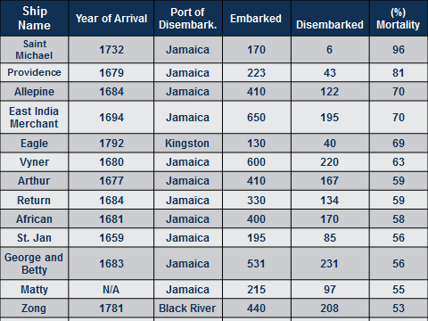
Source: slavevoyages.org

The cramped and inhumane conditions onboard the slavers contributed to the rapid spread of some pathogens and must have been especially present aboard the most overcrowded slavers. The inability of the enslaved to move freely, the contagious nature of some of the diseases combined with the slow pace of oceanic travel led to high rates of infections onboard some vessels. Based on the rate of death, it is now clear, and we can readily accept this, that not all who embarked on those slavers were conditioned for the uncertainty ahead. Each enslaved African, whether male or female, adult or child, or geographic region, had unique vulnerabilities and psychical and mental suitability that readily explain why some survived and many others did not. The stomach-churning conditions aboard those floating tombs were explained by Falconbridge.
The deck, that is, the floor of their rooms, was covered with the blood
and mucus which had proceeded from them in consequence of the flux,
that it resembled a slaughter house. It is not in the power of human
imagination, to picture itself a situation more dreadful or disgusting.
Numbers of slaves having fainted, they were carried upon deck, where
several of them died…it had nearly proved fatal to me also.

Commenting of the dreaded conditions, Equiano stated
In this situation I expected every hour to share the fate of my companions, some of whom were almost daily brought upon deck at the point of death, which I began to hope would soon put an end to my miseries... I now wished for the last friend, death, to relieve me.

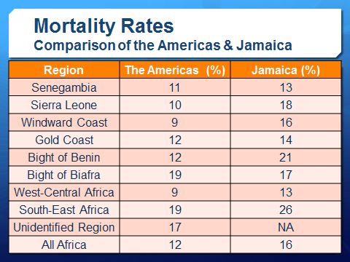
Source: slavevoyages.org

Dysentery or the bloody flux is the inflammation of the mucous membrane and glands of the large intestine and it usually results in severe pain and the discharge of blood and mucous. It is usually associated with diarrhea and was largely seen, along with smallpox, as one of the most infectious diseases during the TTA. An example of its devastating nature can be seen on the slaver Hannibal. Owned by Britain’s Royal African Company, the Hannibal spent six months trawling the African coast for human cargo. On July 27, 1694, it departed the Gold Coast with 700 African for the British Caribbean island of Barbados. During the course of the journey some 320 Africans died. According to ship captain Thomas Phillips, “...what the smallpox spar’d, the flux swept off”.
Tragedy on the Zong
The tragic events on board the Zong serves as a grueling reminder of the atrocities committed against enslaved Africans and the vagaries of a system that continued for too long. By the standards of the 18th century, or any era for that matter, the events on board the Zong were shocking, with no equal in barbarity. The decision by Luke Collingwood, Captain of the Zong, to throw overboard 133 live Africans has assumed a canonical form as it embodies the horrors of the TTA.

The Zong left Merseyside, Liverpool, on 5th March 1781 for the West African Coast. On board was Luke Collingwood, first captain, and Edward Howard second captain. They were supported by a crew of 20, mostly men drawn from Liverpool and its immediate surroundings. Luke Collingwood was an experienced seaman having undertaken a previous voyage to West Africa.
The date the Zong arrived in West Africa is not listed in the database, however it does show that it traversed the Gold Coast and in particular, the Cape Coast, Anomabu, Adja and Agga, looking for hapless African victims to kidnap and transport to Jamaica. On September 6, 1781, a total of 440 Africans faced a life and a future of uncertainty as the Zong left the Gold Coast for Jamaica.
The large number of Africans on board and the cramped and inhumane conditions caused sickness and death to chartacterize the journey of the Zong. The Africans were afflicted with dysentery, fever, small pox, and some respiratory related illnesses. Based on the evidence, as many as 60 Africans died within 7 weeks of the voyage. But the death toll would rise as Collingwood had to determine what to do with the many other Africans who fell ill. If those who were ill eventually died from natural causes, the consortium that owned the vessel would have to absorb the financial loss; but the insurers would pay, the captain reasoned, if it could be proven that the Africans drowned. In the ensuing court case, deposition by chief mate, Colonel James Kelsal, outlined how Collingwood met with his crew to outline his murderous plans.
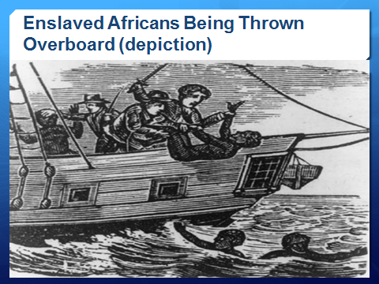
Source: The Liberator, 7 January 1832 (vol. 11, p. 2)
Within a few days, 133 Africans who the crew thought were least likely to recover were chained, ankle by ankle, and then thrown overboard, weighing them down with balls. Some 55 Africans were thrown overboard on 29th November, and 42 on 30th November. In his defense Collingwood posited that the lack of potable water influenced his decision but Kelsal noted that there was a heavy downfall of rain on 30th November, which could provide fresh water for 11 days. In fact, when the ship arrived in Black River on 28th December, it had over 400 gallons of fresh water on board. Despite this, 26 more Africans were thrown overboard on 1st December, while 10, in a last act of defiance, committed suicide.
The Zong arrived in Black River on 28th December 1781 with 208 Africans, 232 less than it had when it departed the African Coast - a mortality rate of 53%. This ranks among the ships with the highest mortality rate and is noteworthy because the largest number of deaths was deliberate and premeditated. To elude international enforcement after Britain abolished the trade in 1807, many slavers would routinely dispose of their cargo on the high seas. If the mortality rate is extended to the trade as a whole, therefore, the number of deaths would be seen to have reached alarming proportions; and this in itself would then justify the claim that the Transatlantic Trade in Africans constituted genocide and was a crime against humanity.
Sexual Abuse
Like death, the abuse of enslaved women’s bodies was common during the TTA and the evidence provided by Falconbridge is indicative of the wantonness with which these acts were sanctioned and allowed to continue. “On board some ships”, quotes Falconbridge, “the common sailors are allowed to have intercourse with such of the black women whose consent they can procure. The officers are permitted to indulge their passions among them at pleasure, and sometimes are guilty of such brutal excesses, as disgrace human nature”. These acts he argued, led many women to commit suicide by jumping overboard. The ‘consensual-sex’ to which Falconbridge refers is a common theme among contemporaries who refused to explore, or even acknowledged the uneven power dynamics between male enslavers and enslaved women. The sexual exploitation of enslaved women during the TTA was also prevalent during the plantation period. What took place in effect was the transference of the rights to women’s bodies to enslavers. Hilary Beckles succinctly argues that enslavers had, and exercised, their ‘property rights in pleasure’.
Resistance
There is incontrovertible evidence that enslaved Africans were the first to confront the injustices of the TTA, effectively questioning its motives and underlying assumptions. We have at present evidence of 543 acts of resistance by Africans against enslavers and their crews. These include 97 instances of attacks from the shore by Africans against ships and 435 cases of shipboard revolts. Of the 435 insurrections, roughly 90% took place between 1700 and 1807. The high rate of resistance during the first phase of enslavement suggests that ships experienced revolts before they were fully loaded.
On ships trading at Senegambia, Sierra Leone, and the Windward Coast, the rates of revolts were more frequent than one might expect from their shares of the trade. West Central Africa, which accounted for some 45% of the trade, had the lowest rate of resistance compared to the Senegambian region.

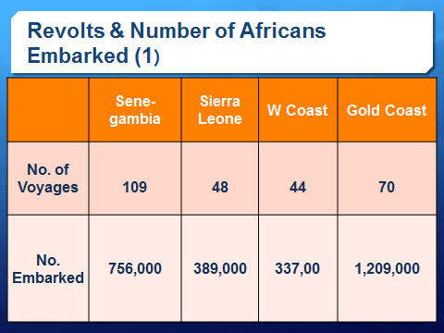
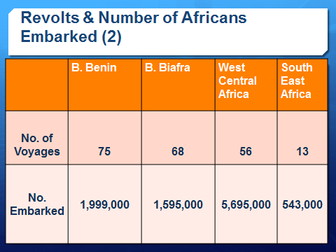
Source: slavevoyages.org

The database can also be used to gauge the frequency of resistance based on the countries involved in the trade. Of the 543 cases, there are 227 incidents of resistance on British registered vessels, while 153were alleged to have taken place on vessels registered in France. Even though we have established that Portugal transported 46% of enslaved Africans, the frequency of resistance was much lower on Portuguese registered vessels compared to British and French registered vessels.
Conclusion
I will end with the words that are enshrined on the wall of the dungeon at Cape Coast Castle: ‘May those who died rest in peace; may those who return find their roots; may humanity never again perpetrate such injustice against humanity. We the living vow to uphold this.’ Thank You.

Declaration of the World Conference against Racism, Racial Discrimination, Xenophobia and Related Intolerance, Durban, South Africa, 2001; www.un.org/WCAR/durban.pdf
Hilary Beckles and Verene Shepherd. Trading Souls: Europe’s Transatlantic Trade in Africans (Ian Randle Publisher, 2007).
Eric Williams. Capitalism and Slavery (University of North Carolina Press, 1944). See The University College of London’s Legacies of British Slave-ownership database. http://www.ucl.ac.uk/lbs/
Baroness Howells of St Davids (British House of Lords Debate on the Bicentenary of the Abolition of the Slave Trade, 10 May 2007)
Catherine Hall, ‘Britain’s massive debt to slavery’. Guardian, Tuesday February 26, 2013.
Federico Mayor, Director-General, UNESCO, Conference to launch the ‘Slave Route’ project, Ouidah (Benin), 1 September 1994 DG/94/26.
See http://slavevoyages.org/tast/index.faces.
See for example Philip D. Curtin, The Atlantic Slave Trade: A Census (Madison, Wisconsin: University. of Wisconsin Press, 1969). Roger Anstey, ‘The Volume and Profitability of the British Slave Trade’, in S.L. Engerman and Eugene D Genovese (eds.) Race and Slavery in the Western Hemisphere: Quantitative Studies (Princeton: Princeton University Press, 1974). Joseph Inikori, ‘Measuring the Atlantic Slave Trade: An Assessment of Curtin and Anstey’, Journal of African History, 17, no.2, 1976, pp. 197-223; ‘Measuring the Atlantic Slave Trade: A Rejoinder’, Journal of African History, 17, no.4, 1976, pp.607-27; Colin A. Palmer, Slaves of the White God: Blacks in Mexico, 1570-1650 (Harvard University Press, 1976); Robert Stein, ‘Measuring the French Slave Trade, 1713-1792/93’, Journal of Africa History, 19, no.4, pp. 515-21; David Eltis, ‘The Export of Slaves from Africa, 1821-43’, Journal of Economic History, 37, 1977, pp. 409-33; ‘The Direction and Fluctuation of the Transatlantic Slave Trade, 1821-43: a Revision of the 1845 Parliamentary Papers’, in The Uncommon Market: Essays in the Economic History of the Atlantic Slave Trade , Henry A. Gemery and Jan S. Hogendorn (eds.), (New York: Academic Press, 1979); The Chaining of a Continent: Export Demand for Captives and the History of Africa South of the Sahara, 1450-1870 (Institute of Social and Economic Research, University of the West Indies, Mona, Jamaica, 1992);
Joseph Inikori, ‘Measuring the Atlantic Slave Trade: An Assessment of Curtin and Anstey’, op. cit.
Joseph Inikori, The Chaining of a Continent: Export Demand for Captives and the History of Africa South of the Sahara, 1450-1870 op. cit.
A clear insight into the regional distribution of the trade is provided by David Eltis and David Richardson, ‘West Africa and the Transatlantic Slave Trade: New Evidence on Long Run Trends’, in Slavery and Abolition, Vol. 18 (1997), pp. 16-35; See also David Eltis, The Rise of African Slavery in the Americas (Cambridge University Press, 2000), pp. 85-113
See Douglas Chambers’ essay on ‘My own nation’: Igbo Exiles in the Disapora’, in Slavery and Abolition, Vol. 18 (1997), pp. 72-97; Philip Morgan ‘The Cultural Implications of the Atlantic Slave Trade: African Regional Origins, American Destinations and New World Developments’, in Slavery and Abolition, Vol. 18 (1997), pp. 122-145
Paul E. Lovejoy, Transformations in Slavery: A History of Slavery In Africa (Cambridge University Press, 2000); ‘Competing markets for male and female slaves: slave prices in the interior of West Africa, 1780-1850’, International Journal of African Historical Studies, vol. 28 (1995), pp. 261-93; Joseph Inikori, ‘Export Versus Domestic Demand: The Determinants of Sex Ratios in the Transatlantic Slave Trade’, Research in Economic History, vol. 14 (1992), pp.
Elizabeth Donnan, Documents Illustrative of the Slave Trade to America, 4 vols. (Washington, DC, 1930-33) vol. I, 199-209.
Alexander Falconbridge, An Account of the Slave Trade on the Coast of Africa (London: James Phillips, 1788), p.18.
Alexander Falconbridge, An Account of the Slave Trade on the Coast of Africa (London: James Phillips, 1788), p.25.
Olaudah Equiano. The Interesting Narrative of the Life of Olaudah Equiano, or Gustavus Vassa, the African (London, 1789).
Quoted in Elizabeth Donnan, ed. Documents Illustrative of the History of the Slave Trade to America, 4 vols. (New York, 1965) vol.1, p.393-410.
See Slavevoyages.org; James Walvin. The Zong: A Massacre, The Law and the end of Slavery (Yale University Press, 2011).
Alexander Falconbridge, An Account of the Slave Trade on the Coast of Africa (London: James Phillips, 1788), pp.23-24.
Hilary Beckles. “Property Rights in Pleasure: The Marketing of Enslaved Women’s Sexuality”, In Verene Shepherd And Hilary Beckles (eds.) Caribbean Slavery in the Atlantic World (Kingston, 2000)

