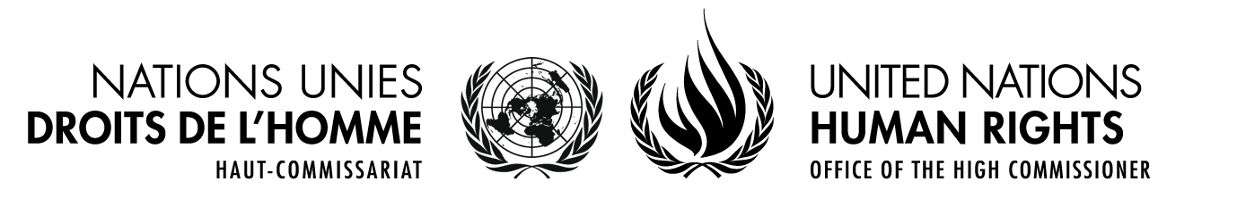
HAUT-COMMISSARIAT AUX DROITS DE L’HOMME • OFFICE OF THE HIGH COMMISSIONER FOR HUMAN RIGHTS
PALAIS DES NATIONS • 1211 GENEVA 10, SWITZERLAND
www.ohchr.org • TEL: +41 22 917 9000 • FAX: +41 22 917 9008 • E-MAIL: registry@ohchr.org
Mandate of the Special Rapporteur on trafficking in persons, especially women and children
Concept note

Expert Group Meeting on
the impact of armed conflict on people’s vulnerability to trafficking in persons, including sexual and labour exploitation

29-30 November 2015

Hotel Landmark & Conference Center, Amman, Jordan

Context
In her 2015 report to the Human Rights Council (A/HRC/29/38), the UN Special Rapporteur on trafficking in persons, especially women and children has identified the linkage between human trafficking and conflict as one of the thematic issues of interest to her mandate. Based on this, the Special Rapporteur has initiated research, in order to shed light on this emerging form of trafficking, and make concrete recommendations on how to address this phenomenon.

Worldwide, conflict exacts a heavy toll on individuals, families, communities and nations. The Armed Conflict Database maintained by the International Institute for Strategic Studies (IISS) currently recognises the existence of 41 active conflicts, with the most acute flashpoints being located in Africa, the Middle East, and Asia. Of these, eight are classified as high intensity; twenty as medium intensity; and thirteen as low intensity. During 2014, conflict and persecution forced a daily average of 42,500 individuals to leave their homes and seek protection elsewhere, either within the borders of their own country or in other countries. The total number of persons displaced due to conflict and persecution now stands at an unprecedented 59.5 million, a 40 per cent increase in just three years.

The features and patterns of modern day conflict are highly relevant to the specific subject of the links between trafficking and conflict. While the past decade witnessed several large-scale conflicts between States, the trend towards internal conflict continues to grow. Indeed, several of the most significant international armed conflicts in recent times, including wars in both Afghanistan and Iraq, have morphed into complex internal conflicts and spilled over to fuel internal crises in neighbouring states. Internal conflict is inevitably accompanied by a breakdown in public institutions; erosion of essential services; heightened tensions within and between communities that previously co-existed in relative peace; inequalities and widespread impoverishment. The rapid growth in the number of conflicts and the resulting increase in displacement have strained an already overburdened international asylum system to breaking point. Lack of access to safe and legal migration options forces many persons fleeing conflict to use the services of illegal facilitators, increasing their exposure to exploitation.

It is widely accepted that human trafficking is an increasingly common feature of modern conflict – whether internal or international. Many of the elements known to increase individual and group vulnerability to trafficking - from gender-based violence to discrimination to lack of economic opportunity – are exacerbated before, during and after conflict. Furthermore, conflict fuels the impunity, the breakdown of law and order, the destruction of institutions and communities that foster the conditions within which trafficking will flourish, often well past the point at which hostilities cease.

The international community has now long recognized that trafficking in persons violates human rights and continues to pose a serious challenge to humanity, including in conflict situations.

Despite the wealth of international human rights and humanitarian laws and standards, the trafficking mandate has noted a gap in research in this area and has emphasized the responsibility of States to protect and uphold the rights of persons within their jurisdiction and to do all that is possible to address conditions such as poverty, inequality, lack of opportunity, discrimination, as well as conflict and insecurity, which enable trafficking to thrive. The lack of progress “in establishing ways of increasing accountability of non-State actors who are also implicated, often more directly, in the harm of trafficking” has also been highlighted along with a continuous call for “closer human rights-based collaboration with international, regional and national mechanisms to combat trafficking in persons in consultation with victims.” In order to examine why these gaps persist and discuss possible responses, the Special Rapporteur has decided to convene this Expert Group Meeting on 29 and 30 November 2015.

Objectives and expected outcomes of the meeting
The objectives of the meeting are as follows:

- To examine the current state of affairs in relation to how conflict situations can fuel trafficking in persons;
- To discuss possible recommendations on the responses States and non-state actors should put in place in order to fight trafficking emerging from conflicts;
- Providing a forum for enhanced cooperation and networking between national and international experts across the world on the issue of trafficking in conflict

The expected outcome of the expert group meeting is to inform one of the future the Special Rapporteur’s reports, with a view to offering guidance to States and Non-State actors on the impact of armed conflict on people’s vulnerability to trafficking in persons, including sexual and labour exploitation.

Modalities
The meeting will be organized as a day and a half of panel discussions. It is envisaged that it will consist of a number of sessions addressing the following topics:

- International legal and policy frameworks addressing trafficking and conflict: An overview
- Trafficking in persons and conflict: Understanding the Challenges
- Conclusions and recommendations

An agenda will be sent to participants in due course.

Experts on trafficking in persons and conflicts will be invited to participate in this expert meeting taking into account to the extent possible geographical and gender balance

The meeting will be held in English only; no simultaneous interpretation in any other UN languages will be provided.

****

Armed Conflict database: https://acd.iiss.org/en/conflicts?tags=D6943ABDB5364229B5A0E3338AC94EA1
UNHCR, World at War: Global Trends (2014)
Ibid.
A/HRC/10/16 (2009), para. 50.
A/HRC/26/37/Add.2, para. 92
Ibid., para. 111(d).

