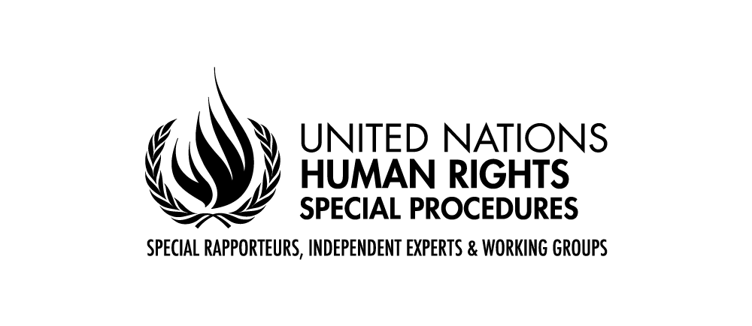
PALAIS DES NATIONS • 1211 GENEVA 10, SWITZERLAND
www.ohchr.org • TEL: +41 22 917 9000 • FAX: +41 22 917 9008 • E-MAIL: registry@ohchr.org

Joint call by Committee of Experts of the MESECVI, the UN Special Rapporteur on Violence against Women and the Working Group on the issue of discrimination against women in law and in practice expressing concern over sentence that denies freedom to Teodora Vázquez

Washington (12 January 2018) - The Committee of Experts of the Follow-up Mechanism of the Convention on the Prevention, Punishment and Eradication of Violence against Women, Convention of Belém do Pará (MESECVI), of the Organization of American States (OAS), the UN Special Rapporteur on violence against women, its causes and consequences, Ms. Dubravka Šimonović, and the UN Working Group on the issue of discrimination against women in law and practice express their concern over the resolution of the Second Sentencing Court of San Salvador, which on 13 December 2017, resolved to deny freedom to Ms. Teodora Vázquez, who had been imprisoned after suffering an obstetric emergency .
The case of Teodora deserves our serious consideration, given that in 2008 she was sentenced to 30 years imprisonment for a gynecological complication, under the accusation of aggravated homicide. According to information that the experts have received, Teodora, nine months pregnant, had requested emergency medical assistance; while waiting for assistance, she gave birth to the baby and suffered a faint. The police suspected that she had tried to end the pregnancy and arrested her. Civil society organizations have reported violations of due process, including the lack of an adequate legal representation.
The facts show the clear legal limitations existing in the State of El Salvador for the treatment of women with obstetric complications in their pregnancy, which could aggravate to a greater extent the terrible circumstances of which Teodora has been a victim. In this same context, the experts deeply regret the cases of so many Salvadoran women wrongfully prosecuted and sentenced to disproportionate sentences for obstetric complications. Teodora’s case is not only about the unjust consequences of El Salvador's criminal abortion ban not to mention its misapplication, but it also reflects the lack of access to emergency obstetric care and criminal prosecution for obstetric emergencies.
The Committee of Experts of the MESECVI, in its Declaration on violence against women, girls and adolescents and their sexual and reproductive rights in 2014, stated that it considers it necessary "to eliminate from the legal systems the laws that perpetuate the practice of violence against women, girls and adolescents, as well as ensuring that mistreatment and humiliation behaviors are not reproduced in institutional settings, and that health personnel do not revictimize or deny access to health services to women who require them”, they also stated that "access to health services in general, and pregnancy termination services in particular, must be confidential and (...) can not in any case result in a violation of women's human rights.”
Similarly, Dubravka Šimonović, UN Special Rapporteur on violence against women, its causes and consequences, previously expressed that "the criminalization of termination of pregnancy restricts women's access to sexual and reproductive health information and services, and because of the threat of criminal punishment, women and girls are afraid to seek medical attention when they experience complications related to pregnancy.” She also reiterates her call to review the sentences against all women currently serving prison sentences on charges related to abortion with a view to their release.
The Working Group on discrimination against women would like to reiterate that much of the discrimination in access to health services and preventable ill health, including maternal mortality and morbidity, can be attributed to the instrumentalization of women’s bodies for political, cultural, religious and economic purposes. The exposure of pregnant women to obstetric emergencies due to discrimination in access to health services disproportionately impacts poor women and puts their lives and pregnancies at risk. Also, lack of access to justice and due process, which has contributed to the prosecution of women, especially poor women, whose pregnancies do not result in a live birth is a major concern to the Working Group.

Additionally, the United Nations High Commissioner for Human Rights, Zeid Ra'ad Al Hussein, in a recent visit to El Salvador, called upon the Government to launch a moratorium on the application of article 133 of the Penal Code, and review all cases where women have been detained for abortion-related offences, with the aim of ensuring compliance with due process and fair trial standards. The High Commissioner also recalled that El Salvador should comply with its international human rights obligations and lift the absolute prohibition on abortion. The absolute prohibition of the termination of pregnancy in El Salvador, even when it is necessary to save the life of the woman, results in the prosecution, imprisonment of women who have suffered miscarriages and complications related to pregnancy, which is why all these cases are criminally investigated.

The experts urge the Salvadoran authorities to take all necessary measures to revise their legislation and put it in line with its international obligations and commitments, especially those emanating from the Convention of Belém do Pará and the UN CEDAW Convention, both international instruments signed and ratified by the State of El Salvador. In particular, the experts call upon the Government of El Salvador to decriminalize abortion and to release any woman charged or sentenced for abortion or related charges, and to provide them with reparation in compliance with international obligations to protect the human rights of women and girls in El Salvador. The experts also make themselves available for any technical support the State may require.

The Committee of Experts of the Follow-up Mechanism to the Belém do Pará Convention (MESECVI), Ms. Dubravka Šimonovic, Special Rapporteur on violence against women, its causes and consequences and the Working Group on the issue of discrimination against women in law and practice.

