Smart Cities and Gender: main arguments and dimensions for a promising research and policy development area
Maria Sangiuliano
Maria Sangiuliano is a senior Gender & Innovation researcher and project manager working at the intersections between social and technological innovation to make innovation policies and processes more sustainable and inclusive through diversity sensitive co-design and implementation.
Maria's research profile is bridging socio political and learning studies (PhD in Cognitive and learning science) and has cooperated with universities and research centres in Italy as well as international NGOs, consultancies and agencies in Italy and abroad. She is currently a research fellow at the Department of Computer Sciences Ca' Foscari University on the EQUAL-IST H2020 Project and CEO at Smart Venice, a startup working on promoting the urban regeneration processes and sustainable tourism. She also leads the Citizen Focus Action Cluster of the European Innovation Partnership on Smart Cities and Communities.

Intro
In the quickly advancing interdisciplinary debate on smart cities a specific gender dimension is not fully taken into consideration, even when an inclusion or equality issue is raised. This short paper starts is arguing for the relevance of gender as an indicator for inclusive smart cities drawing on gender studies from several disciplinary areas and presenting 6 key dimensions which motivate the relevance of gender as a key variable in studying urban innovation policies. Mobility and transport as a specific vertical area of intervention is highlighted as an example of how fertile could be an integration of gender issues into smart cities. Finally, the importance of embedding gender into transnational and EU level policy initiatives is stressed and the example of the Inclusive Smart Cities Manifesto of the EIP SCC is presented.
- Women in local Politcs
In 2014, the large majority of EU countries had no main cities having a woman as a mayor and only 5 of the 28 EU capitals had a female leader (Paris, Warsaw, Madrid, Luxembourg and Sofia). In Europe, women represent on average only 26.65% of the elected municipality councillors (Sundström, 2013).
- Women and/in ICT
Low representation of women into ICT professions leads to having male dominated teams of ICT designers. Gendered digital divides (along with class, ethnicity, age and disability) negatively affects women’s empowerment as smart citizens.
ICT Workforce in Europe (out of the overall work force)
10.76%
20.67%
29 out of every 1000 female graduates have a degree in computer sciences/ICT
Women constitute only 19% of digital entrepreneurs in Europe, compared to an average 33% in the USA
(data from: EC, 2013a)
From the Gender Digital Divide to users’ types divide.
According to recent research, age and Internet access are the most salient predictors for digital divide, whereas gender and household seems to be less relevant but still important. There are some differences between genders with regard to user types, but these are not very acute. There are generally more male advanced and entertainment users.
Colley and Maltby (2008) identiﬁed differences in the effects of Internet use on both men’s and women’s lives and concluded that Internet represents an extension of broader social roles and interests in the ofﬂine

world. These gender differences might tell us that the power relationships in the real world creep into cyberspace as well, in contrast to the hypothesis of an online world free of gender restrictions. However, the
amount of variance explained differs between countries. A future increase in the digital divide between the identiﬁed user types — a user type divide is foreseen (Brandtzaeg, Heim & Karahazanovic, 2011).

- Gender neutral/blind (urban) innovation and gender blind design of smart cities ICT solutions
Many of the scholars in the field agree on the fact that innovation studies and practices share a normative frame of understanding which needs to be challenged. A model of technical and bureaucratic rationality identified as driver of innovation, at the expenses of what is defined as ‘rationality of care/reproduction’ which is more focused on ideas, methodologies and services as crucial aspects of innovation (Danilda & Thorslund, 2008; Ve, 1994; Hacker, 1989; Mellstrom, 2004).
Gender studies on innovation criticize techno-centric visions of innovation and their being blind in terms of social and environmental impact. It is recognized that including women among the stakeholders in innovation networks would increase the robustness of innovations. On the other hand, focusing only on ICT and manufacturing as “the” innovation’s sectors leads to oversee methodological and even technological innovations that women bring about in the sectors where they are mainly occupied, i.e. the economy of services or traditional occupations in the primary sectors (Lindberg & Hodlun, 2008).
As urban innovation is more and more relying on urban open data analytics, the lack of gender/sex disaggregation in data collection and analysis risks to lead to gender blind/neutral smart cities policies. Global initiatives such as Data2X try to address this important challenge.
On similar notes, feminist studies on technology (Wajcman, 2010) and more recently within the field of STS (Society and Technology Studies) have analysed the genealogy of technological artefacts and the complex ways they are implicated with several socio-economic factors. A so called ‘gender script’ is often present although implicit in the mind of the designers (van Oost, 2003; Oudshoorn, Brouns & van Oost, 2005) as an effect of occupational segregation in STEM, still having more often men involved into the design of technology, and also due to persisting traditional cultures and symbols. This leads to exclusionary effects in terms of artefacts’ use or to diminishing the potential empowering impact they could have if they were designed for the needs of both men and women. A search for new methods and tools for gender sensitive design has started and some interesting pilot initiatives are already available (Buchmuller & Joost, 2009). Recent experiences are interestingly based on gendering user-centred design rather than on user-led participatory methodologies of co-creation which would make them even more suitable to be integrated into social innovation initiatives.

- The lack of women’s participation as active citizens impacts also on web based forms of civic consultation and engagement in smart cities initiatives
People who reported they feel that the time spent on voluntary work and political activities is too little
53% women 45% employed women with children
47% men 38% employed men with children
(Source: Eurofund, Third EQL Survey, 2012)
Case studies about electronic town meetings in Italy showed difficulty in having women involved (Garramone & Aicardi, 2011). Gender segregation reported in the type/sector areas of involvement within e-planning Living Lab experiences in the Greater Helsinki Area to develop web 2.0 services for neighbourhood communication (Home Street Sites), with men joining more frequently for creating the technical applications labs and women participating to management and provision services (Horelli, 2013).
- The big urban challenges of the XXI Century to be looked at with ‘gender lenses’
• Economic and financial crisis effects such as increased unemployment rates have a gender dimension. As for now female unemployment rates have dropped less than male ones, as male- dominated sectors like building and manufacturing have been hit by the crisis more than the service economies where women are mostly occupied. On the reverse, there are clear signals that fiscal consolidation can lead to cutting public administration jobs where there is a prevailingly female work force and to curtailing welfare provisions with strong impact on gender equality (European Commission, 2012) . In recovery scenarios Europe shall aim at building a strong knowledge based and service economy to compete in the global arena through sectors like ICTs and Future Internet economy, green tech and renewable energies; it’s important to pursue gender balanced employment in these strategic sectors to overcome continued gender segregation in the economy. Urban social innovation dealing with these sectors in particular needs to pay specific attention to the risks of gendered segregation.
• In the ageing society women are overrepresented as they constitute 55.7% of the population aged 65+ (Eurostat on line database, 2013). Due to the gender pay gap and more discontinuous careers, senior women are at greater risk of poverty and they are definitely one of the vulnerable groups with unmet needs which social innovation initiatives shall pay attention to. Moreover, healthcare and long-term care are among the sectors where the female work force is higher than other occupational areas: all social innovation initiatives targeting these sectors shall take this into consideration.
• Environmental challenges such as climate change demand for a radical transformation of industrial production and energy consumption which are also relying on changes in personal behaviour and consumption patterns. Research undertaken by the European Institute for Gender Equality is showing how women are actually more sensitive towards issues of sustainability and more prone to adopting an environmentally friendly behaviour (EIGE, 2012). At a global level, several studies have demonstrated how gender is adding to the discriminatory effects of other social and economic differences leading to increased negative impacts of climate change on women in cities (Syngh, Svensson, Kaliampur, 2010; Dankelman, 2010).
- Gender and Social Innovation
As it has become more and more clear that tech driven orientation in smart cities policies need to be balanced by bottom up approaches that leverage on citizens emporwerment and their autonomous initiatives to re-invent and self organize public spaces and services, the need to integrated technological and social innovation has been arising into research and policiers agendas. The contemporary promise of increased citizens’ participation and involvement in urban planning as well as in services’ provisions through social innovation is strongly connected to digital technologies contributing to shape new forms of civic participation and social relations: the widespread use of social media, peer collaboration, knowledge sharing and civic hacking platforms can therefore be seen as triggering social innovation (Townsend, 2013). Gender equality is a widely recognized milestone among the major social changes which have been transforming Europe in the 20th century (Esping Andersen, 2009; Giddens & Sutton, 2013) even if several scholars referred to it as an ‘unfinished revolution’ (Gerson, 2009).

Along with urbanization, empowerment of marginalized groups and the rise of mass media, transformation of gender roles is included among the social innovations in Europe by some of the most authoritative literature’s sources on the topic (Andrè, in Moulaert et al., 2013). This is why this chapter’s title reiterates the call to “not reinventing the wheel”, one of the most common sayings within the urban innovation and smart cities debates: if gender equality is to be intended as one of the major forms of social innovation and if as figures and statistics reported in Chapter 1 clearly show that we are still far from a gender equal Europe, then it is important to get the most out of the interconnections between these two fields of action and policy. The aim, then, shall definitely be to build and capitalize on what civil societies of women and institutions have already managed to achieve until now and at the same time exposing them to new alliances and innovative urban environments. The following paragraphs aim at arguing how transformations in gender roles and power structures in society are an expression of social innovation and showcasing the analogies between gender equality policies and social innovation ones.

The BEPA report on social innovation (BEPA, 2011) summarizes three main ways of conceiving social innovations in the present debate and when describing them in detail it integrates gender equality initiatives among concrete examples of social innovation.
The SeiSMiC Gender Action Plan and Toolkit pursues a more in depth exploration of the gender dimensions of social innovation, identifies the importance of including so called “gendered ecosystems into social innovation networks” and draw a series of guidelines to assess social innovation actions from a gender perspective in the form of three questions to be articulated for each phase of any project’s or initiative’s implementation process.

Applying a gender perspective to vertical smart cities areas of intervention: mobility and transport as an example
Figures show how relevant gender is a variable and dimension also in so called ‘vertical areas of urban life’ where smart cities policies are implemented (mobility, energy efficiency, egovernment, health & well being). Mobility and transportation provide a good example to this respect as there is substantial research already carried out on gendered mobilities (Sanchez de Madariaga & Roberts, 2013) as data below show and some applications in practice have also proved how a gender inclusive perspective is useful for improving smart mobility services as the good practice illustrated below is showing.
Daily use of car
42%
57%
(Source: European Commission, 2013c)
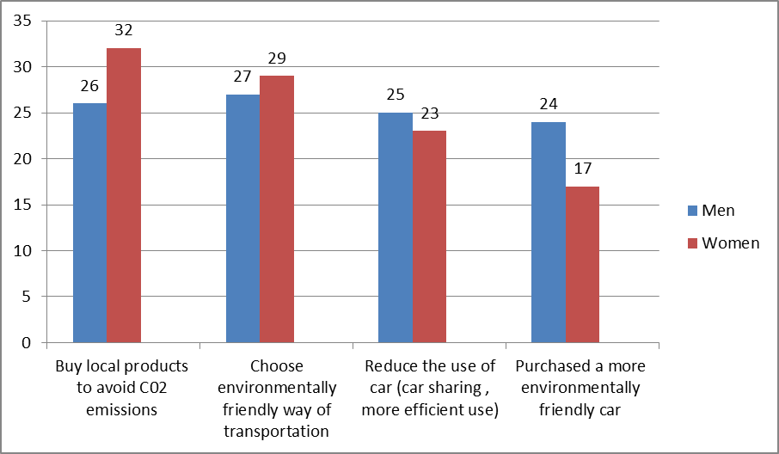
(Source: European Parliament, 2012b)

Different mobility patterns have been detected, kept constant against other factors such as education, marital status and income.
- smaller spatial rate of women's mobility: shorter travelled distances
- chain trip' model

Space

- less time spent to travel to work due to workplaces closer to home
- women more likely to work from home

Time

Purpose

- men travel more for work, more likely to travel overnight for work reasons or have mobile workplaces

Safety

- women feel less safe on public transport, especially in transit environments
- women take less risk by driving

(Data from: EP, 2012; EC, She Moves, 2014; Ceccato, 2014).
Gendered Innovations for info mobility apps

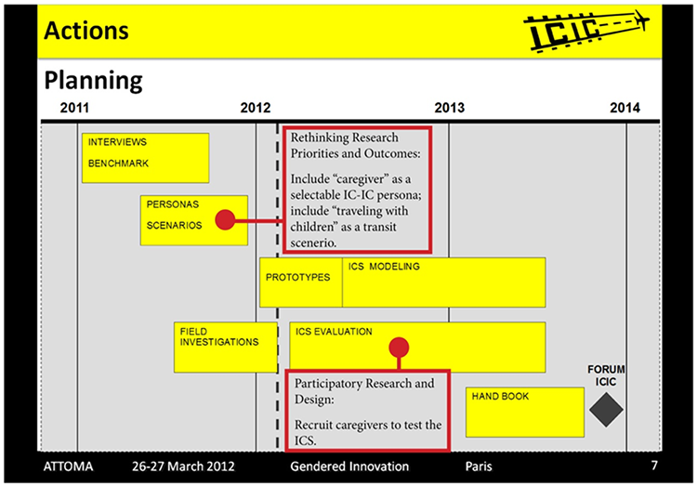

Within the Gendered Innovations project (run by Stanford University and partnered by the European Commission) the EC commissioned an evaluation of an FP7th project named IC-IC (Interconnectivity through Info-connectivity) to assess whether and how the designed services and solutions could benefit from taking into account a gendered approach and women’s needs. The overall aim of IC-IC was to meet air travellers’ needs when accessing and transiting to/from and through airports in several EU capital cities by way of

increasing their access to information. The evaluation focused on one potential area for adding value to the project, researching the needs of caregivers travelling with dependents and the availability of airport infrastructure to convey all the necessary information to them. The evaluation demonstrated how including “care givers” among the thousands of interviewed airports’ customers could lead to broadening the number and type of mapped airport facilities (lactation rooms, playground, accessible pathways, diaper changing stations) as well as in train/bus/metro stations connecting the airport to the main cities and different types of specific services in the arrival zone (like paediatric health services, playgrounds etc.). Adding different types of care givers to the already employed ‘personas’ (the fictional characters around which the ICT service design process is built) would have allowed to make the info mobility application richer and better able to provide tailored sets of information to air travellers (men and women) with dependents, more often kids, customized to their needs. Recommendations were provided for the need to look at the gender dimension as intersected with other social characteristics (age, ethnicity-spoken language, employment etc.) for a more nuanced picture of users needs.

- Embedding a gender perspective in transnational smart cities policy level initiatives the case of the EIP SCC Inclusive Smart Cities Manifesto
Smart cities & gender issues would strongly benefit from becoming mainstreamed into transational policy level initiatives jointly with an attention to other dimensions of inclusion/potential discrimination and with an intersectional approach. One first example of this integration is the Inclusive Smart Cities Manifesto: promoted by the Citizen Focus Action Cluster of the European Innovation partnership on Smart Cities and Communities jointly with ERRIN and ICLEI Europe, it is open for endorsment to the attention of cities in particular. The document was co-created through an open on line consultation process during spring and summer 2016: comments from several civil society organization dealing with gender issues further strenghtened reference to gender which was already included in the original draft, leading to the first official policy document which is having this peculiar approach. It was already endorsed by more than 100 stakedholders while the process of engaging cities is still open as well as further activities to monitor its local implementation, the gender related aspects included.

References
André, I. (2013). Gender and Social Innovation. The role of EU Policies. In F. Moulaert, D. MacCallum, A- Mehmood, & A. Hamdouch (Editors), The international handbook on Social Innovation. Collective action, social learning, and transdisciplinary research. Cheltenham, Camberley, Northampton: Edwar Elgar Publishing.
BEPA (Bureau of Policy Advisors, European Commission) (2011). Empowering people, driving change. Social Innovation in the European Union. Luxembourg: Publications Office of the European Union.
Brandtzaeg, P.B., Heim, J. & A. Karahasanovic (2011). Understanding the new digital divide—A typology of Internet users in Europe. International Journal of Human- Computer Studies, 6 (3), 123-138.
Buchmüller, Sandra, Joost, Gesche (2009): Women’s Phone – a Case Study on Knowledge Management in a Participatory Design Process, IASDR 09 Conference, Seoul/ Korea, 18th to 22th October 2009.
Ceccato, V. (2014). Safety on the move. Crime and perceived safety in transit environments, Security Journal, 27, 127-131.
Colley, A. & Maltby, J. (2008). The impact of internet into our lives. Male and female personal perspectives. Computers in Human Behaviours, 24, 2005-2013.
Danilda, I. & Thorslund, J.G. (2011). Innovation & Gender. Stockholm: Vinnova, Innovation Norway & Tillväxtverket.
EIGE (European Institute for Gender Equality) (2012). Review of the Implementation in the EU of area K of the Beijing Platform for Action: Women and the Environment Gender Equality and Climate Change. Luxembourg: Publications Office of EU.
Esping Andersen, G. (2009). Incomplete revolution. Adapting to women’s new roles. Cambridge: Polity Press.
Eurofund (2012). Third European Quality of Life Survey Quality of life in Europe. Impact of the crisis. Luxembourg: Publications Office of the European Union.
European Commission (2014). She Moves. Women’s issues in transportation. Luxembourg: Publications Office of the European Union. Retrieved from: http://wiit-paris2014.sciencesconf.org/conference/wiit-paris2014/pages/shemoves_wiit_web_3.pdf
European Commission (2013a). Study on Women active in the ICT sector. Luxembourg: Publications Office of the European Union.
European Commission (2013b). Special Eurobarometer 406. Attitudes of Europeans towards Urban Mobility. Retrieved from: http://ec.europa.eu/public_opinion/archives/ebs/ebs_406_en.pdf
European Commission, (2012). The impact of the economic crisis on the situation of women and men and on gender equality policies. Synthesis Report.Luxembourg: Publications Office of the European Union.
Retrieved from: http://www.ingenere.it/sites/default/files/ricerche/crisis%20report-def-7web.pdf
European Parliament (2012). The role of women in the green economy. The issue of mobility. Retrieved from: http://www.trt.it/documenti/PT_12_-Gender_mobility.pdf
Eurostat (2010), (2011), (2013): On line Statistics retrieved from: http://epp.eurostat.ec.europa.eu/portal/page/portal/statistics/themes
Garramone, V. & Aicardi, M. (Editors) (2012). Democrazia partecipata ed Electronic Town Meeting. Incontri ravvicinati del terzo tipo. Milano: Franco Angeli.
Gerson, K. (2009). The unfinished revolution. Coming of age in a new era of gender, work and family. Oxford: Oxford University Press.
Giddens, A. & Sutton, P. W. (2013). Sociology. 7th Edition, Cambridge: Polity Press.
Hacker, S. (1989). Pleasure, Power and Technology. Boston, MA: Unwin Hyman.
Horelli, L. (Editor) (2013). New Approaches to Urban Planning, Insights from Participatory Communities. Helsinki: Aalto University.
JPI Urban Europe (2011). Strategic Research Framework. Vienna: AIT (Austrian Institute of Technology). Retrieved from: http://jpi-urbaneurope.eu/activities/sria-agenda/
Lindberg, M. & Uden, M. (2010). Research Note: Women, reindeer herding and the Internet: an innovative process in northern Sweden. Innovation. The European Journal of Social Science Research, 3(2), 169-177.
Mellström, U. (2004). Machines and masculine subjectivity: technology as an integral part of men’s life experience, power and technology. Men and Masculinities, 6, 362-82.
Murray, R., Caulier-Grice, J. & Mulgan, G. (2010). The Open Book of Social Innovation, The
Young Foundation and NESTA. Retrieved from: http://youngfoundation.org/wp-content/uploads/2012/10/The-Open-Book-of-Social-Innovationg.pdf
Oudshoorn, N., Brouns, M. & Van Oost, E. (2005). Diversity and Distributed Agency in the Design and Use ofMedical Video- Communication Technology. In H. Harbers, (Ed.) Inside the Politics of Technology. Agency and Normativity in the Co-Production of Technology and Society. Amsterdam: Amsterdam University Press.
Sanchez de Madariaga, I. & Roberts, M. (2013). Fair shared cities. The impact of gender planning in Europe. Farnham: Ashgate.
Sundstrom, A. (2013). Women’s local political representation within 30 European Countries: a comparative data set on regional figures. QoG Working Paper Series 2013, 18. University of Gothenburg.
Syngh, A., Svensson, J. & Kaliampur, A. (2010). The State of Sex-disaggregated Data for Assessing the Impact of Climate Change. Procedia Environmental Sciences, 1, 395-404.
Townsend, A. (2013). Smart Cities. Big Data, civic hackers and the quest for a new utopia. New York: Norton and Company.
Ve, H. (1994). Gender differences in rationality, the concept of praxis, knowledge and future trends. In E. Gunnarson, & L. Trojer (Editors), Feminist voices on gender, technology and ethics. Lulea: Centre for Women’s Studies Lulea University of Technology.
Wajcman, J. (2010). Feminist theories of technology. Cambridge Journal of Economics, 34(2), 143-152.
Walby, S. (2007). Complexity Theory, Systems Theory, and Multiple Intersecting Social Inequalities. Philosophy of the Social Sciences, 37(4), 449-470.

This short paper it is based on the Gender and Social Innovation in Cities. SeiSMiC Gender Action Plan and Toolkit, which I authored when working as a researcher in the SeiSMiC Project, FP7, Grant Agreement no. 612493, developed out of my previous studies on this topic through my own PhD Thesis as well as participating to the GenderSTE COST Action WG3 and coordinating the EIP SCC Action Cluster on Citizen Engagement.

