Input to Report on ways to bridge the gender digital divide from a human rights perspective

VITO endorsed the United Nations Sustainable Development Goals. When it comes to “gender equality” we formulated following ambition:
“At VITO, we are dedicated to further build on a fair and inclusive work environment with a diverse workforce. Through our company culture, value set and leadership, we strive for a positive attitude towards diversity and embrace diversity as an asset for innovation. We will support this culture with a wide set of positive actions”.
This input is not limited to the questionnaire on “digital divide”. We want to describe our integrated approach.

VITO
VITO is a leading European independent research and technology organization in the areas of cleantech and sustainable development, elaborating solutions for the large societal challenges of today.
VITO provides innovative and high-quality solutions, whereby large and small companies can gain a competitive advantage, and advises industry and governments on determining their policy for the future. VITO has +750 highly-qualified employees who work on international projects all around the world. VITO’s headquarters are located in Mol, Belgium, and the company has a subsidiary in China.
Climate change, food security, resource scarcity, sustainable energy, ageing population… VITO’s research agenda tackles the major societal challenges we are facing today.
VITO focuses on five different research programs: sustainable chemistry, energy, health, materials management and land use. Each program builds up a strong base of knowledge and skill, with added value for industry and society. The result is new and innovative research and a comprehensive range of scientific services.
Being a Belgian company, VITO resorts under the Belgian social and labour law. Equality, non-discrimination and equal chances for each individual employee are fundamental rights in our laws. Moreover, equal rights for any individual is part of our national and corporate culture. At VITO, we see a positive attitude towards diversity as an asset.

HR practices – development of employees and “gender neutral” initiatives
There are already several initiatives on diversity in place in the processes of recruitment and selection, onboarding, mentoring, learning and development and performance management.
Gender neutral vacancies, women in selection committees, established mentoring programs (women in mentor roles), objective evaluation criteria and gender neutral job descriptions/ career paths, participation of women in management, … are examples of diversity in the organizations practice . Career guidance to support employees in clarifying their ambition and expectations is foreseen for employees as well as a training offer for employees and managers (commercial, excellence in research, personal skill development, team development, management development, ICT and social media skills,…). Since learning and development is high on the agenda in the changing VITO context, strategic development plans and portfolios are designed to support organizational as well as personal growth. Personal development of employees always starts from an appreciative talent approach that builds on strengths. We offer an inclusive, low-entry set of learning activities.
As an employer VITO offers a lot of flexibility; in working hours, work schedules, part-time regimes, leave-taking, flex-budget (personal choice for a 13th month or extra holidays). The role-out of a new project about “the new way of working”, also known as “time and place independent work” was set up to facilitate the staff even more in their work-life balance. Training programs for employees and managers were set up to support the process (distance management, self- management, … ).
In the management agreement 2014-2018 VITO endorsed the European Charter for Researchers and Code of Conduct for the Recruitment of Researchers. To fulfil this commitment, we obtained the European “HR Excellence Research” label in 2016. In 2017 we endorsed the United Nations Sustainable Development Goals.
In our companies management, services and taskforces, we strive to maintain a diverse employee representation. We maintain agreement with the works council to make sure all company decisions take into account the needs of all employees and subgroups.
On a regulary basis we report on diversity parameter e.g. gender statistics, nationalities,… (VITO-staff, new hires, exit). Diversity is top of mind in our organization.
Last example is the “FIT@VITO” program, which is a framework that was designed after conducting the well-being survey. Within this framework there is a “Fit4All” section for diversity initiatives.

Conclusion
In our daily practices, there is a gender awareness and several initiatives that support diversity and gender equality -in a direct and/or indirect way- were deployed.
Specific legal and company standards have been adopted in an effort to promote our values.
We are engaged to make efforts with respect to diversity formal and explicit. VITO endorsed the European Charter for Researchers and the Code of Conduct for the Recruitment of Researchers and therefore obtained the European “HR Excellence in Research”. We also formulated our ambition on gender equality in the United Nations Sustainable Development Goals.
Unfortunately, there are factors that still could give rise to raciscm or discrimination, including people’s ethnic, national or social origins, their religion, language, gender. political leanings, sexual orientation, age, state of health and so forth. It is crucial to promote respect and tolerance if we are to guarantee everyone a harmonious life in diversity.
VITO strongly believes that impact only can be achieved when aligning all gender, diversity and inclusion activities with the organisational culture its values and the subconscious behaviour of everyone.
VITO’s Gender & Inclusion Officer co-ordinates all initiatives.
Contact: Niels Piette (male)
VITO’s Social Media Officer co-ordinates the social media activities.
Contact: Ellen Leyssens (female)

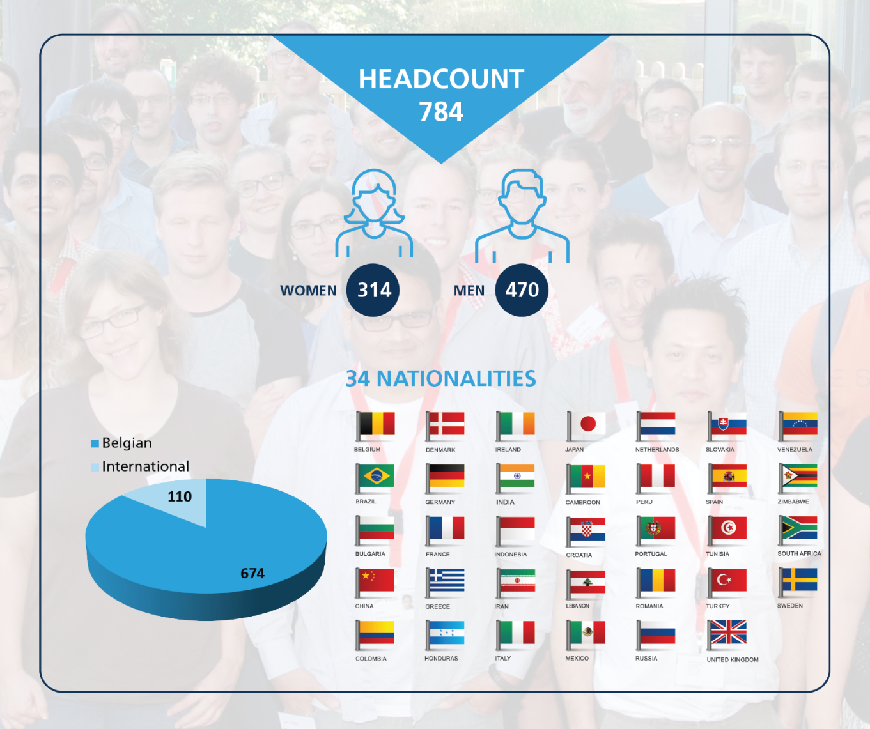
Figure: VITO’s diverse population at a glance.

