|  |  |  |  |
| --- | --- | --- | --- |
|  | United Nations | A/HRC/30/38 | |
| _unlogo | **General Assembly** | | Distr.: General  10 August 2015  Original: English |

**Human Rights Council**

**Thirtieth session**

Agenda item 3  
**Promotion and protection of all human rights, civil,   
political, economic, social and cultural rights,   
including the right to development**

Report of the Working Group on Enforced or Involuntary Disappearances[[1]](#footnote-2)\*

|  |
| --- |
| *Summary* |
| The Working Group on Enforced or Involuntary Disappearances was the first United Nations human rights thematic mechanism to be established with a universal mandate by resolution 20 (XXXVI) of 29 February 1980 of the Commission on Human Rights. The mandate was most recently extended by the Human Rights Council in its resolution 27/1 of 25 September 2014. |
| The mandate of the Working Group is to assist families of disappeared persons to ascertain the fate and whereabouts of their disappeared relatives; and to monitor States’ compliance with their obligations deriving from the Declaration on the Protection of All Persons from Enforced Disappearance and to provide States with assistance in the implementation of those norms. |
| Since its inception, the Working Group has transmitted a total of 54,557 cases to 105 States. The number of cases under active consideration stands at 43,563 in a total of 88 States. During the reporting period, 65 cases were clarified. |
| The present report reflects the activities of and communications and cases examined by the Working Group on Enforced or Involuntary Disappearances covering the period 17 May 2014 to 15 May 2015. |
|  |

Contents

*Page*

I. Introduction 3

II. Activities of the Working Group on Enforced or Involuntary Disappearances:   
 17 May 2014 to 15 May 2015 3

A. Activities 3

B. Meetings 5

C. Communications 5

D. Country visits 5

E. Follow-up reports and other procedures 6

F. Press releases and statements 6

G. Thematic study on enforced disappearance and economic, social and cultural rights 8

III. Decisions on individual cases taken by the Working Group and communications  
 transmitted to the States concerned during the reporting period 9

IV. Observations 14

V. Conclusions and recommendations 20

Annexes

I. Country visit requests and invitations extended 23

II. Statistical summary: cases of enforced or involuntary disappearance reported to the Working  
 Group between 1980 and 2015, and general allegations transmitted 25

III. Graphs showing the number of cases of enforced disappearances per year and per country   
 according to the cases transmitted by the Working Group during the period   
 1980–15 May 2015 (only for countries with more than 100 cases transmitted) 32

I. Introduction

1. The Working Group on Enforced or Involuntary Disappearances was the first United Nations human rights thematic mechanism to be established with a universal mandate, by the Commission on Human Rights resolution 20 (XXXVI) of 29 February 1980. The mandate was most recently extended by the Human Rights Council in its resolution 27/1 of 25 September 2014.
2. The primary task of the Working Group is to assist families in determining the fate or whereabouts of their family members who are reportedly disappeared. In that humanitarian capacity, the Working Group serves as a channel of communication between family members of victims of enforced disappearance and other sources reporting cases of disappearances, and the Governments concerned.
3. Following the adoption by the General Assembly of its resolution 47/133 and of the Declaration on the Protection of All Persons from Enforced Disappearance (hereinafter “the Declaration”), the Working Group was entrusted to monitor the progress of States in fulfilling their obligations derived from the Declaration. The Human Rights Council, in its resolution 7/12, encouraged the Working Group to provide assistance in the implementation by States of the Declaration and of existing international rules.
4. The present report reflects the activities of and communications and cases examined by the Working Group covering the period from 17 May 2014 to 15 May 2015. A summary of the decisions on individual cases taken by the Working Group and communications transmitted to the States concerned during the reporting period is presented in a table (see sect. III).
5. Since its inception, the Working Group has transmitted a total of 54,557 cases to 105 States. The number of cases under active consideration that have not yet been clarified, closed or discontinued stands at 43,563 in a total of 88 States. During the reporting period, 65 cases were clarified.
6. The Working Group notes with appreciation that there has been an improvement in speed of the translation of the replies received from Governments concerning cases.
7. In spite of some improvements to the content and layout of the English web page of the Working Group’s website, the Working Group regrets that the majority of the content on the website is in English only. The Working Group once again calls on the Office of the United Nations High Commissioner for Human Rights to provide adequate resources to bring it up to date and render it more accessible.
8. The Working Group is grateful to the Human Rights Council and the General Assembly for the recognition, through the granting of an additional post under the regular budget, of its need to receive additional support, given its huge workload and variety of activities. It is also thankful for the continuous support, including through voluntary contributions, provided by donor States, notably Argentina, France and Japan.

II. Activities of the Working Group on Enforced or Involuntary Disappearances: 17 May 2014 to 15 May 2015

A. Activities

1. During the period under review, the Working Group held three sessions: the 104th session, from 15 to 19 September 2014; the 105th session, from 2 to 6 March 2015; and the 106th session, from 6 to 15 May 2015. The 105th session was held in Buenos Aires and the other sessions were held in Geneva.
2. Further to its comments in 2012 annual report (A/HRC/22/45 and Corr.1, para. 5) the Working Group has continued to produce post-sessional documents to allow the translation of information and timely reporting on its activities.
3. Post-sessional documents were adopted and published after the 104th (A/HRC/WGEID/104/1); 105th (A/HRC/WGEID/105/1); and 106th (A/HRC/WGEID/106/1) sessions. Those post-sessional documents should be considered complements to the present annual report.[[2]](#footnote-3)
4. As from 1 October 2013, the Chair-Rapporteur of the Working Group has been Ariel Dulitzky. Jasminka Dzumhur was elected Vice-Chair during the 104th session of the Working Group. Olivier de Frouville completed his appointment as a member of the Working Group on 31 October 2014 and was replaced by Bernard Duhaime, appointed in October 2014. The other members of the Working Group are Houria Es Slami and Osman El-Hajjé.
5. On 12 September 2014, the Chair-Rapporteur presented the annual report for the period 10 November 2012 to 16 May 2014 to the Human Rights Council at its twenty-seventh session, and participated in the interactive dialogue with Member States.
6. Between 29 September and 3 October 2014, the Vice-Chair represented the Working Group during the twenty-first annual meeting of special rapporteurs/representatives, independent experts and working groups of the special procedures of the Council.
7. On 22 October 2014, the Chair-Rapporteur of the Working Group addressed the General Assembly at its sixty-ninth session and participated in the interactive dialogue with Member States. That was the third consecutive time that the Chair-Rapporteur addressed the General Assembly, which was highly valued and appreciated.
8. On 24 November 2014, the Vice-Chair took part in an expert consultation entitled “Human rights considerations relating to the administration of justice through military tribunals and role of the integral judicial system in combating human rights violations”, organized by the Office of the United Nations High Commissioner for Human Rights, pursuant to Human Rights Council resolution 25/4.
9. The Working Group held its 105th session in Argentina from 2 to 6 March 2015, to mark the 35th anniversary of its creation. The Working Group is grateful to the Government of Argentina for this opportunity. The Working Group continues its practice to have one of its sessions per year outside Geneva.
10. On 23 March 2015, Mr. Duhaime participated in a “Meeting of victims and human rights defenders” on the occasion of the International Day for the Right to Truth concerning Gross Human Rights Violations and for the Dignity of Victims in San Salvador.
11. During the reporting period, all the members of the Working Group carried out a number of activities connected to enforced disappearance, which included their participation in conferences, consultations, seminars, training events, workshops and lectures, organized by Governments and/or civil society organizations.

B. Meetings

1. During the period under review, representatives of the Governments of: Angola, Algeria, Japan, Morocco, Qatar, Sri Lanka, and Tajikistan (104th); Argentina and Japan (105th); Bhutan, Gabon, Japan and the Republic of Korea (106th) attended the sessions of the Working Group. A number of informal meetings were also held with representatives from various States. The Working Group expresses its appreciation to those Governments for the meetings and emphasizes the importance of cooperation and dialogue.
2. The Working Group also met with the Committee on Enforced Disappearances during its 104th session, and held two meetings with the President of the Human Rights Council during the reporting period. It also met with State representatives from the African and Asian regional groups during the 104th and 106th sessions, as well as representatives of international governmental organizations, relatives and associations of relatives of disappeared persons, and non-governmental organizations.

C. Communications

1. During the reporting period, the Working Group transmitted 384 new cases of enforced disappearance to 33 States.
2. The Working Group transmitted 151 of the above-mentioned cases under the urgent action procedure to Bahrain, Bangladesh, Cuba, the Democratic Republic of the Congo, Egypt, Gambia, Honduras, the Islamic Republic of Iran, Jordan, Kenya, Mexico, Oman, Pakistan, the Syrian Arab Republic, the United Arab Emirates and Zimbabwe.
3. The Working Group clarified 65 cases, in Algeria (1), Bahrain (1), Chile (10), China (1), Cuba (1), Egypt (6), the Gambia (3), Georgia (1), Guatemala (1), Oman (1), Pakistan (12), Peru (3), Saudi Arabia (3), Sri Lanka (10), the Syrian Arab Republic (5), Tajikistan (1), Turkey (1), the United Arab Emirates (2) and Uruguay (2). Of the 65 cases, 32 were clarified on the basis of information provided by Governments, and 33 on the basis of information provided by sources.
4. The Working Group transmitted 13 prompt intervention communications addressing allegations of harassment of and/or threats to human rights defenders and relatives of disappeared persons in Colombia, El Salvador, Honduras, India, Mexico, the Russian Federation and Sri Lanka.
5. It transmitted 21 urgent appeals concerning persons who had been arrested, detained, abducted or otherwise deprived of their liberty or who had been forcibly disappeared or were at risk of disappearance in Burundi, China, Congo, Eritrea and the Islamic Republic of Iran.
6. The Working Group transmitted seven general allegations, to the Governments of Bahrain, Colombia, the Democratic Republic of the Congo, El Salvador, Kenya, Pakistan and Paraguay.
7. It also transmitted six other letters to the Governments of Guatemala, India, Morocco, Nepal and Spain.

D. Country visits

1. The Working Group, represented by Mr. Dulitzky, Ms. Dzumhur and Mr. El-Hajjé visited Croatia, Montenegro and Serbia including Kosovo from 15 to 30 June 2014. The reports on the visit are contained in addenda to the present report (A/HRC/30/38/Add.1, Add.2 and Add.3). The Working Group thanks the Governments of Croatia, Montenegro and Serbia for the invitation as well as for the cooperation extended to it, before and during its visit to the country. It also thanks United Nations Interim Administration Mission in Kosovo and the Kosovo authorities for the assistance in the context of the visit to Kosovo.
2. At the invitation of the Government of Peru, the Working Group visited the country from 1 to 10 June 2015. The Working Group thanks the Government of Peru for the invitation and the cooperation extended to it. It also thanks the other States that have extended invitations to the Working Group to visit their countries: the Governments of Sri Lanka and Turkey, which invited the Working Group to undertake a visit in 2015; as well as the Governments of Albania, which extended an invitation to the Working Group for 2016, and the Sudan, which extended an invitation in principle.
3. During the reporting period, the Working Group requested visits to Albania, Bahrain, the Former Yugoslav Republic of Macedonia, Rwanda and South Africa.
4. In addition to these new requests, the Working Group has requested in the past a visit to the following countries, without having yet received a positive response: Bangladesh, Belarus, Burundi, China, Egypt, India, Indonesia, Kenya, Nepal, Nicaragua, the Philippines, the Russian Federation, South Sudan, the Syrian Arab Republic, Thailand, the United Arab Emirates, Uzbekistan and Zimbabwe. The Working Group invites all States that have received a request for a visit by the Working Group to respond favourably to it, in accordance with Human Rights Council resolution 21/4.[[3]](#footnote-4)
5. The Working Group recalls the fact that the Islamic Republic of Iran agreed to a visit by the Working Group in 2004, which was delayed at the request of the Government. The Working Group calls upon the Government to set the dates for the visit. Similarly, the Working Group regrets that the visit to Algeria did not materialize, in spite of an invitation extended to visit the country in the second half of 2014.

E. Follow-up reports and other procedures

1. The Working Group prepared follow-up reports on the implementation of recommendations made following its visits to Mexico and Timor-Leste. The follow-up reports are contained in an addendum to the present report (A/HRC/30/38/Add.4).

F. Press releases and statements

1. On 30 May 2014, the Working Group, jointly with other special procedures, issued a press statement emphasizing that the decision of the Security Council not to refer the situation in the Syrian Arab Republic to the International Criminal Court leaves the door wide open for new atrocities in the ongoing conflict.[[4]](#footnote-5)
2. On 13 June 2014, the Working Group, jointly with other special procedures, issued a press release in which it urged Thailand authorities to reverse all measures affecting basic rights and to restore democratic rule in the country, and stressed that stability and reconciliation could hardly be achieved in Thailand if human rights guarantees were neglected.[[5]](#footnote-6)
3. On 4 July 2014, the Working Group issued, jointly with other special procedures mandate holders, a press release in which it called upon the Government of Nepal to amend its new legislation allowing for amnesties in cases of serious violations of human rights and humanitarian law.[[6]](#footnote-7)
4. On 11 July 2014, the Working Group issued a statement at the end of its visit to the Western Balkans emphasizing the urgent need for new national and regional strategies and a renewed commitment at the highest political level to address the question of enforced disappearances and missing persons.[[7]](#footnote-8)
5. On 8 August 2014, the Working Group issued a press release welcoming the reunion of Argentine activist Estela de Carloto with her grandson after 36 years and urging full support for families of the disappeared from Governments around the world.[[8]](#footnote-9)
6. On 30 August 2014, the Working Group issued a press release jointly with the Committee on Enforced Disappearances on the occasion of the International Day of the Victims of Enforced Disappearances calling all States to remove all obstacles to aid investigations into the fate of disappeared persons.[[9]](#footnote-10)
7. On 17 September 2014, the Working Group, jointly with the Committee on Enforced Disappearances, issued a statement on the occasion of the fourth meeting between the two bodies, held on 17 September 2014.[[10]](#footnote-11)
8. On 29 September 2014, the Working Group issued a press release, jointly with other special procedure mandate holders, calling on the Government and the Congress of Colombia to reconsider the possible adoption of Bill No. 85 (Senate) of 2013, which aims to restructure and expand the scope of the jurisdiction of military courts.[[11]](#footnote-12)
9. On 10 October 2014, the Working Group issued a press release underlining that the investigation of the killings and enforced disappearances of students in the State of Guerrero, Mexico, represent a crucial test for the willingness and the capacity of Mexico to deal with serious violations of human rights.[[12]](#footnote-13)
10. On 23 October 2014, a press release was issued at the occasion of the presentation of the Chair of the Working Group to the General Assembly.[[13]](#footnote-14)
11. On 19 November 2014, the Working Group, jointly with other mandate holders, raised the alarm over the potential imminent release of Milorad Trbić, who was convicted in 2009 by the Bosnian State Court of committing genocide in Srebrenica and sentenced to 30 years in prison.[[14]](#footnote-15)
12. On 26 November 2014, the Working Group, jointly with other special procedure mandate holders, urged the President of the United States of America Barack Obama to support the fullest possible release of the report on Central Intelligence Agency interrogation practices conducted by the Senate Select Committee on Intelligence.[[15]](#footnote-16)
13. On 26 February 2015, the Working Group announced the holding of its 105th session in Argentina, 35 years after its creation in response to the disappearances committed by the dictatorship there.[[16]](#footnote-17)
14. On 10 March 2015, a story was published on the OHCHR website on the holding of the 105th session in Argentina.[[17]](#footnote-18)
15. On 27 March 2015, the Working Group, jointly with other special procedure mandate holders, issued a press release calling the Government of Spain to either try or extradite individuals allegedly responsible of grave human rights violations, including enforced disappearances.[[18]](#footnote-19)
16. On 21 April 2015, the Working Group, jointly with other special procedure mandate holders, issued a press release welcoming the decision by the Supreme Court of Pakistan to suspend death sentences imposed by military courts.[[19]](#footnote-20)
17. On 1 May 2015, the Working Group, jointly with other special procedure mandate holders, issued a press release welcoming the constitutional reform approved by the Parliament of Mexico to legislate on a number of human rights violations, including enforced disappearances.[[20]](#footnote-21)

G. Thematic study on enforced disappearance and economic, social   
and cultural rights

1. The Working Group has completed its study on the relationship between enforced disappearances and economic, social and cultural rights. The report is contained in an addendum to the present report (A/HRC/30/38/Add.5).
2. That study examines the indivisibility of economic, social and cultural rights, and civil and political rights in the case of enforced disappearances. Enforced disappearance, by its nature, violates the economic, social and cultural rights of the disappeared person, his or her family and others. In addition, those lacking the full enjoyment of economic, social and cultural rights are, in many instances, more vulnerable to becoming victims of enforced disappearance.
3. The study also emphasizes how people who are active in promoting or exercising the enjoyment of economic, social and cultural rights are, in many contexts, at a greater risk of becoming victims of enforced disappearance. In such circumstances, enforced disappearances are used as a tool to deter people from promoting and exercising economic, social and cultural rights.
4. The Working Group also observes that, under the Declaration, States have an obligation to prevent and eradicate enforced disappearances and to provide reparations to all victims of enforced disappearances, taking into account the intrinsic connection between enforced disappearances and economic, social and cultural rights. Effective measures to prevent and eradicate enforced disappearances, and to provide reparation to the victims, require a comprehensive approach that encompasses proper promotion and protection of economic, social and cultural rights.

III. Decisions on individual cases taken by the Working Group and communications transmitted   
to the States concerned during the reporting period[[21]](#footnote-22)

| *Countries* | *Number of outstanding cases at the beginning of the period under review* | *Cases transmitted to the Government during the reporting period* | | *Cases clarified during the period under review by:* | | *Number of cases of possible clarification by Government (6-month rule)* | *Number of outstanding cases at the end of the period under review* | *Communications sent during  the period under review* | | | | *Communications received during  the period under review* | | | |
| --- | --- | --- | --- | --- | --- | --- | --- | --- | --- | --- | --- | --- | --- | --- | --- |
| *Prompt intervention letter* | *Urgent appeal* | *General allegation* | *Other letter* | *Response to prompt intervention letter* | *Response to urgent appeal* | *Response to general allegation* | *Response to other letter* |
| *Urgent actions* | *Standard cases* | *Government* | *Sources* |
| Afghanistan | 3 | - | - | - | - | - | 3 | - | - | - | - | - | - | - | - |
| Albania | 1 | - | - | - | - | - | 1 | - | - | - | - | - | - | - | - |
| Algeria | 3 047 | - | 58 | - | 1 | - | 3 104 | - | - | - | - | - | - | - | - |
| Angola | 2 | - | - | - | - | - | 2 | - | - | - | - | - | - | - | - |
| Argentina[[22]](#footnote-23) | 3 271 | - | 1 | - | - | - | 3 271 | - | - | - | - | - | - | - | - |
| Bahrain | 3 | 1 | - | 1 | - | - | 3 | - | - | 1 | - | - | 1 | 1 | - |
| Bangladesh | 15 | 2 | 13 | - | - | - | 30 | - | - | - | - | - | - | - | - |
| Belarus | 3 | - | - | - | - | - | 3 | - | - | - | - | - | - | - | - |
| Bhutan | 5 | - | - | - | - | - | 5 | - | - | - | - | - | - | - | - |
| Bolivia (Plurinational State of) | 28 | - | - | - | - | - | 28 | - | - | - | - | - | - | - | - |
| Bosnia and Herzegovina | 0 | - | - | - | - | - | 0 | - | - | - | - | - | - | 1 | - |
| Brazil | 13 | - | - | - | - | - | 13 | - | - | - | - | - | - | - | - |
| Burundi | 52 | - | - | - | - | - | 52 | - | 1 | - | - | - | - | - | - |
| Cambodia | 1 | - | - | - | - | - | 1 | - | - | - | - | - | - | - | - |
| Cameroon | 14 | - | - | - | - | - | 14 | - | - | - | - | - | - | - | - |
| Central African Republic | 3 | - | - | - | - | - | 3 | - | - | - | - | - | - | - | - |
| Chad | 23 | - | - | - | - | - | 23 | - | - | - | - | - | - | - | - |
| Chile | 796 | - | - | 10 | - | - | 786 | - | - | - | - | - | - | - | - |
| China | 37 | - | 4 | - | 1 | 1 | 40 | - | 2 | - | - | - | 2 | - | - |
| Colombia | 971 | - | - | - | - | - | 971 | 2 | - | 1 | - | 1 | - | - | - |
| Congo | 88 | - | 1 | - | - | - | 89 | - | 1 | - | - | - | - | - | - |
| Cuba | 0 | 1 | - | 1 | - |  | 0 |  |  |  | - |  |  |  | - |
| Democratic People’s Republic of Korea | 47 | - | 6 | - | - | - | 53 | - | - | - | - | - | - | - | - |
| Democratic Republic of the Congo | 45 | 1 | 1 | - | - | - | 47 | - | - | 1 | - | - | - | - | - |
| Dominican Republic | 2 | - | - | - | - | - | 2 | - | - | - | - | - | - | - | - |
| Ecuador | 5 | - | - | - | - | - | 5 | - | - | - | - | - | - | - | - |
| Egypt[[23]](#footnote-24) | 52 | 66 | 13 | 3 | 3 | 16 | 124 | - | - | - | - | - | 1 | - | - |
| El Salvador | 2 277 | - | 3 | - | - | - | 2 280 | 1 | - | 1 | - | 1 | - | - | - |
| Equatorial Guinea | 8 | - | - | - | - | - | 8 | - | - | - | - | - | - | - | - |
| Eritrea | 54 | - | 2 | - | - | - | 56 | - | 1 | - | - | - | - | - | - |
| Ethiopia | 112 | - | - | - | - | - | 112 | - | - | - | - | - | - | - | - |
| France | 1 | - | - | - | - | - | 1 | - | - | - | - | - | - | - | - |
| Gambia | 3 | 7 | - | - | 3 | - | 7 | - | - | - | - | - | - | - | - |
| Georgia | 1 | - | - | 1 | - | - | 0 | - | - | - | - | - | - | - | - |
| Greece | 1 | - | - | - | - | - | 1 | - | - | - | - | - | - | - | - |
| Guatemala[[24]](#footnote-25) | 2 899 | - | - |  | 1 | - | 2 897 | - | - | - | 1 | - | - | - | 1 |
| Guinea | 37 | - | - | - | - | - | 37 | - | - | - | - | - | - | - | - |
| Haiti | 38 | - | - | - | - | - | 38 | - | - | - | - | - | - | - | - |
| Honduras | 129 | 1 | - | - | - | - | 130 | 1 | - | - | - | - | - | - | - |
| India | 354 | - | - | - | - | - | 354 | 1 | - | - | 1 | - | - | - | - |
| Indonesia | 163 | - | - | - | - | - | 163 | - | - | - | - | - | - | - | - |
| Iran (Islamic Republic of Iran) | 518 | 2 | 2 | - | - | 2 | 522 | - | 1 | - | - | - | - | - | - |
| Iraq | 16 408 | - | - | - | - | - | 16 408 | - | - | - | - | - | - | - | - |
| Israel | 2 | - | - | - | - | - | 2 | - | - | - | - | - | - | - | - |
| Jordan | 2 | 1 | - | - | - | - | 3 | - | - | - | - | - | - | - | - |
| Kenya | 60 | 1 | - | - | - | - | 61 | - | - | 1 | - | - | - | - | - |
| Kuwait | 1 | - | - | - | - | - | 1 | - | - | - | - | - | - | - | - |
| Lao People’s Democratic Republic | 2 | - | - | - | - | - | 2 | - | - | - | - | - | - | - | - |
| Lebanon | 313 | - | - | - | - | - | 313 | - | - | - | - | - | - | - | - |
| Libya | 10 | - | - | - | - | - | 10 | - | - | - | - | - | - | - | - |
| Maldives | 0 | - | - | - | - | - | 0 | - | 1 | - | - | - | - | - | - |
| Mauritania | 4 | - | - | - | - | - | 4 | - | - | - | - | - | - | - | - |
| Mexico | 359 | 2 | 5 | - | - | - | 366 | 4 | 2 | - | - | 2 | 2 | - | - |
| Morocco | 60 | - | 26 | - | - | - | 86 | - | - | - | 1 | - | - | - | - |
| Mozambique | 2 | - | - | - | - | - | 2 | - | - | - | - | - | - | - | - |
| Myanmar | 2 | - | - | - | - | - | 2 | - | - | - | - | - | - | - | - |
| Namibia | 2 | - | - | - | - | - | 2 | - | - | - | - | - | - | - | - |
| Nepal | 459 | - | - | - | - | - | 459 | - | - | - | 1 | - | - | - | 1 |
| Nicaragua | 103 | - | - | - | - | - | 103 | - | - | - | - | - | - | - | - |
| Norway | 0 | - | - | - | - | - | 0 | - | - | - | - | - | 1 | - | - |
| Oman | 0 | 1 | 1 | - | 1 | - | 1 | - | 1 | - | - | - | - | - | - |
| Pakistan | 151 | 57 | 4 | - | 12 | - | 200 | - | - | 1 | - | - | - | - | - |
| Paraguay | 0 | - | - | - | - | - | 0 | - | - | 1 | - | - | - | 1 | - |
| Peru[[25]](#footnote-26) | 2 370 | - | - | - | 3 | - | 2 365 | - | - | - | - | - | - | - | - |
| Philippines | 625 | - | - | - | - | - | 625 | - | - | - | - | - | - | - | - |
| Russian Federation | 471 | - | 5 | - | - | - | 476 | 1 | - | - | - | - | - | - | - |
| Rwanda | 21 | - | 1 | - | - | - | 22 | - | 1 | - | - | - | 1 | - | - |
| Saudi Arabia | 6 | - | 2 | 2 | 1 | - | 5 | - | - | - | - | - | - | - | - |
| Senegal | 1 | - | - | - | - | - | 1 | - | - | - | - | - | - | - | - |
| Seychelles | 3 | - | - | - | - | - | 3 | - | - | - | - | - | - | - | - |
| Somalia | 1 | - | - | - | - | - | 1 | - | - | - | - | - | - | - | - |
| South Africa | 1 | - | - | - | - | - | 1 | - | - | - | - | - | - | - | - |
| South Sudan | 1 | - | - | - | - | - | 1 | - | - | - | - | - | - | - | - |
| Spain | 6 | - | - | - | - | - | 6 | - | - | - | 2 | - | - | 1 | - |
| Sri Lanka | 5 731 | - | 29 | 10 | - | 7 | 5 750 | 3 | - | - | - | - | - | - | - |
| Sudan | 173 | - | - | - | - | - | 173 | - | 1 | - | - | - | 1 | - | - |
| Syrian Arab Republic | 102 | 2 | 31 | - | 5 | - | 130 | - | 2 | - | - | - | 1 | - | - |
| Tajikistan | 4 | - | - | 1 | - | - | 3 | - | 1 | - | - | - | 1 | - | - |
| Thailand | 81 | - | 1 | - | - | - | 82 | - | 1 | - | - | - | 1 | - | - |
| Timor-Leste | 428 | - | - | - | - | - | 428 | - | - | - | - | - | - | - | - |
| Togo | 10 | - | - | - | - | - | 10 | - | - | - | - | - | - | - | - |
| Tunisia | 2 | - | - | - | - | - | 2 | - | - | - | - | - | - | - | - |
| Turkey | 62 | - | 18 | 1 | - | - | 79 | - | 1 | - | - | - | - | - | - |
| Turkmenistan | 1 | - | 2 | - | - | - | 3 | - | - | - | - | - | - | - | - |
| Uganda | 15 | - | - | - | - | - | 15 | - | - | - | - | - | - | - | - |
| Ukraine | 4 | - | 1 | - | - | - | 5 | - | 1 | - | - | - | - | - | - |
| United Arab Emirates[[26]](#footnote-27) | 12 | 5 | 2 | - | 2 | 6 | 16 | - | 2 | - | - | - | 2 | - | - |
| Uruguay | 19 | - | - | 2 | - | - | 17 | - | - | - | - | - | - | - | - |
| Uzbekistan | 7 | - | - | - | - | - | 7 | - | - | - | - | - | - | - | - |
| Venezuela (Bolivarian Republic of) | 12 | - | - | - | - | - | 12 | - | - | - | - | - | - | - | - |
| Viet Nam | 1 | - | - | - | - | - | 1 | - | - | - | - | - | - | - | - |
| Yemen | 10 | - | 1 | - | - | - | 11 | - | 1 | - | - | - | - | - | - |
| Zimbabwe | 4 | 1 | - | - | - | - | 5 | - | - | - | - | - | - | - | - |
| State of Palestine | 4 | - | - | - | - | - | 4 | - | - | - | - | - | - | - | - |

IV. Observations

1. In addition to the observations formulated in its post-sessional documents (see para. 11 above), the Working Group makes the following country-specific observations based on the cooperation received and on significant developments regarding its mandate during the whole reporting period.

Albania

1. The Working Group thanks the Government of Albania for the invitation to the Working Group to visit the country. The Working Group hopes that the visit can be carried out in the course of 2016

Algeria

1. The Working Group expresses its deep disappointment that, in spite of an official communication received in February 2014 in which the Government of Algeria invited the Working Group to visit Algeria during the second semester of 2014, it has not accepted the different dates offered by the Working Group. The Working Group hopes that it can soon be allowed to conduct a visit to the country.

Bahrain

1. The Working Group thanks the Government for the reply to the general allegation sent on 23 September 2014 (see A/HRC/WGEID/104/1, paras. 13-32, and A/HRC/WGEID/105/1, para. 13 and annex I). It would appreciate receiving additional information on the specific steps taken by the Government to prevent and terminate alleged cases of short-term enforced disappearance and on the measures taken to ensure that the relatives of persons deprived of their liberty are informed accurately and promptly of their detention, in accordance with article 10 (2) of the Declaration.
2. On 27 October 2014, the Working Group requested an invitation to undertake a visit to the country. The Working Group hopes that a positive reply will be received soon.

Bangladesh

1. The Working Group regrets that no information has been received from the Government in connection with a general allegation transmitted on 4 May 2011, concerning the alleged frequent use of enforced disappearance as a tool by law enforcement agencies, paramilitary and armed forces to detain and even extrajudicially execute individuals (see A/HRC/22/45 and Corr.1, para. 33).
2. On 12 March 2013, the Working Group requested an invitation to undertake a visit to the country. No response yet has been received from the Government in spite of a reminder sent on 28 October 2014. The Working Group hopes that a positive reply will be received soon.

Bosnia and Herzegovina

1. In relation to the press release issued on 19 November 2014 (A/HRC/WGEID/105/1, para. 18), the Working Group reminds the Government that, according to the Declaration, persons accused of committing enforced disappearances should be prosecuted, tried and, if found guilty, appropriately punished.

Brazil

1. The Working Group welcomes the release of the report of the Truth Commission, which recognizes the right to truth in the context of the grave human rights violations that occurred in the past.

Burundi

1. On 27 May 2009, the Working Group requested an invitation to undertake a visit to the country. Despite reminders sent, no response yet has been received from the Government. The Working Group hopes that a positive reply will be received soon.

Democratic People’s Republic of Korea

1. The Working Group, on the basis of the recommendation of the Special Rapporteur on the situation of human rights in the Democratic People’s Republic of Korea (see A/HRC/28/71, para. 67), decided to request an invitation to undertake a visit to the country. The Working Group hopes that a positive reply will be received soon.

Egypt

1. The Working Group thanks the Government for the high number of replies which demonstrate the Government’s commitment to engage with the Working Group and allowed it to clarify some cases. It is however concerned that, during the reporting period, it transmitted 66 reported cases of enforced disappearances under the urgent action procedure to the Government (see A/HRC/WGEID/104/1, para. 53; A/HRC/WGEID/105/1, para. 45; A/HRC/WGEID/106/1, paras. 25 ff.) in relation to what seems to be a recent pattern of short-term disappearances. It reiterates that, as provided in article 7 of the Declaration, no circumstances whatsoever may be invoked to justify enforced disappearances, and that accurate information on the detention of such persons and their place or places of detention, including transfers, shall be made promptly available to their family members, their counsel or to any other persons having a legitimate interest in the information (art. 10 (2) of the Declaration).
2. On 30 June 2011, the Working Group requested an invitation to undertake a visit to the country. No response yet has been received from the Government in spite of reminders sent. The Working Group hopes that a positive reply will be received soon.

El Salvador

1. With reference to a general allegation and a follow-up thereon transmitted to the Government (see A/HRC/WGEID/105/1, paras. 52-57, and A/HRC/WGEID/106/1, paras. 39 ff.) the Working Group encourages the Government to intensify its efforts to ensure truth and justice as well as adequate reparation to victims, in accordance with article 13 (1) of the Declaration.
2. The Working Group also invites the Government to look into the allegations of new modalities of current forms of disappearances and to support relatives and victims in this regard.

Gambia

1. The Working Group is concerned that, during the reporting period, it transmitted to the Government seven cases under its urgent action procedure (see A/HRC/WGEID/105/1, para. 58). No response was received thereto. The Working Group recalls articles 7 (“no circumstances whatsoever … may be invoked to justify enforced disappearances”) and 10 (“accurate information on the detention of such persons and their place or places of detention, including transfers, shall be made promptly available to their family members, their counsel or to any other persons having a legitimate interest in the information”) of the Declaration.

Guatemala

1. The Working Group thanks the Government for the substantive reply dated 16 January 2015 to the communication transmitted on 22 December 2014 (see A/HRC/WGEID/105/1, paras. 61 and 62 and annex II) concerning the allegations of a possible application of amnesty for the former Head of State José Efraín Ríos Montt on charges of genocide and crimes against humanity. In this respect, the Working Group emphasizes the important of truth and justice for victims reiterating its previous observation (see A/HRC/27/49, para. 77) that they are both fundamental elements both for reparation for the victims and to ensure the non-recurrence of the heinous crimes that characterized the civil war, including enforced disappearances.

India

1. The Working Group regrets that it has not received a reply to a letter, transmitted jointly with two other special procedures mandate holders on 23 January 2015, concerning the allegations of continuing construction work on the site of a newly discovered mass grave (see A/HRC/WGEID/105/1, para. 66). The Working Group emphasized the importance of preserving mass grave sites, including ensuring that an effective criminal and forensic investigation can take place, and to take appropriate measures to assist victims to achieve truth and justice.
2. On 16 August 2010, the Working Group requested an invitation to undertake a visit to the country. No positive response has been received yet in spite of reminders sent. The Working Group hopes that a positive reply will be received soon.

Iraq

1. The Working Group regrets that it has not received during the reporting period any information regarding the outstanding cases, including the seven individuals abducted in September 2013 (see AHRC/27/49, para. 80).

Kenya

1. The Working Group is concerned at the lack of replies from the Government to its communications, including a general allegation transmitted on 30 September 2014 in relation to enforced disappearances and other human rights violations reportedly carried out by the Anti-Terrorism Police Unit (see A/HRC/WGEID/104/1, paras. 71-78). It recalls Human Rights Council resolution 21/4, in which the Council urges States to cooperate with the Working Group to help it to carry out its mandate effectively. The Working Group reiterates that, as provided in article 7 of the Declaration, no circumstances whatsoever may be invoked to justify enforced disappearances.
2. On 19 February 2013, the Working Group requested an invitation to undertake a visit to the country. No response yet has been received from the Government in spite of a reminder sent on 28 October 2014. The Working Group hopes that a positive reply will be received soon.

Mexico

1. The follow-up report on the implementation of the recommendations made by the Working Group after its visit to Mexico in 2011 (see A/HRC/19/58/Add.2) can be found in document A/HRC/30/38/Add.4. The Working Group thanks the Government of Mexico for its cooperation throughout the process and hopes that the recommendations contained therein will be duly implemented.

Morocco

1. The Working Group reiterates the observations contained in the previous annual report (A/HRC/27/49, para. 86) on the importance to ensure the right to truth for the families of victims, including a full and independent investigation into the allegations of enforced disappearances. In this respect, the Working Group recommends the Government to take in adequate account all the information available on enforced disappearances, including that of forensic experts. It also recalls article 13, paragraph 4, of the Declaration, which provides that the findings of investigation on cases of enforced disappearances shall be made available upon request to all persons concerned, unless doing so would jeopardize an ongoing criminal investigation.

Pakistan

1. The Working Group is concerned that, during the reporting period, it transmitted to the Government 57 new cases under its urgent action procedure (see A/HRC/WGEID/104/1, para. 93; A/HRC/WGEID/105/1, para. 96; A/HRC/WGEID/106/1, para. 58). It reiterates that, as provided in article 7 of the Declaration, no circumstances whatsoever may be invoked to justify enforced disappearances, and that accurate information on the detention of such persons and their place or places of detention, including transfers, shall be made promptly available to their family members, their counsel or to any other persons having a legitimate interest in the information (art. 10 (2) of the Declaration). The Working Group thanks the Government for the reply dated 6 May 2015 providing information on a high number of cases and reiterating the Government’s commitment to remain engaged with the Working Group. The reply will be considered in detail at next session of the Working Group.

Paraguay

1. In relation to the general allegation of 7 October 2014 (see A/HRC/WGEID/104/1, paras. 97-107), while the Working Group appreciates the reply received on 7 January 2015 (see A/HRC/WGEID/105/1, paras. 111-115), it considers that more efforts should be made to establish the fate and whereabouts of the disappeared persons and to identify the bodies.

Russian Federation

1. On 2 November 2006, the Working Group requested an invitation to undertake a visit to the country. No positive response has been received yet in spite of reminders sent. The Working Group hopes that a positive reply will be received soon.

Rwanda

1. On 27 October 2014, the Working Group requested an invitation to undertake a visit to the country. The Working Group hopes that a positive reply will be received soon.

Spain

1. The Working Group reminds the Government of its obligation to either investigate cases of enforced disappearances or, alternatively, cooperate with other countries who want to investigate and prosecute these cases, including by extraditing suspects present in its territory (see A/HRC/WGEID/106/1, para. 68). The Working Group emphasizes that, in accordance with article 17 of the Declaration, acts constituting enforced disappearance shall be considered a continuing offence as long as the perpetrators continue to conceal the fate and the whereabouts of persons who have disappeared and these facts remain unclarified.

Sri Lanka

1. The Working Group appreciates the invitation received from the Government to visit Sri Lanka from 3 to 12 August 2015. It notes however that, on 17 July 2015, the Government has requested a postponement of the visit in the light of the proximity of the dates scheduled for the visit with the Parliamentary elections. The Working Group notes the commitment expressed by the Government to ensure that the visit can take place at a mutually agreed date before the end of 2015.

Syrian Arab Republic

1. The Working Group continues to be gravely concerned about the situation in the Syrian Arab Republic, which may facilitate the occurrence of enforced disappearances. It reiterates article 7 of the Declaration, which provides that no circumstances whatsoever may be invoked to justify enforced disappearances.
2. On 19 September 2011, the Working Group requested an invitation to undertake a visit to the country. No response yet has been received from the Government in spite of reminders sent. The Working Group hopes that a positive reply will be received soon.

Thailand

1. With reference to its previous observations on the matter (see A/HRC/WGEID/104/1, para. 140), the Working Group emphasizes that democratic order and the rule of law are essential elements to prevent the occurrence of enforced disappearances.
2. On 30 June 2011, the Working Group requested an invitation to undertake a visit to the country. No positive response yet has been received from the Government in spite of reminders sent. The Working Group hopes that a positive reply will be received soon.

Timor-Leste

1. The follow-up report on the implementation of the recommendations made by the Working Group after its visit to Timor-Leste in 2011 (A/HRC/19/58/Add.1) can be found in document A/HRC/30/38/Add.4. The Working Group regrets that the Government of Timor-Leste did not cooperate with the Working Group in the process of producing the follow-up report. It hopes that the recommendations contained in the report will be duly implemented.

Turkey

1. The Working Group appreciates the invitation received from the Government to visit Turkey in November 2015 and looks forward to the visit.

United Arab Emirates

1. On 13 September 2013, the Working Group requested an invitation to undertake a visit to the country. No response yet has been received from the Government in spite of a reminder sent on 27 October 2014. The Working Group hopes that a positive reply will be received soon.

Ukraine

1. The Working Group continues to be gravely concerned about the situation in Ukraine, which may facilitate the occurrence of enforced disappearances. It reiterates article 7 of the Declaration, which provides that no circumstances whatsoever may be invoked to justify enforced disappearances.

Uruguay

1. The Working Group encourages the Government of Uruguay to deepen and strengthen the efforts to secure the right to truth and justice for enforced disappearances, in accordance with international standards.

Yemen

1. The Working Group is concerned about the deteriorating situation in Yemen, which may facilitate the occurrence of enforced disappearances. It reiterates article 7 of the Declaration, which provides that no circumstances whatsoever may be invoked to justify enforced disappearances.

V. Conclusions and recommendations

1. **The Working Group finalized its study on enforced or involuntary disappearances and economic, social and cultural rights, which is presented as an addendum to this report (see paras. 52-55 above). It will continue to conduct studies on thematic issues of relevance to its mandate and has decided to conduct the next one on enforced disappearances in the context of migration.**
2. **Sadly, enforced disappearances are not a crime of the past but continue to be used across the world with the false and pernicious belief that they are a useful tool to preserve national security and combat terrorism or organized crime.**
3. **During the reporting period, the Working Group transmitted 384 newly reported cases of disappearance to 33 States. It used the urgent action procedure in 151 of those cases, which allegedly occurred within the three months preceding the receipt of the report by the Working Group.**
4. **The year 2015 marked the thirty-fifth anniversary of the creation of the Working Group. The Working Group is grateful to the Government of Argentina for its invitation to hold the 105th session of the Working Group in Argentina, from 2 to 6 March 2015, in a former secret detention centre, to symbolically mark that date. Much has been achieved during those 35 years to bring truth and justice to victims, although it is still too little vis-à-vis the suffering of all relatives who are still searching for their loved ones. During the reporting period, the Working Group was only able to clarify 65 cases of enforced disappearance. More than 43,000 cases still remain unclarified, many dating back decades. Cases remain outstanding with the Working Group for a number of reasons, notably for the lack of sufficient State willingness, capacity and/or efforts to establish the fate and whereabouts of the disappeared. States should urgently take into account the sufferings of the families and strengthen their efforts to search for the disappeared persons. The Working Group emphasized in that respect the importance of expanding the use of forensic expertise and DNA testing.**
5. **In spite of the large number of cases, underreporting remains a major problem, and is due to various reasons, including fear of reprisals, weak administration of justice, ineffectual reporting channels, institutionalized systems of impunity, poverty, illiteracy, language barriers, a practice of silence and restrictions on the work of civil society. More assistance should be provided to family members and members of civil society to enable them to report cases to the Working Group and more importantly to keep working on enforced disappearance issues.**
6. **The Working Group cannot discharge its mandate without the cooperation of States, particularly in providing information to the families about the fate or whereabouts of disappeared persons. In that respect, the Working Group remains concerned that, of the 84 States with outstanding cases, a significant number have never replied to the Working Group or have provided responses that do not contain any relevant information. The Working Group urges all States to fulfil their obligations under the Declaration and the relevant resolutions of the General Assembly and the Human Rights Council to properly investigate cases of enforced disappearances and to cooperate with the Working Group.**
7. **During the reporting period, the Working Group continued to observe a pattern of “short-term” enforced disappearances being used in a number of countries. The Working Group expresses its deep concern at the phenomenon. It stresses that there is no time limit, no matter how short, for an enforced disappearance to occur and that accurate information on the detention of any person deprived of liberty and their place of detention shall be made promptly available to their family members.**
8. **The Working Group is also concerned about the deteriorating situation in a number of countries, as reflected in the present report. It reiterates article 7 of the Declaration, which provides that no circumstances whatsoever, whether a threat of war, a state of war, internal political instability or any other public emergency, may be invoked to justify enforced disappearances.**
9. **The Working Group continues to note a pattern of threats, intimidation and reprisals against victims of enforced disappearance, including family members, witnesses and human rights defenders working on such cases. It calls upon States to take specific measures to prevent such acts, protect those working on cases of enforced disappearances and punish the perpetrators, in accordance with article 13 (1) and (3) of the Declaration. The Working Group reiterates its support for the establishment of a United Nations-wide senior focal point to engage with all stakeholders, in particular Member States, to promote the prevention of, protection against and accountability for reprisals and intimidation related to cooperation with the United Nations, its representatives and mechanisms (see A/HRC/27/49, para. 119). It regrets that no progress has been made on that matter during the reporting period.**
10. **Country visits are an integral part of the mandate fulfilled by the Working Group. Visits allow the Working Group to highlight country practices in addressing enforced disappearance, to assist States in reducing obstacles to implement the Declaration and to ensure direct contact with the family members of victims. The Working Group thanks the Governments of Albania, Sri Lanka, the Sudan and Turkey for the invitations extended during the reporting period. It also recognizes the support provided by the Governments of Croatia, Montenegro, Peru and Serbia during the visits carried out in the reporting period. During that period, the Working Group requested visits to Albania, Bahrain, the former Yugoslav Republic of Macedonia, Rwanda and South Africa. In addition to those new requests, the Working Group has requested in the past a visit to the following countries, without having yet received a positive response: Bangladesh, Belarus, Burundi, China, Egypt, India, Indonesia, Kenya, Nepal, Nicaragua, the Philippines, the Russian Federation, South Sudan, the Syrian Arab Republic, Thailand, the United Arab Emirates, Uzbekistan and Zimbabwe**. **There are other countries that have invited the Working Group to visit and/or confirmed invitations, but for which specific dates to visit have not been agreed, such as Algeria and the Islamic Republic of Iran. The Working Group therefore calls upon all States with pending requests for visits to respond favourably to them in the light of Human Rights Council resolution 21/4, and those that have agreed to visits to respond as soon as possible with specific dates.**
11. **The Working Group once again calls upon States that have not signed and/or ratified the International Convention for the Protection of All Persons from Enforced Disappearance to do so as soon as possible and to accept the competence of the Committee on Enforced Disappearances to receive individual cases under article 31, and inter-State complaints under article 32 of the Convention.**
12. **The Working Group is concerned about increasing instances of abductions carried out by non-State actors, which may be tantamount of acts of enforced disappearances. The Working Group has decided to continue paying attention to and studying the question of disappearances carried out by non-State actors in order to determine if those situations fall under its mandate and, if so, what actions should be taken. The Working Group calls on all relevant stakeholders to take appropriate measures in relation to this issue and to provide information to, and share their views on this matter with, the Working Group.**
13. **The Working Group is grateful to the Human Rights Council and the General Assembly for the recognition, through the granting of an additional post under the regular budget, of its need to receive additional support, given its huge workload and variety of activities. It is also thankful for the continuous support, including through voluntary contributions, provided by donor States, notably Argentina, France and Japan The Working Group calls on all States for greater assistance to allow it to better accomplish its mandate.**
14. **The obligations to prevent and eradicate enforced disappearance and to secure the right to truth, justice and reparation of victims remain the same although there are changing circumstances in which enforced disappearances occur or in which public policies are developed. Thus new strategies to counter this heinous crime are needed and the Working Group urges States to adopt and/or strengthen measures as to fulfil the obligations laid out in the Declaration.**

Annex I

*[English only]*

Country visit requests and invitations extended

| *Invitations extended to the WGEID* | |
| --- | --- |
| *Country* | *Date* |
| Albania | tbd |
| Algeria[[27]](#footnote-28) | tbd |
| Ecuador | tbd |
| Iran (Islamic Republic of)[[28]](#footnote-29) | tbd |
| Kyrgyzstan | tbd |
| Libya | tbd, postponed |
| Sri Lanka | 3-12 August 2015 (postponed) |
| Sudan | tbd |
| Turkey | 16-20 November 2015 |
| Tajikistan | tbd |

| *Visits requested by the WGEID* | | |
| --- | --- | --- |
| *Country* | *Request sent* | *Last reminder sent* |
| Bahrain | 27 October 2014 | 28 October 2014 |
| Bangladesh | 12 March 2013 | 28 October 2014 |
| Belarus | 30 June 2011 | 28 October 2014 |
| Burundi | 27 May 2009 | 27 October 2014 |
| China | 19 February 2013 | 28 October 2014 |
| Egypt | 30 June 2011 | 27 October 2014 |
| India | 16 August 2010 | 28 October 2014 |
| Indonesia | 12 December 2006 | 28 October 2014 |
| Kenya | 19 February 2013 | 28 October 2014 |
| Nepal | 12 May 2006 | 27 October 2014 |
| Nicaragua | 23 May 2006 | 27 October 2014 |
| Philippines | 3 April 2013 | 28 October 2014 |
| Russian Federation | 2 November 2006 | 28 October 2014 |
| Rwanda | 27 October 2014 | 28 October 2014 |
| South Africa | 28 October 2014 | 28 October 2014 |
| South Sudan | 29 August 2011 | 28 October 2014 |
| Syrian Arab Republic | 19 September 2011 | 27 October 2014 |
| Thailand | 30 June 2011 | 28 October 2014 |
| The former Yugoslav Republic of Macedonia | 27 October 2014 | 27 October 2014 |
| United Arab Emirates | 13 September 2013 | 27 October 2014 |
| Uzbekistan | 30 June 2011 | 28 October 2014 |
| Zimbabwe | 20 July 2009 | 28 October 2014 |

Annex II

*[English only]*

Statistical summary: cases of enforced or involuntary disappearance reported to the Working Group between 1980 and 2015, and general allegations transmitted

| *States/entities* | *Cases transmitted to the Government* | | | | *Cases clarified by:* | | *Status of person at date of clarification* | | | *Discontinued cases* | *Closed cases* | *General Allegation* | |
| --- | --- | --- | --- | --- | --- | --- | --- | --- | --- | --- | --- | --- | --- |
| *Outstanding cases* | | *Total* | | *Government* | *Sources* | *At liberty* | *In detention* | *Dead* | *GA sent* | *Response* |
| *Cases* | *Female* | *Cases* | *Female* |
| Afghanistan | 3 | - | 3 | - | - | - | - | - | - | - | - | - | - |
| Albania | 1 | - | 1 | - | - | - | - | - | - | - | - | - | - |
| Algeria | 3 104 | 20 | 3 132 | 21 | 9 | 20 | 11 | 10 | 8 | - | - | Yes (2013) | Yes |
| Angola | 2 | - | 12 | 1 | 7 | - | - | - | 7 | 3 | - | - | - |
| Argentina[[29]](#footnote-30) | 3 271 | 735 | 3 449 | 774 | 124 | 52 | 30 | 5 | 141 | - | - | - | - |
| Bahrain | 3 | - | 12 | - | 2 | 7 | 2 | 7 | - | - | - | Yes (2014) | Yes |
| Bangladesh | 30 | 1 | 31 | 2 | 1 | - | 1 | - | - | - | - | Yes (2011) | No |
| Belarus | 3 | - | 3 | - | - | - | - | - | - | - | - | - | - |
| Bhutan | 5 | - | 5 | - | - | - | - | - | - | - | - | - | - |
| Bolivia (Plurinational  State of) | 28 | 3 | 48 | 3 | 19 | 1 | 19 | - | 1 | - | - | - | - |
| Bosnia and Herzegovina | - | - | - | - | - | - | - | - | - | - | - | Yes (2009/ 2011/2014) | Yes |
| Brazil | 13 | - | 63 | 4 | 46 | 4 | 1 | - | 49 | - | - | - | - |
| Bulgaria | - | - | 3 | - | 3 | - | - | - | 3 | - | - |  |  |
| Burkina Faso | - | - |  | - | 3 | - | - | - | 3 | - | - |  |  |
| Burundi | 52 | - | 53 | - | - | 1 | 1 | - | - | - | - | - | - |
| Cambodia | 1 | - | 3 | - | - | - | - | - | - | 2 | - |  |  |
| Cameroon | 14 | - | 19 | - | 5 | - | 4 | 1 | - | - | - | - | - |
| Central African Republic | 3 | - | 3 | - | - | - | - | - | - | - | - | Yes (2013) | No |
| Chad | 23 | - | 34 | - | 3 | 8 | 9 | 1 | 1 | - | - | - | - |
| Chile | 786 | 63 | 908 | 65 | 98 | 23 | 2 | - | 119 | - | - | - | - |
| China | 40 | 10 | 132 | 21 | 77 | 15 | 55 | 35 | 2 | - | - | Yes (2010/2011) | Yes |
| Colombia | 971 | 96 | 1 258 | 126 | 219 | 68 | 160 | 24 | 103 | - | - | Yes (2012/ 2013/2015) | Yes |
| Congo | 89 | 3 | 115 | 3 | - | - | - | - | - | - | - | - | - |
| Cuba | 0 | 0 | 1 | 0 | 1 | - | - | 1 | - | - | - | - | - |
| Czech Republic | - | - | - | - | - | - | - | - | - | - | - | Yes (2009) | Yes |
| Democratic People’s Republic of Korea | 53 | 10 | 53 | 10 | - | - | - | - | - | - | - | Yes (2012) | No |
| Democratic Republic  of the Congo | 47 | 11 | 56 | 11 | 6 | 3 | 9 | - | - | - | - | Yes (2015) | No |
| Denmark | - | - | 1 | - | - | 1 | - | 1 | - | - | - | Yes (2009) | No |
| Dominican Republic | 2 | - | 5 | - | 2 | - | 2 | - | - | 1 | - | - | - |
| Ecuador | 5 | - | 27 | 2 | 18 | 4 | 12 | 4 | 6 | - | - | - | - |
| Egypt[[30]](#footnote-31) | 124 | 1 | 159 | 2 | 11 | 24 | 5 | 30 | - | - | - | Yes (2011) | Yes |
| El Salvador | 2 280 | 296 | 2 671 | 333 | 318 | 73 | 196 | 175 | 20 | - | - | Yes (2015[[31]](#footnote-32)) | No |
| Equatorial Guinea | 8 | - | 8 | - | - | - | - | - | - | - | - | - | - |
| Eritrea | 56 | 4 | 56 | 4 | - | - | - | - | - | - | - | Yes (2012) | No |
| Ethiopia | 112 | 1 | 119 | 2 | 3 | 4 | 2 | 5 | - | - | - | - | - |
| France | 1 | - | 1 | - | - | - | - | - | - | - | - | - | - |
| Gambia | 7 | 2 | 11 | 2 | - | 4 | 4 | - | - | - | - | - | - |
| Georgia | 0 | - | 1 | - | 1 | - | - | - | 1 | - | - | - | - |
| Greece | 1 | - | 3 | - | - | - | - | - | - | 2 | - | - | - |
| Guatemala[[32]](#footnote-33) | 2 897 | 372 | 3 154 | 390 | 177 | 80 | 187 | 6 | 64 | - | - | Yes (2011/2013) | Yes |
| Guinea | 37 | 2 | 44 | 2 | - | 7 | - | - | 7 | - | - | - | - |
| Haiti | 38 | 1 | 48 | 1 | 9 | 1 | 1 | 4 | 5 | - | - | - | - |
| Honduras | 130 | 21 | 210 | 34 | 37 | 43 | 54 | 8 | 18 | - | - | - | - |
| India | 354 | 11 | 434 | 13 | 68 | 12 | 51 | 7 | 22 | - | - | Yes (2009/ 2011/2013) | No |
| Indonesia | 163 | 3 | 166 | 3 | 3 | - | 3 | - | - | - | - | Yes (2011/2013) | No |
| Iran (Islamic Republic of) | 522 | 102 | 541 | 103 | 14 | 5 | 8 | 2 | 9 | - | - | - | - |
| Iraq | 16 408 | 2 300 | 16 555 | 2 317 | 117 | 30 | 122 | 16 | 9 | - | - | - | - |
| Ireland | - | - | - | - | - | - | - | - | - | - | - | Yes (2009) | No |
| Israel | 2 | - | 3 | - | - | 1 | - | - | - | - | - | - | - |
| Japan | - | - | 4 | 3 | - | - | - | - | - | - | - | - | - |
| Jordan | 3 | - | 3 | - | - | - | - | - | - | - | - | - | - |
| Kazakhstan | - | - | 2 | - | - | 2 | - | - | - | - | - | - | - |
| Kenya | 61 | - | 61 | - | - | - | - | - | - | - | - | Yes (2011/2014) | No |
| Kuwait | 1 | - | 1 | - | - | - | - | - | - | - | - | - | - |
| Lao People’s Democratic Republic | 2 | 1 | 8 | 1 | - | 5 | - | 4 | 1 | 1 | - | - | - |
| Lebanon | 313 | 19 | 321 | 19 | 2 | 6 | 7 | 1 | - | - | - | - | - |
| Libya | 10 | 1 | 18 | 1 | - | 8 | 6 | 2 | - | - | - | Yes (2014) | No |
| Lithuania | - | - | - | - | - | - | - | - | - | - | - | Yes (2012) | Yes |
| Malaysia | - | - | 2 | - | - | 1 | - | 1 | - | 1 | - | - | - |
| Mauritania | 4 | - | 4 | - | - | - | - | - | - | - | - | - | - |
| Mexico | 366 | 33 | 545 | 43 | 134 | 29 | 77 | 18 | 68 | 16 | - | Yes (2013/2014) | No |
| Montenegro | - | - | 16 | 1 | 1 | - | - | 1 | - | 14 | 1 | - | - |
| Morocco | 86 | 8 | 320 | 30 | 160 | 52 | 142 | 16 | 55 | 21 | - | Yes (2013) | Yes |
| Mozambique | 2 | - | 2 | - | - | - | - | - | - | - | - | - | - |
| Myanmar | 2 | 1 | 9 | 6 | 7 | - | 5 | 2 | - | - | - | - | - |
| Namibia | 2 | - | 3 | - | - | 1 | 1 | - | - | - | - | - | - |
| Nepal | 459 | 56 | 673 | 72 | 135 | 79 | 153 | 60 | 1 | - | - | Yes (2014) | No |
| Nicaragua | 103 | 2 | 234 | 4 | 112 | 19 | 45 | 11 | 75 | - | - | - | - |
| Nigeria | - | - | 6 | - | 6 | - | 6 | - | - | - | - | - | - |
| Oman | 1 | - | 2 | - | - | 1 | 1 | - | - | - | - | - | - |
| Pakistan | 200 | 2 | 267 | 2 | 42 | 24 | 39 | 17 | 10 | - | - | Yes (2015) | Yes[[33]](#footnote-34) |
| Paraguay | - | - | 23 | - | 20 | - | 19 | - | 1 | 3 | - | Yes (2014) | Yes |
| Peru[[34]](#footnote-35) | 2 365 | 236 | 3 006 | 311 | 253 | 388 | 450 | 85 | 106 | - | - | - | - |
| Philippines | 625 | 74 | 786 | 94 | 126 | 35 | 108 | 19 | 29 | - | - | Yes (2009/2012) | No |
| Romania | - | - | 1 | - | 1 | - | 1 | - | - | - | - | - | - |
| Russian Federation | 476 | 25 | 488 | 27 | 2 | 10 | 12 | - | - | - | - | - | - |
| Rwanda | 22 | 2 | 25 | 2 | - | 2 | 1 | 1 | - | 1 | - | - | - |
| Saudi Arabia | 5 | - | 15 | - | 4 | 4 | 3 | 4 | 1 | 2 | - | - | - |
| Senegal | 1 | - | 1 | - | - | - | - | - | - | - | - | - | - |
| Serbia | - | - | 1 | - | 1 | - | 1 | - | - | - | - | - | - |
| Seychelles | 3 | - | 3 | - | - | - | - | - | - | - | - | - | - |
| Somalia | 1 | - | 1 | - | - | - | - | - | - | - | - | - | - |
| South Africa | 1 | 1 | 12 | 2 | 3 | 2 | 1 | 1 | 3 | 6 | - |  |  |
| South Sudan | 1 | - | 1 | - | - | - | - | - | - | - | - | - | - |
| Spain | 6 | - | 8 | - | 2 | - | - | - | 2 | - | - | Yes (2014) | Yes |
| Sri Lanka | 5 750 | 100 | 12341 | 170 | 6 551 | 40 | 118 | 27 | 6 446 | - | - | Yes (2011/2014) | Yes |
| Sudan | 173 | 5 | 383 | 37 | 205 | 4 | 209 | - | - | - | - | - | - |
| Switzerland | 0 | - | 1 | - | 1 | - | - | 1 | - | - | - | - | - |
| Syrian Arab Republic | 130 | 11 | 186 | 12 | 15 | 41 | 30 | 20 | 6 | - | - | Yes (2) (2011) | Yes |
| Tajikistan | 3 | - | 10 | - | 5 | 2 | 1 | - | 6 | - | - | - | - |
| Thailand | 82 | 8 | 90 | 8 | 2 | - | 1 | 1 | - | 2 | - | Yes | No |
| The former Yugoslav Republic of Macedonia | - | - | - | - | - | - | - | - | - | - | - | Yes (2009) | No |
| Timor-Leste | 428 | 28 | 504 | 36 | 58 | 18 | 51 | 23 | 2 | - | - | - | - |
| Togo | 10 | 2 | 11 | 2 | - | 1 | 1 | - | - | - | - | - | - |
| Tunisia | 2 | - | 19 | 1 | 12 | 5 | 1 | 16 | - | - | - | - | - |
| Turkey | 79 | 2 | 202 | 11 | 73 | 49 | 71 | 24 | 27 | 1 | - | - | - |
| Turkmenistan | 3 | - | 5 | - | 2 | - | - | 2 | - | - | - | - | - |
| Uganda | 15 | 2 | 22 | 4 | 2 | 5 | 2 | 5 | - | - | - | - | - |
| Ukraine | 5 | - | 7 | - | 2 | - | 1 | - | 1 | - | - | - | - |
| United Arab Emirates | 16 | 3 | 36 | 3 | 2 | 18 | 4 | 16 | - | - | - | - | - |
| United Kingdom of Great Britain and Northern Ireland | - | - | 1 | - | - | - | - | - | - | - | - |  |  |
| United Republic of Tanzania | - | - | 2 | - | 2 | - | 2 | - | - | - | - |  |  |
| United States of America | - | - | 1 | - | 1 | - | - | - | - | - | - |  |  |
| Uruguay | 17 | 2 | 31 | 7 | 13 | 1 | 5 | 4 | 5 | - | - | Yes (2013) | Yes |
| Uzbekistan | 7 | - | 20 | - | 12 | 1 | 2 | 11 | - | - | - | - | - |
| Venezuela (Bolivarian Republic of) | 12 | 2 | 16 | 3 | 4 | - | 1 | - | 3 | - | - | - | - |
| Viet Nam | 1 | - | 2 | - | 1 | - | - | - | - | - | - | - | - |
| Yemen | 11 | - | 169 | - | 135 | 9 | 66 | 5 | 73 | 14 | - | - | - |
| Zambia | - | - | 1 | 1 | - | 1 | - | 1 | - | - | - |  |  |
| Zimbabwe | 5 | 1 | 7 | 1 | 1 | 1 | 1 | - | 1 | - | - | Yes (2009) | No |
| State of Palestine | 4 | 1 | 4 | 1 | - | - | - | - | - | - | - | - | - |

Annex III

*[English only]*

Graphs showing the number of cases of enforced disappearances per year and per country according   
to the cases transmitted by the Working Group during the period 1980–15 May 2015 (only for countries   
with more than 100 cases transmitted)

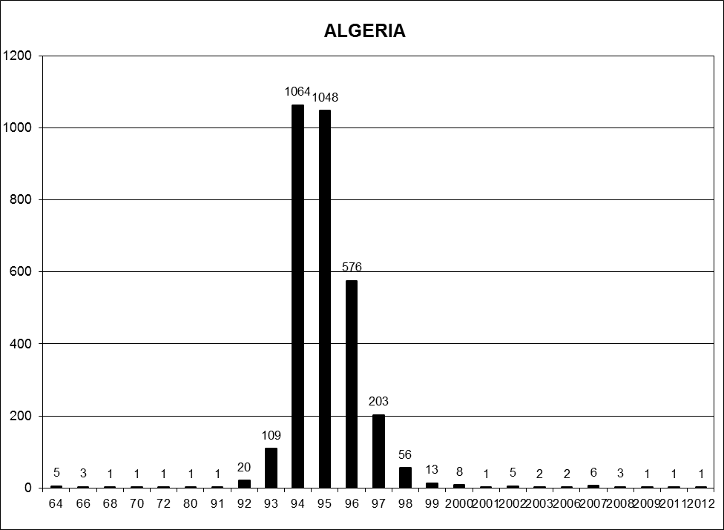

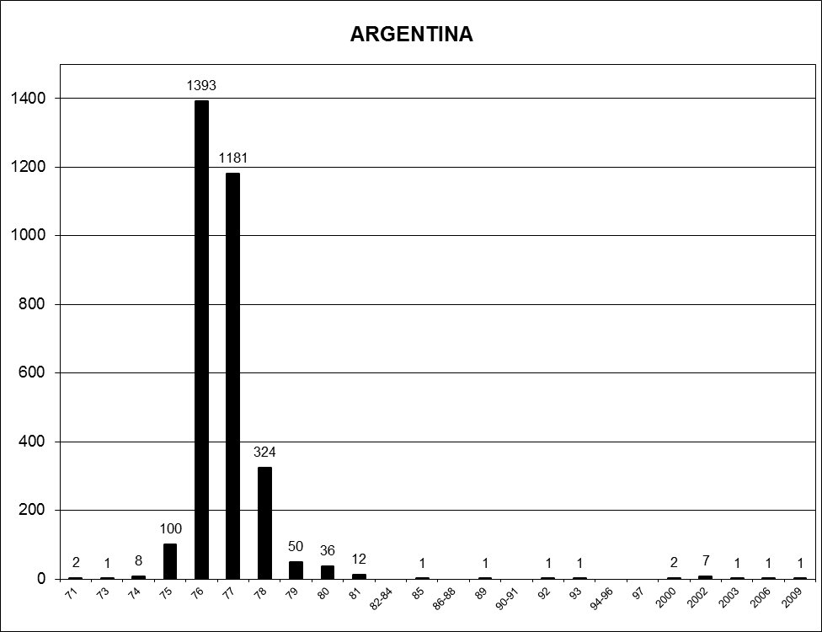

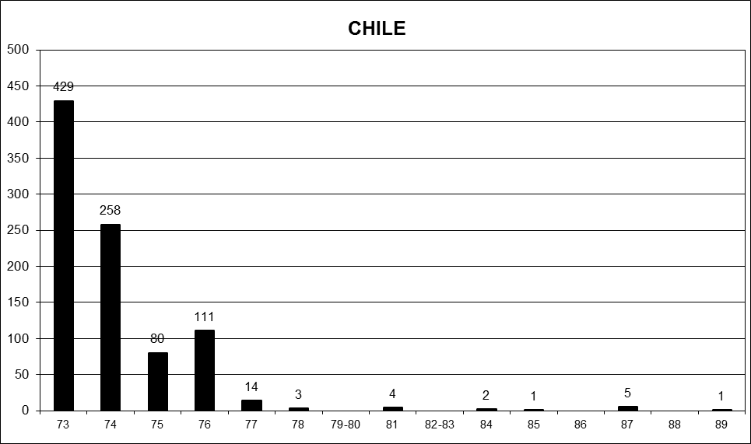

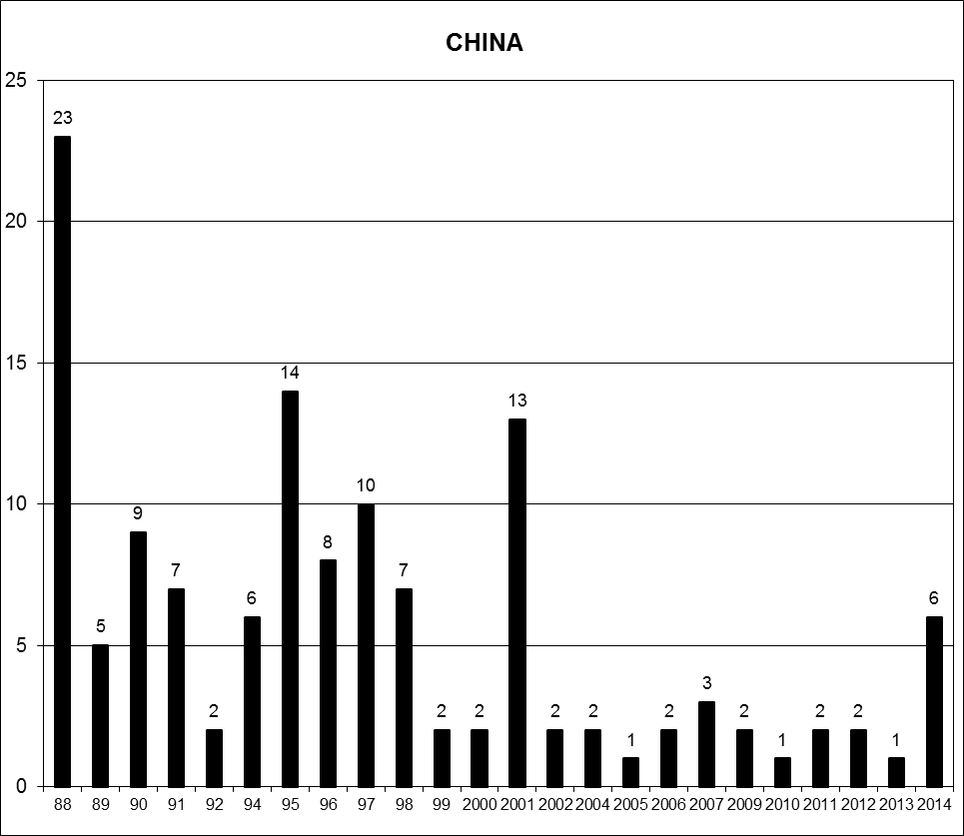

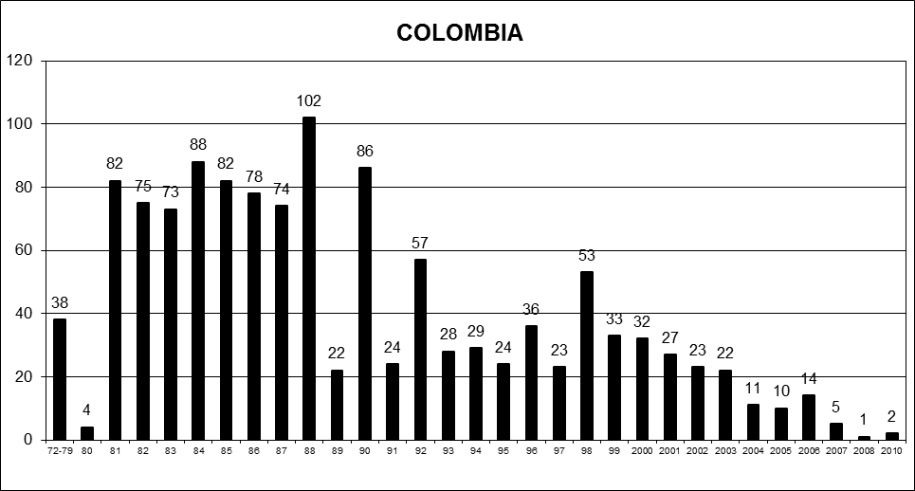

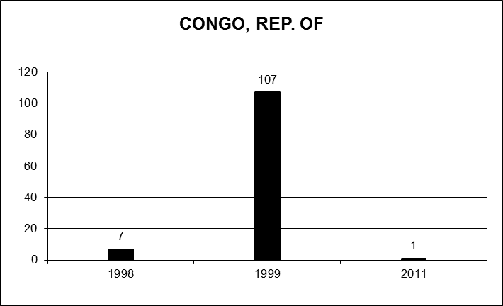

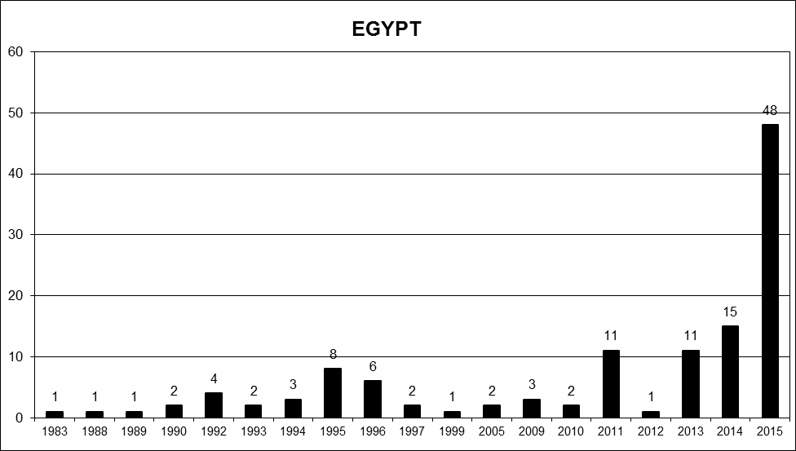

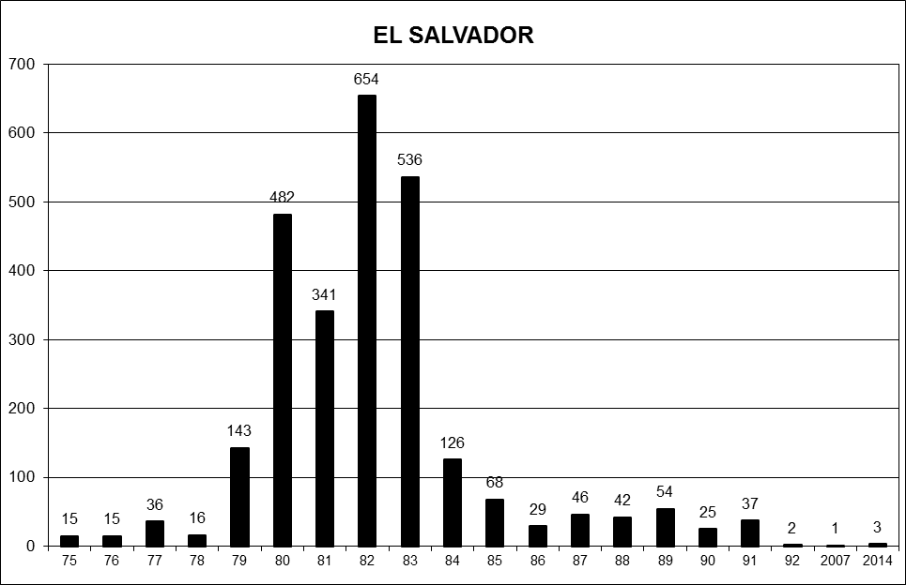

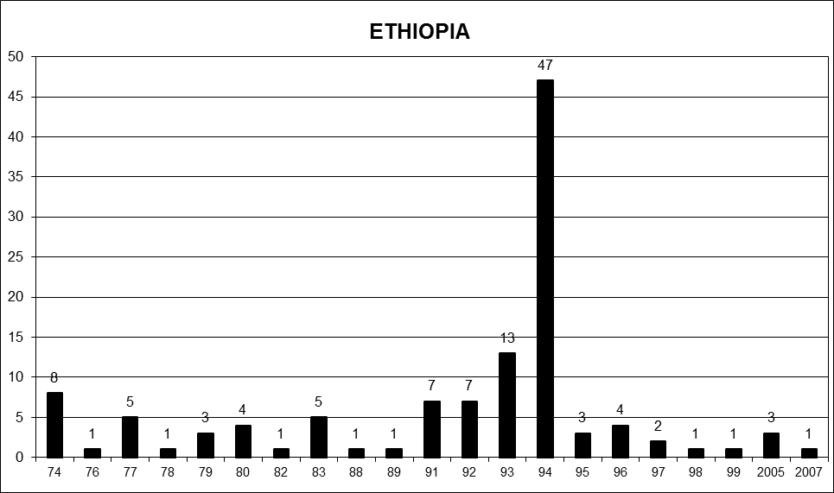

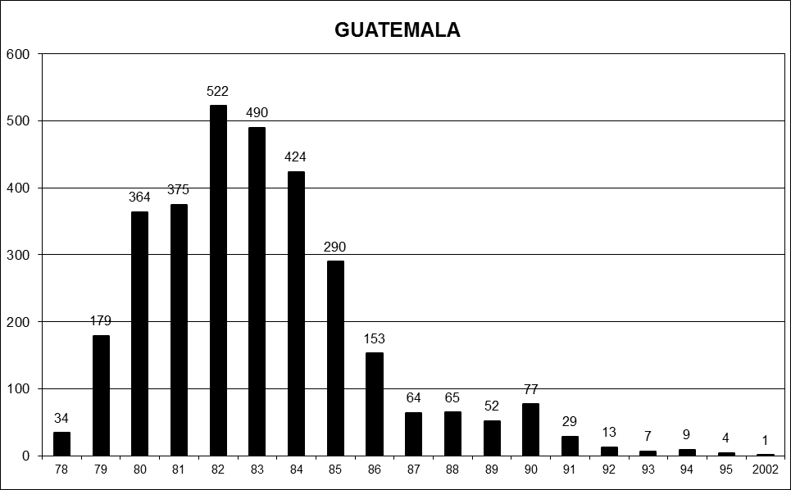

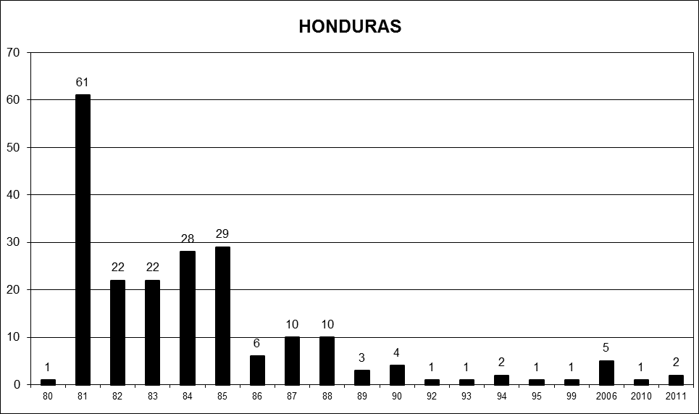

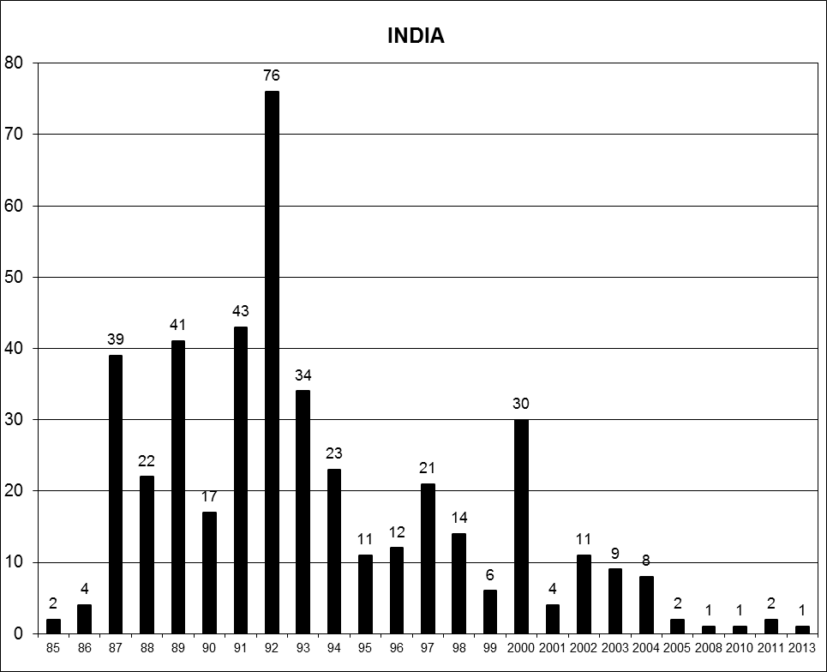

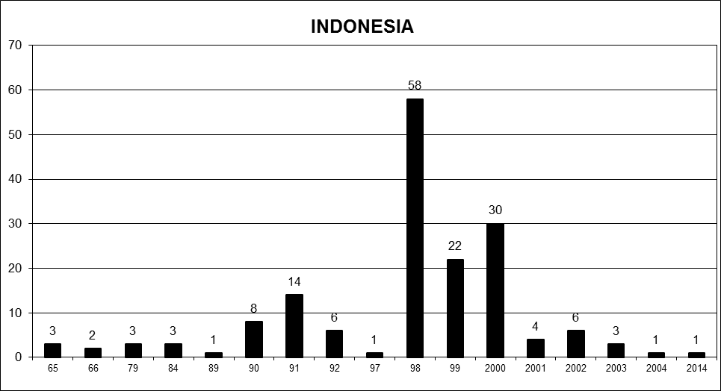

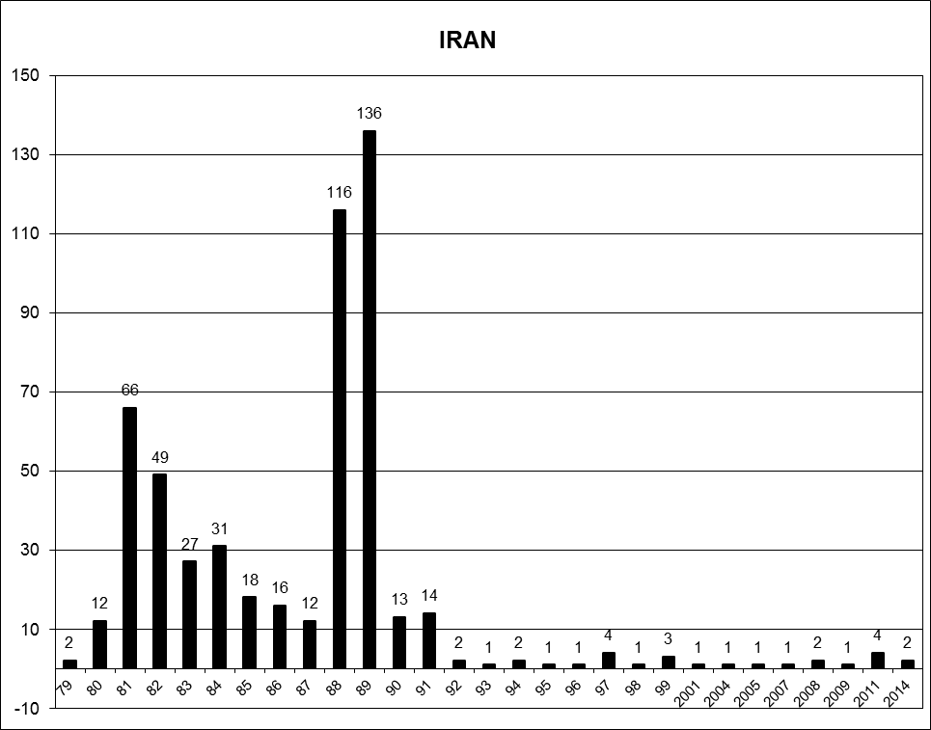

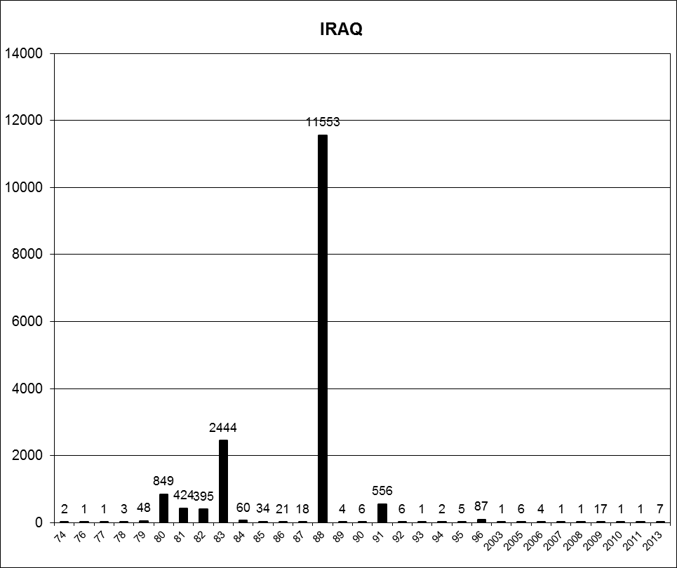

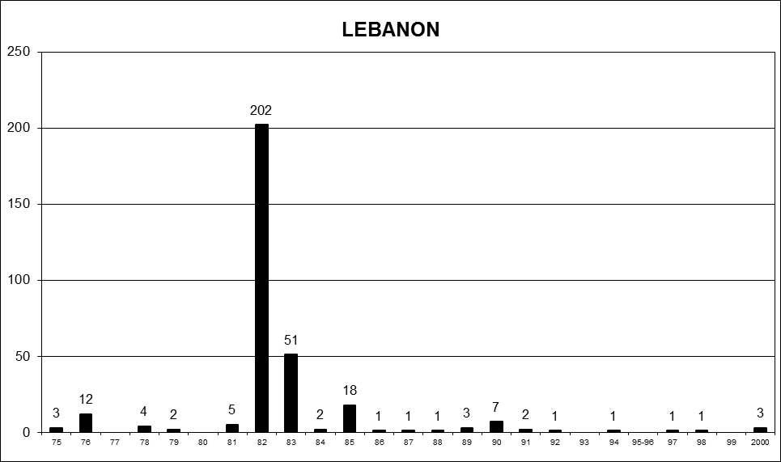

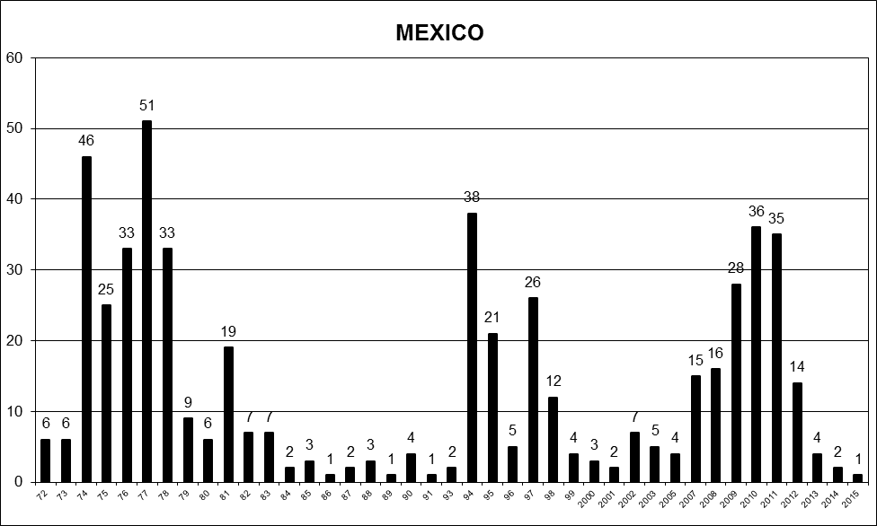

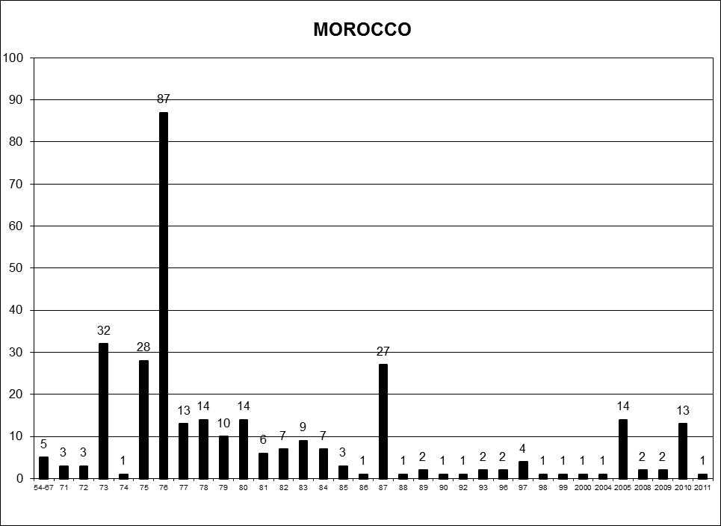

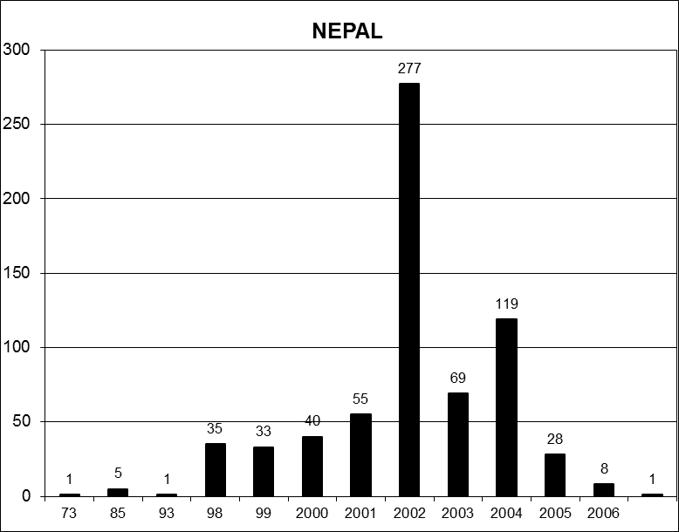

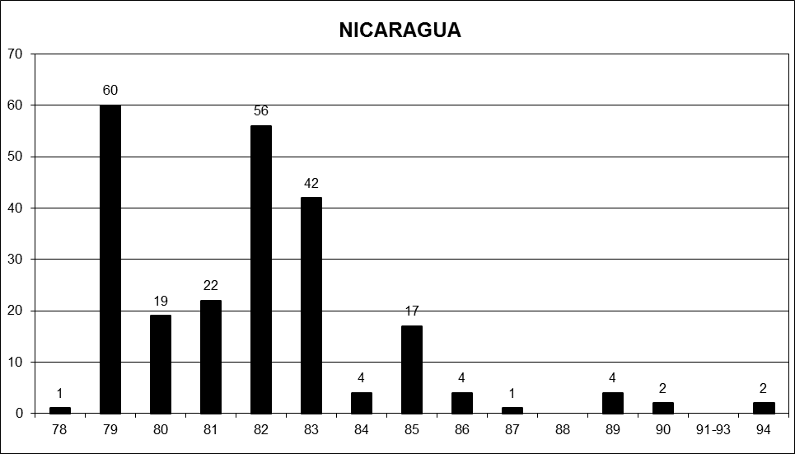

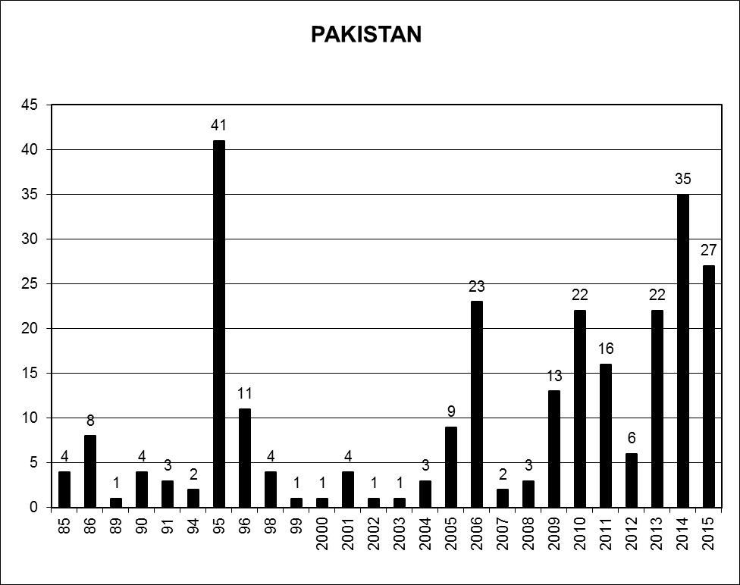

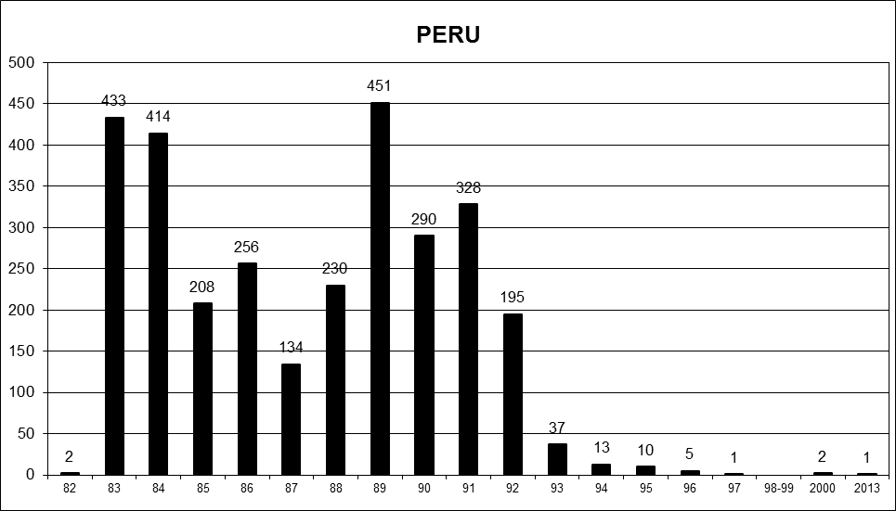

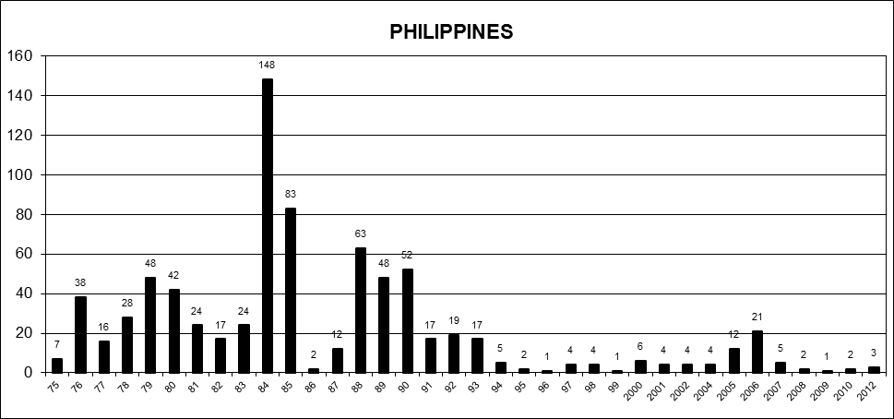

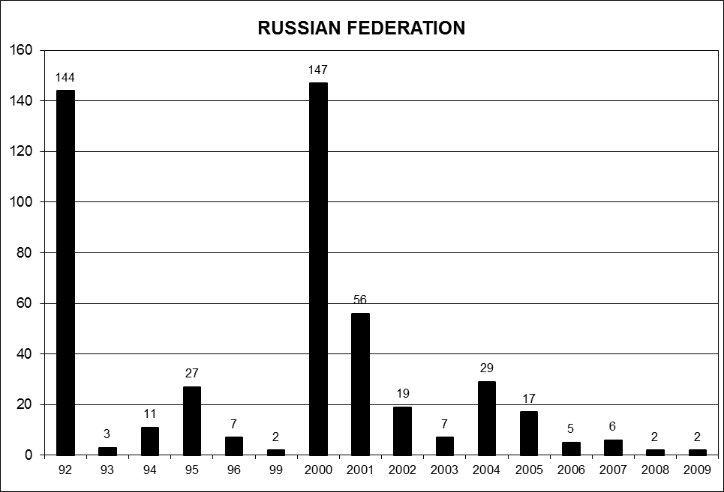

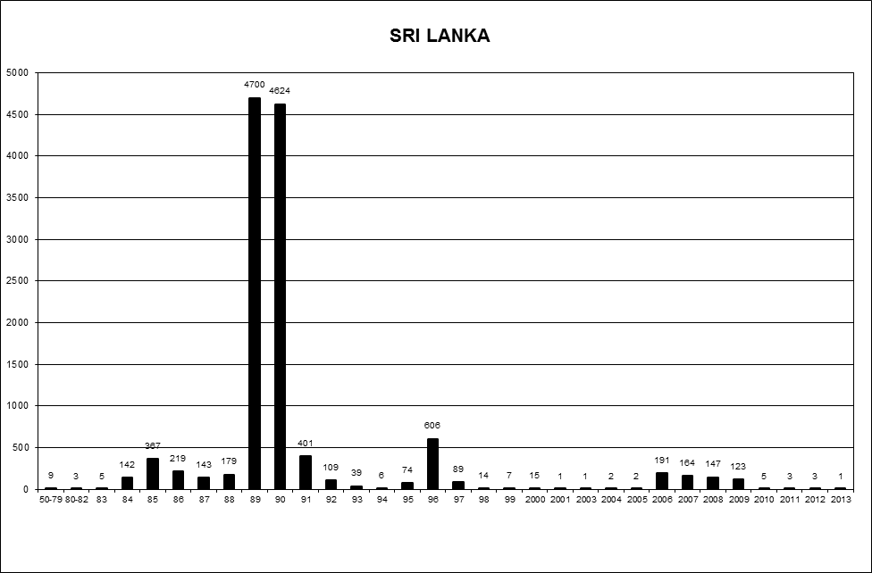

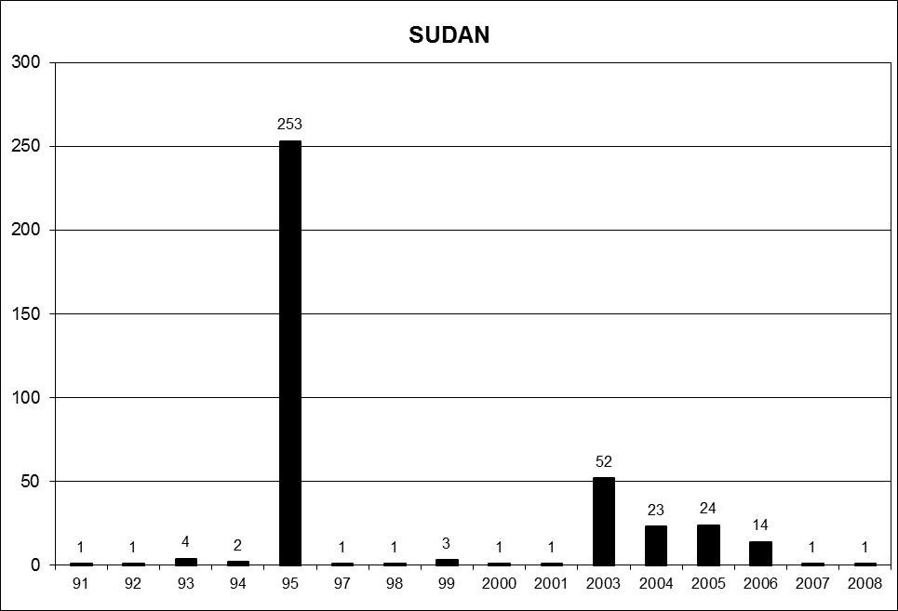

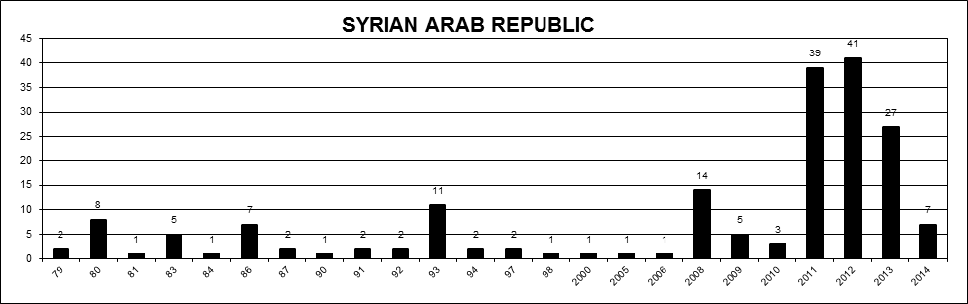

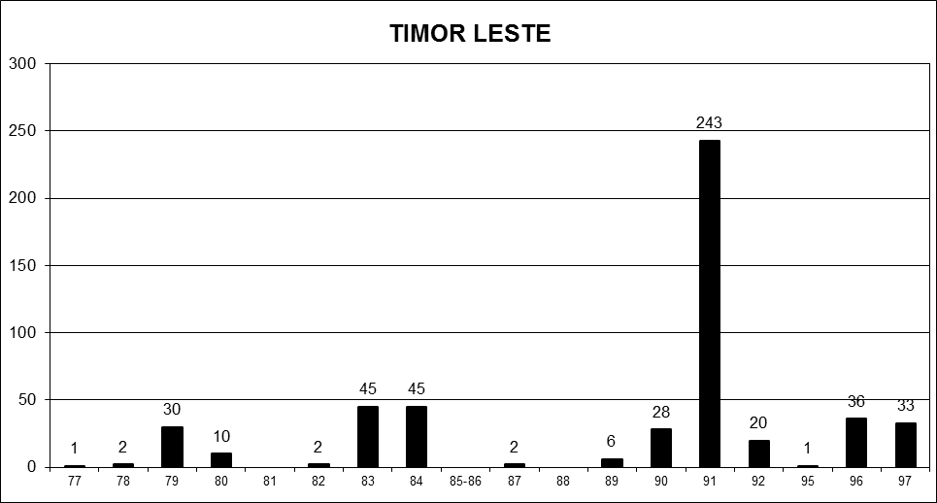

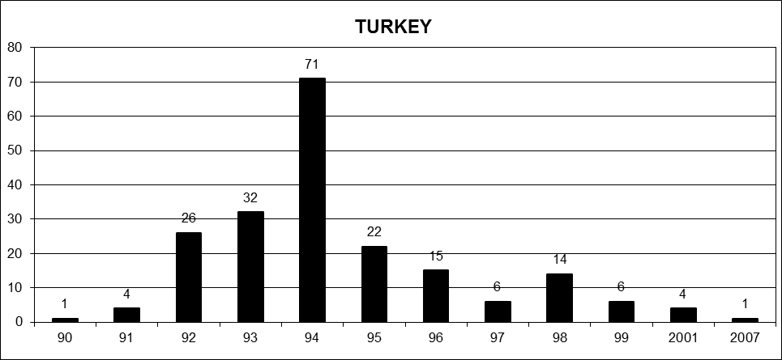

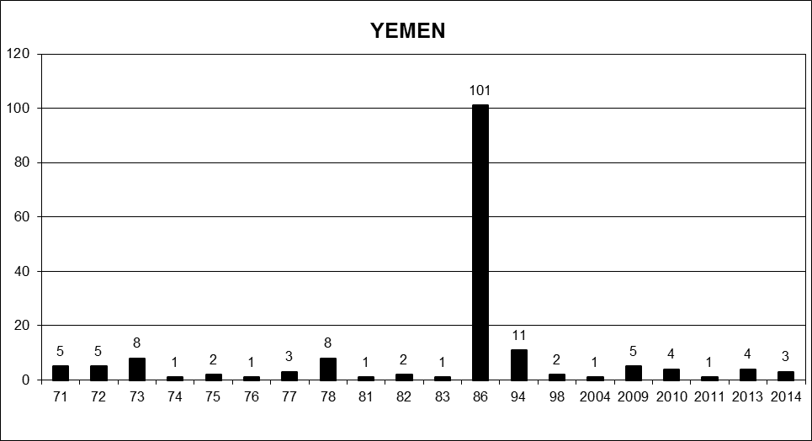

1. \* The annexes to the present report are circulated as received, in the language of submission only. [↑](#footnote-ref-2)
2. See http://www.ohchr.org/EN/Issues/Disappearances/Pages/Annual.aspx. [↑](#footnote-ref-3)
3. Please see annex I for country visit requests and invitations extended. [↑](#footnote-ref-4)
4. See www.ohchr.org/EN/NewsEvents/Pages/DisplayNews.aspx?NewsID=14655&LangID=E. [↑](#footnote-ref-5)
5. See www.ohchr.org/EN/NewsEvents/Pages/DisplayNews.aspx?NewsID=14696&LangID=E. [↑](#footnote-ref-6)
6. See www.ohchr.org/EN/NewsEvents/Pages/DisplayNews.aspx?NewsID=14824&LangID=E. [↑](#footnote-ref-7)
7. See www.ohchr.org/EN/NewsEvents/Pages/DisplayNews.aspx?NewsID=14854&LangID=E. [↑](#footnote-ref-8)
8. See www.ohchr.org/EN/NewsEvents/Pages/DisplayNews.aspx?NewsID=14929&LangID=E. [↑](#footnote-ref-9)
9. See www.ohchr.org/EN/NewsEvents/Pages/DisplayNews.aspx?NewsID=14970&LangID=E. [↑](#footnote-ref-10)
10. See www.ohchr.org/EN/NewsEvents/Pages/DisplayNews.aspx?NewsID=15087&LangID=E. [↑](#footnote-ref-11)
11. See www.ohchr.org/EN/NewsEvents/Pages/DisplayNews.aspx?NewsID=15125&LangID=E. [↑](#footnote-ref-12)
12. See www.ohchr.org/EN/NewsEvents/Pages/DisplayNews.aspx?NewsID=15155&LangID=E. [↑](#footnote-ref-13)
13. See www.ohchr.org/EN/NewsEvents/Pages/DisplayNews.aspx?NewsID=15199&LangID=E. [↑](#footnote-ref-14)
14. See www.ohchr.org/EN/NewsEvents/Pages/DisplayNews.aspx?NewsID=15310&LangID=E. [↑](#footnote-ref-15)
15. See www.ohchr.org/EN/NewsEvents/Pages/DisplayNews.aspx?NewsID=15348&LangID=E. [↑](#footnote-ref-16)
16. See www.ohchr.org/EN/NewsEvents/Pages/DisplayNews.aspx?NewsID=15618&LangID=E. [↑](#footnote-ref-17)
17. See www.ohchr.org/EN/NewsEvents/Pages/ExpertsInArgentina35YearsAfter.aspx. [↑](#footnote-ref-18)
18. See [www.ohchr.org/SP/NewsEvents/Pages/DisplayNews.aspx?NewsID=15765&LangID=S](http://www.ohchr.org/SP/NewsEvents/Pages/DisplayNews.aspx?NewsID=15765&LangID=S) (Spanish only). [↑](#footnote-ref-19)
19. See www.ohchr.org/EN/NewsEvents/Pages/DisplayNews.aspx?NewsID=15868&LangID=E. [↑](#footnote-ref-20)
20. See [www.ohchr.org/SP/NewsEvents/Pages/DisplayNews.aspx?NewsID=15913&LangID=S](http://www.ohchr.org/SP/NewsEvents/Pages/DisplayNews.aspx?NewsID=15913&LangID=S) (Spanish only). [↑](#footnote-ref-21)
21. Urgent actions are cases of enforced disappearances occurred within three months prior to the receipt of a report by the Working Group; or cases of enforced disappearances occurred prior to the three-month limit, but within one year prior to the receipt of a report by the Working Group, provided that there is a link with a case that occurred within the three-month period. Standard cases are cases of enforced disappearances occurred prior to the three-month limit. Prompt intervention letters concern cases of intimidation, persecution or reprisal against families of disappeared persons, witnesses, lawyers, human rights defenders and other individuals concerned with disappearances. Urgent appeals concern allegations of enforced disappearances; or allegations regarding persons deprived of liberty who are at risk of being disappeared. General allegations concern alleged obstacles encountered in the implementation of the Declaration. [↑](#footnote-ref-22)
22. The Working Group determined during its 106th session that one case was a duplicate and subsequently expunged it from the records. [↑](#footnote-ref-23)
23. The Working Group determined during its 106th session that one case was a duplicate and subsequently expunged it from the records. [↑](#footnote-ref-24)
24. The Working Group determined during its 106th session that one case was a duplicate and subsequently expunged it from the records. [↑](#footnote-ref-25)
25. The Working Group determined during its 104th session that two cases were duplicates and subsequently expunged them from the records. [↑](#footnote-ref-26)
26. The Working Group decided during its 104th session to transfer one case registered under the statistics of the United Arab Emirates to Egypt. [↑](#footnote-ref-27)
27. Please refer to para. 58 of the current document. [↑](#footnote-ref-28)
28. Please refer to para. 33 of the current document. [↑](#footnote-ref-29)
29. The Working Group determined that one case was a duplicate and subsequently deleted it from its records. [↑](#footnote-ref-30)
30. The Working Group determined that one case was a duplicate and subsequently deleted it from its records. [↑](#footnote-ref-31)
31. The Working Group transmitted one General Allegation and a follow-up General Allegation to El Salvador in 2015. [↑](#footnote-ref-32)
32. The Working Group determined that one case is a duplicate and subsequently deleted it from its records. [↑](#footnote-ref-33)
33. The Working Group received a reply to the General Allegation from the Government of Pakistan during its 106th session. The content of the reply will be reviewed during the 107th session of the Working Group. [↑](#footnote-ref-34)
34. The Working Group determined that two cases are duplicates and subsequently deleted them from its records. [↑](#footnote-ref-35)