Check against delivery
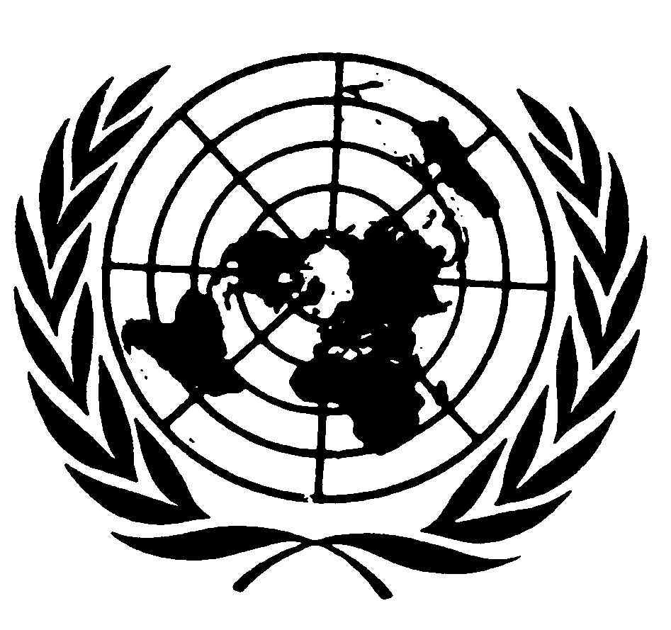

Statement by Ms. BISERKO and Ms. HOSSAIN,

Group of Independent Experts on Accountability designated pursuant to Human Rights Council resolution 31/18 on the situation of human rights in the Democratic People’s Republic of Korea

34th session of the Human Rights Council
Agenda Item 4

13 March 2017
Geneva

Mr. President, Distinguished Representatives, Observers, Ladies and Gentlemen,

It is with great honor that we address this Council in our capacity as the Group of Independent Experts designated pursuant to Human Rights Council resolution 31/18.

Mr. President,

We were mandated to support the work of the Special Rapporteur on issues of accountability for human rights violations in the DPRK, in particular where such violations amount to crimes against humanity, as found by the commission of inquiry. Taking the commission of inquiry report as a basis, we unpacked the notion of accountability, and how to secure truth and justice for victims of gross human rights violations in the DPRK. Importantly, we analyzed the issue in line with international law and prevailing State practice on accountability, and within the current political context.

Throughout our mandate we have sought to engage with the Government of the DPRK, but to no avail.

We have undertaken missions to Geneva, The Hague, Seoul, Tokyo and New York, during which we met with a wide range of officials, civil society actors and legal experts and practitioners. We also received written submissions.

We wish to express our sincere appreciation to those who shared their views and provided information, in particular the victims of human rights violations we met.

Mr. President,

Our report stresses that seeking accountability for gross human rights violations is not simply a legal requirement. Accountability processes also hold the potential to restore the position of victims in society as rights holders and to transform society into one based on the rule of law and respect for the dignity of all - thereby contributing to long-term peace and stability.

In our report, we call for a framework for accountability that is human rights-based - ensuring that the rights and needs of victims of human rights violations are at the centre of any accountability measures. In our view, this goal can only be achieved through a fully participatory process involving victims and affected communities. Given the severity and complexity of the human rights situation in the DPRK, a comprehensive and multi-pronged approach is required, in line with international norms and standards.

This approach should encompass measures to establish individual criminal responsibility of perpetrators, as well as measures to ensure the right of victims and societies to know the truth about violations, the right of victims to reparations, and guarantees of non-recurrence. Accountability requires coordinated efforts on all these fronts and in multiple forums.

In this light, we mapped options for accountability through domestic systems, in the DPRK and elsewhere, as well as through international and internationally assisted courts, and the international human rights machinery.

Mr President,

We underscore that the DPRK is the primary duty holder of the obligation to bring perpetrators of violations in the country to account. However, the information before us led us to conclude that it appears that no viable options for accountability exist or have been used in the DPRK, and that a fundamental reform of its justice system is required.

Similarly, hybrid justice models involving the DPRK or its justice personnel cannot currently be envisaged, given the lack of impartiality and independence of the judiciary and its alleged implication in the commission of human rights violations.

This brings us to accountability options outside the DPRK. While other domestic legal systems offer some legal bases for accountability, they face legal, political and practical challenges. In these circumstances, we call on the international community to continue to pursue a referral of the situation in the DPRK to the International Criminal Court.

In view of the large number of reported crimes and perpetrators, we also recommend that other criminal accountability processes be undertaken. The groundwork for future criminal trials should be laid now. This should include due consideration of the scope for the establishment of an ad hoc international tribunal, which could serve as a deterrent for future crimes and a signal that victims will be heard.

Mr. President,

Despite the unique challenges that the context in the DPRK presents, our report outlines a number of practical steps that can be taken immediately towards accountability.

Sustained and sound information and evidence gathering and preservation on human rights violations in the DPRK must continue. Further, an assessment of existing information and evidence from a criminal justice perspective should be undertaken, to identify gaps and develop possible investigation and prosecution strategies and blueprints for suitable international court models.

Finally, it is of critical importance to ensure participation and ownership of victims in accountability processes. This requires awareness-raising of victims and affected communities about their rights, including through regional initiatives and professional and civil society networks. Consultations with victims and other stakeholders about their views and expectations in terms of accountability must be undertaken. All this work can begin with the sizeable groups of victims and stakeholders living outside the DPRK.

Mr. President,

We urge for the issue of accountability for human rights violations in the DPRK to remain on the international agenda. Victims have long been yearning for truth and justice. Concrete steps towards making accountability a reality are needed now.

We thank you for your attention and look forward to a fruitful dialogue.
****************

