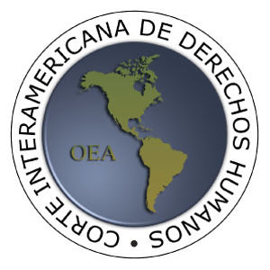
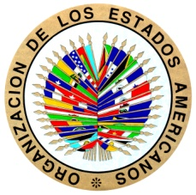

INTER-AMERICAN COURT OF HUMAN RIGHTS

INTERVENTION BY THE PRESIDENT OF THE INTER-AMERICAN COURT OF HUMAN RIGHTS, JUDGE ROBERTO F. CALDAS, AT THE 5TH UNITED NATIONS INTERNATIONAL WORKSHOP ON REGIONAL ARRANGEMENTS FOR THE PROMOTION AND PROTECTION OF HUMAN RIGHTS
Panel 5: Cooperation at national level, including follow-up on the United Nations and regional human rights mechanisms recommendations and decisions
(Geneva, 5 October 2016)

Distinguished members of this Panel, ladies and gentlemen, please accept once again the warmest greetings on behalf of my colleagues at the Inter-American Court and myself. I’m honoured to chair this Panel on the challenges experienced by civil society organisations and human rights defenders at the national level.

From the perspective of the Americas, the issue of human rights defenders has been a major concern throughout the years. Carlos Luna López and Blanca Jeannette Kawas-Fernández were murdered after a lifetime of pro-environment advocacy in Honduras; Gilson Nogueira de Carvalho fell victim to a homicide after denouncing the crimes committed by a ‘death squad’ police force in Brazil; Jesús María Valle Jaramillo was killed for speaking against the crimes committed by paramilitary groups in Colombia; Lysias Fleury was tortured for representing victims of domestic violence in Haiti; and Maria Emilia García was harassed after co-founding an NGO that aimed to support families facing the forced disappearance of their relatives in Guatemala. These are all examples of cases brought to the attention of the Court in which human rights defenders were victims of human rights violations because of their work in promoting and protecting these very rights.

The Inter-American Court has interpreted the concept of ‘human rights defender’ and the scope of the violations in question in line with the definition put forward by the UN Special Rapporteur in the last decade, by stating that the defender’s character resides ‘in the work carried out, regardless of whether the individual acts as a private individual or as a public servant’, and by expanding the defense of human rights to include the tasks of ‘monitoring, reporting and educating on civil and political rights, as well as on economic, social and cultural rights,’ in accordance with ‘principles of universality, indivisibility, and interdependence’. The ‘collective’ effect of attacks on human rights defenders was also highlighted ‘inasmuch as society is prevented from learning the truth concerning the observance or the violation of the rights of those subject to the jurisdiction of a specific State.’

Thus, human rights defenders are often the instigators and always the watchmen of the international human rights standards. Their contribution to the strengthening of democracy and rule of law has been acknowledged by human rights and political bodies in every region of the world.

In light of the importance of the work carried out by human rights defenders, reinforcing the cooperation between regional mechanisms and human rights defenders in the domestic sphere is crucial to the fulfilment of our shared objective, which is the protection of human rights.

In this Panel we will discuss the challenges faced by civil society organisations and how the regional human rights mechanisms and the UN system can cooperate to improve their situation on the ground, looking at best practices, lessons learnt and possible forms of new cooperation. In particular, we will hear from of experts from regional and UN mechanisms, but also from national NGOs what are the specific human rights challeneges faced in their countries, as they conduct their work; How can the UN and regional mechanisms support them; and what are the best practices identified to that effect.

With that introduction I would like to give the floor to our first panelist, Mr. Fabian Salvioli, Chairperson of the UN Human Rights Committee.

