 

|  |  |  |
| --- | --- | --- |
| United Nations Stabilization  Mission in Haiti |  | UN Office of the High Commissioner  for Human Rights |

**Bi-Annual Report on Human Rights in Haiti**

**July - December 2012**

**(Executive Summary and Recommendations)**

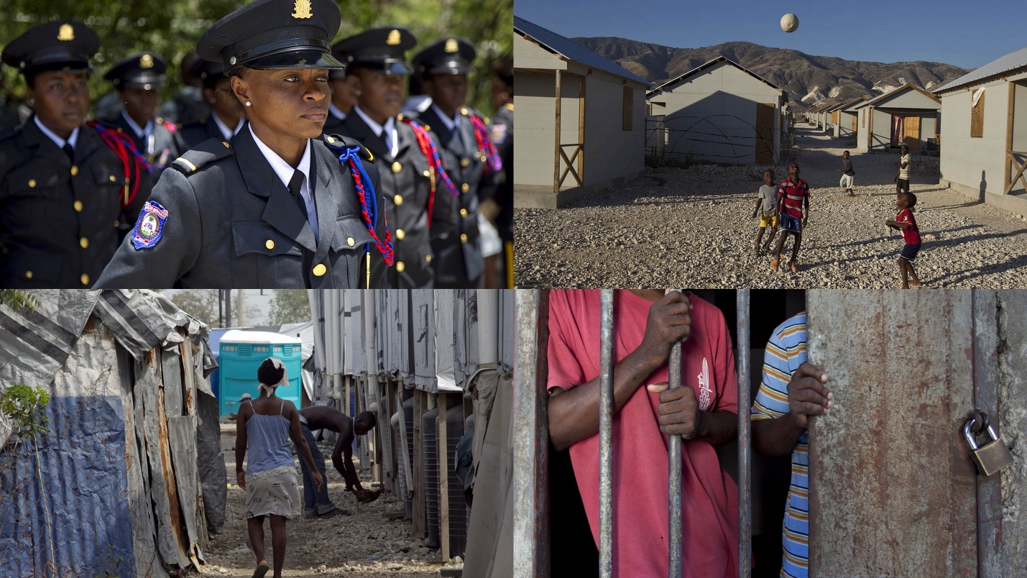

**April 2013**

**EXECUTIVE SUMMARY**

This report presents and analyses key elements of the human rights situation in Haiti during the period July to December 2012. It follows a previous report covering January to June 2012, published in October 2012. The second half of 2012 has seen some positive developments in human rights protection, but has also been marked by a lack of implementation and follow-up on important advances identified in the first half of the year.

The promulgation of the Law on the Organization and the Functioning of the Haitian Ombudsperson (*Loi portant sur l’organisation et le fonctionnement de l’Office de la protection du citoyen*) on 20 July is one of the most notable improvements. It guarantees the independence of the Ombudsperson’s office, defines its status and role and provides the framework for an independent national human rights institution.

On 30 November, the Haitian government submitted its initial report to the Human Rights Committee, 21 years after having ratified the International Covenant on Civil and Political Rights (ICCPR). This marks an important step in the engagement of the Haitian State with international human rights mechanisms. This accomplishment can be viewed in the context of the encouraging statements made by government officials on Haiti’s willingness to improve the promotion and protection of human rights, notably with regard to the ratification of international human rights instruments and the fulfilling of the government’s periodic reporting obligations to human rights treaty bodies.

The formal commitment by the Haitian government to ratify or adhere to six international human rights instruments deserves mention. On 24 September, during the 67th session of the United Nations General Assembly, Prime Minister Laurent Lamothe committed the Haitian government to adhere to or ratify the Convention against Torture and Other Cruel, Inhuman or Degrading Treatment or Punishment; the International Convention for the Protection of All Persons from Enforced Disappearance; the International Convention on the Protection of the Rights of All Migrant Workers and Members of their Families; the Rome Statute establishing the International Criminal Court; the 1954 Convention Relating to the Status of Stateless Persons, and the 1961 Convention on the Reduction of Statelessness.

Despite these encouraging steps, in this report, the Human Rights Section of MINUSTAH / Office of the High Commissioner for Human Rights draws attention to a lack of progress in other domains. The Permanent Electoral Council and the Constitutional Council, established pursuant to the constitutional amendments of June 2012, have not yet been created, and the Superior Council of the Judiciary is still not entirely functional. The organization of municipal and legislative elections has been suspended since 2011 due to the inability to constitute the electoral council.

The practice of appointing Interim Executive Agents (*Agents exécutifs intérimaires)* to replace local elected officials whose mandates have expired continues. The indefinite extension of these appointments - initially justified by the need to ensure the proper functioning of local institutions - compromises the elective character of the functions concerned and presents a risk for the principle of democracy. In a similar fashion, the Executive has appointed or transferred a significant number of judges. In the current political landscape, these decisions could be perceived as an infringement of the independence of judges.

During the second half of 2012, the Human Rights Section documented several cases of apparent excessive use of force and ill-treatment by members of the Haitian National Police, during forced evictions, suppression of protest demonstrations, anti-criminality operations and other incidents.

In May 2012, MINUSTAH submitted to the General Inspection of the Haitian National Police 47 cases of alleged human rights violations committed by police officers. At the end of the period under review, the Human Rights Section had received answers from the General Inspection on only 10 of the 47 cases.

The Human Rights Section documented a number of cases of local administrative and judicial authorities using parallel security forces made up of civilians to perform various functions pertaining strictly to police authorities. Certain local political figures have established civilian *brigades* ostensibly to guarantee their security. The constitution of such groups is particularly worrisome in a pre-electoral context.

The phenomenon of lynching remains of great concern. Fifty-six cases of lynching were recorded by MINUSTAH UN Police (UNPOL) from July to December 2012. The authorities’ efforts to prevent and suppress lynching remain insufficient. Similarly, the judicial response to acts of sexual violence is still inadequate in Haiti and the recommendations that the Human Rights Section made in its public report of June 2012 have largely not been implemented.

On 13 December, the Court of Appeals should have ruled on the appeals against the Closing Order (*ordonnance)* issued the investigative judge in the proceedings launched against former Haitian President Jean-Claude Duvalier. However, upon request of the victims, the Court postponed the hearing to 24 January 2013.

The Human Rights Section has seen no improvement nationally in the situation of detainees and persons in police custody. The Section has continued to monitor large numbers of cases of police custody exceeding the legal limit of 48 hours and to document numerous cases of prolonged pre-trial detention in prisons, despite the holding of additional correctional hearings and criminal *assises*. Furthermore, it has documented a number of cases of persons being detained beyond the term of their sentences. On detention conditions, the Human Rights Section remains concerned about the general lack of access to food and health care, poor hygienic conditions and prison overcrowding. The situation of minors and women in detention, particularly pregnant women, is especially worrisome.

The second half of the year was marked by important natural disasters that have affected, once again, the humanitarian situation and the functioning of the country. These events have highlighted the country’s persistent vulnerability to such disasters and the limited response capacity of the protection authorities such as the *Direction de la protection civile*. Following Hurricane Sandy, on 31 October, the Haitian government proclaimed a countrywide state of emergency, explicitly allowing for restrictions of fundamental freedoms and providing exceptional powers to the Executive. The government is required to report to Parliament after the expiration of the state of emergency on the measures it took during the period, which began on 1 November and was extended on 5 December for an additional month.

With regard for economic and social conditions, the period under review was marked by demonstrations throughout the country against the high cost of living, unequal distribution of electricity, inadequate infrastructure, lack of sufficient access to adequate housing, the persistent cholera epidemic and insecurity. This report insists on the importance of consulting and taking into account the opinions of civil society on public policies.

**RECOMMENDATIONS**

**To the Haitian State:**

1. Take legal, administrative and financial measures to institutionalize a permanent State organ charged with drafting national reports for international human rights treaty bodies and following up on the implementation of recommendations from the Universal Periodic Review.
2. Submit government reports to the human rights treaty bodies, in particular:

- Periodic reports to the Committee on the Elimination Racial Discrimination, due since 2000;

- Periodic reports to the Committee on the Rights of the Child, due since 2007;

- The initial report to the Committee on the Rights of Persons with Disabilities, due since 2011.

1. Ratify, as announced by the Prime Minister during the High Level Meeting on the Rule of Law held in New York in September 2012, the following human rights treaties:

- The Convention against Torture and Other Cruel, Inhuman or Degrading Treatment or Punishment;

- The International Convention for the Protection of All Persons from Enforced Disappearance;

- The International Convention on the Protection of the Rights of All Migrant Workers and Members of their Families;

- The 1954 Convention relating to the Status of Stateless Persons and the 1961 Convention on the Reduction of Statelessness;

- The Rome Statute establishing the International Criminal Court.

1. Promulgate the Law ratifying the International Covenant on Economic, Social and Cultural Rights that was adopted by the Parliament, and deposit an instrument of accession so that the Covenant can enter into force.
2. Finalize as quickly as possible reform of the Criminal Code and the Code on Criminal Procedure, the final drafts of which have been submitted to the Ministry of Justice.
3. Commit to publish in the Official Gazette, *Le Moniteur,* laws adopted by the Parliament and promulgated by the President, so that the population is informed of its rights and duties. Specifically, the Law ratifying the International Covenant on Economic, Social and Cultural Rights (adopted by the Parliament on 31 October 2012), the Law on Paternity and Filiation (voted by the Senate on 12 April 2012) and the Decree on the State of Emergency (adopted on 30 October 2012), should be published.
4. With assistance of the international community, continue to support the consolidation of the *Office de la protection du citoyen*, especially with regard to its establishment of regional offices and facilitation of its cooperation with civil society.
5. Allocate an operating budget to the Minister for Human Rights and the Fight against Extreme Poverty.
6. With support of the international community, the Housing and Public Buildings Unit should adopt and implement a global strategy, especially a housing policy, in order to respond to the needs of displaced persons living in camps, prevent forced evictions and develop a vision for urban development that is respectful of human rights.
7. The Parliament should adopt a legislative framework in accordance with the Protocol to Prevent, Suppress and Punish Trafficking in Persons, especially Women and Children, supplementing the United Nations Convention against Transnational Organized Crime, ratified by Haiti in 2011.
8. The Executive, in the interest of transparency, should provide an account to the Parliament of the use of funds during the state of emergency.
9. Formally prohibit the use of parallel security forces made up of armed civilians by local elected and appointed officials.

**To the State organs mandated to monitor the proper functioning of the police and judicial authorities:**

1. The General Inspection of the Haitian National Police should systematically investigate cases in which use of force by officers of the Haitian National Police has led to the death or severe injury of persons. The General Inspection should also respond to the cases that remain unanswered among the 47 that were submitted by the Human Rights Section.
2. The Superior Council of the Judiciary should fully assume its role as disciplinary and control organ over the Judiciary, particularly by ensuring that judges exercise their functions with full independence and the maximum efficiency.
3. The Police Academy and the School of Magistrates (*Ecole de la magistrature*), with assistance from the international community, should improve the training of officers of the Haitian National Police and of magistrates with regard to the treatment of cases of sexual violence, including the prohibition of friendly settlements in such cases and raising awareness with regard to women’s rights.
4. The Ministry of the Interior, as well as the Ministry of Justice and the Superior Council of the Judiciary should adopt a Directive aimed at officers of the Haitian National Police and magistrates, clarifying that in cases of sexual aggression the absence of a medical certificate should not preclude judicial proceedings.
5. The Minister of Justice should develop a comprehensive national strategy to combat prolonged preventive detention, in respect of international principles on detention.
6. In the absence of juvenile courts in various jurisdictions, the Deans of the courts should designate juvenile judges as quickly as possible.
7. Police authorities and the Prison Administration (*Direction de l’administration pénitentiaire)* should ensure that minors are always detained separately from adults.
8. The Ministry of the Interior, as well the Ministry of Justice and the Superior Council of the Judiciary should send clear and precise instructions to the officers of the Haitian National Police and to the magistrates in order to make sure that the necessary measures would be taken to prevent and repress lynching.

**To civil society organizations:**

1. Undertake monitoring of implementation of human rights treaties ratified by Haiti, including by drafting so-called “shadow reports” to human rights treaty bodies and organizing advocacy activities when national reports are examined by human rights treaty bodies.
2. Take a more active role in the development of public policies by supporting the preparation and presentation by communities of priority assessment reports (*cahiers des charges*) on basic needs and by organizing related advocacy events with competent State authorities.