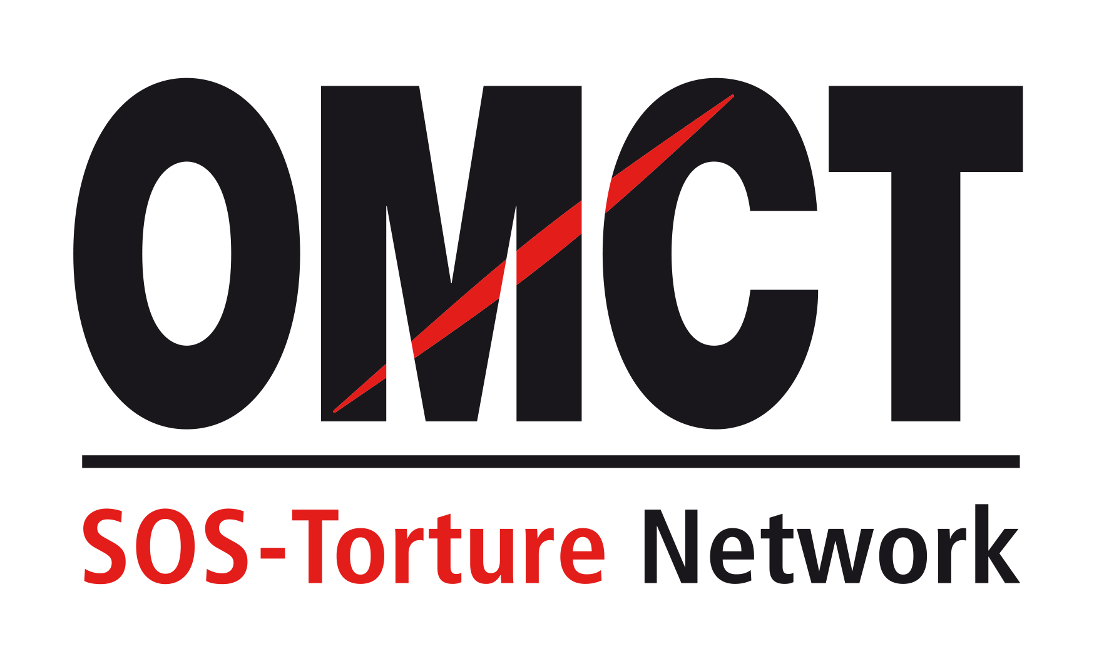

66th CAT session

23 April – 17 May 2019
Confirmation of attendance for in-session NGO briefing

Please return this form to the OMCT at cat@omct.org before 1st of April 2019.

State concerned

Name of State

Alternative report
Title
Author(s)
Short summary
(50 to 100 words)

NGO presenting the report in Geneva
Name of NGO
Address
Country
Telephone / fax
Email

Person(s) attending
Surname /Name
Email
Telephone/Mobile
Surname /Name
Email
Telephone / Mobile

Principal issues of concern to be raised before the Committee against Torture
Principal issue 1
Principal issue 2

Your recommendation(s) for the follow up procedure

