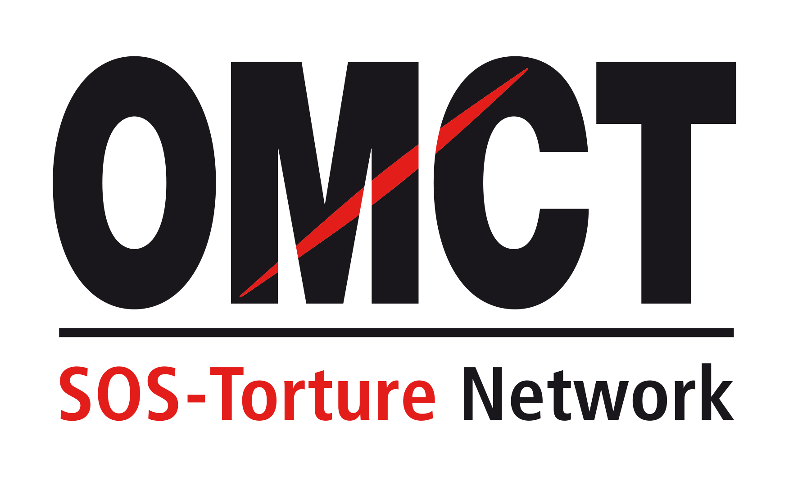

71st CAT session

12 July – 30 July 2021
Confirmation of attendance for in-session NGO briefing

Please return this form to the OMCT at cat@omct.org before 28 June 2021.

State concerned

Name of State

Alternative report
Title
Author(s)
Short summary
(50 to 100 words)

NGO presenting the report online
Name of NGO
Address
Country
Telephone / fax
Email

Person(s) attending
Surname /Name
Email
Telephone/Mobile
Surname /Name
Email
Telephone / Mobile

Principal issues of concern to be raised before the Committee against Torture
Principal issue 1
Principal issue 2

Your recommendation(s) for the follow up procedure

