CURRICULUM VITAE  Cornelis (Cees) Flinterman | 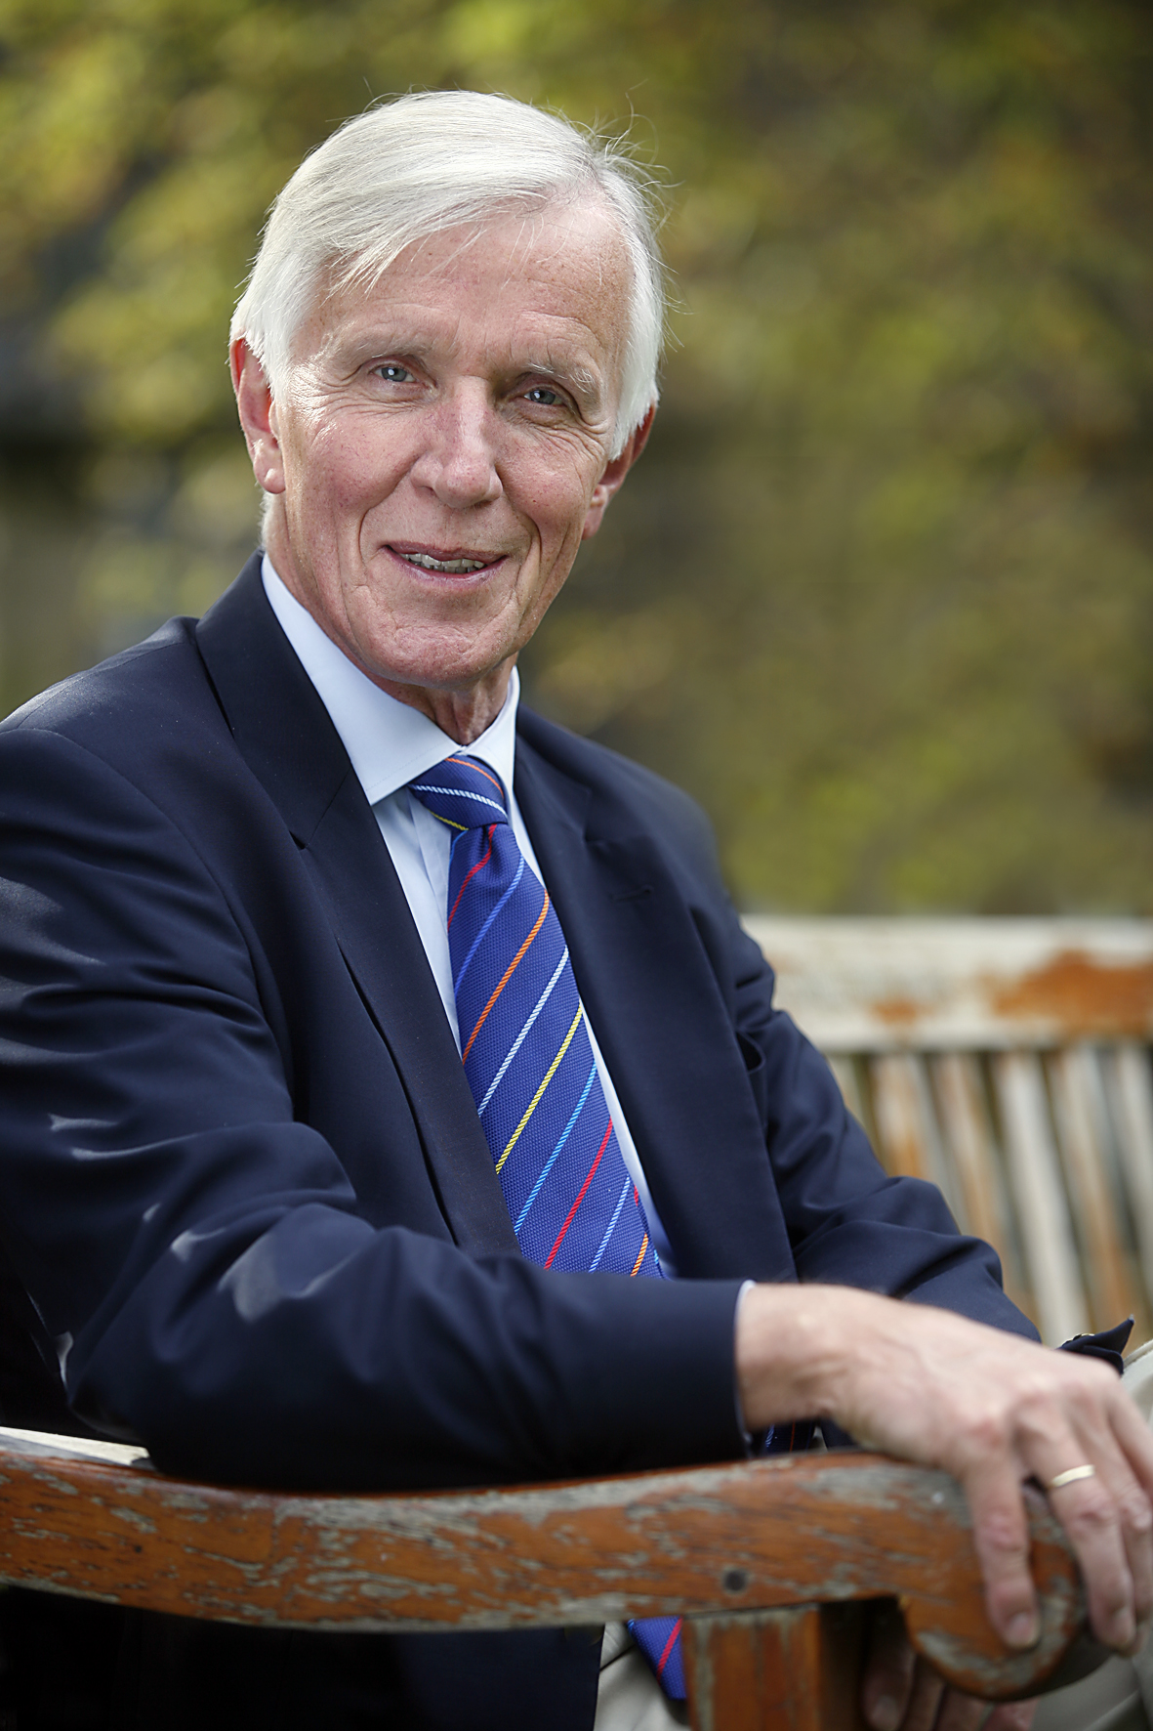

- PERSONAL DETAILS

Date of birth : 3 November 1944
Gender : male
Nationality : Dutch
Marital status : married, two children
Home address : Bemelerweg 72, 6226 HB Maastricht, the Netherlands
Tel: 043 637 586, fax: 043 363 7586,
email: Flinterman.maastricht@planet.nl
Work address : Utrecht University, Faculty of Law
Drift 15, 3512 BR Utrecht, the Netherlands
Tel: 030-2537214, fax: 030-2537168,
email: c.flinterman@uu.nl

- EDUCATION AND ACADEMIC QUALIFICATIONS

LLM Degree, Leiden University, the Netherlands (1969)
LLM Degree, University of Virginia, USA (1971)
Visiting Scholar, Yale Law School, USA (1973)
PhD Degree, Leiden University, the Netherlands (1981)

- MAIN PROFESSIONAL ACTIVITIES

- Lecturer and senior lecturer in law, comparative and constitutional law, Leiden University, 1969-1970, 1971-1974, 1976-1978
- Visiting lecturer in law (comparative and constitutional law), University of Ghana, 1974-1976
- Research associate of the Ghana Law Reform Commission, 1974-1976
- Ministry of Foreign Affairs, Legal and Social Affairs Division, The Hague, 1979-1981
- Professor of Law (international and constitutional law), Maastricht University, the Netherlands, 1982-1998
(1984-1986 Dean of the Faculty of Law)
(1986-1991, 1994-1996 Chairman of the International and European Law Department)
(1991-1993 Chairman of the Board of Directors, Research Institute, Faculty of Law)
(1992-1998 Co-director of the Maastricht University Research Centre for Human Rights)
- Professor of Human Rights and Director of the Netherlands Institute for Human Rights (SIM) and the Netherlands Research School of Human Rights Research (participating institutes: Faculties of Law of Utrecht University, Leiden University, Maastricht University, Tilburg University, Erasmus University Rotterdam, Faculty of Humanities of Utrecht University and the T.M.C. Asser Institute for International Law (The Hague)), 1998-2007
- 2007-present: Emeritus professor of human rights (Utrecht University) and honorary professor of human rights (Maastricht University)

- OTHER PROFESSIONAL ACTIVITIES

Current:
- Member of the United Human Rights Committee (HRC)
- Member of the Board of the Netherlands Helsinki Committee
- Member of the Advisory Board of the Dutch Health Professionals and Human Rights Foundation
- Member of the Board of African Legal Aid (AFLA), Maastricht, the Netherlands
- Member of the Editorial Board of the Netherlands Human Rights Quarterly
- Member of the Advisory Board of the Human Rights Quarterly (USA)
- Member of the Advisory Board of the Maastricht Journal of European and Comparative Law
- Member of the Advisory Board of the African Human Rights Law Journal
- Member of the Advisory Board on Responsible Investment of PGGM/PFZW (pension fund)
- Chair of the Advisory Council of Clingendael Institute for International Relations, The Hague
- Member of the Advisory Board of the African Centre for Democracy and Human Rights Studies, Banjul, the Gambia.

Past (inter alia)
- Alternate member of the UN Sub-Commission for the Prevention of Discrimination and the Protection of Minorities (1986-1991)
- Chairman of the Advisory Committee on Human Rights and Foreign Policy of the Netherlands (1992-1998)
- Head of the Delegation of the Kingdom of the Netherlands to the 49th and 50th session of the United Nations Commission on Human Rights (1993 and 1994) and the Second United Nations World Conference on Human Rights (1993)
- Vice-Chairman of the 49th session of the United Nations Commission on Human Rights (1993)
- Special Adviser to the Delegation of the Kingdom of the Netherlands to the UN Commission on the Status of Women (1996-1999); negotiator in the Working Group on the Elaboration of a Draft Optional Protocol to the Convention on the Elimination of All Forms of Discrimination Against Women
- Member of the United Nations Committee on the Elimination of Discrimination Against Women (CEDAW), 2003-2010 and chair and/or member of the CEDAW Working Group on Communications (2003-2010)
- Member of the Advisory Council on International Affairs of the Netherlands and Chair of its Human Rights Committee (1997-2002)
- Member of the Editorial Board of the Nederlands Tijdschrift voor de Rechten van de Mens [Netherlands Review of Human Rights] (1982-1990)
- Member of the Editorial Board of the Netherlands International Law Review (1981-2003)

- PROFESSIONAL MEMBERSHIPS
Member of (inter alia):
- American Society of International Law
- International Law Association
- Netherlands Association of International Law
- Netherlands Association of European Law
- Netherlands Lawyers' Committee for Human Rights (co-founder in 1974); Dutch Section of International Commission of Jurists
- African Society for International and Comparative Law
- Netherlands Association for Gender and Law
- Netherlands Association of Lawyers

- PUBLICATIONS
Publications in the field of (comparative) constitutional and administrative law, international law, law of international organisations and national, European and international human rights law. Publications include:
H.B. Schoepp-Schilling and C. Flinterman, eds., The Circle of Empowerment. Twenty-five Years of the UN Committee on the Elimination of Discrimination Against Women, New York, 2007;
P.R. Baehr, M. Senders and C. Flinterman, eds., Innovation and Inspiration. Fifty Years of the Universal Declaration of Human Rights, Amsterdam, 1999;
L. Erades, M. Fitzmaurice and C. Flinterman, Interactions between International and Municipal Law, The Hague, 1993;
E.V.O. Dankwa, M. Hamalengwa and C. Flinterman, eds., International Law of Human Rights in Africa: Basic Documents and Annotated Bibliography, Dordrecht, 1988.

