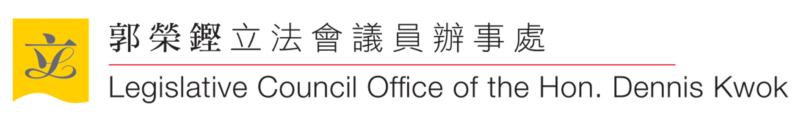
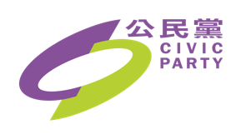

Submission by The Legislative Council Office of Hon. Dennis Kwok, Civic Party,
Hong Kong Special Administrative Region
on Revised Draft General Comment No. 37 on Article 21 (Right of Peaceful Assembly) of the International Covenant on Civil and Political Rights

- Civic Party is a pro-democracy political party in Hong Kong with five elected members at the Hong Kong Legislative Council (LegCo), namely Hon. Alvin Yeung, Hon. Tanya Chan, Hon. Jeremy Tam, Hon. Ka-ki Kwok and Hon. Dennis Kwok. Civic Party is also a member of Civil Human Rights Front in Hong Kong, the main organiser of pro-democracy assemblies and marches.

- Gratitude must be given to the Human Rights Committee’s effort in preparing the draft General Comment No.37, updating the relevant interpretation and elaboration on the right of peaceful assembly under Article 21 of the International Covenant on Political and Civil Rights. This is of particular importance as the form of protests, ways of communications and policing tactics have evolved over time with technological advancement. Our office wishes to submit the followings in light of the Hong Kong context –

Facemask Ban (paragraph 70)
- Our office welcomes the disapproval of prohibition of facial covering in paragraph 70. It must be stressed that even when there is probable cause for arrest for participants in an assembly, without demonstrable evidence of imminent violence on their part, prohibition on facial covering cannot be justified.

- To avoid doubt, banning facial covering in peaceful assembly (including unauthorised assemblies) as a measure to deter participants from using violence is generally disproportionate.

- Reference can be made to a recent judicial review case in Hong Kong by pro-democracy legislators (including the five Civic Party legislators) against an emergency facemask ban in all kinds of public assemblies, of which the High Court ruled as unconstitutional. The case is pending appeal to higher courts.

Seizure of digital device (paragraphs 71 & 94)
- Our office agrees with the need to conform to the applicable international standards in the collection of relevant information and data by the authorities in paragraph 71. It also appreciates the draft General Comment pointing out that powers of “stop and search” and “stop and frisk” could amount to unwarranted interference with the right to privacy in paragraph 94. Our office wishes to add that attention must be paid to seizure of digital device, such as mobile phones, computer or laptops of those arrested in the context of or on offences related to public assembly, public marches or any other form of protests.

- In the Hong Kong context, the police have seized over 3,700 mobile phones from protestors in the first five months of ongoing anti-Extradition Bill protests since June 2019, and broke into and read the contents of nearly 1,500 of them. It must be noted that the legal basis of some of the arrests are questionable. Access by the authorities into individual protestor’s phones systemically and at a large-scale could likely be unwarranted infringement to the right to privacy.

Business and Human Rights (paragraph 35)
- In relation to paragraph 35, our office appreciates that the draft General Comment recognises the responsibility of business enterprises to respect human rights, including the right of peaceful assembly. Our office, however, wishes to emphasise the need to include express provision stating that the state has a positive duty to provide a legal framework which protects the right of peaceful assembly of individuals free from interference and reprisal by employers or enterprises.

- In the Hong Kong context, Civic Party member, Mr. Jeremy Tam, who is also a sitting member at LegCo, had to reluctantly resign from his pilot position in Cathay Pacific Airways Ltd due to his participation in pro-democracy movements. There have also been reports on other flying crew of Cathy Pacific being dismissed for expressing sympathy towards the anti-Extradition Bill movement.

The Legislative Council Office of Hon. Dennis Kwok, Civic Party
February 2020

Kwok Wing Hang & others v Chief Executive in Council & another HCAL 2945/2019 [2019] HKCFI 2820
https://www.scmp.com/news/hong-kong/law-and-crime/article/3045263/hong-kong-police-seized-more-3700-mobile-phones
https://www.scmp.com/news/hong-kong/politics/article/3023617/hoping-end-political-storm-related-hong-kong-protests-pro

