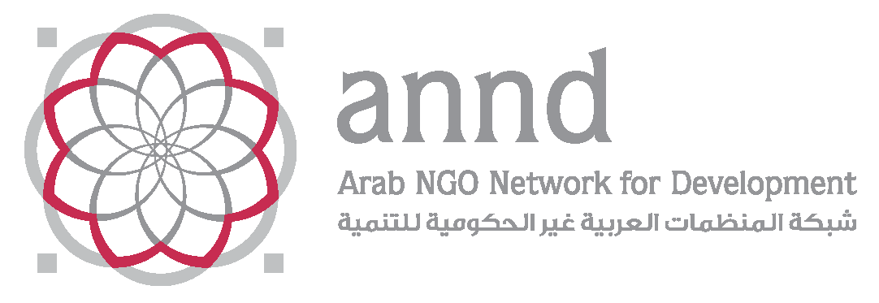

Submission by the Arab NGO Network for Development

Consultation on the Draft General Comment

on Article 6 of the International Covenant on Civil and Political Rights

– Right to life–

The right to life, as stated in the Draft General Comment (DGC) para 2, is “a right that inheres in every human being, but it also constitutes a fundamental right, whose effective protection is the prerequisite for the enjoyment of all other human rights and whose content can be informed and infused by other human rights”. With this only, the DGC makes a strong emphasis on the interdependence and indivisibility of all human rights and that violation of another right (i.e. the right to adequate standard of living) would invariably impede the right to life.

Nevertheless, the DGC approach remains limited when further clarifications are provided on measures to be taken to protect life, as stated in para 30. The DGC shrinks its ‘human rights language’ to rather ‘general conditions’ and ‘goods and services’ when focusing on key economic and social rights, including that of the right to water, food, health. DGC should continue with the same strong human rights language, referring to these rights, as fundamental rights interrelated and interdependent to the right to life. Shifting from services to ‘rights’ approach would also help enhance accountability of the State towards their fulfillment. It would help focus on the root causes of human rights violations faced deriving from implementation of social and economic policies negatively affecting the full enjoyment of the right to life. In relation, DGC’s propositions on developing strategies, action plans and organizing campaigns (i.e. on domestic violence) should not be as ad hoc initiatives proposed to States, on the contrary to highlight the need for comprehensive and rights-based development plans in each country that identifies structural challenges, root causes of human rights violations and appropriate steps to tackle them, with a genuine political will reflected through allocation of resources (i.e. through budget allocations) to ensure their realization. These plans should be adopted following an inclusive, transparent and participatory approach, to protect, promote and ensure the right to life of, all, in dignity.

The DGC in para 26 makes reference to jurisdiction, including against deprivations of life by other States operating within their territory or in other areas subject to their jurisdiction. Furthermore in para 66, DGC notes that States parties must respect and protect the lives of individuals located in territories, which are under their effective control, such as occupied territories, and in territories over which they have assumed an international obligation to apply the Covenant. These paragraphs are particularly important for the Arab region, and the Palestinians living under the Israeli occupation now since 50 years. As OCHAOpt points it out, “Occupation denies Palestinians control over basic aspects of daily life. Their ability to move unimpeded within their own country, to exit and return, to develop large parts of their territory, build on their own land, access natural resources or develop their economy is largely determined by the Israeli military.” Likewise, UN reports shed lights on the obligations of Israel as the occupying power to protect notably from all acts of violence, threats and insults. It further notes the settlers’ violence and harassments that impede the enjoyment of the right to life by Palestinian population. This being so, further stress on the right to life under occupation should be made, and the accountability of the occupying power should be stressed, in light of realization of Article 6 and other relevant human rights treaties. In addition, further stress should be put on the right to life of human rights defenders and activists, given repressive Israeli policies, and the increasing excessive use of force and Palestinian activists killed during demonstrations.

Another significant issue for the Arab region, namely the refugees and IDPs should be elaborated further in the DGC, given the figures of UNHCR that now we have an unprecedented 65.6 million people forced from home; among which nearly 22.5 million are refugees and over half of whom are under the age of 18. Practices and policies implemented, in particular with a solely security approach-focusing on border security-, violates the rights of refugees, including the right to life, the right to seek asylum.

About the Arab NGO Network for Development: ANND is a regional network, working in 12 Arab countries with nine national networks (with an extended membership of 250 CSOs from different backgrounds) and 23 NGO members. ANND was established in 1997 and its headquarters is located in Beirut, Lebanon since 2000. ANND aims at strengthening the role of civil society, enhancing the values of democracy, respect of human rights and sustainable development in the region. ANND advocates for more sound and effective socio-economic reforms in the region, which integrate the concepts of sustainable development, gender justice, and the rights-based approach.

For more information: www.annd.org

Contact: annd@annd.org

Facebook: https://www.facebook.com/www.annd.org

Twitter: https://twitter.com/ArabNGONetwork

https://www.ochaopt.org/50Stories/
https://www.google.com.tr/url?sa=t&rct=j&q=&esrc=s&source=web&cd=2&ved=0ahUKEwjeg7fvspXWAhUB1BoKHXNCBU0QFgguMAE&url=http%3A%2F%2Fwww.ohchr.org%2FEN%2FHRBodies%2FHRC%2FRegularSessions%2FSession34%2FDocuments%2FA_HRC_34_38_AUV.docx&usg=AFQjCNF7yaND2J1lAnygqdOcTWzAGMam1g
http://www.alhaq.org/advocacy/topics/right-to-life-and-body-integrity
http://www.unhcr.org/figures-at-a-glance.html

