CIVIL SOCIETY FOR THE FAMILY
OBSERVATIONS ON DRAFT GENERAL COMMENT 36
Submitted to the Human Rights Committee on October 5, 2017

INTRODUCTION

Below are nine observations of Civil Society for the Family on the contents of paragraphs 9 and 10 of draft General Comment 36, submitted to the Human Rights Committee pursuant to its call for inputs in July 2017.

Civil Society for the Family is an alliance of over 180 organizations from around the world dedicated to promoting the family in international policy. The organizing committee of Civil Society for the Family includes the following organizations accredited with the Economic and Social Council of the United Nations: Center for Family and Human Rights (C-Fam), the European Center for Law and Justice, Family Research Council, HazteOir, Human Life International, the Institute for Family Policy, the National Organization for Marriage, Novae Terrae, and Ordo Iuris for Legal Culture. More information about the coalition and its platform can be found at www.civilsocietyforthefamily.org.

OBSERVATIONS
1. The Human Rights Committee does not have the authority to create new obligations that were never agreed by sovereign states or even modify existing obligations.
The independence of treaty bodies and other UN experts is at the service of an authentic and judicious stewardship of the obligations that State Parties agreed in UN treaties. It is not a license to re-write treaties that took decades to negotiate. Treaty bodies must not usurp the role of State Parties, who alone are the final interpreters of their obligations. This is borne out by how the views and recommendations of UN treaty bodies must be germane to the reporting under the treaties that establish them and, by design of the negotiating states, are neither binding nor authoritative on State Parties.
2. Paragraphs 9 and 10 of General Comment 36 threaten the sovereignty and democratic legislative prerogatives of nations and their peoples.

Abortion and euthanasia are hot-button issues still debated in politics and culture all across the Globe. They are not issues that should be decided or resolved by an unelected, unaccountable, and mostly obscure committee of experts in Geneva. Moreover, many countries have policies directly contrary to what the committee suggests. At least 60 countries in the world have highly restrictive laws that contradict the contents of General Comment 36.
3. The International Covenant on Civil and Political Rights does not exclude unborn children from the right to life.
Unborn children are not excluded from the right to life in the International Covenant on Civil and Political Rights. To say or imply otherwise is not consistent with the text and history of the treaty. Article 6 of the covenant prohibits the application of the death penalty to pregnant mothers, precisely out of concern for the innocent unborn child as the General Assembly 3rd committee records and the reports of the Secretary General at the time bear out. At no point during the negotiations of the covenant were children in the womb ever said to be excluded from the right to life.
Moreover, at the same time as the Covenant was negotiated, the 1959 Declaration on the Rights of the Child was adopted by the General Assembly, committing States to protect children “before as well as after birth.” This very declaration was made binding in 1989 in the prologue of the Convention on the Rights of the Child, which has achieved near universal ratification. The committee should interpret the ICCPR in a way that is consistent with how state parties interpret their obligations under international law, including in subsequent international treaties.
4. The International Covenant on Civil and Political Rights does not contain an obligation for State Parties to provide “safe access to abortion” under any circumstance.
Early in the drafting stages of the covenant in 1947, the framers explicitly rejected an obligation to allow abortion in cases where a child is conceived by rape, incest, or when carrying a pregnancy to term might endanger the life of a mother. To only look at the 1957 decision to exclude a positive obligation to protect the unborn from abortion and to ignore the 1947 decision to exclude a positive right to abortion in the very circumstances proposed by the committee, as the committee has done in its discussions of the right to life, appears intellectually dishonest and applies a double standard.
While a positive obligation to protect children in the womb from abortion was rejected in 1957, this cannot be interpreted as excluding children in the womb from the protections of the Covenant, for the reasons cited above. Rather, it must be seen as a compromise that allowed states with vastly different understandings of when and how the right to life applies in the prenatal phase to ratify the treaty. It does not exclude children from the right to life. It merely gives State Parties a wide margin of appreciation in protecting the right to life before birth.
5. Experts in international law and policy declare that abortion is not a right and that international law “may, and indeed should be used” to protect the life of the unborn.
“As a matter of scientific fact a new human life begins at conception,” the San Jose Articles declare. The 2011 document signed by over 30 experts in health and law states that “No matter how an individual member of the species begins his or her life, he or she is, at every stage of development, entitled to recognition of his or her inherent dignity and to protection of his or her inalienable human rights.” The articles further state, “There exists no right to abortion under international law, either by way of treaty obligation or under customary international law. No United Nations treaty can accurately be cited as establishing or recognizing a right to abortion.” When treaty bodies say otherwise they act ultra vires and cannot create new obligations on state parties.
6. UN consensus rejects abortion as a right and continues to recognize abortion laws as an exclusively national prerogative.
Even sixty years after the UN Declaration on the Rights of the Child the General Assembly continues to reject a right to abortion. In 2015, when the General Assembly adopted the Sustainable Development Goals it reaffirmed that any policies related to sexual and reproductive health, including abortion, must be in accordance with the Programme of Action of the International Conference on Population and Development (ICPD), which explicitly rejected a right to abortion. More recent General Assembly resolutions mention abortion as part of "access to sexual and reproductive health" only "where such services are legal."
7. The International Covenant on Civil and Political Rights does not contain an obligation for state parties to allow euthanasia or assisted suicide.
State parties have never understood the covenant to require or permit euthanasia for terminally ill persons afflicted by great suffering. No more than half a dozen states permit euthanasia in any form. And none of these even permitted euthanasia at the time the covenant was negotiated, with most changes happening in recent years. Nothing in the text and history of the covenant lends itself to the aberrant notion that euthanasia or assisted suicide may be characterized as “death with dignity,” as the committee does in paragraph 10 of General Comment 36.
8. There is no scientific evidence that making abortion legal or more widely accessible leads to a reduction in maternal mortality due to abortion.
Claims that the legal status of abortion has an effect on overall maternal mortality are not supported by scientific evidence. If making abortion legal and more widely accessible were a key measure to improving maternal health, one would expect to see lower relative percentage of maternal mortality attributable to abortion in countries with more liberal abortion laws. The evidence simply does not show this. The legal status of abortion appears unrelated to maternal mortality levels from WHO data (See figure on next page).
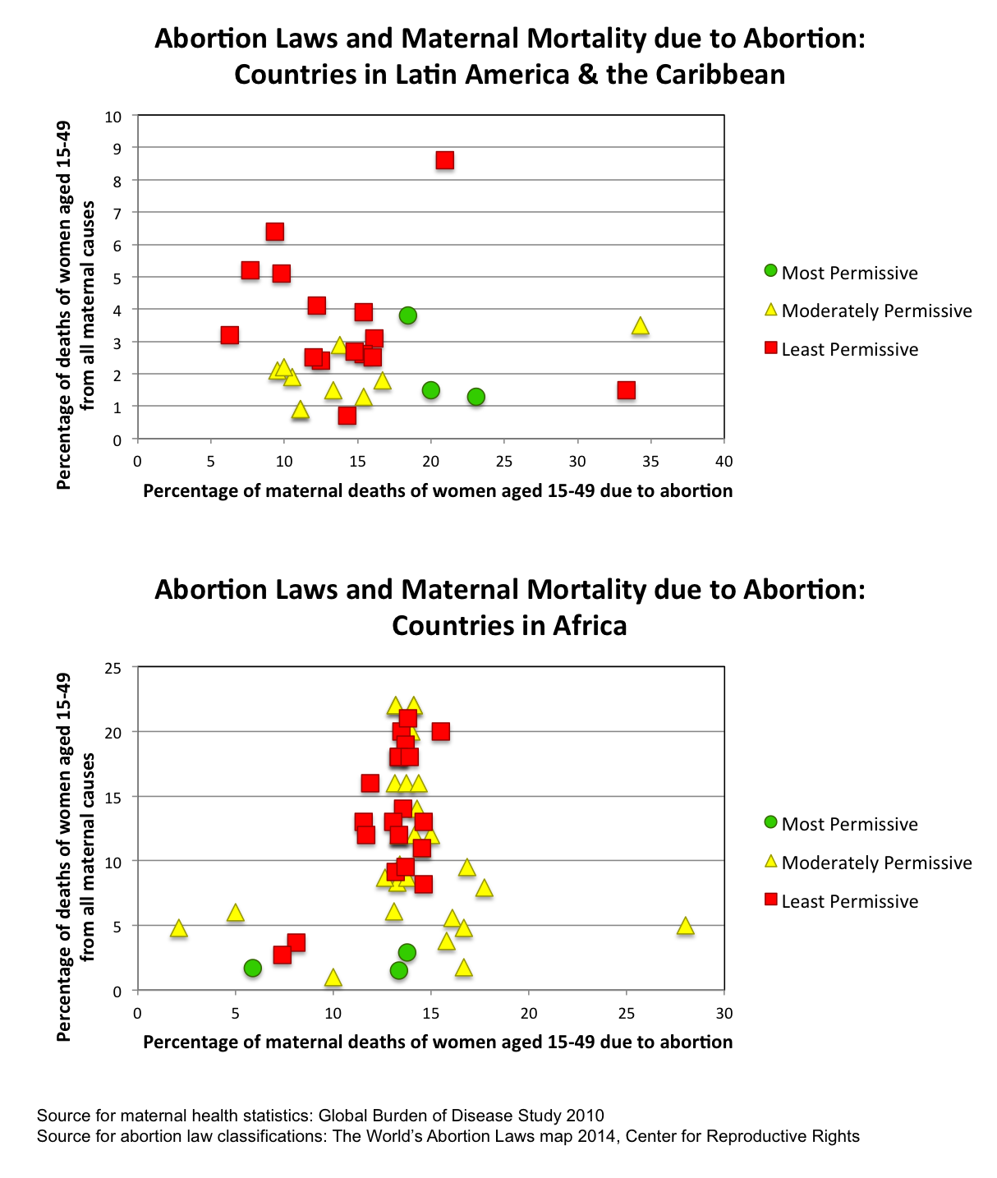
In the African region, which posts the highest rates of maternal mortality in the world, as maternal health overall improves deaths attributable to abortion decrease proportionally with all other causes of maternal death. This means the reduction in maternal deaths attributable to abortion have more to do with better and more accessible health care, particularly emergency obstetric care, than the legal framework of abortion. Indeed, the best epidemiological evidence shows that access to maternal health care and education level are the best predictors of maternal mortality levels, not the legal status of abortion.
9. Physicians increasingly call into question the medical necessity of abortion under any circumstance, including in cases where the life of a mother is danger from a medical condition.
While the committee cites the risk to the life of a woman as a reason to permit abortion, the medical community increasingly discourages abortion for so-called “therapeutic” reasons. As an invasive and intensive procedure, the physical stress and emotional trauma of abortion are likely to aggravate already existing medical conditions that threaten the life of a pregnant mother. Moreover, abortion, which is the direct killing of a child in the womb, should be distinguished from treatment options that may result in the premature delivery of a child or in the child’s death, where such interventions are deemed necessary to save the life of a mother. This is the conclusion of Dublin Declaration on Maternal Health written and signed by a select panel of the Committee on Excellence in Maternal Healthcare, in September 2012. Over 1000 Obstetricians/Gynecologists, Medical Professionals, Nurses and Midwives, Neonatologists & Pediatricians, and Medical Students have subsequently signed the Declaration.

Pedone, Joanne; Kloster, Andrew R., New Proposals for Human Rights Treaty Body Reform, Journal of Transnational Law & Policy 22: (2012-2013) 29, available at: http://research.un.org/en/treatybodies.
ABORTION WORLDWIDE REPORT: PART VI GLOBAL SUMMARIES: LIST, TABLES, MAPS & GRAPHS, Wm. Robert Johnston and Thomas W. Jacobson, available at: https://docs.wixstatic.com/ugd/cacd2b_89cc040a3f714067b14d1cca3ea10adf.pdf
Report of the Third Committee to the 12th Session of the General Assembly, UN Document A/3764, para. 18 (5 December 1957); Report of the Secretary-General to the 10th Session of the General Assembly, UN Document A/2929, Chapter VI, paragraph 10 (1 July 1955).
Finegan, Thomas, International Human Rights Law and the "Unborn": Texts and Travaux Préparatories, Tulane Journal of International & Comparative Law, Winter 2016, Vol. 25 Issue 1, at p. 14-23 (detailing the traveaux preparatoire of the International Covenant on Civil and Politcial Rights).
Convention on the Rights of the Child, opened for signature 20 November 1989, 1577 UNTS 3.
Finegan, Ibid. note 4.
The San Jose Articles and explanatory notes on the article are a document relevant to the general discussion of Article 6 of the International Covenant on Civil and Political Rights by the Human Rights Committee. Forty-four human rights lawyers and advocates, scholars, elected officials, diplomats, and medical and international policy experts signed the articles in 2011. The articles have been presented at UN headquarters in New York, and in parliaments across the world. The articles and footnotes are available at: www.sanjosearticles.com.
See 2030 Agenda for Sustainable Development, UN Document A/RES/70/1, target 5.6, and Programme of Action of the International Conference on Population and Development, UN Document A/CONF.171/13, Chapter 8, paragraph 6.
General Assembly Resolution on Intensification of efforts to prevent and eliminate all forms of violence against women and girls: domestic violence, UN Document A/RES/71/170, para. 14f.
Penney Lewis, Assisted dying: What does the law in different countries say?, October 6, 2015 (BBC News), available at: http://www.bbc.com/news/world-34445715.
Stefano Gennarini, J.D. and Rebecca Oas, Ph.D., Securing a Better Future for Mothers in the Post-2015 Development Agenda: Evaluating the ICPD Operational Review, International Organizations Research Group, Briefing Paper Number 11 March 28, 2014, available at https://c-fam.org/briefing_paper/securing-a-better-future-for-mothers-in-the-post-2015-development-agenda-evaluating-the-icpd-operational-review/.
Koch E, Thorp J, Bravo M, Gatica S, Romero CX, et al. (2012) Women's Education Level, Maternal Health Facilities, Abortion Legislation and Maternal Deaths: A Natural Experiment in Chile from 1957 to 2007. PLOS ONE 7(5): e36613.
“As experienced practitioners and researchers in obstetrics and gynecology, we affirm that direct abortion – the purposeful destruction of the unborn child – is not medically necessary to save the life of a woman. We uphold that there is a fundamental difference between abortion, and necessary medical treatments that are carried out to save the life of the mother, even if such treatment results in the loss of life of her unborn child. We confirm that the prohibition of abortion does not affect, in any way, the availability of optimal care to pregnant women.” For more information on the Dublin Declaration on Maternal Health Care visit the website www.dublindeclaration.com.

