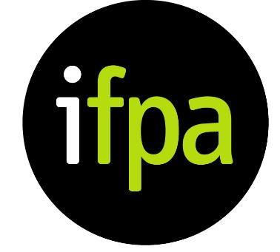
Submission by the Irish Family Planning Association to the Human Rights Committee in respect of the Draft General Comment on Article 6 (Right to Life) of the International Covenant on Civil and Political Rights
The Irish Family Planning Association (IFPA) welcomes this opportunity to make a written submission to the Human Rights Committee ahead of the second reading of its draft general comment No. 36 on article 6 of the International Covenant on Civil and Political Rights on the right to life.
The IFPA makes these comments from the perspective of a sexual and reproductive healthcare provider in a State whose laws inadequately vindicate the right to life of pregnant women and girls, and where the law that purports to uphold their right to life-saving abortion imposes significant barriers, such as complex and burdensome certification processes and the threat of criminal sanction, which can impede access to care. For example, in 2015, three IFPA clients who believed that their pregnancy put their lives at risk, chose to travel abroad to access abortion, rather than subject themselves to the onerous certification process under the Protection of Life During Pregnancy Act 2013. For these reasons, the IFPA welcomes the removal of references to the application of Covenant rights before birth.
The IFPA operates in an extremely restrictive legal context where a constitutional provision (inserted in 1983) affords an embryo or foetus an equal right to life with that of a pregnant woman or girl. As a result of the law, our clients have experienced significant harms and violations of their rights to life (article 6), but also their rights to non-discrimination (articles 2 and 3), freedom from torture or cruel, inhuman or degrading treatment (article 7), privacy (article 17) and the right to equality before the law and equal protection of the law without discrimination (article 26).
The relationship between the rights to life, health and non-discrimination is demonstrated by the experiences of marginalised women and girls in Ireland in the context of abortion. Those who experience multiple, intersecting forms of disadvantage, such as asylum-seeking women, poor women and minors, are disproportionately impacted by the laws on abortion and face significant barriers in accessing healthcare as they must either travel to another jurisdiction to access safe and legal abortion (at significant psychological, physical and financial cost) or risk prosecution by illegally importing and self-administering the abortion pill.
Therefore, we respectfully suggest that the language in paragraph 9 of the draft general comment could be further strengthened to reflect the interdependency of the right to life with the above listed rights, particularly the right to non-discrimination.
The Irish experience also demonstrates the need for State parties to decriminalise abortion in all circumstances. Criminal sanctions perpetuate stigma and create a chilling effect for both women and healthcare providers. The IFPA has treated women who have incurred risks to their health when complications arose after using the abortion pill, because they were deterred or delayed by fear of prosecution from going to their doctor or presenting at a hospital. By calling for the decriminalisation of voluntary termination of pregnancy in paragraph 9, General Comment No. 36 would provide critical guidance to States parties on compliance with article 6 and the realisation of women’s and girls’ right to life.
In conclusion, the IFPA also endorses the Written Contribution to the Committee made by the Center for Reproductive Rights, Amnesty International, Human Rights Watch, the International Commission of Jurists and Ipas. In this regard, we respectfully suggest the Committee take into account the following considerations in its second reading of the general comment on the right to life:

- Emphasizing the importance of non-discrimination, as well as equality before the law and equal protection of the law, especially in relation to gender- and sex-based discrimination, as well as intersectional discrimination, in outlining States parties’ obligations to realise the right to life (paragraph 9);
- Reaffirming States parties’ obligations to guarantee access to safe and legal abortion in order to protect women’s and girls’ right to life, encompassing a call for immediate decriminalisation and removal of barriers to abortion (paragraph 9); and
- Realising women’s enjoyment of the right to life by ensuring access to the full range of sexual and reproductive health services, provided in a non-discriminatory manner that respects informed consent and confidentiality (paragraph 30).

