UN Human Rights Committee Draft General Comment on Article 6
of the International Covenant on Civil and Political Rights
Comments on Paragraph 9

My concern with the Draft General Comment Paragraph 9 is its high level of ambiguity which could lead to it being interpreted as an instrument for liberalising abortion leading to increased loss of human life not compatible with Article 6, especially draft Paragraphs 2, 3, & 4. Paragraph 2 “recognizes and protects the right to life of all human beings” and Paragraph 3 states “the right to life is a right which should not be interpreted narrowly. Article 6 guarantees this right for all human beings, without distinction of any kind” meaning this right to life must extend to the unborn child.

States may adopt measures to regulate terminations of pregnancy but the specific circumstances it describes of abortion to preserve the life of a pregnant woman is extremely rare in the United Kingdom and abortion due to fatal foetal impairment is also proportionally uncommon. Abortion because of rape and/or incest appears to be uncommon proportionally in the United States meaning the specific circumstances of the Paragraph themselves seem to be overwhelmingly not the reason for abortion in populations and by inference States.

Yet adjoined to these specific circumstances are statements that would allow those in favour of abortion to use Paragraph 9 to extend it more liberally (perhaps by encouraging States to make regulations less stringent), leading to greater loss of life and whereby the removal of criminal sanctions may actually increase the prevalence of unsafe abortions which the Paragraph seeks to avoid, because it allows for medical regulation and/or supervision that protects women undergoing abortion not to be present. States must be permitted to have in place criminal sanctions that deter inappropriate actions and be imposed where harm is caused against persons including the unborn child.

There is no acknowledgement in the Paragraph of the part contraceptive failure plays in reproductive losses which is exacerbated through the widespread availability sought and where a UK abortion provider in July 2017 reported that 51.2% of abortions it undertook was due to contraceptive failure. Therefore, some of the physical and mental pain or suffering for women described in the draft text is in part due to dissatisfactory reproductive health advice and agency as not all women and couples will use the most effective methods – this information is a red flag which contraceptive educators and providers must investigate with purpose as it poses an existential question of the United Nation’s work such as the 2030 Agenda for Sustainable Development. Worldwide only 0.7% of married or in-union women in 2015 were using the most effective contraceptive method (long-acting reversible contraceptive implants) according to the UN’s Trends in Contraceptive Use Worldwide (2015) report. As it is known that even the most effective contraceptives fail, the Paragraph’s focus should be shifted to encouraging long-term relationships, including marriage (but excluding child marriage) as the conduit to avoiding loss of human life through abortion as these relationships are more likely to cope with unexpected pregnancy, and with States encouraged to ensure a robust adoption system is in place.

From my research, there is also a concern that abortion may be linked to raised levels of violence against women which interpreting the Paragraph as permitting more liberal access could further admit thereby impacting and limiting women’s life chances.
Evidence of the specific circumstances as the overwhelming minority of reasons for abortion

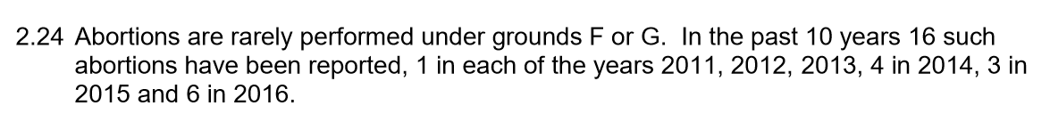
In the United Kingdom, the official Department of Health Abortion statistics for 2016 (where the total number of abortions was 185,596) describes under grounds F and G which are; in an emergency, certified by the operating practitioner as immediately necessary: F to save the life of the pregnant woman (section 1(4)); G to prevent grave permanent injury to the physical or mental health of the pregnant woman (section 1(4)), the following paragraph:
© Department of Health 2016
Foetal impairment was the reason for around 2% of the United Kingdom’s abortions in 2016 and has been consistently so between 2011-2016 meaning around 98% of unborn children aborted in the United Kingdom during that period were healthy. The proportion of fatal foetal impairments is not provided in official statistics only that the foetus is described as “handicapped/seriously handicapped.”

The US Guttmacher Institute in two studies from 1987 and 2004 found rape was a contributory reason for abortion in 1% of respondents and incest less than 0.5% in both 1987 and 2004. Rape was the most important reason for abortion in less than 0.5% of respondents in the 2004 study and 1% in 1987.

The Paragraph seems to indicate an acceptance of abortion for rape and/or incest with which not everyone may agree, with many believing every human life, including the unborn child’s, is unique and has equal value irrespective of the nature of their conception, their mental well-being, or physical form.

Therefore, whilst the right to life and health of a pregnant woman and the circumstances of rape and/or incest and fatal foetal impairment are included in the draft Paragraph and for which there may be physical and/or mental pain and suffering, these grounds appear overwhelmingly not to be the reason for abortion and abortion purely because suffering exists and outside of the reason of contraceptive failure, perhaps because the pregnancy is solely unwanted or for social reasons (as shown in the Guttmacher study) should not be an interpretation of the draft text which in present form it could. These adjoining sentences create an ambivalence or uncertainty which should not be the aim of the Paragraph.

The Paragraph then adds ambivalence in the next sentence which is “States parties may not regulate pregnancy or abortion in a manner that runs contrary to their duty to ensure that women do not have to undertake unsafe abortions.” This text may be sound but those in favour of liberal access to abortion can interpret “[States parties] should not take measures such as criminalizing pregnancies…or applying criminal sanctions against women undergoing abortion” in addition to the previous sentences not to “[or] cause physical or mental pain or substantial pain or suffering” to mean abortion should be allowed in the absence of criminal sanctions (for example there is an offence ‘against the Person’ in the UK & Northern Ireland) certainly admitting unsafe abortions because the act can then be removed from medical regulation and/or supervision (as is currently a requirement in the UK) allowing the self-administering of abortion drugs in a non-clinical setting and beyond legally regulated time limits. This can also mean less favourable outcomes for women with problems such as in their relationships and result in inadequate post-abortion health care the Paragraph states must be ensured. It could also lead to sex-selective abortion of female [or male] foetuses again harming women. Ergo, it is possible criminalisation can significantly lead to resort to unsafe abortions but so too can decriminalisation, violating States duty to ensure safe abortions when regulated, and making the Paragraph inconsistent with its aims. In the milieu of States where laws differ, who judges “…when taking such measures is expected to significantly increase resort to unsafe abortions”? There must be an expectation of citizens to abide by States laws and shape them by democratic means and not resort to inappropriate action. A fundamental difference between States adopting “measures to regulate terminations of pregnancy”, “legal restrictions” (such as time limits), and “criminal sanctions” must be recognised and suitability of the concept of criminality reassessed for inclusion in the Paragraph. In the UK, only two women have been convicted under criminal sanctions in the 50 years since the Abortion Act of 1967 – both were vulnerable and had personal problems that could have been noticed and treated via medical supervision that they did not receive - demonstrating that criminal sanctions deter inappropriate actions, protect women undergoing abortion, and are not intrinsically used as punishment.

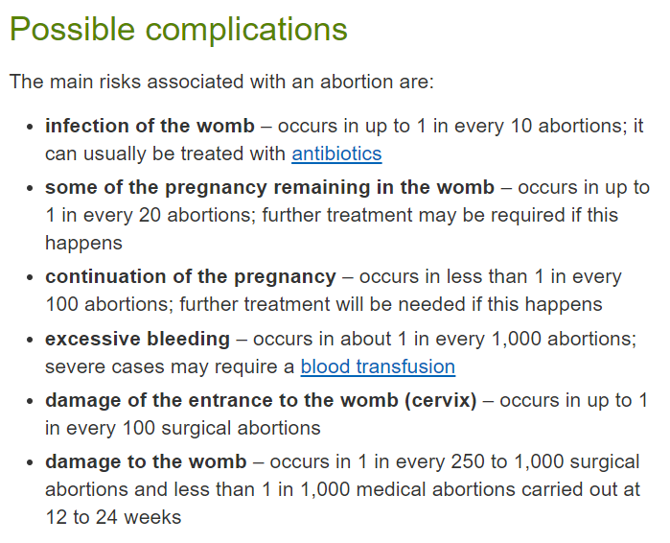
The following sentence not to “introduce humiliating or unreasonably burdensome requirements on women seeking to undergo abortion” - for example, having to travel costly long distances or where women are in employment and so have difficulty in attending clinics – is also a precursor that (resort to) unsafe abortions could take place should it be included in the Paragraph. These examples were put forward in the UK Parliament in March 2017 as arguments to decriminalise abortion but which are obvious could lead to the unsafe abortions (as described above) that the Paragraph rightly seeks to avoid. Women seeking to undergo abortion have every right not to be humiliated (for example when attending a clinic) but they also have the right to safe abortion when regulated, calling into question the inclusion of this sentence in the Paragraph. The UK’s National Health Service (NHS) lists the possible harm due to abortion on its website making it extremely clear that medical supervision for this procedure, by any means, is necessary:
Source: NHS Choices website – Risks of an abortion ©NHS 2017
Concerns about contraceptive failure as the reason for reproductive losses
The next sentence regarding States “ensure access for women, men, and adolescents to information and education about reproductive options and to a wide range of contraceptive methods” (such as is the case in the UK) whilst aiming to fulfil “a duty to protect the lives of women against the health risks of unsafe abortions” does not acknowledge that contraceptive failure is the reason for many abortions and therefore the pain and suffering for women contained in the draft text and so is an oxymoron. As mentioned, abortion provider the British Pregnancy Advisory Service (BPAS) stated on 7th July 2017 that 51.2% of cases of abortion at its clinics (approximately 30,296) were due to contraceptive failure – that is women and couples actively seeking to avoid pregnancy suffering reproductive loss.

More data points may be required to corroborate this proportion of failure but, whilst not representative of the population as a whole, only 15% of women and couples attending reproductive health services in the UK were issued with the most effective method of contraception in 2015/16 - long-acting reversible contraceptive (LARC) implants which are 99.95% effective in both ‘perfect’ and ‘typical’ use according to the Association of Reproductive and Health Professionals (ARHP) table and are recommended by the UK National Institute for Care and Health Excellence as they are cost-effective and “their increased uptake could help to reduce unintended pregnancy.” Annex Table III of the UN’s report Trends in Contraceptive Use Worldwide (2015) shows that LARC implants were being used by only 0.7% of married or in-union couples worldwide with the greatest prevalence in Kenya at only 10.8% in 2015. Female sterilization and the IUD are more prevalent worldwide in married or in-union couples but in ‘perfect’ use are 10 and 16 times less effective respectively, and no contraceptive is rated as 100% effective at present which should be a goal. The number of abortions in the UK could be reduced by over 40% in theory if all couples used LARC implants.

The BPAS data, study of contraceptive patterns of use in the UK, and the Association of Reproductive Health Professionals (ARHP) effectiveness table indicates that contraceptives fail closer to ‘perfect’ rather than ‘typical’ use meaning improvements can and must be made by reproductive health services to avoid the pain and suffering for women and couples described in the draft text via dissatisfactory advice and agency, with a shift in culture to consciousness of the unborn child being the largest factor and primary concern in their decision when providing contraception and family planning advice. A shortfall in LARC implant method training and investment may be an issue as may commercial pressures.

The Paragraph should include text something similar to “States should seek to promote healthy relationships and lifestyles that aims to protect all human life and avoid its loss through abortion. Where contraception is used it should be of the most effective kind; more than one form including a barrier method can be used; it may include natural family planning additionally; and without promoting promiscuity.” There is no expectation that where contraceptives fail, abortion will be the result. The UK’s Department of Health Abortion Statistics for 2016 illustrates that married women are more than six times less likely to access abortion services than non-married women, and in the Guttmacher study (2005) “women who were married, who were in the highest income category and who were employed had reduced odds of saying they could not afford a baby (odds ratios, 0.4–0.6).”

A possible link to violence against women

Another concern for any ambiguity in the draft text of Paragraph 9 is a possible link between abortion and violence against women and therefore the effect a liberal interpretation of the draft Paragraph could have on women’s life chances in States including serious injury and the denial of opportunities to them for fear of victimisation. The evidence presented here is factual with references but I believe it requires further investigation for causality.

Based on the European Union’s Agency for Fundamental Rights’ (FRA) Violence against women: an EU-wide survey (2014) in which 42,000 female respondents across the EU were interviewed face-to-face and could report anonymously, it can be seen that women in member states where abortion is naturally opposed (predominantly Catholic and Orthodox Catholic) appear to experience significantly less physical and sexual violence on average than women in predominantly Catholic-minority member states (see Chart 1). A similar pattern was observed for all categories of gender-based violence including psychological partner violence, sexual harassment, and stalking. Four EU member states are Orthodox Catholic-majority (Bulgaria, Cyprus, Greece, and Romania) and the survey was weighted, for example for age and urban/rural ratios. Catholic religiosity itself will be a factor; exposure to the risk of violence and alcohol consumption between countries are also possible factors but evidence for them was not presented in the survey (some EU member states with the highest ‘hazardous drinking score’ rank among the lowest for prevalence of violence) although they should not be ruled out. Member state codes and population percentages are in Appendix B.

The 6 member states with the strictest access to abortion in the EU (restricted or up to a 10- week limit) – Malta, Poland, Ireland, Croatia, Portugal, and Slovenia – all ranked in the 7 lowest country prevalence of physical and/or sexual violence against women since the age of 15 (seen in Chart 1). Austria had the 2nd lowest rate of abortion within the EU according to a UN Department of Social and Economic Affairs report for 2010 and had the 2nd lowest rate of this category of violence. Abortion is not permitted in Malta; only permitted if the mother’s life is at risk in Ireland; except in cases of rape, when the mother's life is at risk, or serious foetal impairment in Poland; 10-week limit in Croatia, Portugal, and Slovenia; 12-week limit in the other EU member states; 14-week limit in Romania; 18-week limit in Sweden; 20-week limit in Finland; and 24-week limit in the UK (excluding Northern Ireland) [as of July 2017].

There is a mild correlation between the prevalence of this category of violence and abortion rates by member state (see Chart 2) with predominantly Catholic-majority countries occupying the bottom left corner of the chart. Abortion rates differ within the EU with possible reasons being under-reporting outside of member states’ official abortion statistics, or the availability of contraception with Catholic-majority member states favouring less effective natural family planning and a social stigma of being pregnant outside of marriage exceeding that of seeking abortion services.

The FRA survey chart (Figure 2.3) also displays this pattern where women appear to experience both less non-partner and domestic violence in countries in the EU where abortion is naturally opposed.

Chart 1 - Relationship between the prevalence of gender-based violence and Catholic (and Orthodox) population (%) by EU member state
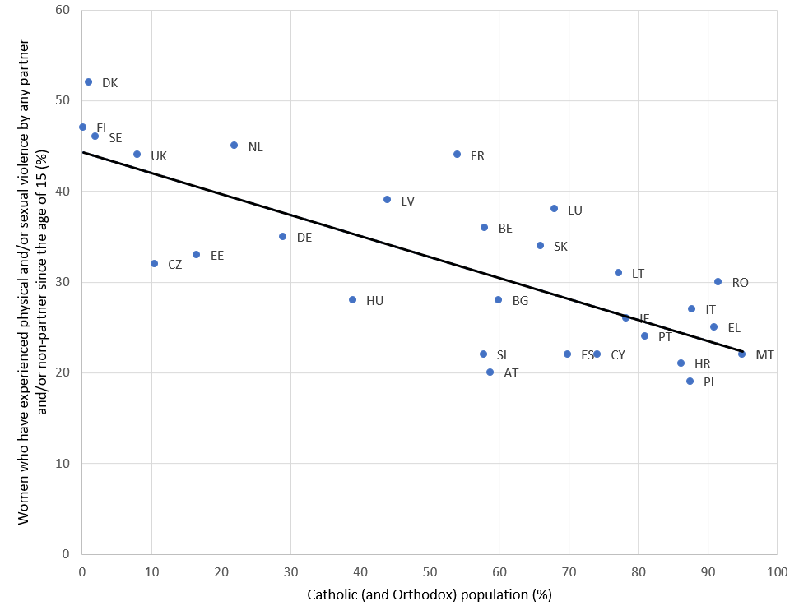

Correlation coefficient -0.763
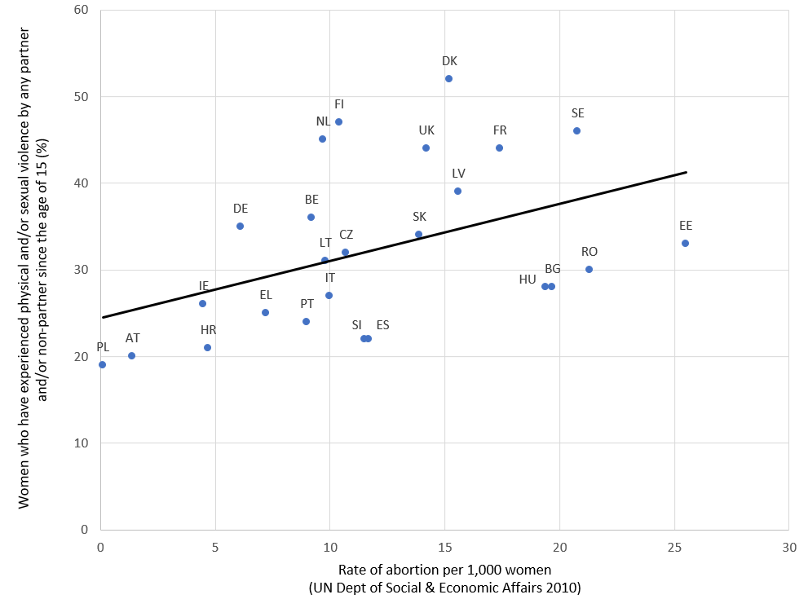
Chart 2 - Relationship between the prevalence of gender-based violence and rate of abortion per 1,000 women by EU member state
20
Predominantly Catholic-majority EU member states
Correlation coefficient 0.440, n=25

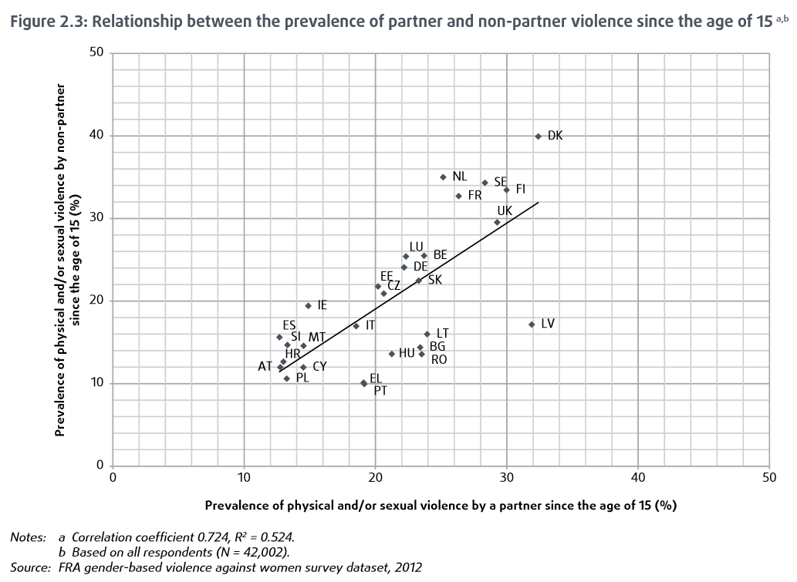
© European Union Agency for Fundamental Rights
Predominantly Catholic-majority EU member states
Predominantly Catholic-minority EU member states

A study of pregnant women attending clinics in the north east of England found women attending to access abortion services were more than six times more likely to be subject to domestic violence than those attending for ante-natal classes (5.8% v 0.9%) again suggesting a link between abortion and violence against women.

Whilst definitions and the methods of recording of rape between countries differ, the FRA survey details that “European Sourcebook data show considerable differences between EU Member States. For example, the average annual figures from official data in the period 2005–2007 range from 47 reported rapes per 100,000 population in Sweden, 27 per 100,000 in Belgium and 25 per 100,000 in England and Wales, through to 2 per 100,000 in Greece and Hungary, and 3 per 100,000 in Croatia, Malta, Portugal and Slovakia.”

Abortion allows for the possibility of a significant proportion of men to treat women badly as they experience few or no consequences from their relationships because they can avoid the responsibility of a child which would otherwise be an excessive cost to them. It is possible that if women are valued less in society by some men, who no longer see them as mothers and givers of life, then the cost of violence is reduced. The evidence suggests that if the act of abortion is liberalised in States and a link between gender-based violence and abortion is established then it could have serious implications for women.

Conclusion

The Paragraph’s present draft form is not appropriate as an instrument for protecting the right to life, insofar as States regulate terminations of pregnancy, as it is ambiguous, allowing a wide interpretation that may result in abortion on multiple grounds and therefore is inconsistent with the other Paragraphs in Article 6. The specific circumstances to protect the life and health of pregnant women are overwhelmingly the minority of instances of abortion.
The evidence of dissatisfactory reproductive health advice and agency resulting in unintended reproductive loss causes women the pain and suffering described, such that there must be a far-reaching and rapid re-examination of contraceptive cultural practices, especially given the goals to provide universal access to reproductive health worldwide. This is because this reason for human loss, as well as those based purely in social reasons, cannot be used to justify abortion and violate the right to life of the unborn child.

In addition to protecting the life and health of pregnant women, the focus of the Paragraph should include relationships that best preserve the right to life and are more likely to nurture children, and with States providing adequate adoption services for unwanted pregnancies. The Paragraph must stress the importance of the unborn child where contraception is used, which should be the most effective form and can include more than one method including a barrier method, without promoting promiscuity, and all unintended pregnancies can be kept.

Criminal sanctions are a valuable tool for States to protect mothers, the unborn child, and their societies and where, in their absence, the avoidance of medical assistance can again harm women through unsafe abortions. The only safe abortions are those where medical supervision is guaranteed.

My research shows that abortion could be linked to violence against women which requires further investigation but which suggests that stricter access and attitudes to abortion in EU member states could result in lower rates of gender-based violence, meaning any moves towards more abortion in States may not be good for women, and the Paragraph must be re-examined for the reasons given.

New human life is the potential that will bring us to a better world and its importance should never be underestimated meaning the right to life must be upheld.

Yours sincerely,

David Earley
Director, North West Pro Life
(dearley12@hotmail.com)
October 2017

References

Appendix A – FRA survey data for physical and/or sexual violence by EU member state
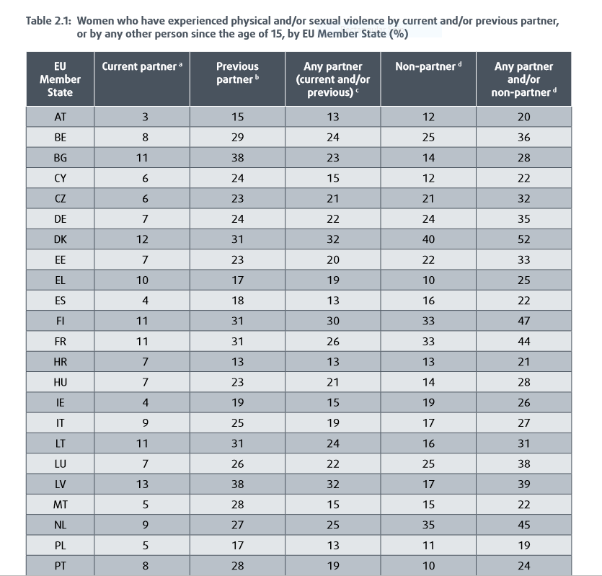
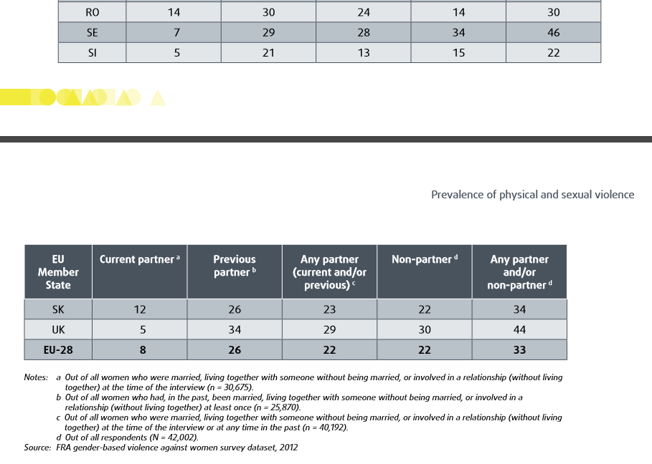

© European Union Agency for Fundamental Rights, 2014
© European Union Agency for Fundamental Rights 2014

Appendix B – Sources for Catholic and Orthodox population percentages in the EU

Accessed 30 June 2017

EU member state | EU code | Ca+Or pop (%) | Source link
Austria | AT | 58.8 | http://www.katholisch.at/statistik
Belgium | BE | 58.0 | http://ec.europa.eu/commfrontoffice/publicopinion/archives/ebs/ebs_393_en.pdf
Bulgaria | BG | 0.6+59 | http://censusresults.nsi.bg/Census/Reports/2/2/R10.aspx
Croatia | HR | 86.2 | http://www.dzs.hr/Eng/censuses/census2011/results/htm/E01_01_10/e01_01_10_RH.html
Cyprus (assumed entire island) | CY | 1+73.2 | http://www.globalreligiousfutures.org/countries/cyprus/religious_demography#/?affiliations_religion_id=0&affiliations_year=2010 – 1002 https://www.cia.gov/library/publications/the-world-factbook/geos/cy.html
Czech Republic | CZ | 10.5 | https://web.archive.org/web/20150221184947/http://www.czso.cz/sldb2011/eng/redakce.nsf/i/tab_7_1_population_by_religious_belief_and_by_municipality_size_groups/$File/PVCR071_ENG.pdf
Denmark | DK | 1.0 | http://www.katolsk.dk/1635/
Estonia | EE | 0.4+16 | http://pub.stat.ee/px-web.2001/Dialog/varval.asp?ma=PC0454&lang=1
Finland | FI | 0.2 | http://www.catholic-hierarchy.org/diocese/dhels.html#stats
France | FR | 54.0 | http://ec.europa.eu/commfrontoffice/publicopinion/archives/ebs/ebs_393_en.pdf
Germany | DE | 29.0 | https://www.ekd.de/ekd_de/ds_doc/zahlen_und_fakten_2016.pdf
Greece | EL | 91.0 | http://www.pewforum.org/2017/05/10/religious-belief-and-national-belonging-in-central-and-eastern-europe/
Hungary | HU | 39.0 | http://www.ksh.hu/docs/hun/xftp/idoszaki/nepsz2011/nepsz_orsz_2011.pdf
Ireland | IE | 78.3 | http://www.cso.ie/en/media/csoie/releasespublications/documents/population/2017/Chapter_8_Religion.pdf
Italy | IT | 87.8 | http://www.corriere.it/Primo_Piano/Cronache/2006/01_Gennaio/17/cattolici.shtml
Latvia | LV | 24+20 | http://ec.europa.eu/commfrontoffice/publicopinion/archives/ebs/ebs_393_en.pdf
Lithuania | LT | 77.2 | https://en.wikipedia.org/wiki/Religion_in_Lithuania
Luxembourg | LU | 68.0 | http://ec.europa.eu/commfrontoffice/publicopinion/archives/ebs/ebs_393_en.pdf
Malta | MT | 95.0 | http://ec.europa.eu/commfrontoffice/publicopinion/archives/ebs/ebs_393_en.pdf
Netherlands | NL | 22.0 | http://ec.europa.eu/commfrontoffice/publicopinion/archives/ebs/ebs_393_en.pdf
Poland | PL | 87.5 | http://stat.gov.pl/download/cps/rde/xbcr/gus/LUD_ludnosc_stan_str_dem_spo_NSP2011.pdf
Portugal | PT | 81.0 | https://www.ine.pt/xportal/xmain?xpgid=ine_main&xpid=INE
Romania | RO | 5+86.5 | http://www.revistadestatistica.ro/supliment/wp-content/uploads/2014/09/RRRS06_2014_A2_en.pdf
Slovakia | SK | 66.0 | http://www.culture.gov.sk/registrovane-cirkvi-a-nabozenske-spolocnosti-f9.html [PDF file]
Slovenia | SI | 57.8 | https://www.dlib.si/details/URN:NBN:SI:DOC-VNL24FNV/?
Spain | ES | 69.9 | http://datos.cis.es/pdf/Es3173sd_A.pdf
Sweden | SE | 2.0 | http://ec.europa.eu/commfrontoffice/publicopinion/archives/ebs/ebs_393_en.pdf
UK | UK | 8.0 | http://www.natcen.ac.uk/news-media/press-releases/2015/may/british-social-attitudes-church-of-england-decline-has-accelerated-in-past-decade/

Ca+Or = Catholic and Orthodox population percentages

British Pregnancy Advisory Service, 2017, Women cannot control fertility through contraception alone: bpas data shows 1 in 4 women having an abortion were using most effective contraception, Available at: https://www.bpas.org/about-our-charity/press-office/press-releases/women-cannot-control-fertility-through-contraception-alone-bpas-data-shows-1-in-4-women-having-an-abortion-were-using-most-effective-contraception/
United Nations Department of Social and Economic Affairs Population Division, 2015, Trends in Contraceptive Use Worldwide [PDF file], Available at: http://www.un.org/en/development/desa/population/publications/pdf/family/trendsContraceptiveUse2015Report.pdf
Department of Health, 2016, Abortion Statistics, England and Wales: 2016 [PDF file], Available at: https://www.gov.uk/government/statistics/report-on-abortion-statistics-in-england-and-wales-for-2016
Dept. of Health, 2016, Abortion Statistics
Prior to the 2015 Abortion Statistics, ‘seriously handicapped’ was described as ‘handicapped.’
Guttmacher Institute, 2005, Reasons American women have abortions [PDF file], Available at: https://www.guttmacher.org/journals/psrh/2005/reasons-us-women-have-abortions-quantitative-and-qualitative-perspectives, p.113-114.
Guttmacher, 2005, Reasons p.113.
Hansard HC, Deb. vol. 623 col. 26, 13 March 2017. Available at: https://hansard.parliament.uk/commons/2017-03-13/debates/D76D740D-2DDD-4CCB-AC11-C0DBE3B7D0D8/ReproductiveHealth(AccessToTerminations)
NHS, 2017, Risks of an abortion, Available at: http://www.nhs.uk/Conditions/Abortion/Pages/Risks.aspx
British Pregnancy Advisory Service, 2017, Women cannot control fertility through contraception alone
NHS Digital, 2016, Sexual and Reproductive Health Services, England - 2015-16 Data tables [Excel file], Available at http://www.content.digital.nhs.uk/catalogue/PUB21969, Table 6
Association of Reproductive Health Professionals, 2014, Choosing a Birth Control Method Contraceptive Failure Rates: Table, Available at: http://www.arhp.org/Publications-and-Resources/Quick-Reference-Guide-for-Clinicians/choosing/failure-rates-table
National Institute for Care & Health Excellence, 2014, Long-acting reversible contraception, Available at: https://www.nice.org.uk/guidance/cg30/chapter/Introduction
United Nations Department of Social and Economic Affairs Population Division, 2015, Trends
Family Planning Association, 2007, Contraception: patterns of use factsheet [PDF file], Available at: http://www.fpa.org.uk/factsheets/contraception-patterns-use
Department of Health, 2016, p.28.
Guttmacher, 2005, Reasons, p.115.
European Union Agency for Fundamental Rights, 2014, Violence Against Women: An EU-wide survey [PDF file], Available at: http://fra.europa.eu/en/publication/2014/violence-against-women-eu-wide-survey-main-results-report
World Health Organisation Regional Office for Europe, 2012, Alcohol in the European Union Consumption, harm and policy approaches [PDF file], Available at: http://www.euro.who.int/en/health-topics/disease-prevention/alcohol-use/publications/2012/alcohol-in-the-european-union.-consumption,-harm-and-policy-approaches, p.12.
United Nations Department of Social and Economic Affairs Population Division, 2013, World Abortion Policies 2013 [PDF file], Available at: http://www.un.org/en/development/desa/population/publications/policy/world-abortion-policies-2013.shtml
Wokoma TT, Jampala M, Bexhell H, Guthrie K & Lindow S, (2014), A comparative study of the prevalence of domestic violence in women requesting a termination of pregnancy and those attending the antenatal clinic, BJOG, 121:627-633
Tavares, C. and Thomas, G., 2010, ‘Crime and criminal justice’, Statistics in Focus Series 58/2010, Eurostat; Aebi et al. (2010), European Sourcebook of Crime and Criminal Justice Statistics – 2010, The Hague, Boom Juridische uitgevers. pp. 354–356.

